Drafting
Step 1 – 1 representative from each team will meet on a call. (discord, google meet, whatever)
Step 2 – They will both select HEADS or TAILS. Once this is agreed, one person will share their screen and do a digital coinflip. See example below:
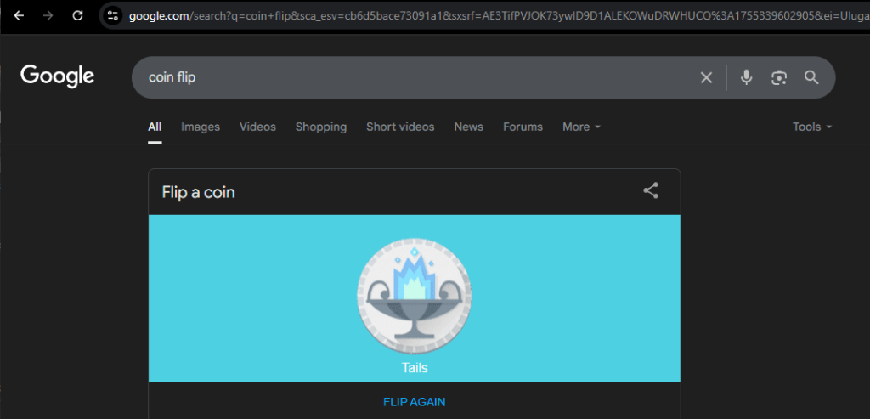
Step 3 – The winner of the coinflip will decide to select God 1st or 2nd. Whoever picks their God 1st, will pick 2nd the next 2 times.
Step 4 – A coinflip will be done to decide the fifth draft order.
See example below:
Moon Princesses vs TeamHAT
TeamHAT wins the coinflip, chooses 2nd.
-GAME 1: Moon Princesses pick 1st, TeamHAT picks 2nd
-GAME 2: TeamHAT picks 1st, Moon Princesses picks 2nd
-GAME 3: TeamHAT picks 1st, Moon Princesses picks 2nd
-GAME 4: Moon Princesses pick 1st, TeamHAT picks 2nd
-Coinflip (Same as above) (In this example Moon Princesses win the coinflip)
-Moon Princesses decide to pick 2nd
-GAME 5: TeamHAT picks 1st, Moon Princesses picks 2nd

