Gods Unchained League (GUL)
League Standings
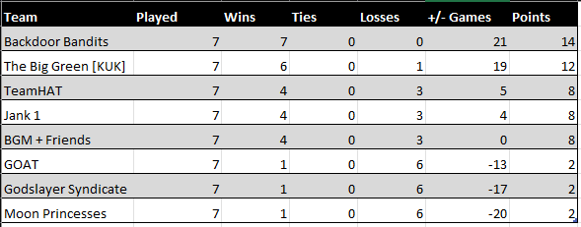
Welcome to the official hub for the Gods Unchained League (GUL).
This is your central command center for everything related to the GUL, TeamHAT’s premier 5v5 tournament. Here, you’ll find everything you need to follow the action, from the competing teams and their full rosters to the official rules and the latest news.
Whether you’re a dedicated fan, an aspiring competitor, or a new player looking to witness the pinnacle of TCG esports, you’ve come to the right place.
Explore the links below to dive in and get ready for the most ambitious Gods Unchained tournament to date.
Player Stats – Overall player stats.
Gods Unchained League Schedule (Season 1) – The schedule for Season 1.
GUL Teams (Season 1) – This is the list of teams.
GUL Rulebook (Work in Progress) – The live rulebook. It will be updated accordingly.
Drafting – This is your guide to drafting before your game.

