Team Hot Glue
Engineering Journal
WRO 2026
Lukas Mažrimas, Jokūbas Buta, Jokūbas Dargevičius

Table of Contents
Preface 2
1. Structuring, workflow, concept 3
1.1. Team structure and workflow 3
1.2. Design process 3
1.3. Physical assembly 4
1.4. Design software 4
1.5. Design philosophy 5
2. List of stock components used 6
3. Mechanical platform 6
3.1. Overview 6
3.2. Steering 6
3.3. Chassis 11
3.4. Driven axle 11
3.5. Overall design summary, tradeoffs 12
4. Circuit design and sensors 13
5. Software 14

Preface
This document is designed to explain some key aspects of the design of our team’s robot. The journal has a couple of distinct chapters, each explaining a different area of the robot’s development. Moreover, the chapters showcase the chronological order of the development, meaning that, for example, the mechanical platform was first created and then all the sensors and circuits were tailored to the existing platform. The reasoning behind this will be explained in chapter 1.

1. Structuring, workflow, concept

1.1. Team structure and workflow
Before starting any meaningful work, we took some time to map out the general ideas and assign each of us a part of the design process. Lukas was responsible for the mechanical platform, Jokūbas Buta for the general movement programming and integration, and Jokūbas Dargevičius for circuits and sensors as well as their programming.
There was, of course, a great deal of team effort and solving problems together, but giving primarily one type of work to each team member was beneficial and efficient for a multitude of reasons. Firstly, we all come from different backgrounds and have different types of experience and skillsets. Therefore, it makes sense to have the person, who is best at coding, design most of the software. It also makes sense having all the soldering done by the person who has the most experience with soldering. Moreover, a mechanical platform will be better if made by one most proficient in physics. Secondly, creating a robot is no simple feat and each of us learned a lot of new things in the process. We found it much easier for us to each concentrate on one field and do lots of in-depth research in that particular field, rather than us all trying to juggle everything at once.

1.2. Design process
Another thing we did in the beginning was decide on the specific electrical components and sensors to use and buy them. More about the exact choices will be explained in chapter 3, but knowing all the components in advance allowed for a better overall design and gave us time to prepare and find good hardware and software solutions for the particular “stock” components.
We chose to follow a simple and linear development path: choose and buy the sensors and other “stock” parts, make a mechanical platform, then make all the circuits and mount them and the sensors on the chassis, and, finally, program everything. This path was easy to structure and follow. However, it also created a double challenge: lots of foresight must be put into the design in the beginning, and later design elements must be flexible enough to work around existing limitations. We tried as best we can to mitigate these issues by brainstorming and agreeing on the general concept and design decisions in advance. Of course, there was still a lot of testing done during every stage of development, and many hotfixes to previous designs were made. The general concepts, however, remained unchanged.

1.3. Physical assembly
Designing a robot is only half of the equation – it must also be built and tested in the real world. This was made possible “Klaipėdos universiteto metodinis STEAM atviros prieigos centras”. They provided us with the ability to meet in one place and also lent us some of tools, necessary for the robot assembly (screwdrivers, screws, glue and other). Most of CAD designing and 3D printing was done at home, while all of the assembly, testing and design discussions were done during team meetings in the STEAM center.

1.4. Design software
In this paragraph we list all the software that we used to facilitate our workflow:
CAD design: Autodesk Fusion(education license) – free for students (our team), powerful, feature rich, easy to use and customize. It also has a cloud synchronization system, that helped us effortlessly share files and make on-the-go adjustments anywhere with internet access, including the STEAM center of KU, where we would meet to work on the robot together.
Programming:

3D printer slicing: Ultimaker Cura – free and open-source software, customizable and works with any FDM 3D printer.

1.5. Design philosophy
One of the main driving principles behind most of the design decision-making was that of the F1 design legend Collin Chapman: “Simplify, then add lightness”. We wanted to have as little moving parts, as possible, because moving parts wear and can ultimately break. We also followed another principle of his: “Rules are for the obedience of fools and interpretations of smart men.” This is to say, we were on the outlook for areas of excessive design freedom.

2. List of stock components used
The reasoning behind each choice will be explained later (see provided links)
Part | Visuals | Part code | Reason for choosing
Front wheel tire | 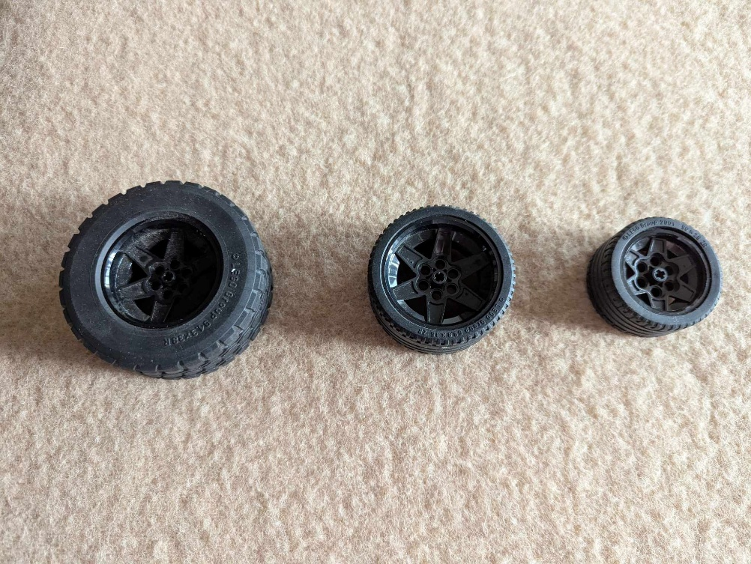 | Tire 43.2 x 22 ZR (44309) | See chapter 3
Chassis | 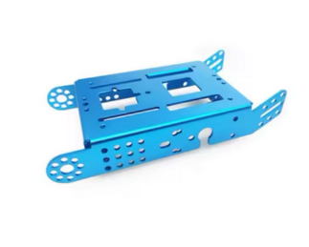 | Metal chassis for Makeblock mBot2 | See chapter 3

3. Mechanical platform

3.1. Overview
The mechanical platform consists of three main areas: steering system, driving axle and the chassis that connects them. We agreed to make a conventional rear-wheel-drive system: front wheels are designated to steering, and rear wheels are driven. This type of package is simple and effective.

3.2. Steering
The principal requirements that we had for our steering were compactness and high steering angles. High steering angles allow for smaller turning radius, which is of utmost importance in the challenge for optimal navigation around circuit and good parking performance. Compactness allows for a smaller overall footprint of the robot and also leaves space for future drivetrain, sensor and electronics placement.
Below are the design iterations of the steering system and their descriptions:
Iteration | Visuals | Description
V1 | 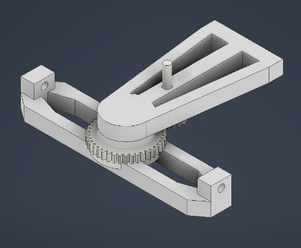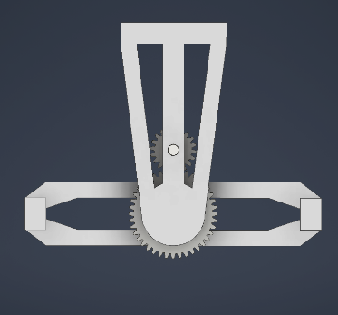 | The very first design. A very simple concept, in which the entire front axle is being turned around a pivot. Scrapped due to excessive space needed and instability of the platform when the entire front axle is at an angle with the rest of the body.
V2 | 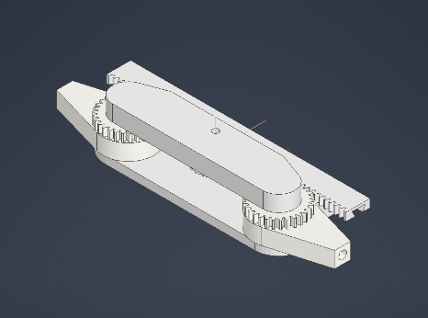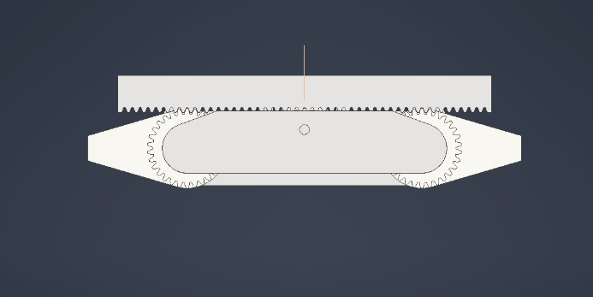 | The concept of this version was to pivot the wheel hubs around their respective axis, and rotate them simultaneously with a shared rack. Scrapped due to high friction and general bulkiness of the design.
V3 | 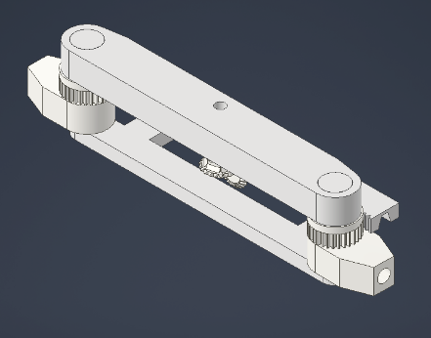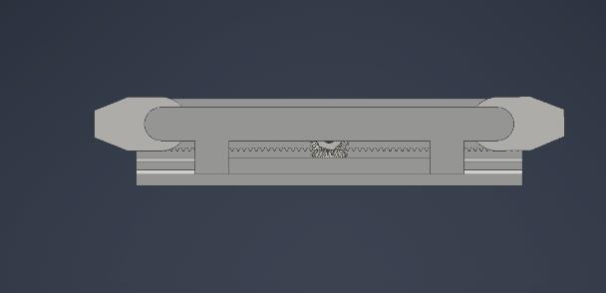 | An evolution of the V2 design. Bevel gears were added to have a possibility of connecting a servo motor. Scrapped due to the complications of integrating a servo motor well, as well as the steering angle not being sufficient.
V4 | 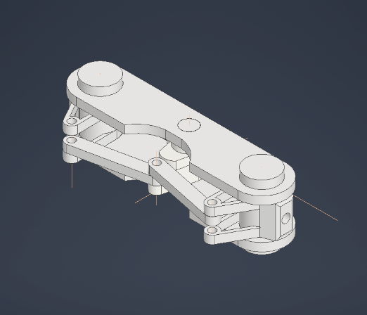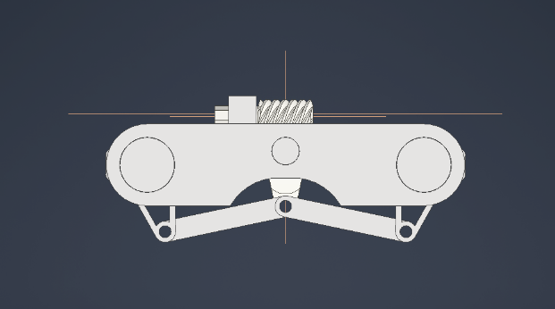 | Brand new concept: have a worm gear connect to a lever arm, that would in turn move control arms that connect to wheel hubs. This design allowed sufficient space for the servo motor. Scrapped due to poor steering angle and the design being too many moving parts taking up too much space.
V5 | 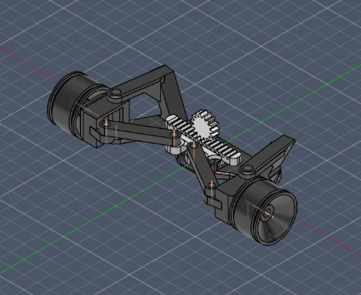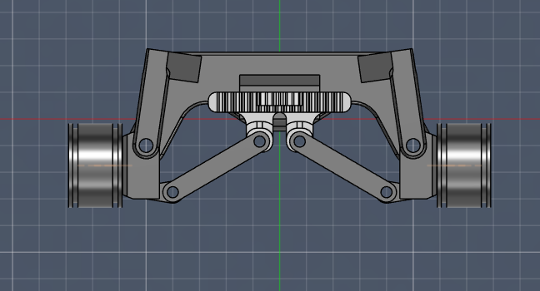 | An attempt at a rack and pinion design concept. Now the steering system was more compact and had less general friction. Through extreme control arm attachment points high steering angles were achieved. Scrapped due to non-existent stability when steering (a direct consequence of control arm attachment), and poor robustness of the system (control arm attachment “ears” would break off).  Custom wheel rims for the tires in use were created (this part would be used in later designs as well)
V6 | 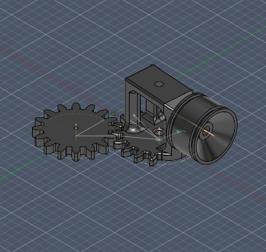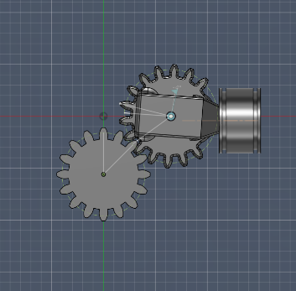 | A test of a (yet another) new concept. The concept is as follows: have 3 spur gears connected together. The middle one attached to the servo and being driven. The gears on the side have wheel hubs on them and attach to the wheels. All three gears move in sync. This concept was evolved further into the V7 variant.
V7 | 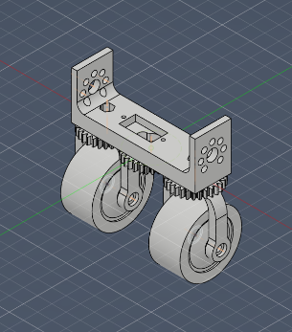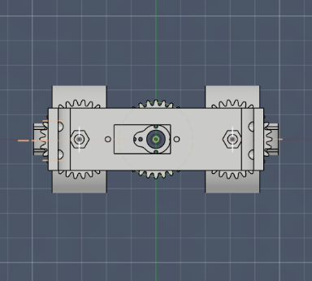 | A full, working adaptation of V6 concept. Features a mounting point for the servo motor. Wheel hubs designed for minimum footprint and optimal leverages. The exact dimensions and mounting hole were tailored to the chassis that we decided to use. Custom wheel rims adjusted to fit wheel hubs.

During the design process of the steering system, at iteration V5, the tire specification to be used was decided. We wanted simple tires, that are abundant on the market. For steering, wide tires were required, as there had to be sufficient grip for sharp turning maneuvers. Also, the tires had to have a small vertical footprint. That is because the front wheels weren’t going to be driven, so the wheel size was inconsequential in this regard, but smaller wheels allowed for a more compact design, which is one of the principal requirements of our steering system.
We considered various LEGO® tires, as all of us had plenty of them at home (so, the effective cost of using one would be 0), and they were made out of a sufficiently grippy material for our purposes.
After trying out multiple variants, we found that, out of the models that we had, tire 43.2 x 22 ZR fit our needs best.
It became clear immediately, that the stock wheel rims wouldn’t work for us, as we needed round holes, whereas the LEGO® rims all have cross shaped holes. Because of that, we designed our own hubs.
The custom wheel hubs also underwent significant evolution, that we showcase here:
Designed for steering version | Visuals | Constraining features
V5 | 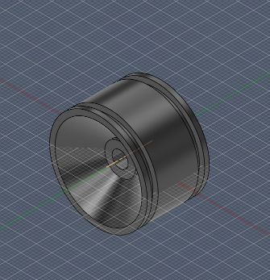 | Mount on the side, of the rotating assembly, have minimum weight.
V7 | 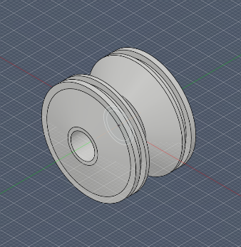 | Mount in the middle of the rotating fork, center the wheel, and have minimum weight

3.3. Chassis
The choice of a chassis was affected not only by engineering needs, but also other surrounding factors at the time. Our school has a big fleet of Makeblock mBot2® robots. During the time of construction of our robot, one of them broke down completely. After an inspection, the school wrote it off as unusable. Thus, we got an opportunity to make use of its part if we wanted to. Indeed, the mBot2® was of use to us. Firstly, it is made of metal, so it will not break during any use case. Secondly, it has, many perforations for mounting various sensors and attachments, so it allows for good design flexibility. Also, there is an economical and environmental benefit as well, because using this chassis didn’t cost us any money, and didn’t allow a perfectly usable metal component be put to waste. That is how we chose our main chassis.

3.4. Driven axle
The biggest possible problem for the rear axle is the fact, as per the rules, that both rear wheels have to be connected to the same driving motor. This means that both wheels will always have the same angular velocity of rotation. That is bad for stable cornering, as from simple geometry, the rotational speeds of rear wheels must differ if the wheels are to not slip, because the outer wheel has to cover a greater distance in the same amount of time. Therefore, due to the formulation of the rules, any compliant rear axle by design will have some wheel slip during cornering.
Again, from simple geometry, the wider the rear axle, the bigger rotation speed difference is needed for the wheels not to slip. Therefore, in our situation, having as narrow rear axle as possible is beneficial, due to the fact, that there will be less of a speed difference between the rear wheels, so less slip, so the axle will be more predictable and under control. The downside of such a configuration is that the platform will be vulnerable to falling on its side if the turn is too sharp. That can be mitigated by having a lower center of gravity and a wide, stable front axle.
While searching for a suitable motor, we stumbled upon a curious offering on Aliexpress – an N30 dual shaft motor. It already had a built-in gearbox and two shafts for mounting the wheels. Besides, the whole assembly was pretty narrow – only 10 mm. This was a perfect option for us, so we decided to use it as a rear axle.
For the wheels, we again chose to go for LEGO® tires, as they we have plenty different options at home and these tires are made of durable material with good traction. As for the specific tire, we went for Tire Technic Wedge Belt Wheel, because they were extremely narrow, and this would further minimize tire slip when cornering. Again, like with the front wheels, we needed to design our own wheel rims, that fit the motor gearbox shafts.

3.5. Overall design summary, tradeoffs
Finally, we want to take one last look at overall design of the mechanical platform that we made and its main features as well as tradeoffs.

4. Circuit design and sensors

5. Software

