MMP- IshLa

**AIDI 2005 CAPSTONE II**

**Course Facilitator: Marcos Bittencourt**

**Prepared By:**

Izza Godinez - 100556078

Maviya Javed Shaikh - 100766785

Meryl Gabrielle Tubio – 100763231

Nandini Malhotra – 100768797

March 26th, 2021

Table of Contents

1. Executive Summary 3

2. Rationale Statement 3

3. Problem Statement 3

4. Data 3

5. AI Agent 4

6. Optimal Path Route 4

7. Front-End and Back-End 5

8. Next Steps 5

9. Project Plan 6

# Executive Summary

Optimal path algorithms are a major interest in artificial intelligence. It has many applications in business, including product delivery and shipment processes, as well as in navigation. This project aims to allow the user to create an optimal path between different stores to allow them to complete their shopping lists with various items in the shortest possible time.

# Rationale Statement

To develop a website that takes in user credentials and asks the user to select their TO-DO list by clicking on various sub-categories like groceries, electronics, clothing apparel. The user selects items from these sub-categories. Based on the items selected, the website suggests a route from the user's current location that he can take to complete all its errands in one go.

# Problem Statement

“To find the optimal path from the starting point (source), covering all the sub-destinations”.

The problem statements aim at determining the closest sub-destination from the current position, the starting point being the user’s current location.

# Data

A dataset containing the addresses of various destinations is used to help find the optimal path from the user’s current location to various sub-destinations. 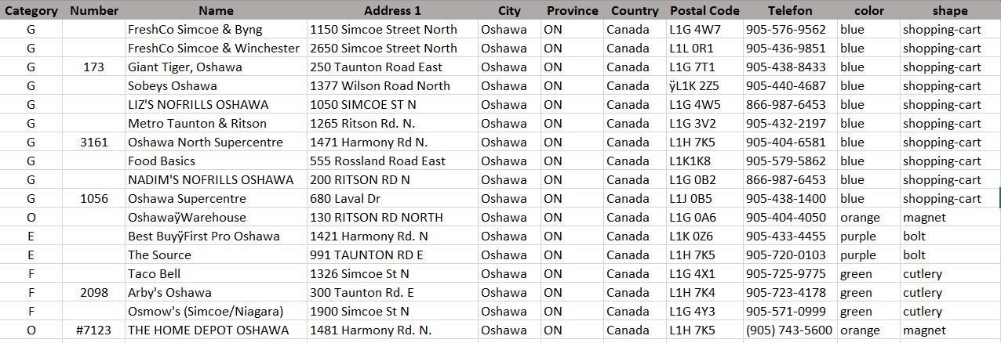

Where:

1. **Category:** It is the category of the store for various kinds of errands like Groceries(G),Electronics(E), Food(F), Clothing(C), Others(O), which might include Home Depot, Gas Stations and Car Wash
2. **Number:** It includes the Store Number if valid.
3. **Name:** It includes the name of the store.
4. **Address 1:** This field contains the street number and street name of the store.
5. **City, Province, Country, Postal Code:** These fields would specify the city, province, country and postal code of the store.
6. **Telefon:** This field would contain the telephone number of the store.

**color, shape:** These two fields are solely for the purpose of plotting the destinations on the map intuitively.

# AI Agent

AI agent is the artificial intelligence component that helps to achieve the goal of our project. Based on the business problem to find the shortest path for the user, we will be using Utility-based AI agents. The reason for choosing a Utility-based AI agent is that it not only helps to find the shortest path, but it also provides the best possible way to achieve it. Another advantage of using a Utility-based AI agent is that in our project there will be multiple alternatives i.e. multiple paths to choose from and agents must choose the best path amongst all.

To achieve the shortest path for the user, we are using Open-Source Routing machine which provides the shortest distance between source and destination. However, our business problem includes sub-destination, we are achieving that by choosing the current location as our source and next location as our destination. The selection of the sub-destinations is done by programming it from scratch.

AI agent will first take user input as a source and then calculate the shortest path to show the nearest store using the Open-Source Routing Machine method then in the next iteration user will choose that nearest store as the source and then calculate the shortest distance to show the other nearest store which user want to visit and so on. Therefore, the final Optimal Path dataset based on the user input is as shown below:

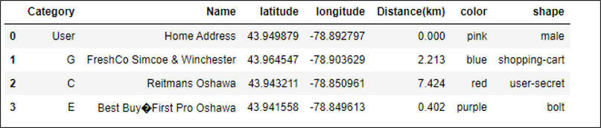

# Optimal Path Route

As shown in the above optimal path map, we have the entire location of all the stores from the user destination. As users want to visit three stores, below is the route user can follow.

Route from user address to Grocery store FreshCo, FreshCo to Best Buy and Best Buy to Home Depot.

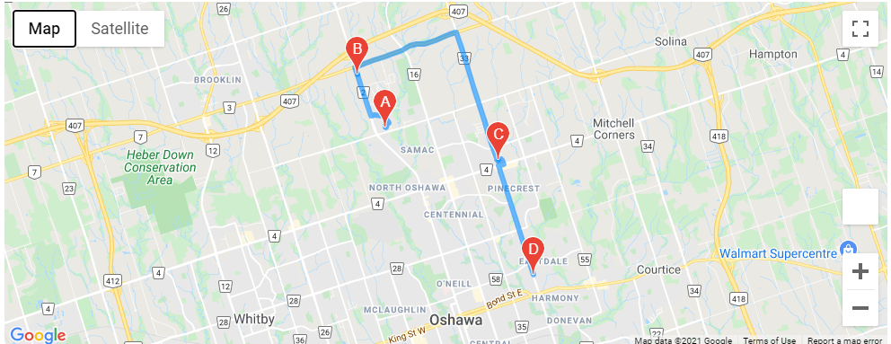

# Front-End and Back-End

As shown below in screenshot 1, the front page of the application is where the end-user inputs data such as current address (step 1) and places to visit (step 2). End-users can simply tic the boxes for the desired destination, then click calculate route (step 3).

Another browser would appear and visualize the route where user starts from user address to destination B.

Screenshot 1

Screenshot 2

# Next Steps

* To make the application intuitive as to the user’s location
* To present final product to Project Manager

# Project Plan

|  |  |  |  |  |
| --- | --- | --- | --- | --- |
| **ID** | **Milestone** | **Submission Date** | **# of hours** | **# of Resources** |
| 1 | Submit Project proposal (including: SOW, ppt slides, github profile) | Feb 1, 2021 | 10 | 4 |
| 2 | Minimum Viable Product (MVP)  (version 1) | Feb 19, 2021 | 10 | 4 |
| 3 | MVP (version 2) | Mar 12, 2021 | 10 | 4 |
| 4 | Minimum Marketable Product (MMP) | March 26, 2021 | 10 | 4 |
| 5 | Product to launch | April 11, 2021 | 10 | 4 |
| 6 | Final Evaluation | April 16, 2021 | 10 | 4 |