**Use Case Diagram**

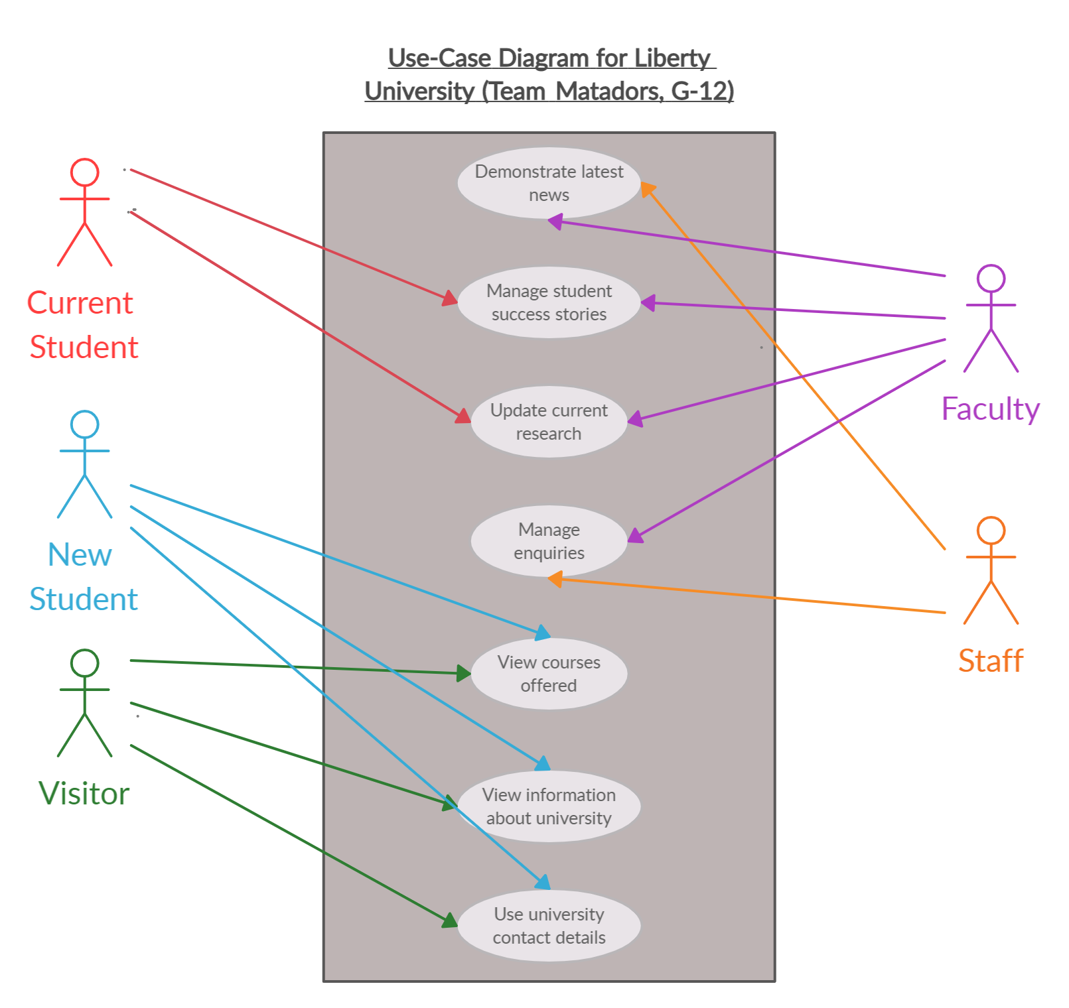Use Case Diagram captures the system's functionality and requirements by using actors and use cases. It demonstrates the services, tasks and function that a system requires to perform. The Use Case Diagram for our chosen University is shown below: