**Site information architecture:**

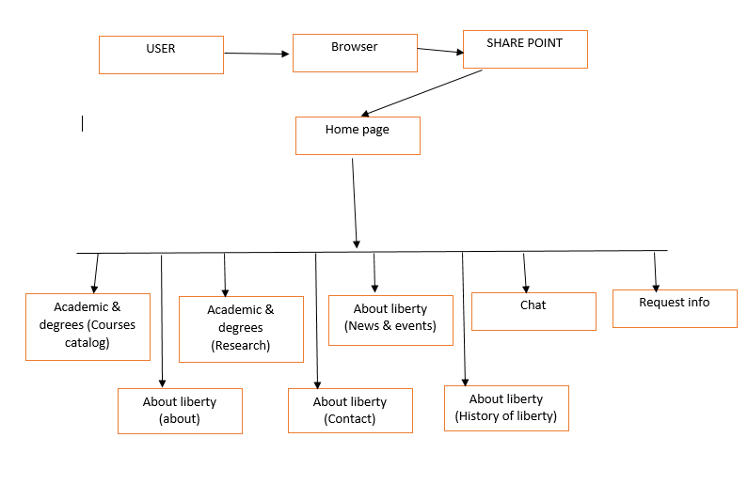

Figure 21 site information architecture