Table of Contents

I. Problem definition 2

Traditional management style 2

Modern management style 2

II. Customer Requirement Specification Function 2

Input 2

Output 2

III. Customer Requirement Specification device 2

Hardware requirement (minimal configuration) 2

Hardware requirement (recommended configuration) 2

Software requirement 3

IV. Project details 3

Client 3

About us 3

V. Roles & Schedules 3

Roles 3

Schedules 3

VI. Design 3

Structure 3

Drugs.txt 4

Custommers.txt 4

Dealers.txt 4

Distributors.txt 4

Class diagrams 5

VII. Interface 6

VIII. Checklist 7

# Problem definition

Surveying the pharmacy situation in Vietnam, now there are many pharmacies open everywhere to meet the needs of everyone. However, they are mainly traditional-style management. Therefore, we will compare the convenience between traditional management style and modern management style:

* Traditional management style
  + Firstly: all data is recorded in the book. So, it's easy to lose data and when searching or copying information
  + Secondly, we must store our books in a fixed place. Hence, we can access the data wherever we want. Besides, others can easily retrieve or read our data and safety is not high.
  + In addition, we also difficult to inventory and add products to the repository, besides, periodic inventories checking is quite complicated.
* Modern management style
  + Firstly: Data is stored and linked to each other on a computer to help us easily find, copy, and hard to lose data.
  + Secondly, we can store and backup accessible anywhere via web browser or application support, capable of provisioning user rights, ensuring proper access to different locations.
  + Thirdly, there are many computing features built into the app that easily compute inventory and add products to the repository, besides, periodic inventory checks are quite easy.
  + Last: Easily find the news and readability for the content.

# Customer Requirement Specification Function

## Input

Medicine: name, company, MFG, EXP, quantity, money

Customer: ten, tuoi, diaChi, sdt, ten_sp_mua, money

Dealers: ten, diaChi, sdt, ten_sp_mua, money

Distributors: ten, diaChi, sdt, ten_sp_mua, money

## Output

Almost data and information what you entered into program:

Overview of processes involved:

* + - Show the quantity of stock, money customers buy and money importing from distributors.
    - Find information, add: medicine, customers, dealers, distributors

# Customer Requirement Specification device

## Hardware requirement (minimal configuration)

CPU: Intel I3-7000U

RAM: 4GB

HDD: 10GB

## Hardware requirement (recommended configuration)

CPU: Intel I3-9000U

RAM: 6GB

HDD: 20GB

## Software requirement

Operator System: Windows 10

Software: JRE 1.8 or higher

# Project details

## Client

* + Name of customer/company: Luong Hoang Huong
  + Address: FPT University, Nguyen Van Cu street, An Binh ward, Ninh Kieu district, Can Tho city
  + Email: [huonglh3@fpt.edu.vn](mailto:huonglh3@fpt.edu.vn)

## About us

* + Name of customer/company: Group 5 (DKMN Hiền)
  + Address: FPT University, Nguyen Van Cu street, An Binh ward, Ninh Kieu district, Can Tho city
  + Email: khoithace140273@fpt.edu.vn - Phone number: 0948294024

# Roles & Schedules

## Roles



## Schedules



# Design

## Structure

We have 4 data files are:

### Drugs.txt



### Custommers.txt



### Dealers.txt



### Distributors.txt



## Class diagrams

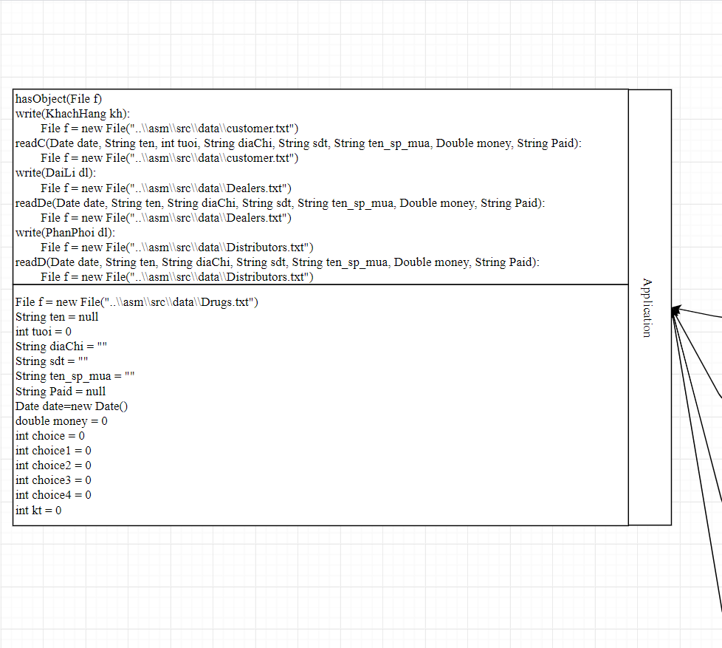

Figure 1: Name of file and main of Application

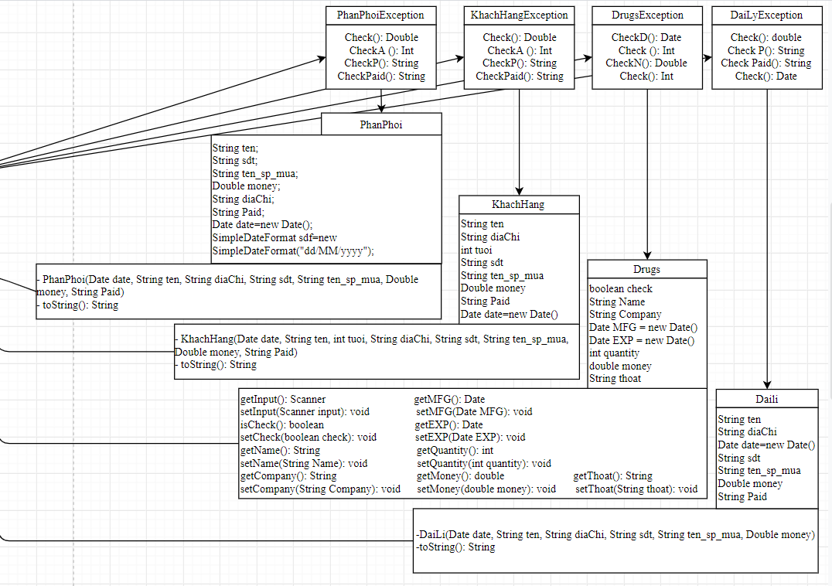

Figure 2: Variables in file and Exception of each variables

# Interface

Menu application

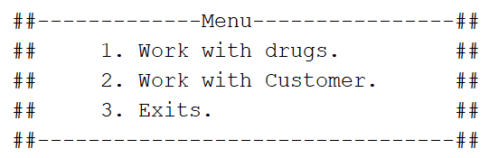

First choice of main application:

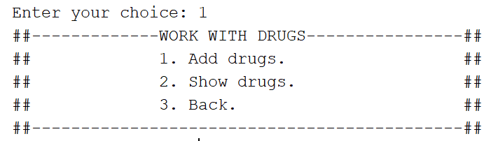

Second choice of main application:

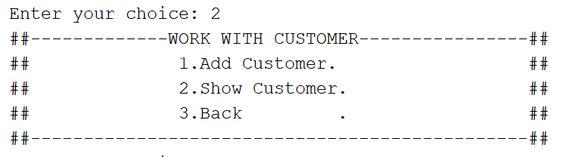

Choice of Add function:

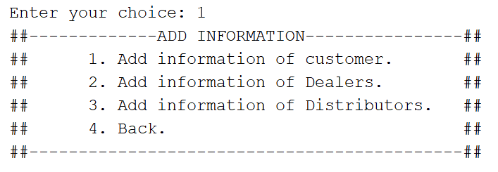

Choice of Show function:

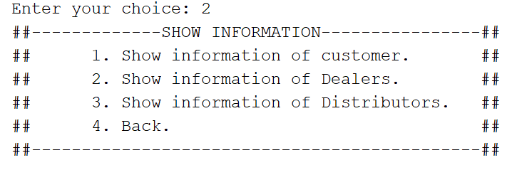

# Checklist

