# Results for Different Runs

This document shows the results of the Monte Carlo simulations evaluating the following characteristics: 66/22 kV transformer utilisation level, the distribution transformers' maximum utilisation level, the utilisation level for 22kV conductors, and the percentage of customers with voltage issues. The number of simulations in this Monte Carlo study was 10, 30, 100, and 200.

On average, and depending on the user's computer specifications, each simulation without the PV inverter could last at least 1 minute, meaning that, in some cases, the Monte Carlo study contemplating 200 simulations could last more than 3 hours. On the other hand, if this control is active, each simulation can last up to 10 minutes, considerably increasing the computation times.

Figure 1 to Figure 4 present the Monte Carlo simulation results for the abovementioned characteristics without inverter control, whereas Figure 5 to Figure 9 illustrate the results with inverter control. Boxplots are the most fitted plots for this type of study involving numerous simulations; they give an insight into the behaviour of the evaluated characteristics and the range of values in which the results are. Another essential factor to consider when doing this type of study is that the number of simulations is relevant: more simulations indicate a better tendency of the results. However, storing all the resulting data also requires more computation resources and time.

When evaluating the utilisation level of the MV transformer, it is possible to see from Figure 1 and Figure 5 that despite the number of simulations and the penetration percentage of PVs in the whole network, it never gets into a utilisation level above 100%. On the other hand, Figure 2 and Figure 6 reveal that utilisation levels above 100% on distribution transformers are most likely to occur in penetration percentage scenarios above 60%. Furthermore, without inverter control, Figure 3 indicates that MV lines do not reach their nominal utilisation levels until 100% penetration scenarios. In contrast, Figure 7 shows that with inverter control, the MV utilisation levels are within normal limits for whole penetration levels.

Figure 4 and Figure 8 indicate the general tendency of the rise in the number of customers with voltage problems when the penetration percentage of PVs increases. The size of the boxplots reveals that in the two highest penetration percentage scenarios, more than 80% of the customers do not comply with the statutory voltage limits. Despite having PV curtailed with inverter control, as shown in Figure 9, there remains an insignificant change in customer voltage non-compliance, indicating limited improvement even with applied inverter control.

From the evaluated characteristics, it is possible to observe that when increasing the number of simulations, the distribution and size of the boxplots change. Nevertheless, the changes from the 100 and 200 simulation cases are less evident than switching from 30 to 100 simulations, meaning that the Monte Carlo studies using 10 and 30 simulations are not representative enough. So, it is necessary to identify a suitable number of simulations to lead to representative results. Also, it must not be large enough to have computational problems.

Figure 1. Boxplots for the Monte Carlo simulations assessing the MV transformer level of utilisation (without inverter control)

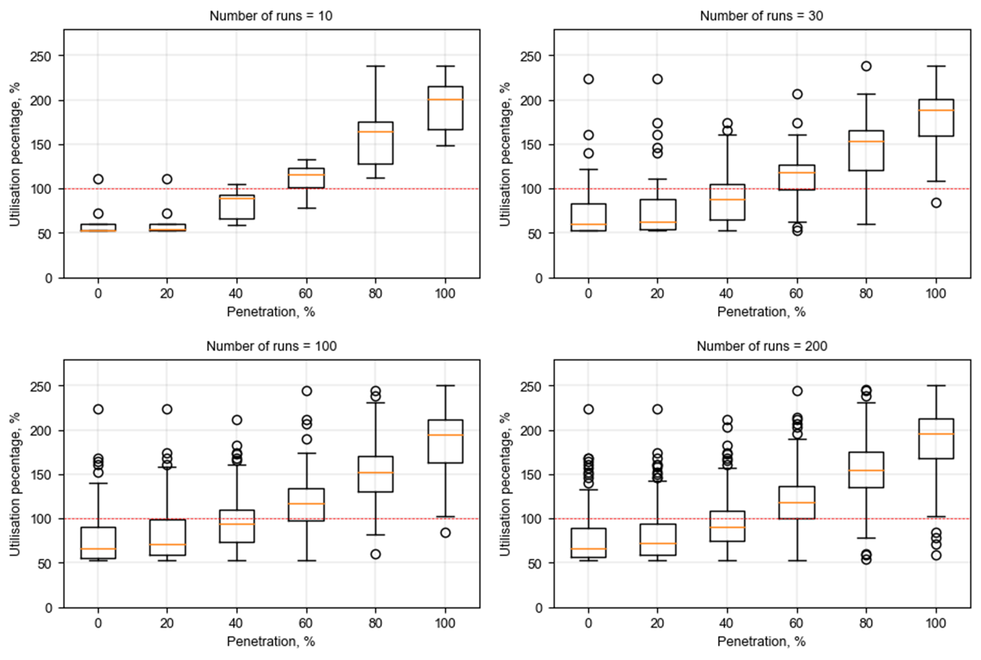

Figure . Boxplots for the Monte Carlo simulations assessing the maximum level of utilisation of distribution (LV) transformers (without inverter control)

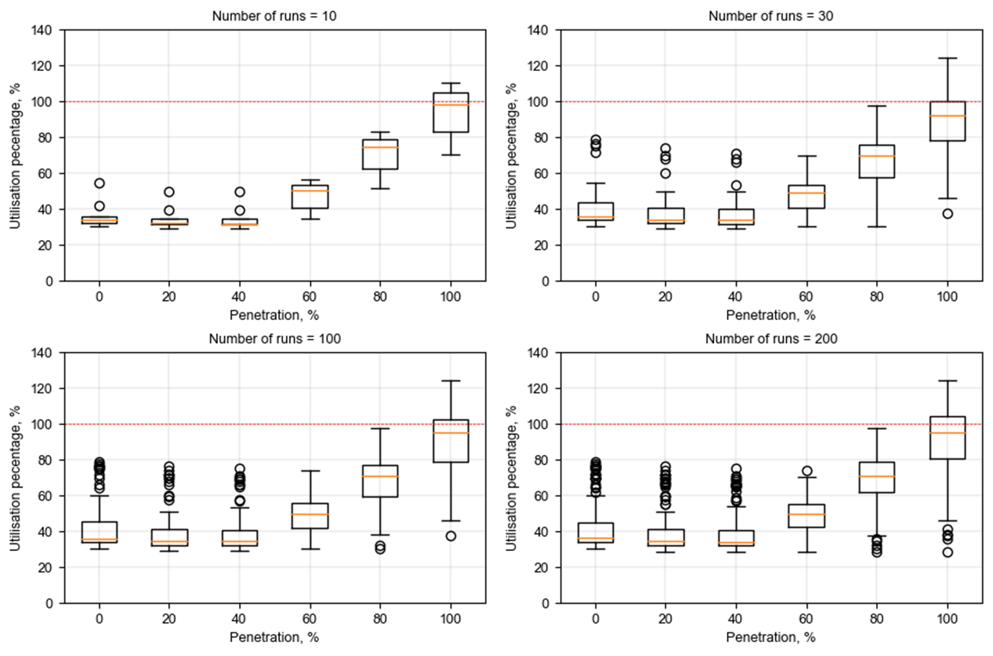

Figure . Boxplots for the Monte Carlo simulations assessing the maximum level of utilisation of MV lines in the circuit (without inverter control)

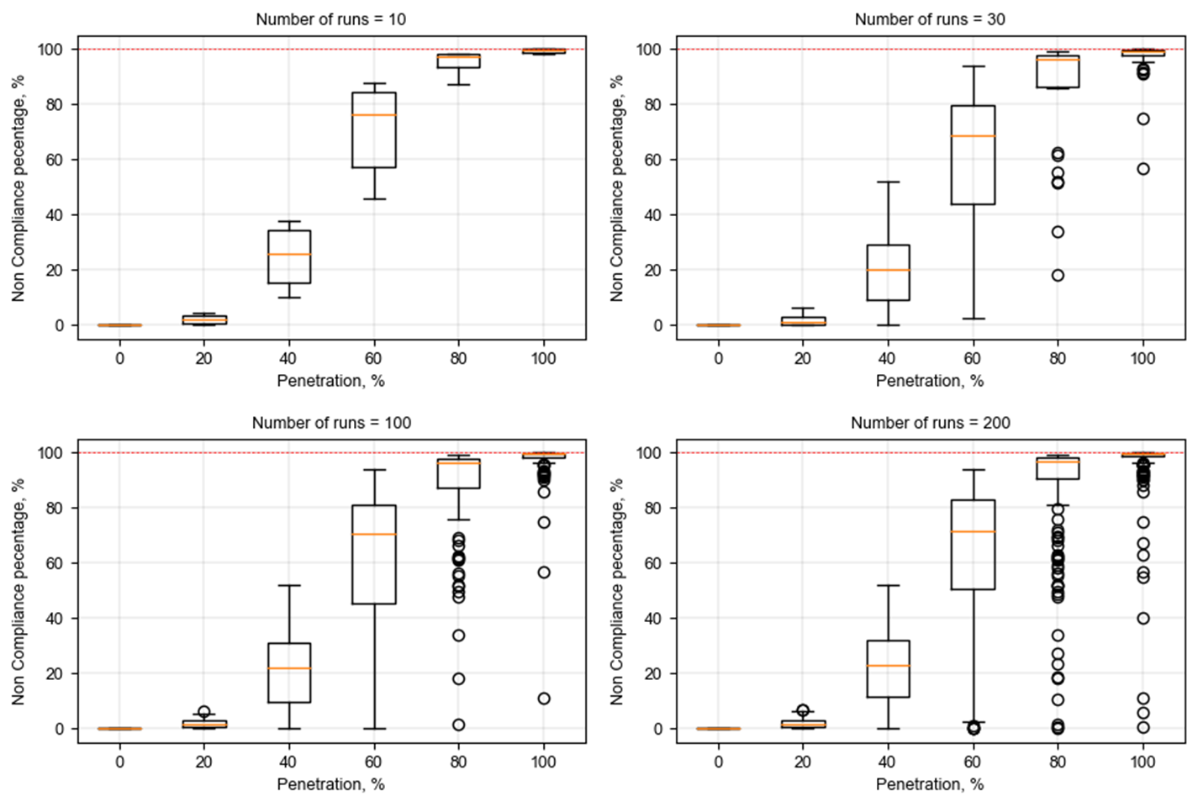

Figure . Boxplots for the Monte Carlo simulations assessing the percentage of customers not complying with the statutory voltage levels (without inverter control)

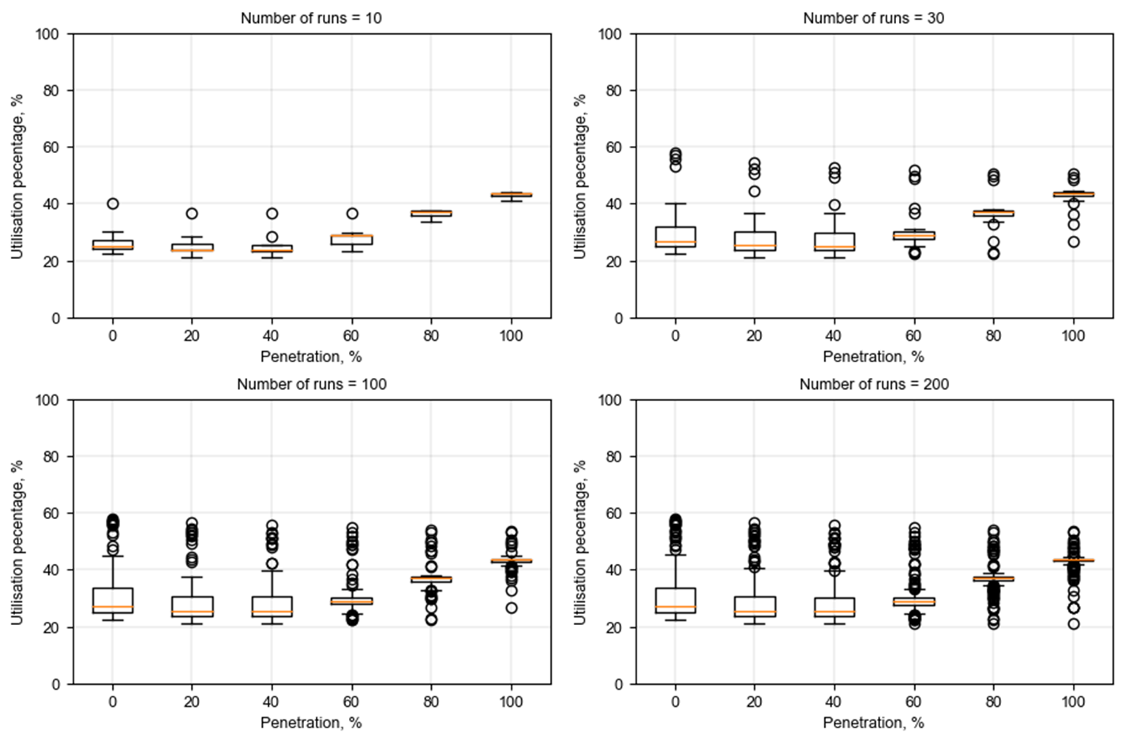

Figure 5. Boxplots for the Monte Carlo simulations assessing the MV transformer level of utilisation (with inverter control)

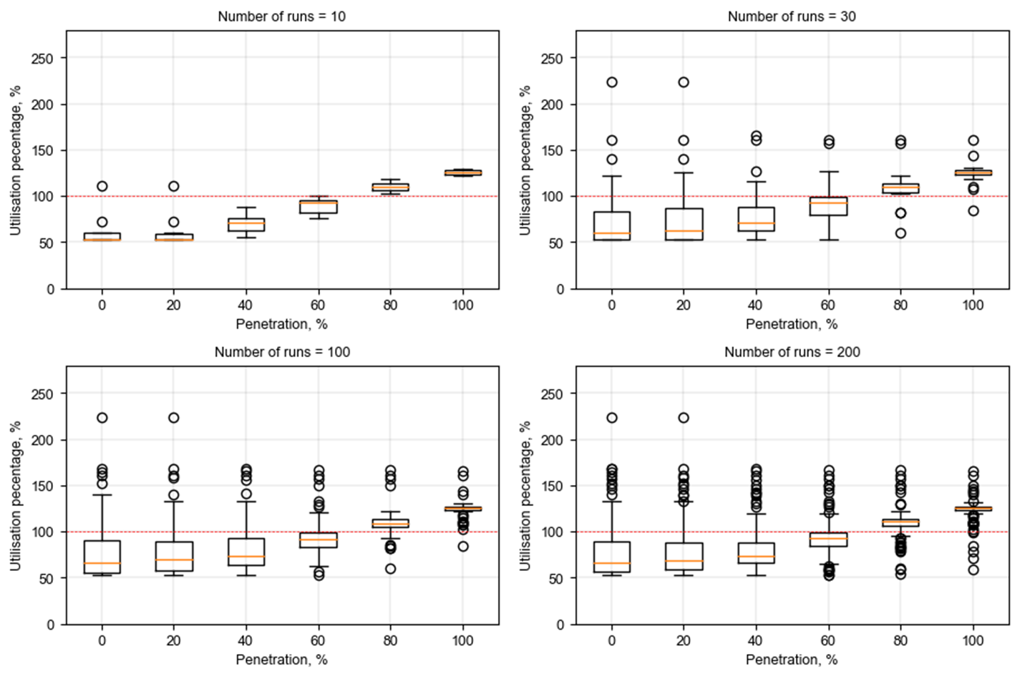

Figure . Boxplots for the Monte Carlo simulations assessing the maximum level of utilisation of distribution (LV) transformers (with inverter control)

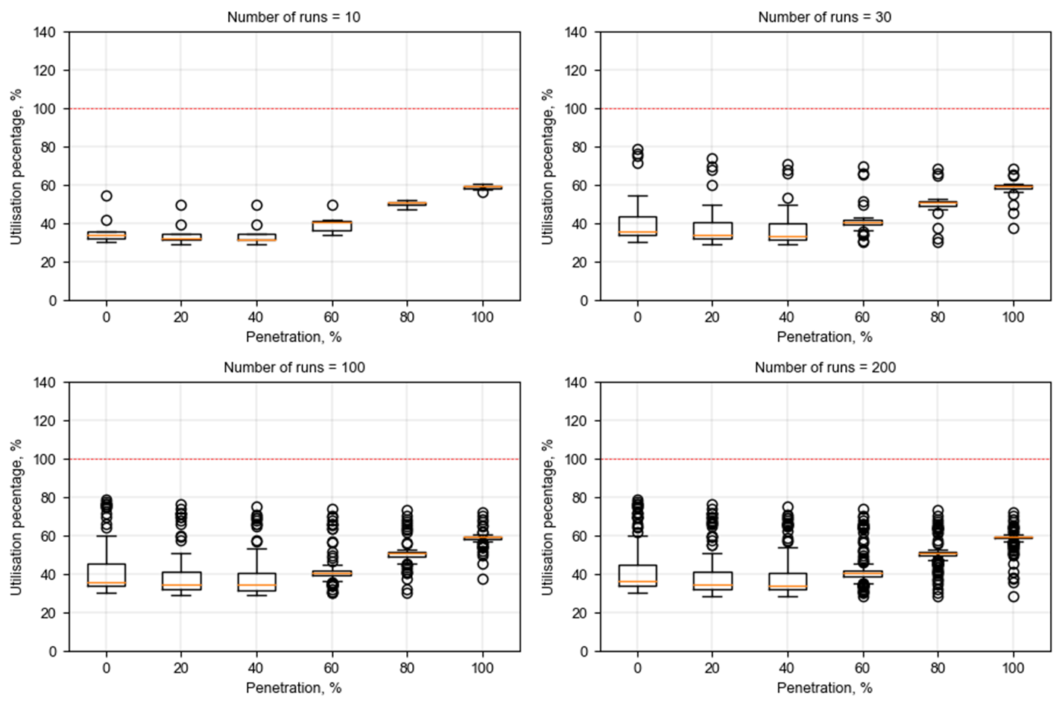

Figure . Boxplots for the Monte Carlo simulations assessing the maximum level of utilisation of MV lines in the circuit (with inverter control)

Figure . Boxplots for the Monte Carlo simulations assessing the percentage of customers not complying with the statutory voltage levels (with inverter control)

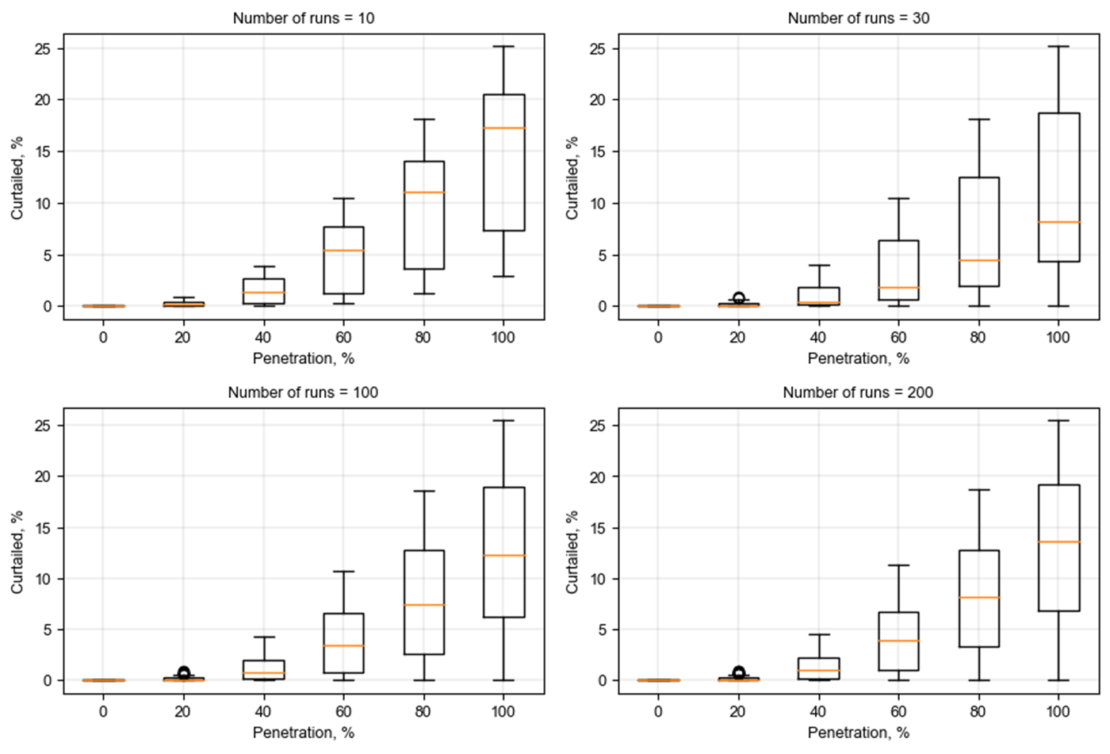

Figure . Boxplots for the Monte Carlo simulations assessing the percentage of curtailed PV power (with inverter control)