CampusLink
  - Campus Placement Management Project Report
CampusLink brings students, recruiters, and campus placement teams into a shared recruitment process. It combines career preparation with campus-approved drives, applications, interviews, and post-selection records.
This report explains the product, its role-specific features, the supporting software, and the checks completed before deployment.
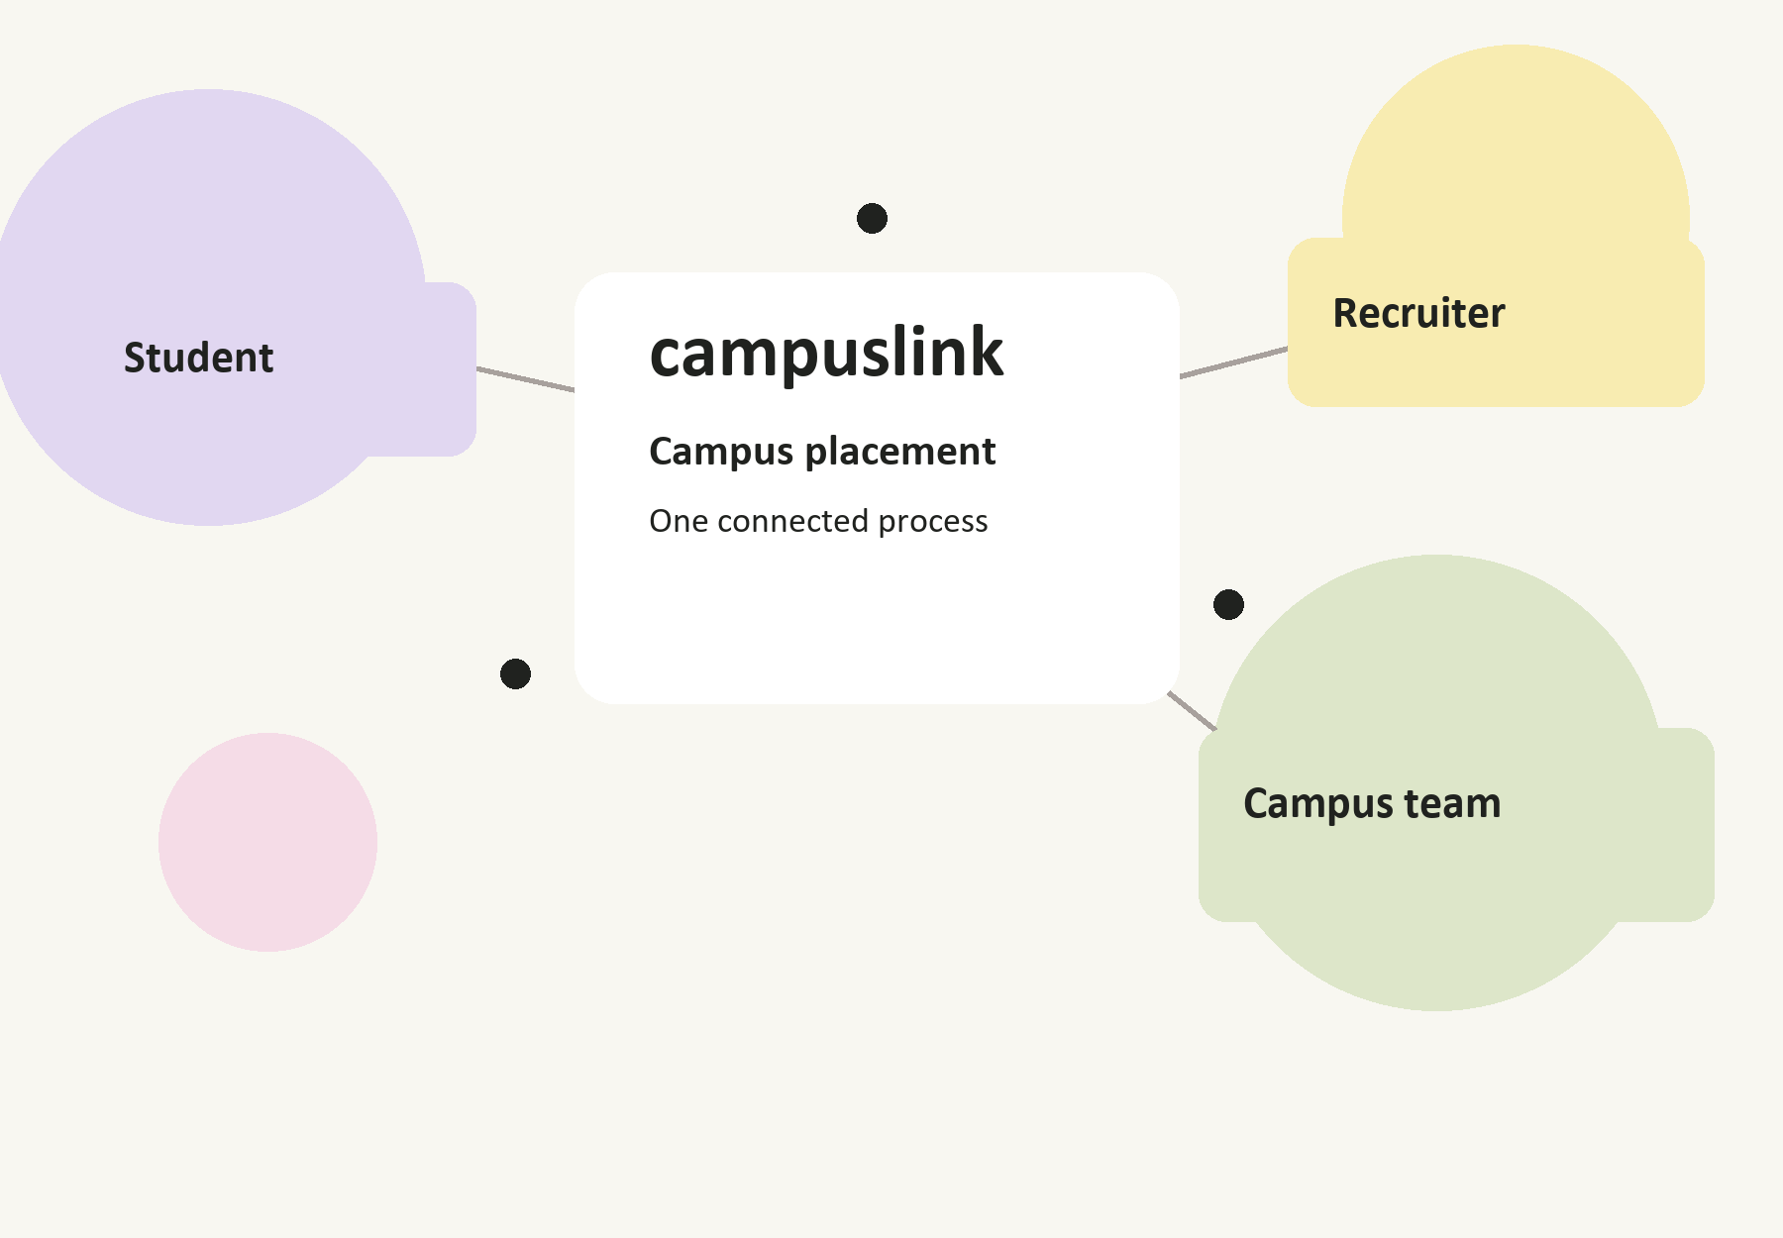

Team StartX
Project report | 4 October 2026
Implementation complete for local review. Hosted integrations still require live verification.

Project overview
  - Purpose and report guide
The central idea is straightforward: a student should know what to prepare, a recruiter should know which campus activity needs attention, and the placement team should control what becomes available to its students. CampusLink keeps these responsibilities visible without making everyone use the same dashboard.
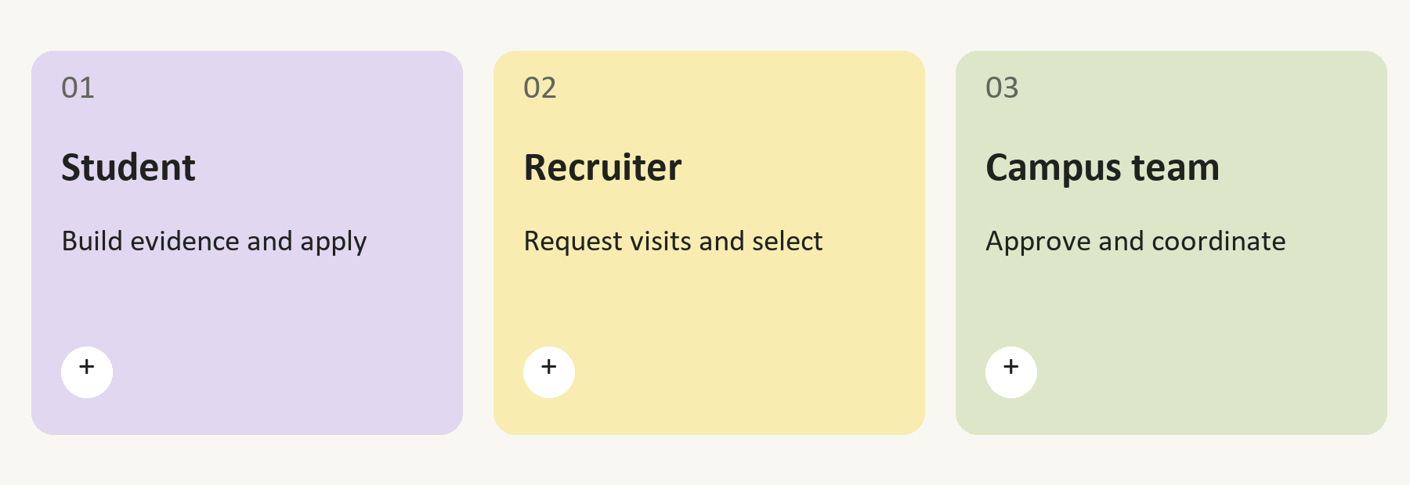

What the project delivers
The implementation includes a responsive Next.js website and an Express API. Users can build career profiles, verify skills, take assessments, coordinate drives, manage applications, conduct interview practice, and record offers. The system also includes private documents, targeted notifications, and a separate administrator console.
Report section | Page
Problem and requirements | 3
Student workspace | 4
Recruiter workspace | 5
Campus and administrator workspaces | 6
Placement drive workflow | 7
Preparation and analysis | 8
Interface and action center | 9
Architecture and records | 10
Security and access | 11
Testing and deployment | 12
Team and next steps | 13

The three business roles share a placement process. Administrator access is an additional server-controlled permission.

Problem and requirements
  - A placement process with clear responsibilities
Campus recruitment involves more than publishing a vacancy. A physical visit needs a date, rooms, labs, computer systems, an eligible student group, and agreement from the recruiter. Student preparation continues alongside this coordination. Keeping these activities in separate lists makes it harder to see what is ready and what still needs a decision.
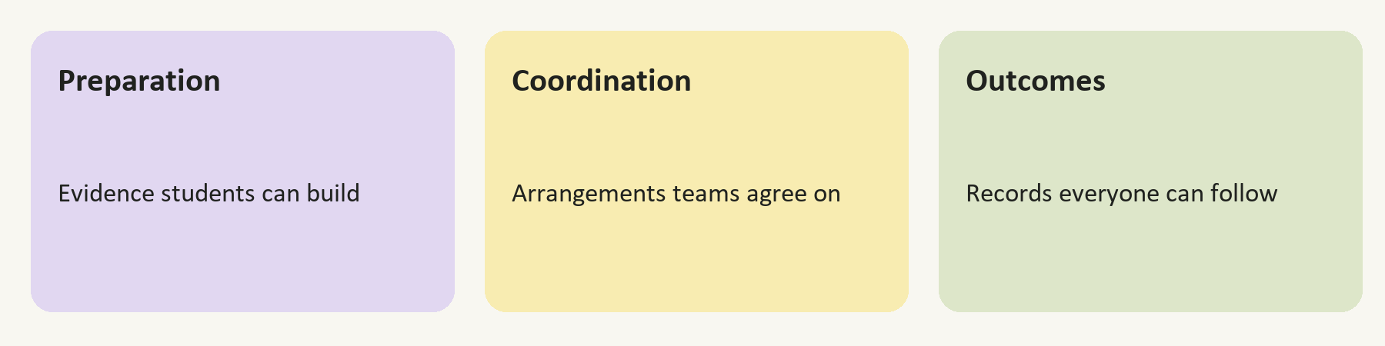

The project objective
CampusLink gives each participant a reliable view of the next step. A drive moves through approval and scheduling before it becomes a student opportunity. Applications use eligibility checks, and preparation records help students decide where to improve. Outcomes remain connected to the recruitment workflow.
Requirement | Implementation
Separate role workspaces | Student, recruiter, and campus navigation with role checks
Controlled drive publication | Campus review, recruiter confirmation, and campus activation
Student preparation evidence | Verified skills, assessments, projects, and interview records
Resource coordination | Schedule validation and checks for campus visit conflicts
Private records | Cookie authentication, ownership checks, and private uploads
Usable daily operations | Search, filters, notifications, and an action center

Boundaries of the current version
The project includes local scoring, resume text extraction, and optional external analysis. Contests validate short answers rather than running submitted code. Scanned resume PDFs need an OCR service that is not connected. Membership choices in demo mode do not process payments.
The aim is a working placement platform with explainable records. Final hiring decisions remain with recruiters and campus teams.

Student workspace
  - Preparation applications and placement outcomes
The student workspace starts with a career profile and follows the student through preparation, applications, interviews, and offers. Its purpose is to make the available evidence and upcoming decisions easy to find.
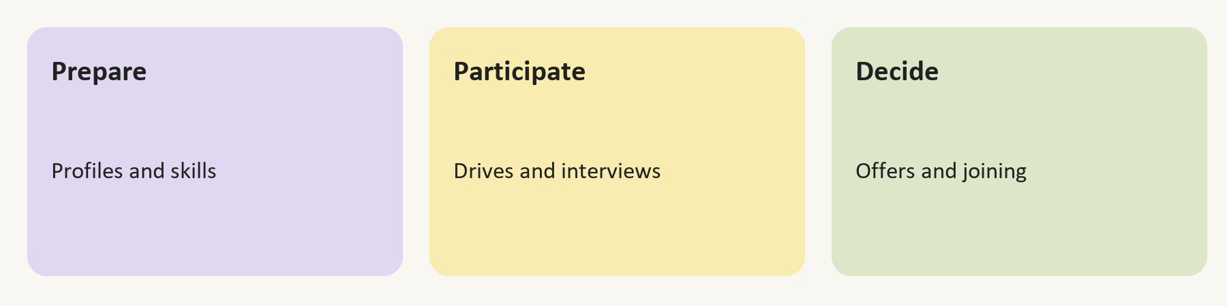
Area | What the student can do
Career profile | Maintain academic details, skills, projects, and a profile photograph
Skill verification | Take assessments and earn verified evidence through recorded results
Opportunities | Explore activated campus drives and review eligibility and fit
Applications | Submit an eligible application and track its stage
Interview hub | See scheduled rounds and complete practice sessions
Offers | Review, accept, decline, defer, or withdraw a response at allowed stages
Documents | Upload supported files and access them through authorized downloads

A typical student session
A student opens the action center and sees an upcoming application deadline. Before applying, the student reviews the drive and checks academic eligibility. An unverified skill can lead to an assessment. When a recruiter schedules a conversation, the interview appears in the workspace and can be included in a calendar download.

Readiness without hidden assumptions
Readiness combines recorded skills, academics, projects, aptitude, communication, and interview evidence. A missing result is shown as missing evidence. The score helps the student plan preparation; it does not guarantee selection or award an offer.
Expired opportunities and opportunities already applied to are removed from the student action queue. Decisions are completed in the relevant workflow.

Recruiter workspace
  - Campus coordination and candidate review
Recruiters begin with a company profile and campus discovery. They request a placement drive instead of publishing directly to students. This lets the campus review the role, eligibility rules, and practical arrangements before opening participation.
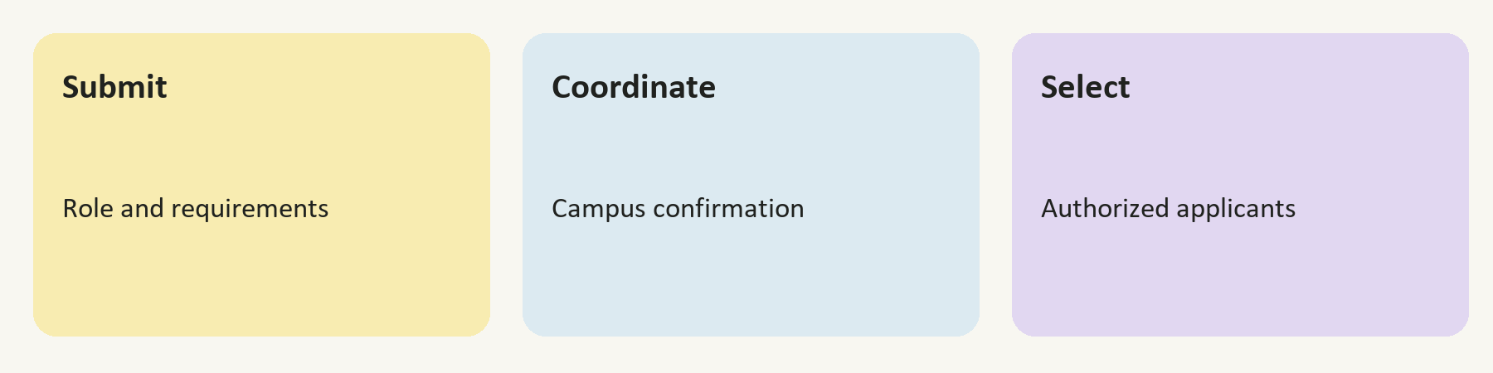
Recruiter task | Supported workflow
Describe the organization | Save a company profile and recruitment information
Request a campus visit | Submit the role, eligibility, dates, rounds, and resources
Respond to review | Revise requests when the campus asks for changes
Confirm the schedule | Review and confirm the campus-proposed visit arrangements
Review candidates | Inspect authorized applicants, fit factors, and readiness evidence
Manage selection | Shortlist, schedule interviews, and record allowed selection steps
Issue offers | Record offers after an application reaches the offer stage

Candidate discovery with context
In connected mode, recruiters see applicants within their authorized recruitment pool. Eligibility is checked before matching. Ranking combines recorded profile evidence with text relevance and presents the factors so a reviewer can understand the result.

The recruiter action center
Draft requests, requested revisions, schedules awaiting confirmation, and active selection work appear as actions. Each action opens the existing drive or interview screen. The list follows record status, which keeps it consistent with the underlying workflow.
A recruiter cannot make an inactive drive visible to students. Campus activation is required after confirmation and finalization.

Campus and administrator workspaces
  - Placement coordination and platform administration
The campus workspace is the operational center for an institution. It brings together students, recruiters, requests, campus resources, and placement results. Campus teams approve and coordinate activities within their own institution.
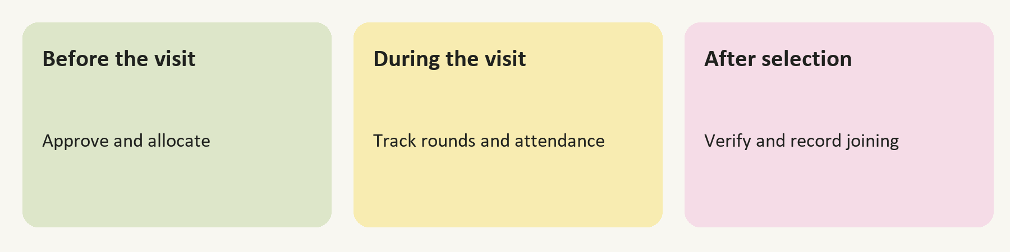
Campus responsibility | Available controls
Review requests | Inspect drive details, approve scheduling, request changes, or reject
Coordinate visits | Allocate dates, venues, labs, rooms, and systems
Open participation | Finalize confirmed arrangements and activate the drive
Track the event | Record attendance, cleared rounds, and selection progress
Complete outcomes | Verify documents and record joining at the permitted stage
Review the cohort | Use students, applications, reports, and placement analytics

Administrator access
The administrator console manages accounts, campuses, question banks, assessments, contests, integration status, and audit history. It is separate from public registration. An operator grants administrator permission to a specified existing account; the browser cannot assign that permission.

Content management
Assessment and contest content starts as a draft. Administrators can create questions, choose an audience, publish content, and archive it later. Correct answers are excluded from student APIs. Assessment scoring uses answer snapshots held by the server.
Campus authority is scoped to the institution. Administrator permission is checked independently and requires an approved, verified account.

Placement drive workflow
  - From a recruitment request to a campus visit
A drive is a controlled sequence of decisions. The state tells each participant what can happen next and prevents an unfinished request from appearing as an opportunity.
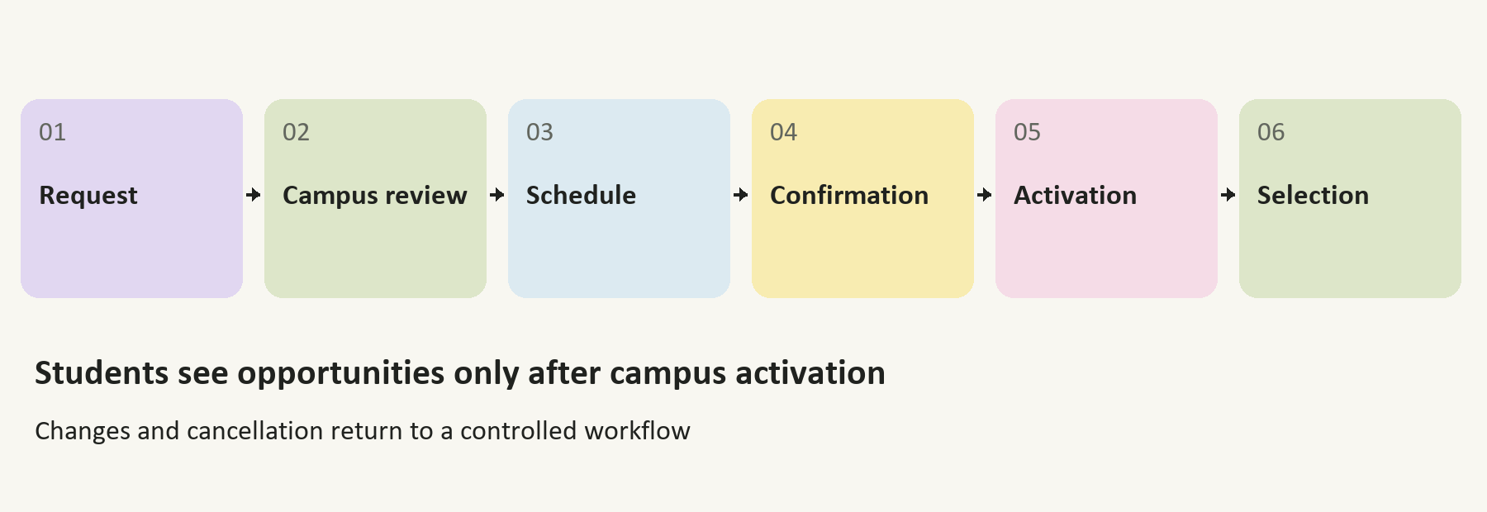
Stage | Who acts | Result
Draft and submission | Recruiter | A request is prepared and sent to the campus
Review | Campus | The request advances, returns for changes, or is rejected
Scheduling | Campus | A proposed visit and resource allocation are recorded
Confirmation | Recruiter | The proposed campus arrangements are confirmed
Finalization and activation | Campus | Student participation is opened
Event and completion | Authorized teams | Attendance, rounds, outcomes, and completion are recorded

Eligibility and conflict checks
Student eligibility uses campus, course, branch, graduation year, CGPA, and backlog rules. Scheduling checks sample resource, recruiter, and student-cohort conflicts. The API rechecks reservations when a schedule is saved. Transactions protect concurrent placement changes.
Rejected and cancelled drives stay outside the student opportunity feed. Changes return to the appropriate review step rather than bypassing the approval process.
Lifecycle tests cover visibility, role permissions, transition order, eligibility, scheduling conflicts, cancellation, and cleared-round counts.

Preparation and analysis
  - Recorded evidence behind student guidance
Preparation tools connect study activity to evidence. Assessments record results, passed verification updates skills, and practice interviews store feedback on submitted answers. Learning paths support continued study without treating a completed reading task as a verified skill.
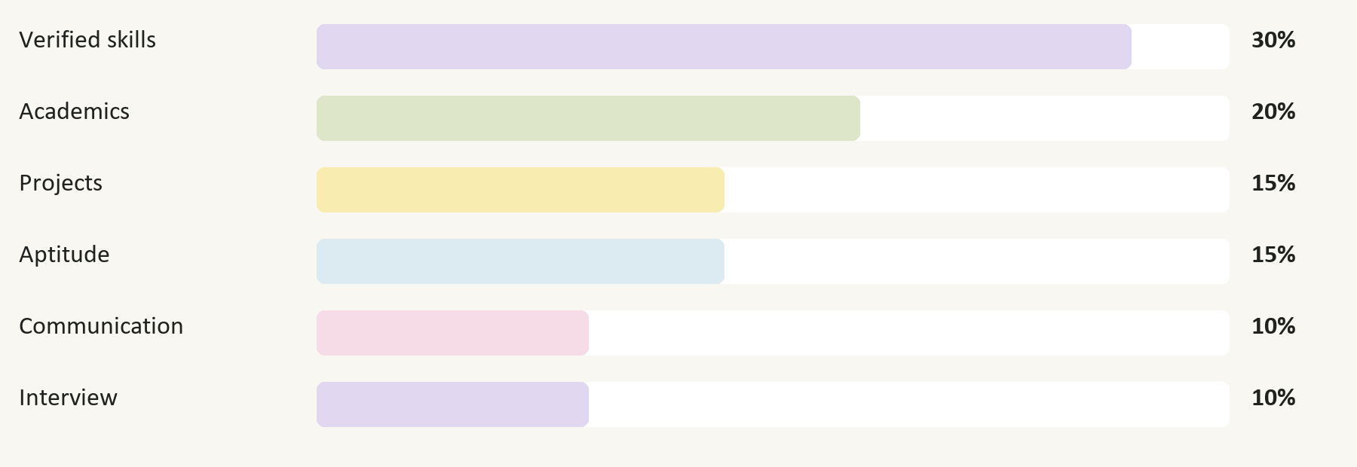
Readiness weights used by the shared scoring implementation

Resume and interview analysis
Local resume analysis extracts text from supported PDF files and recognizes technology aliases and explicit job criteria. Interview feedback looks for detail, relevance, structure, and examples. These are preparation tools, so students review suggestions before acting on them.

Optional external services
Generative coaching and the external ML service require separate student consent. Email and phone patterns are removed from submitted text, though other identifying details may remain. If consent is off or a service fails, supported workflows retain local analysis.
Outcome prediction uses a trainable model with held-out cohort evaluation. Synthetic demonstration models are blocked from production inference. A probability estimate needs validated historical records and checked scoring rubrics before it can be interpreted responsibly.
Career Points reward completed activity: 120 for passed skill verification, 80 for an assessment, 150 for a contest, and 75 for a mock interview. They are not a hiring score.

Interface and action center
  - A website designed around the next task
CampusLink uses a cream base, dark text, and pastel lavender, sage, yellow, pink, and blue surfaces. Rounded cards, consistent spacing, and clear controls give the public site and workspaces a related visual identity. The recent workspace update adds a lighter navigation panel and stronger hierarchy.
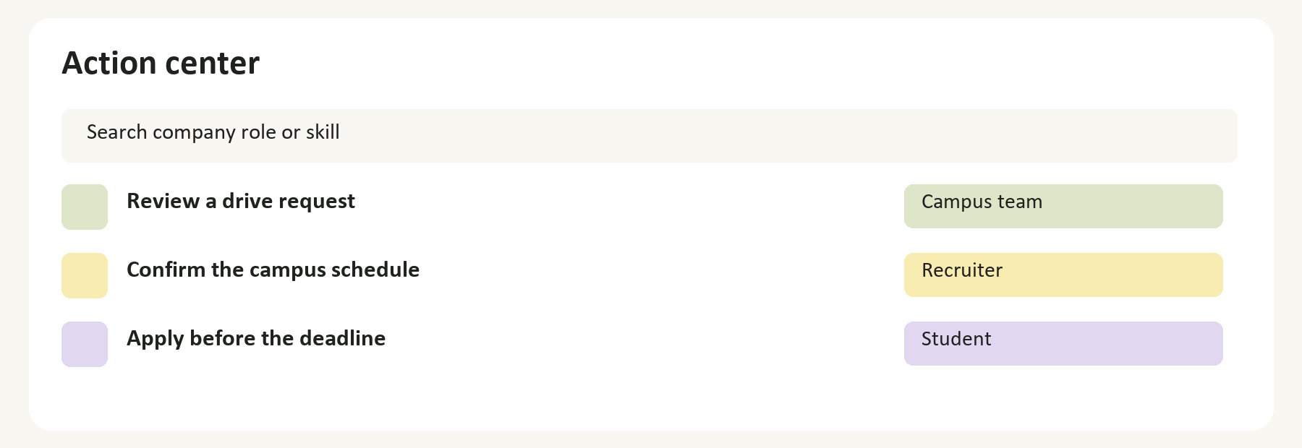
Illustration of the action-center pattern and role-specific next steps

Role specific work queues
The action center gathers preparation steps, application deadlines, pending decisions, and scheduled interviews from existing records. Search matches titles and details. Category and priority filters narrow the queue, and every item links to its working screen.

Calendar and notification support
Calendar export produces an ICS file with upcoming dates as all-day reminders. Interview times remain in the description. An export is a snapshot and should be downloaded again when schedules change. Notifications have read and unread states, and connected events queue recipient-specific email jobs.

Smaller screens and accessibility
The workspace adapts to smaller displays with a navigation drawer and stacked action rows. Focus indicators, descriptive control labels, dialog keyboard handling, and reduced-motion preferences support keyboard use and a less distracting experience.
The queue is derived from live workspace state in connected mode. It does not maintain a second set of manually completed tasks.

Architecture and records
  - How the browser API and private data connect
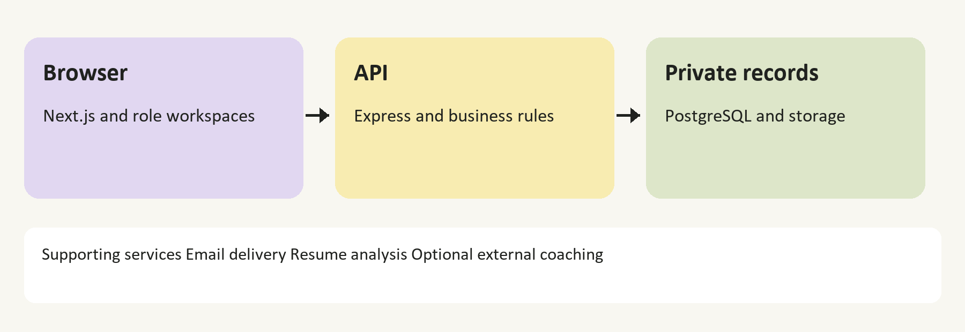

Frontend
Next.js and React render the public pages and role workspaces. TypeScript defines the domain contracts. TanStack Query manages fetched data, Zustand stores session state, and React Hook Form with Zod supports validated forms. Lucide, Recharts, and motion libraries provide interface icons, charts, and transitions.

Backend and persistence
Express exposes the API under /api/v1. The frontend uses a same-origin proxy so browser requests follow the website domain. The service layer checks the role and business rule before changing records. Local development uses persistent SQLite; production requires PostgreSQL and external private file storage.
Record group | Examples
Identity and access | Accounts, sessions, verification tokens, permissions
Student evidence | Profiles, skills, assessment attempts, practice feedback
Placement operations | Drives, applications, schedules, rounds, and offers
Supporting records | Documents, notifications, mail jobs, and audit events

Two operating modes
Standalone demo mode persists sample records in the browser. Connected mode uses server-owned records and real authorization. The interface labels the active mode. Production guards reject local upload storage and the local email outbox.
Vercel is the documented frontend target, Render hosts the persistent API process, and Supabase supplies the hosted PostgreSQL and private-storage services.

Security and access
  - Checks applied before records are read or changed
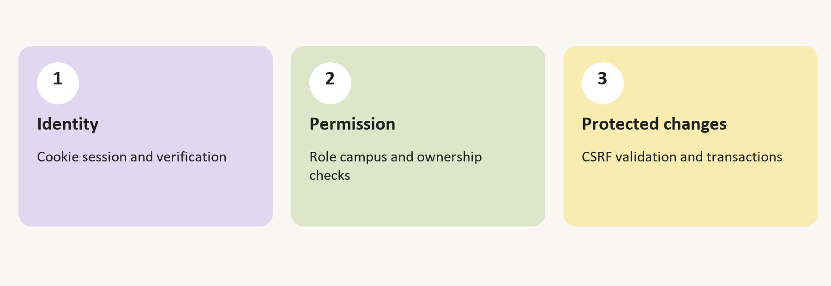

Account identity
Passwords are salted and hashed with scrypt. Login issues a random session token in an HTTP-only cookie; the stored session uses a token digest and expiry. Production cookies are secure. Verification and password-reset links are single-use, and password reset revokes existing sessions.

Role and ownership enforcement
The API checks the authenticated account rather than accepting a browser-supplied role as authority. Campus access is scoped to the institution. Recruiters are limited to their recruitment pool, and private file routes check authorization before returning bytes. Profile patches cannot assign verified skills, XP, or approval status.

Safe changes and responses
Authenticated writes need a session-specific CSRF token. Unexpected browser origins are rejected. Rate limits constrain requests, JSON and upload sizes are bounded, and file signatures are checked. API responses prevent shared caching; unexpected failures return a generic message without infrastructure details.

Startup safeguards
Production settings must select supported providers, a PostgreSQL connection, exact HTTPS origins, private storage, and email delivery. The optional external AI provider needs its server key. Database passwords and provider credentials stay outside browser variables and source control.
Private portrait responses allow a short private browser cache. Documents remain private and are downloaded through authenticated routes.

Testing and deployment
  - Local validation and the remaining launch checks
The latest local review passed 134 tests across 16 test files. Frontend and backend type checks passed, frontend lint passed, and both production builds completed. These checks establish local implementation behavior; they do not prove hosted-service availability.
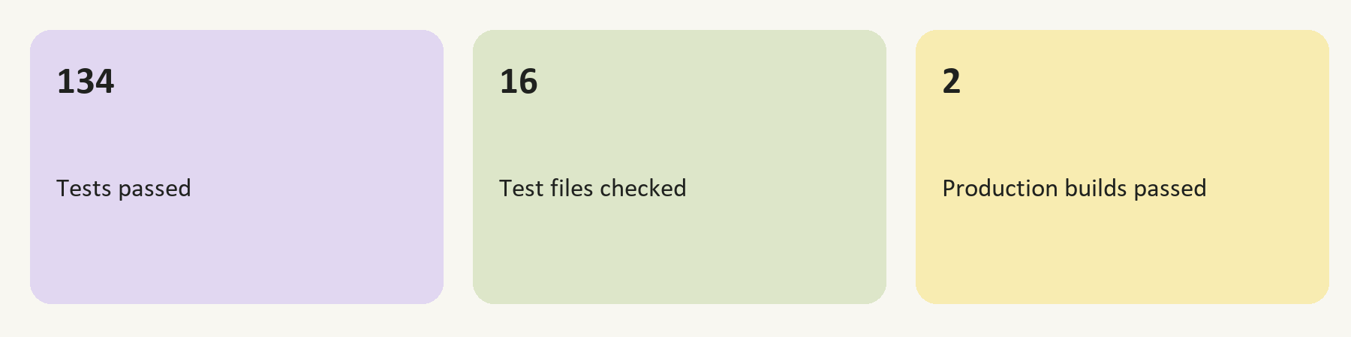
Validation area | Evidence checked
Authentication | Passwords, session handling, CSRF, and reset-token consumption
Record isolation | Role, campus, candidate-pool, and private-file boundaries
Placement workflow | Visibility, eligibility, scheduling races, offers, and joining
Assessment integrity | Server-held answers, grading, and replay protection
Deployment safeguards | Provider validation, response caching, and error disclosure
Action center | Role routing, expired applications, and calendar escaping

Before the hosted launch
Configure the real frontend and backend origins, deploy the API with production settings, and confirm the database connection. Use test accounts to complete a full placement workflow. Verify actual login, account approval, private upload and download, password-reset delivery, and Google login if enabled.

Operational work for a wider rollout
The current hosting template selects a free backend plan. Dependable scheduled delivery needs a process that stays running. Email work currently holds the global placement transaction while contacting the provider. Before scaling, isolate delivery jobs, benchmark concurrent placements, and use a shared rate-limit store across API instances.
Backups, restore drills, personal-record retention, and worker monitoring also need an operating plan. A successful build is one checkpoint in deployment, not a substitute for these checks.
Current status: implemented and locally validated. Hosted integration, recovery, and load checks remain before a production-ready deployment can be claimed.

Team and next steps
  - Project contributors and planned improvements
Team StartX brings development, design, testing, presentation, and analysis roles to CampusLink. The public website lists the following contributors.
Contributor | Project role
Diptiprava Dash | Team leader
Sonalika Nayak | Presenter
Ayushman Nayak | Tester
Rishikanta Sahoo | AI engineer
Sachin Das | AI engineer
Biswojit Sahoo | Developer and UI UX

Next development priorities
The immediate priority is to verify the hosted workflow with real service configuration. After that, a campus pilot can test how well the screens fit day-to-day placement work. Pilot feedback should guide improvements to scheduling, preparation guidance, and reporting.
Technical priorities include separating workers from placement transactions, adding shared rate limits, improving retention and monitoring, and testing backups. OCR for scanned resumes and code execution for contests are possible future features, with their own security and service requirements.

Project conclusion
CampusLink connects preparation with the operational work that makes a campus drive possible. Its strongest feature is the controlled handoff between recruiter, campus, and student: each role has a clear responsibility, and each decision changes what can happen next. The current version is ready for review and local testing, with hosted checks remaining before launch.

Project references
Repository documentation: README.md, BACKEND-SETUP.md, DEPLOYMENT.md, server/API.md, and PRODUCTION-READINESS.md. Feature behavior and scoring are defined by the role screens, service policies, shared scoring rules, and workflow tests.
CampusLink | Team StartX | Project report | October 2026

