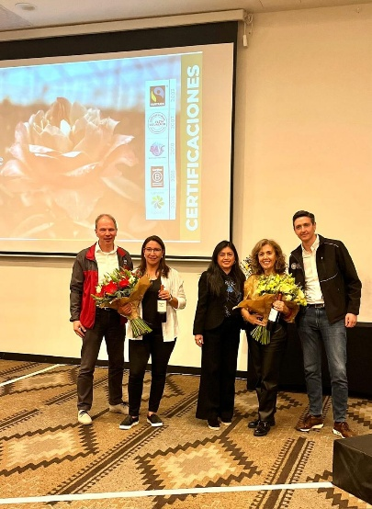**Sustainability Day in Ecuador**

On 18 March 2025, the accelerators of FSI, Dutch Flower Group (with its companies Fresh From Source and Holex), Van der Plas Group, FM Group and Four Seasons Quality organised the informative event ‘Technical Sustainability Day’ at the EB Hotel Eurobuilding in Quito.

The event featured two inspiring sessions where the accelerators shared their knowledge on sustainability in ornamental horticulture and the importance of certification under The Floricultural Sustainability Initiative FSI2025.

During the event, certification experiences were presented by Attar Roses and Hoja Verde Flowers. In addition, the programme highlighted the importance of collaboration within the sector, the impact of data on companies' carbon footprints, and the relevance of the circular economy.

The participating certification bodies – Flor Ecuador, FlorVerde SF and MPS – provided valuable insights into how companies can take steps towards certification, measure and improve their environmental impact, and how collaboration and transparency across the supply chain are essential for achieving sustainability.

The event concluded with a panel discussion, in which the speakers addressed questions from the participants. One of the key takeaways was that the Ecuador brand/country of origin is vital and can be safeguarded through certification in line with FSI2025 standards, as this provides transparency and reliable data – both of which are crucial for the sustainability and future of the sector in the country.

Due to the success of this event more growers promised to get the necessary certifications. In the first months after the event approx.. 14 growers started the certification process, representing more then 50% of the non-compliant volume from Equador.

Afbeelding met overdekt, kleding, hal, persoon

Door AI gegenereerde inhoud is mogelijk onjuist.