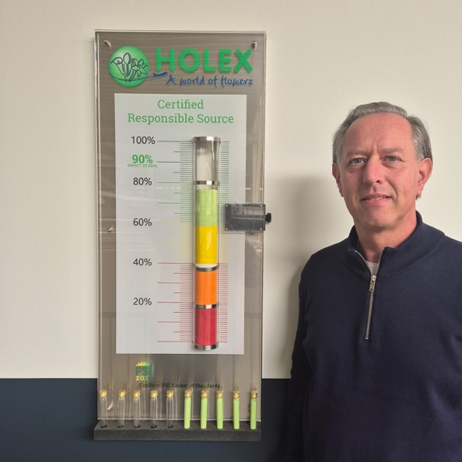**All that effort – what did we achieve?**

Over the past year, Marcel and Jeanet have dedicated themselves to convincing more growers to become certified. That meant compiling a list of non-certified growers, checking in with buyers, and above all: making lots of phone calls and sending countless emails with explanations and encouragement. All with one clear goal: to get more flowers into the FSI 2025 basket. But what did all of that actually achieve?

Let’s start with the numbers. In 2024, the percentage of FSI-certified flowers rose from 63% to 73%. That means we came very close to our target of 75%. In absolute numbers, that’s an impressive 13 million additional stems compared to the previous year, a strong result.

And of course, that didn’t happen by itself. Around 200 hours were spent on conversations, guidance and support. Is that a lot or a little? That depends on what it brings you.

In at least 80% of the cases, it led to valuable conversations. About the future of the company, the pros and cons of certification, critical questions, even political issues. We learned a lot: how the crops are doing, what effect the weather has on quality, who growers are selling to, and also how they view Holex.

So what’s our role in all this? We help wherever we can. For instance, by offering support with GAP certification, including a practical handbook with process descriptions. We’re very aware that certification is often easier for larger companies: they can free up someone to manage the process. For smaller growers, it’s a different story; everything has to be done alongside the day-to-day work.

We’re also in ongoing discussions with certification bodies, tool providers and advisors who support growers through the process. This gives us first-hand insights into the obstacles they face: issues with software, frustrations around registration, and sometimes simply a lack of time or resources. By understanding these challenges, we can offer better support and help lower the barriers.

And yes, there are still growers who either don’t want to or can’t get started yet. Some continue to find reasons to delay certification, even when we offer free help. But that’s part of the journey too.

Looking back on all the effort, we’re proud of what we achieved. Of course, it’s great to be able to show statistics and tick off targets. **But the real value for us lies in the conversations with growers, in the depth, the mutual understanding, and the shared search for solutions**.

As far as we’re concerned: mission accomplished.

Jeanet and Marcel