**K. K. Wagh Institute of Engineering Education and Research, Nashik.**

**Department of Computer Engineering**

**Academic Year 2022-23**

**Course Name:** Laboratory Practice-III **Course Code:** 410246

**Class:** BE **Div:** A

**Name of Students:** Suyam Chaturvedi (01)

Gagandeep Singh Dhindsa (02)

Tushar Avhad (03)

Sameer Pardeshi (04)

**Name of Faculty:** Prof. K.P.Birla

**Mini-Project Report**

**Title of Mini-Project:** Develop a blockchain based application- Movie Rating System using smart contract and deploy it using Ethereum.

**Objective:**

1. Understand and explore the working of Blockchain technology and its applications.

2. Write Smart contract using solidity language and deploy it using ethereum.

**Introduction of Mini-Project:**

Nowadays, Blockchain-based rating/review systems are gaining popularity as a backbone for recommender systems due to the inherent cryptographically secured decentralised architecture, immutability, user anonymity, and inclusion of smart contracts. So, in this miniproject we have write smart contract for movie rating system using solidity language and successfully deploy it on Remix IDE with ethereum.

**Smart Contract:**

Smart contracts are simply programs stored on a blockchain that run when predetermined conditions are met. They typically are used to automate the execution of an agreement so that all participants can be immediately certain of the outcome, without any intermediary’s involvement or time loss. They can also automate a workflow, triggering the next action when conditions are met. To put it simply the code you write that works on Blockchain is called a smart contract. And to write those codes you have to use Solidity Programming language.

Process of Build Smart Contract

1. Coding

2. Compilation – Used EVM

3. Deployed – to deploy you should have wallet with Public Private Key Pair & some Ethereum to spend as gas fee. (Remix provide 10 account with 100 Ethereum with each)

**Tool:** Remix IDE

Provide all facilities like smart contract to compilation, deployment, testing interface, etc

**Code:**

// SPDX-License-Identifier: MIT

pragma solidity >=0.5.1;

contract MyContract{

uint public movieCount;

mapping(uint => Movie) public movieList;

constructor (string memory _moviename,uint _rating) public

{

movieCount+=1;

movieList[movieCount]=Movie(_moviename,_rating);

}

struct Movie

{

string _moviename;

uint rating;

}

function addMovie(string memory _moviename,uint _rating) public {

movieCount+=1;

movieList[movieCount]=Movie(_moviename,_rating);

}

function returnRating(uint _movieCount) public view returns(string memory,uint) {

return (movieList[_movieCount]._moviename,movieList[_movieCount].rating); }

}

**Output:**

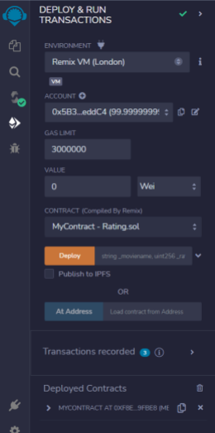Fig 1.: Deploy Smart Contract Successfully

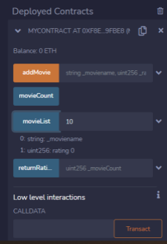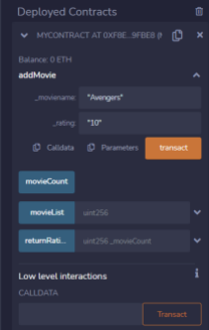Fig 2.: Add Movie with its rating Fig 3.: Display Movie List

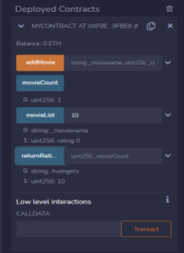

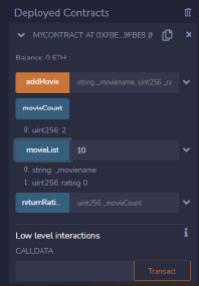

Fig 4.: Display Movies Count Fig 5.: Display Movie Name & its Rating

**Conclusion:**

Our mini-project is on “Develop a blockchain based application- Movie Rating System using smart contract and deploy it using Ethereum.” From this mini-project, we understood and

explored the working of Blockchain technology and its applications like Movie Rating System Smart Contract. We also learned about smart contract based blockchain concept and implement it using solidity language and finally deploy the smart contract on Ethereum successfully for Movie Rating System.