# Game Design Document Outline

1. Title Page
   1. Game Name – Perhaps also add a subtitle or high concept sentence.  
        
      **“ESCAPE THE ?”**
2. **Game Overview**
   1. **Game Concept**

You play as a defective block (Think “Lego”) person who has been selected for decommission. Rather than accept your fate, you battle against your would-be destroyers and attempt the most daring escape. You will battle through many different locations, all the while trying to survive to make it to the next. Victory will be achieved when you emerge from the factory you were built and achieve the freedom you have justly earned.

* 1. **Genre**  
       
     Action / First-Person Shooter
  2. **Target Audience**  
       
     Ages 8+. Casual First-Person Shooter fans. Lego enthusiasts.
  3. **Game Flow Summary – How does the player move through the game. Both through framing interface and the game itself.**  
       
     The player will find the controls similar to other First-Person Shooters. The action will be fast paced and frantic. Players will be running into rooms and quickly dispatching the enemies within, moving on at a brisk pace. Once the objectives of the level are met (If there are any) , the player will be able to escape to the next level. Between levels they will receive currency to spend on upgrades that will make them more durable and more powerful.
  4. **Look and Feel – What is the basic look and feel of the game? What is the visual style?**

Action will feel very cartoon like, with bright colours permeating every scene. Objects will be angular and simple.   
Block style characters, similar to Lego,  
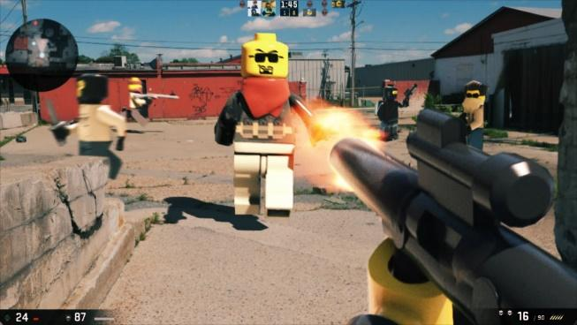

1. Gameplay and Mechanics
   1. Gameplay
      1. Game Progression  
           
         Player will go through the level, which is 1 continuous world. Upon death, the player will be brought back to the nearest checkpoint. The player must kill all enemies in order to progress
      2. Mission/challenge Structure

Mission is to escape the factory alive.

* + 1. Puzzle Structure  
         
       N/A
    2. Objectives – What are the objectives of the game?  
         
       Escape the factory.
    3. Play Flow – How does the game flow for the game player  
         
       Fighting against rooms filled with enemies, in an attempt to find an exit.
  1. Mechanics – What are the rules to the game, both implicit and explicit. This is the model of the universe that the game works under. Think of it as a simulation of a world, how do all the pieces interact? This actually can be a very large section.
     1. Physics – How does the physical universe work?  
          
        Components that will be present in the game:
        1. Gun Projectiles
        2. Explosions
        3. Destructible objects and enemies/players
        4. Physics system
     2. Movement in the game  
          
        First person controls with the exception that player will have short term control upon player death. WASD controls and mouse input for aiming/turning/interaction. Special abilities to be decided.
     3. Objects – how to pick them up and move them   
          
        Walk through object highlighted and hovering above the ground, it then gets picked up into inventory
     4. Combat – If there is combat or even conflict, how is this specifically modeled?  
          
        Physical altercation, by means of punching, shooting, or grenades.
     5. Economy – What is the economy of the game? How does it work?  
          
        Point system, enemies killed award points based on performance, which can be used towards upgrading the player health(armor) or weapons(guns/knives/etc).
  2. Game Options – What are the options and how do they affect game play and mechanics?

Difficulty system – more enemies, which work together as the difficulty increases.  
Checkpoint - Auto save when player reaches next checkpoint.  
Save – to allow the player to take a break.

* 1. Cheats and Easter Eggs

Yes…aka “bugs”

1. Story, Setting and Character
   1. Story and Narrative – Includes back story, plot elements, game progression, and cut scenes. Cut scenes descriptions include the actors, the setting, and the storyboard or script.

You’re a defective Lego unit, which was pulled from production. You hear that you are going to be dismantled so you make a break for it.

* 1. Game World
     1. General look and feel of world  
          
        LEGO
     2. Areas, including the general description and physical characteristics as well as how it relates to the rest of the world (what levels use it, how it connects to other areas)  
          
        moving through different parts of the factory floor, from production lines, to security, etc.

1. Levels
   1. Levels. Each level should include a synopsis, the required introductory material (and how it is provided), the objectives, and the details of what happens in the level. Depending on the game, this may include the physical description of the map, the critical path that the player needs to take, and what encounters are important or incidental.  
        
      Player will go through the factory level, going through various stages of assembly.
      1. Plastic Production
      2. Molding
      3. 4 Assembly Stages (Head / Torso / Arms / Legs)
      4. Soul Installer
      5. Education
      6. Packaging
   2. Training Level  
        
      Target practice / interaction with objects, characters and weapons.
2. Interface
   1. Visual System. If you have a HUD, what is on it? What menus are you displaying? What is the camera model?  
        
      HUD: Health Points, Weapon, Ammo, Crosshair, Timer.
   2. Control System – How does the game player control the game? What are the specific commands?  
        
      WASD, left mouse click, rotate view with mouse, XBOX 360/One Controller
   3. Audio, music, sound effects  
        
      To be determined
   4. Help System  
        
      Showing controls and objective.
3. Artificial Intelligence
   1. Opponent and Enemy AI – The active opponent that plays against the game player and therefore requires strategic decision making   
        
      Yes, individual AI system, not group AI. Or could be combined AI for different difficulties
   2. Non-combat and Friendly Characters  
        
      Factory workers
   3. Support AI -- Player and Collision Detection, Pathfinding  
        
      Collision detection, and path finding for enemy AI
4. Technical
   1. Target Hardware  
        
      PC
   2. Development hardware and software, including Game Engine  
        
      AwesomeEngine  
      XBOX360 Controller
   3. Network requirements  
        
      TBD
5. Game Art – Key assets, how they are being developed. Intended style.

To be created by team. To be block/Lego style.