
A PROJECT REPORT ON
PID-BASED HIGH-SPEED LINE-FOLLOWING ROBOT USING ESP32, IR SENSOR ARRAY, TB6612FNG MOTOR DRIVER AND N20 ENCODER MOTORS
Design and Development of an ESP32-Based PID Line-Following Mobile Robot with Multi-Sensor Feedback and Differential Drive

Table of Contents
Certificate i
Declaration ii
Acknowledgement iii
Abstract iv
List of Figures vi
List of Tables vii
Chapter 1: Introduction 1
Chapter 2: Literature / Technical Background 3
Chapter 3: System Design 5
Chapter 4: Hardware Implementation 9
Chapter 5: Circuit and Pin Configuration 13
Chapter 6: Software Implementation 19
Chapter 7: PID Control Algorithm 24
Chapter 8: Mechanical Design 29
Chapter 9: Testing and Validation 32
Chapter 10: Results and Discussion 34
Chapter 11: Advantages and Limitations 35
Chapter 12: Future Scope 36
Chapter 13: Conclusion 37
References 38
Appendix A: Complete Arduino / ESP32 Source Code 39

List of Figures
Figure 3.1 System Block Diagram of the ESP32-Based PID Line-Following Robot
Figure 4.1 Power Supply Architecture
Figure 5.1 Complete Electrical Wiring Diagram
Figure 6.1 Main Control Loop Flowchart
Figure 7.1 PID Feedback Control Loop (Line-Position Feedback)
Figure 8.1 Mechanical Chassis Design (CAD Drawing)

List of Tables
Table 4.1 Hardware Component List
Table 5.1 IR Sensor to ESP32 GPIO Mapping
Table 5.2 TB6612FNG to ESP32 Pin Mapping
Table 5.3 Motor Output Connections
Table 5.4 Encoder Connections
Table 5.5 Push-Button Connection
Table 5.6 Master Pin-Assignment Table
Table 5.7 ESP32 Special-Function Pin Reference
Table 6.1 IR Sensor Positional Weighting
Table 7.1 PID Controller Parameters
Table 7.2 Dynamic Base-Speed Selection Logic
Table 9.1 Summary of Software / Control Parameters
Table 9.2 Proposed Test Plan

Chapter 1: Introduction

1.1 Background
Line-following robots are a widely used category of autonomous mobile robots that navigate by continuously sensing and tracking a visually distinct path, typically a black line on a light-coloured surface (or vice versa). They are commonly used as an introductory platform for embedded control, robotics competitions, and industrial automated guided vehicle (AGV) concepts, since they combine sensing, feedback control, and actuation in a compact, low-cost system.
Traditional implementations use a small number of infrared (IR) sensors with simple ON/OFF (bang-bang) logic to decide the direction of travel. While straightforward to implement, such systems are prone to oscillatory motion and perform poorly at higher speeds or on curved tracks.

1.2 Need for PID Control
A Proportional–Integral–Derivative (PID) controller allows a robot to respond proportionally to the magnitude of its deviation from the desired path, to correct for small sustained (steady-state) errors through the integral term, and to anticipate and dampen fast changes through the derivative term. Applying PID control to the line-position error, rather than switching motors fully on or off, allows for smoother, faster, and more stable line tracking.

1.3 Project Motivation
This project is motivated by the limitations of simple ON/OFF line-following logic, namely:
- Sudden, jerky steering corrections;
- Oscillation around the line centre;
- Unstable movement at higher speeds;
- Poor handling of curves and sharp turns;
- Reduced tracking performance as speed increases.
The project therefore uses a continuous error value derived from an eight-sensor IR array, rather than relying on a single sensor or a small binary sensor set, and applies a full PID control law to the resulting error so that the differential speed between the left and right motors is adjusted smoothly and proportionally to the detected line position.

1.4 Problem Statement
To design and implement an ESP32-based autonomous mobile robot that can reliably follow a predefined line path using an eight-channel IR sensor array and a PID feedback control algorithm, with differential drive actuation through a TB6612FNG motor driver and two N20 geared DC motors, while providing smooth speed transitions across straight sections, moderate curves, and sharp turns, together with a recovery mechanism for momentary line loss.

1.5 Objectives
- To design and implement an eight-sensor weighted line-position error calculation.
- To implement a discrete PID control algorithm (proportional, integral, and derivative terms with integral anti-windup) on the ESP32 platform.
- To implement dynamic base-speed selection according to the magnitude of the tracking error.
- To implement an amplified correction response for sharp turns.
- To implement a line-loss recovery routine for momentary loss of the track.
- To design the supporting power-conditioning, motor-driver, and mechanical chassis subsystems.
- To document the hardware wiring, pin assignments, and software architecture for future reference and enhancement.

1.6 Scope of the Project
The scope of this project, as defined by the supplied source materials, covers the design of the electrical/electronic hardware (ESP32 controller, IR sensor array, motor driver, power-conditioning circuitry, and push-button interface), the mechanical chassis design, and the embedded firmware implementing weighted-sensor PID line-following control. The scope explicitly excludes encoder-based closed-loop speed control, wireless/IoT connectivity, and analog sensor processing, as these are not implemented in the supplied firmware and are identified in this report as proposed future enhancements (see Chapter 12).
Note: Dimensions, motor RPM, battery capacity, track specifications, and quantitative performance figures (speed, accuracy) are not specified in the provided project data and are therefore not stated in this report.

Chapter 2: Literature / Technical Background

2.1 Line-Following Robot Concept
A line-following robot is a mobile robot designed to detect and follow a line drawn on the floor, most commonly a black line on a white/light-coloured surface or a white line on a dark surface. Detection is achieved using reflectance-based sensors (commonly infrared emitter–detector pairs) positioned across the front of the chassis, and the sensed line position is used as feedback to a motor-control algorithm that steers the robot.

2.2 Infrared (IR) Sensing
Infrared reflectance sensors operate by emitting infrared light and measuring the intensity of the light reflected back from the surface beneath the sensor. A dark (black) surface absorbs more infrared light and reflects less, while a light surface reflects more strongly. Sensors may be read either digitally (a comparator output that switches HIGH/LOW at a fixed reflectance threshold) or as an analog voltage proportional to reflected intensity. The sensor array used in this project is read digitally, using the ESP32's digitalRead() function, with each sensor's output interpreted as HIGH when the black line is detected beneath it.

2.3 Differential Drive Mobile Robots
A differential-drive robot uses two independently driven wheels (or wheel sets), typically one on each side of the chassis. Steering is achieved purely by varying the relative speeds of the two sides rather than through a separate steering mechanism: driving both wheels at equal speed produces straight-line motion, while a speed difference between the wheels produces a turn toward the slower side. This arrangement is mechanically simple and well suited to compact mobile robots such as the one described in this report.

2.4 PID Control Theory
A PID controller computes a control (correction) signal as the weighted sum of three terms acting on the error between a desired and a measured value:
- Proportional (P): produces a correction directly proportional to the instantaneous error, providing the primary corrective response.
- Integral (I): accumulates the error over time, correcting for small sustained (steady-state) errors that the proportional term alone cannot eliminate.
- Derivative (D): responds to the rate of change of the error, providing a damping effect that reduces overshoot and oscillation.
In discrete (sampled) digital implementations, as used on a microcontroller such as the ESP32, the integral term is typically approximated by accumulating the error at each control-loop iteration, and the derivative term is approximated by the difference between the current and previous error samples. Both approximations are used in the implementation described in this report (see Chapter 7).

2.5 Pulse-Width Modulation (PWM) Motor Control
PWM is a technique for controlling the effective (average) voltage delivered to a load, such as a DC motor, by rapidly switching the supply ON and OFF and varying the proportion of time the signal remains ON within each cycle (the duty cycle). A higher duty cycle delivers more average power and therefore a higher motor speed, while a lower duty cycle reduces motor speed. The ESP32's LEDC peripheral is used in this project to generate PWM signals for both motors.

2.6 ESP32 Microcontroller
The ESP32 is a dual-core, Wi-Fi- and Bluetooth-capable system-on-chip (SoC) microcontroller commonly used in embedded and robotics applications. It provides a large number of general-purpose input/output (GPIO) pins, hardware PWM generation (LEDC), analog-to-digital converters (ADC), digital-to-analog converters (DAC), and standard communication peripherals (SPI, I2C, UART). The specific ESP32 module used in this project is the ESP32-WROOM-32D development board.

2.7 Motor Drivers (H-Bridge)
A DC motor driver IC, such as the TB6612FNG used in this project, provides an H-bridge circuit that allows a low-power microcontroller output to control the direction and speed of a higher-current DC motor. Two logic input pins per motor channel set the rotation direction, while a separate PWM input controls speed; a standby (STBY) pin enables or disables the driver outputs.

Chapter 3: System Design

3.1 Overall Architecture
The robot is organised around a central ESP32-WROOM-32D microcontroller that reads the eight-channel IR sensor array and the tactile push-button, executes the PID control algorithm, and drives the TB6612FNG motor driver, which in turn actuates the two N20 geared DC motors. Power for the system is derived from a 12 V source, stepped down through an LM2596S buck converter, with a secondary AMS1117 linear regulator providing a regulated 5 V rail for the encoder circuitry.

3.2 System Block Diagram
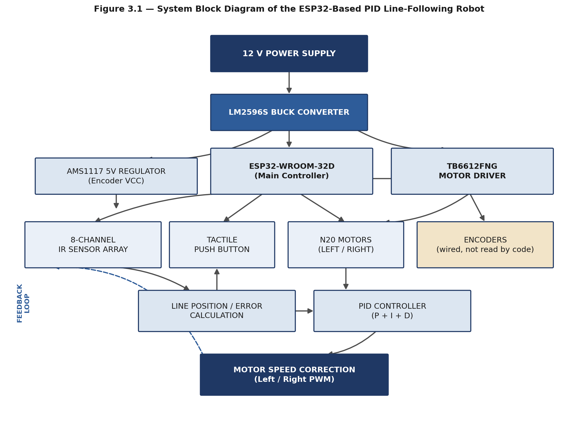
Figure 3.1 — System Block Diagram of the ESP32-Based PID Line-Following Robot

3.3 Basic Working Principle
The overall operating sequence of the system is as follows:
- The robot receives power from a 12 V supply.
- The LM2596S DC-DC converter regulates this supply for the low-voltage electronics.
- The ESP32 controls the complete robot.
- The eight IR sensors detect the black line beneath the sensor array.
- Each sensor produces a digital HIGH/LOW signal (HIGH = black line detected).
- The ESP32 assigns a position weight to each sensor.
- The active sensor positions are averaged to calculate the line position.
- The calculated line position is treated as the PID error.
- The PID controller calculates a correction value.
- The correction is added to one motor's speed command and subtracted from the other's.
- This differential speed causes the robot to turn toward the line.
- A dynamic base speed is selected according to the magnitude of the error.
- If the line is lost, the robot attempts recovery based on the direction of the previously recorded error.

3.4 Hardware Architecture
The hardware architecture consists of the ESP32 controller, the eight-channel IR sensor array, the TB6612FNG dual motor driver, two N20 geared DC motors (each wired with quadrature encoder outputs), a tactile push-button, and the power-conditioning stage (LM2596S buck converter and AMS1117 regulator). Full pin-level connection details are provided in Chapter 5.

3.5 Software Architecture
The firmware is organised into distinct functional modules — GPIO configuration, motor control, sensor processing, PID computation, dynamic speed control, line-recovery handling, and start/stop control — executed cyclically within the ESP32 Arduino-framework loop() function. The complete software architecture is detailed in Chapter 6.

3.6 Mechanical Design Overview
The chassis is a custom-designed mechanical structure intended to mount the electronics, motors, and sensor array while providing adequate structural rigidity. Full mechanical design details are provided in Chapter 8.

3.7 Power Architecture Overview
The power architecture converts a 12 V input supply to the lower regulated voltages required by the ESP32, motor driver, sensor array, and encoder circuitry. The complete power architecture is detailed in Chapter 4.

Chapter 4: Hardware Implementation

4.1 Hardware Component List
Component | Function in the System
ESP32-WROOM-32D development board | Main controller — sensor reading, PID computation, motor/PWM control, button handling
8-channel IR sensor array | Detects the black line; provides digital HIGH/LOW output per channel
TB6612FNG dual motor driver | Drives the two N20 motors (direction + PWM speed control)
2 × N20 DC geared motors (with encoder outputs) | Differential-drive actuation (left / right)
LM2596S DC-DC buck converter | Steps down the 12 V input supply for the electronics
AMS1117 linear regulator | Provides a regulated 5 V rail (used for encoder VCC)
Tactile push-button | Manual start/stop control of the robot
12 V power input | Primary system power source
Custom mechanical chassis | Structural platform for all electrical and mechanical components
Table 4.1 — Hardware Component List

4.2 ESP32-WROOM-32D
The ESP32-WROOM-32D development board is the main controller of the robot. It performs IR sensor reading, line-position error calculation, PID computation, motor direction control, PWM motor-speed control, push-button input handling, robot start/stop control, and line-loss recovery logic. Detailed electrical specifications of the ESP32-WROOM-32D module itself (e.g., exact current ratings, clock speed variants) are not specified in the provided project data.

4.3 Eight-Channel IR Sensor Array
The robot uses an eight-channel IR sensor array (labelled D1–D8 in the supplied wiring diagram) positioned across the front of the chassis to determine the position of the line relative to the robot. The supplied firmware interprets a HIGH digital reading as “black line detected” for each channel. Full pin connections are given in Section 5.2.

4.4 TB6612FNG Dual Motor Driver
The TB6612FNG is a dual H-bridge motor driver IC used to control both direction and PWM speed for the two N20 motors from ESP32 logic-level signals. It is controlled via two direction-control pins and one PWM pin per motor channel, plus a shared standby (STBY) enable pin. Full pin connections are given in Section 5.3.

4.5 N20 DC Geared Motors with Encoders
Two N20 DC geared motors are used to drive the left and right sides of the robot in a differential-drive configuration. Each motor is wired with quadrature encoder outputs (C1/C2) to the ESP32, as documented in Section 5.4. As noted in Section 4.9 and again in Chapter 6, the supplied firmware does not currently read or process these encoder signals. Motor gear ratio, RPM rating, stall torque, and similar specifications are not specified in the provided project data.

4.6 LM2596S DC-DC Buck Converter
The LM2596S is used as the primary DC-DC buck converter, stepping down the 12 V input supply to a lower regulated voltage used to power the low-voltage electronics (ESP32, sensor array, and motor-driver logic supply). According to the supplied wiring documentation, IN(+) connects to +12 V and IN(−) connects to the 12 V return/ground.

4.7 AMS1117 Regulator
The AMS1117 is a linear voltage regulator used downstream of the LM2596S. According to the supplied documentation, its input is taken from the +5 V and GND output of the LM2596S, and its regulated 5 V output is used to supply the encoder VCC lines.

4.8 Tactile Push-Button
A tactile push-button, wired to GPIO 13 and GND with the ESP32's internal pull-up resistor enabled, is used to start and stop the robot. Full operation logic is described in Section 6.7.

4.9 Encoder Hardware (Wired, Not Software-Read)
Note: The wiring diagram and pin documentation include quadrature encoder connections for both N20 motors (see Section 5.4). However, the supplied .ino source code does not contain any encoder-reading logic — there are no interrupt service routines, pulse counters, or encoder-based position/speed calculations implemented in the current firmware. This report therefore describes the encoder hardware as present and wired in the designed system, without claiming that the current software uses encoder feedback.

4.10 Custom Mechanical Chassis
A custom mechanical chassis supports the electronics and motors. Full mechanical design details, including the supplied CAD drawing, are provided in Chapter 8.

4.11 Power Supply System
The complete power system converts the 12 V input supply into the regulated voltages required by the ESP32, motor driver, sensor array, and encoder circuitry, as summarised in Figure 4.1.
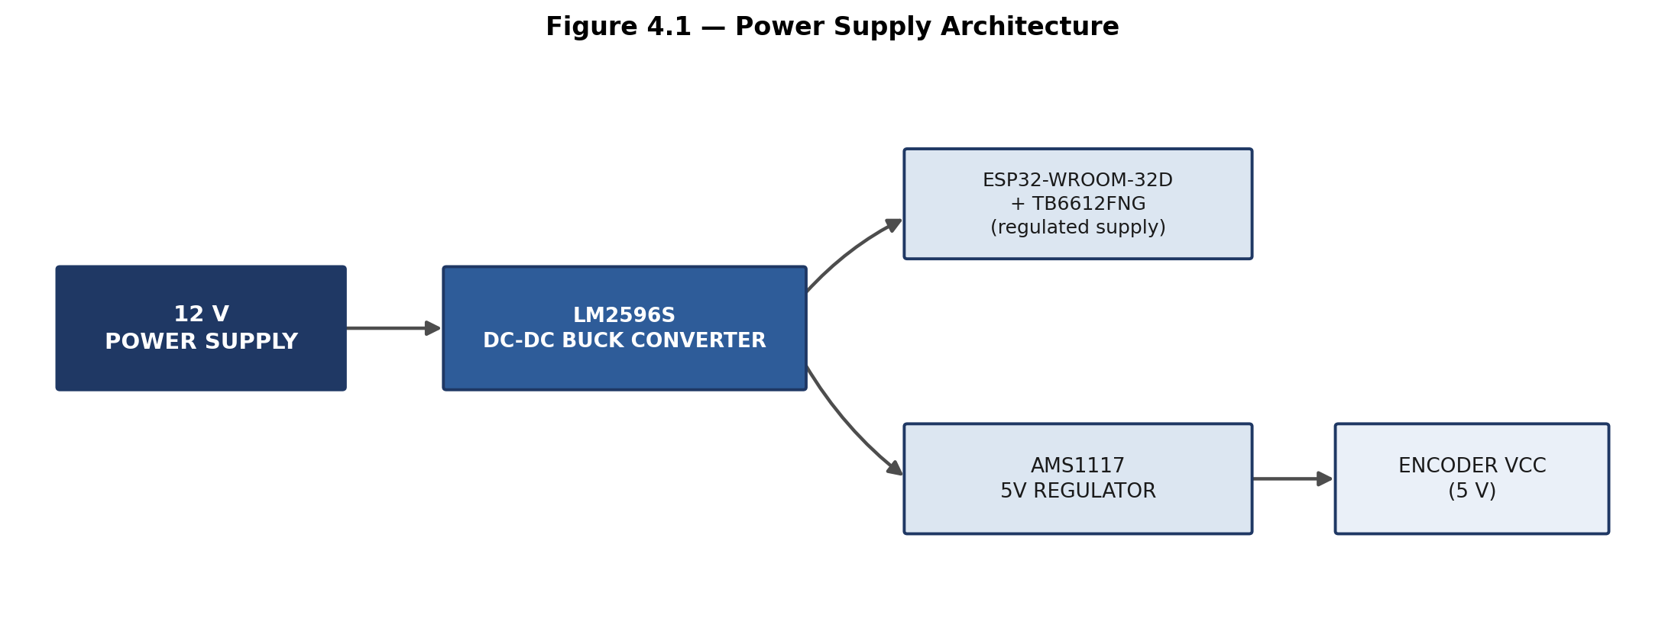
Figure 4.1 — Power Supply Architecture

4.11.1 ESP32 Power Pins (from supplied documentation)
- 3V3 — 3.3 V output, usable for compatible 3.3 V modules.
- 5V / VIN — 5 V supply/VIN connection. The supplied documentation explicitly states: “Do not give 12 V directly.”
- GND — system ground reference.
- EN (Enable) — reset pin; a LOW signal on EN resets the ESP32.

4.11.2 Common Ground
The supplied project notes emphasise that all modules must share a common electrical ground. This includes the ESP32, IR sensor array, motor driver, power supply, encoders, push-button, and both voltage regulators.

Chapter 5: Circuit and Pin Configuration

5.1 Complete Electrical Wiring Diagram
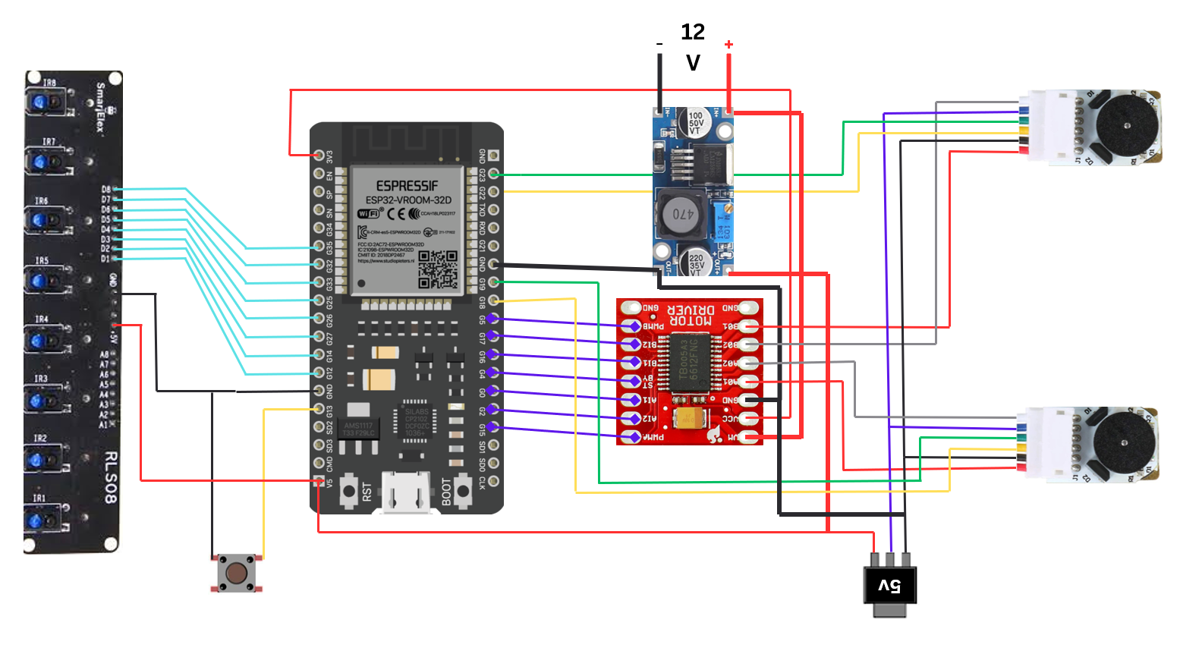
Figure 5.1 — Complete Electrical Wiring Diagram of the ESP32-Based PID Line-Following Robot

5.2 IR Sensor to ESP32 GPIO Mapping
Sensor | ESP32 GPIO
D1 | GPIO 12
D2 | GPIO 14
D3 | GPIO 27
D4 | GPIO 26
D5 | GPIO 25
D6 | GPIO 33
D7 | GPIO 32
D8 | GPIO 35
Table 5.1 — IR Sensor to ESP32 GPIO Mapping
The corresponding declaration in the supplied source code is:
int sensorPins[8] = {12, 14, 27, 26, 25, 33, 32, 35};

5.3 TB6612FNG to ESP32 Pin Mapping
TB6612FNG Pin | ESP32 GPIO
AIN1 | GPIO 0
AIN2 | GPIO 2
PWMA | GPIO 15
BIN1 | GPIO 16
BIN2 | GPIO 17
PWMB | GPIO 5
STBY | GPIO 4
Table 5.2 — TB6612FNG to ESP32 Pin Mapping

5.4 Motor Output Connections
TB6612FNG Output | Motor Terminal
AO1 | LEFT_M1
AO2 | LEFT_M2
BO1 | RIGHT_M1
BO2 | RIGHT_M2
Table 5.3 — Motor Output Connections

5.5 Encoder Connections
Encoder Signal | ESP32 GPIO
Left Encoder C1 | GPIO 18
Left Encoder C2 | GPIO 19
Right Encoder C1 | GPIO 22
Right Encoder C2 | GPIO 23
Table 5.4 — Encoder Connections
Note: Encoder power supply, per the supplied wiring: VCC = 5 V (from the AMS1117 regulator), GND = common GND. As stated in Section 4.9, these connections are wired but not read by the current firmware.

5.6 Push-Button Connection
Terminal | Connection
Signal | GPIO 13
Return | GND
Table 5.5 — Push-Button Connection

5.7 Master Pin-Assignment Table
Component | Signal | ESP32 GPIO
TB6612FNG | AIN1 | GPIO 0
TB6612FNG | AIN2 | GPIO 2
TB6612FNG | PWMA | GPIO 15
TB6612FNG | BIN1 | GPIO 16
TB6612FNG | BIN2 | GPIO 17
TB6612FNG | PWMB | GPIO 5
TB6612FNG | STBY | GPIO 4
IR Sensor | D1 | GPIO 12
IR Sensor | D2 | GPIO 14
IR Sensor | D3 | GPIO 27
IR Sensor | D4 | GPIO 26
IR Sensor | D5 | GPIO 25
IR Sensor | D6 | GPIO 33
IR Sensor | D7 | GPIO 32
IR Sensor | D8 | GPIO 35
Push Button | Signal | GPIO 13
Left Encoder | C1 | GPIO 18
Left Encoder | C2 | GPIO 19
Right Encoder | C1 | GPIO 22
Right Encoder | C2 | GPIO 23
Table 5.6 — Master Pin-Assignment Table

5.8 ESP32 Special-Function Pin Reference
The following reference information, drawn from the supplied ESP32 pin-configuration documentation, describes the general-purpose special functions available on the ESP32-WROOM-32D. Where a pin is reused for a project-specific function (e.g., an IR sensor or an encoder line), the actual project use given in Sections 5.2–5.6 takes precedence over the generic peripheral function listed here.
Category | Details
Input-only GPIOs | GPIO 34, 35, 36, 39 — cannot drive relays, LEDs, or motors; GPIO 35 is used here for IR sensor D8
ADC1 (safe with Wi-Fi) | GPIO 32, 33, 34, 35, 36, 39
ADC2 (unusable with Wi-Fi active) | GPIO 0, 2, 4, 12, 13, 14, 15, 25, 26, 27
DAC pins | GPIO 25 → DAC1, GPIO 26 → DAC2 (used in this project as IR sensor inputs D5 and D4 respectively, not as DAC outputs)
Default I2C | GPIO 22 → SCL, GPIO 21 → SDA (GPIO 22 is used in this project for the right encoder C1 signal; I2C is not used by the supplied firmware)
Default VSPI | GPIO 23 → MOSI, GPIO 19 → MISO, GPIO 18 → SCK, GPIO 5 → SS (not used by the supplied firmware)
Alternative HSPI | GPIO 13 → MOSI, GPIO 12 → MISO, GPIO 14 → SCK, GPIO 15 → SS (not used by the supplied firmware)
UART0 (programming) | GPIO 1 → TX, GPIO 3 → RX
UART2 (free to use) | GPIO 16 → RX2, GPIO 17 → TX2 (used in this project for TB6612FNG BIN1/BIN2, not for serial communication)
Touch-capacitive pins | GPIO 0, 2, 4, 12, 13, 14, 15, 27, 32, 33
Good PWM-capable pins | Almost all GPIOs except 34–39, including 2, 4, 5, 12–19, 21–23, 25–27, 32, 33
Boot / strapping pins (caution required) | GPIO 0, 2, 4, 5, 12, 15 — incorrect pull-up/pull-down states on these pins can affect boot mode
Flash-connected pins (must not be used) | GPIO 6, 7, 8, 9, 10, 11
Pins generally considered safest for robotics use | GPIO 16, 17, 18, 19, 21, 22, 23, 25, 26, 27, 32, 33
Table 5.7 — ESP32 Special-Function Pin Reference

5.9 Common Ground Requirement
As emphasised in the supplied project documentation, all modules — the ESP32, IR sensor array, motor driver, power supply, encoders, push-button, and both voltage regulators — must share a common electrical ground for reliable operation.

Chapter 6: Software Implementation

6.1 Program Architecture
The firmware, written for the Arduino/ESP32 framework, is organised into the following functional modules:
- Module 1 — GPIO configuration: configures motor pins, the standby pin, the button pin, and the IR sensor pins.
- Module 2 — Motor control: controls direction and PWM speed for the left and right motors (setMotor() function).
- Module 3 — Sensor processing: reads all eight IR sensors and calculates the weighted line position (readSensors() function).
- Module 4 — PID controller: calculates the proportional, integral, and derivative terms and the total correction.
- Module 5 — Dynamic speed controller: selects the motor base speed according to the magnitude of the error.
- Module 6 — Line recovery: attempts to reacquire the line when all eight sensors become inactive.
- Module 7 — Start/stop controller: uses the tactile push-button to toggle robot operation.

6.2 GPIO Configuration (setup())
The setup() function configures the motor direction pins and STBY pin as outputs, configures the push-button as an input with the internal pull-up resistor enabled, configures all eight IR sensor pins as inputs, enables the TB6612FNG standby pin, and configures PWM generation for both motor channels using the ESP32 LEDC peripheral:
ledcAttach(PWMA, 20000, 8); ledcAttach(PWMB, 20000, 8);
This configures a PWM frequency of 20,000 Hz with 8-bit resolution (0–255) on both PWMA (GPIO 15) and PWMB (GPIO 5).

6.3 Sensor Reading and Line-Position / Error Calculation
The function readSensors(int &activeSensors) performs the following sequence:
- Initialises the sensor positional weights: int weights[8] = {4, 3, 2, 1, -1, -2, -3, -4};
- Clears the running sum and the active-sensor counter.
- Reads each of the eight sensor pins using digitalRead().
- Adds the corresponding weight to the sum, and increments the active-sensor counter, whenever a sensor reads HIGH (interpreted as “black line detected”).
- Calculates the average active-sensor position (the error) by dividing the sum by the number of active sensors.
If no sensor detects the line, the function itself returns the previous error value (lastError); however, the main control loop separately checks for activeSensors == 0 and, when true, activates the dedicated line-loss recovery procedure described in Section 6.6, rather than continuing with the returned lastError value.

6.4 Dynamic Speed Control
Rather than operating at a single fixed base speed, the firmware selects a base motor speed according to the magnitude of the current error, as summarised in Table 7.2 (Chapter 7). This allows the robot to move quickly when close to the line centre while automatically slowing down for moderate curves and sharp turns.

6.5 Motor Control (setMotor())
The function setMotor(int leftSpeed, int rightSpeed) sets the direction pins for each motor according to the sign of the requested speed (forward for a non-negative value, reverse — with the speed magnitude taken — for a negative value), constrains both speed magnitudes to the range 0–255 (int maxSpeed = 255;), and writes the resulting PWM values using ledcWrite(PWMA, leftSpeed) and ledcWrite(PWMB, rightSpeed).

6.6 Line-Loss Recovery
If no sensor detects the line (activeSensors == 0), the integral term is reset to zero to prevent excessive accumulated correction once the line is reacquired:
integral = 0;
The robot then uses the sign of the previously recorded error (lastError) to determine which direction the line was last seen in, and commands one motor to reverse while the other continues forward, producing a turning/search motion intended to reacquire the line:
- If lastError > 0: setMotor(-80, 150);
- Otherwise: setMotor(150, -80);

6.7 Push-Button Start/Stop Control
The push-button, connected to GPIO 13 with the internal pull-up enabled (HIGH = not pressed, LOW = pressed), is polled each loop iteration. A HIGH-to-LOW transition, after a 150 ms debounce delay, toggles the robotRunning flag:
if (lastButtonState == HIGH && currentButtonState == LOW) { delay(150); robotRunning = !robotRunning; }
When robotRunning is false, both motors are immediately commanded to zero speed (setMotor(0, 0);) and the remainder of the control loop for that iteration is skipped.

6.8 Main Control Loop
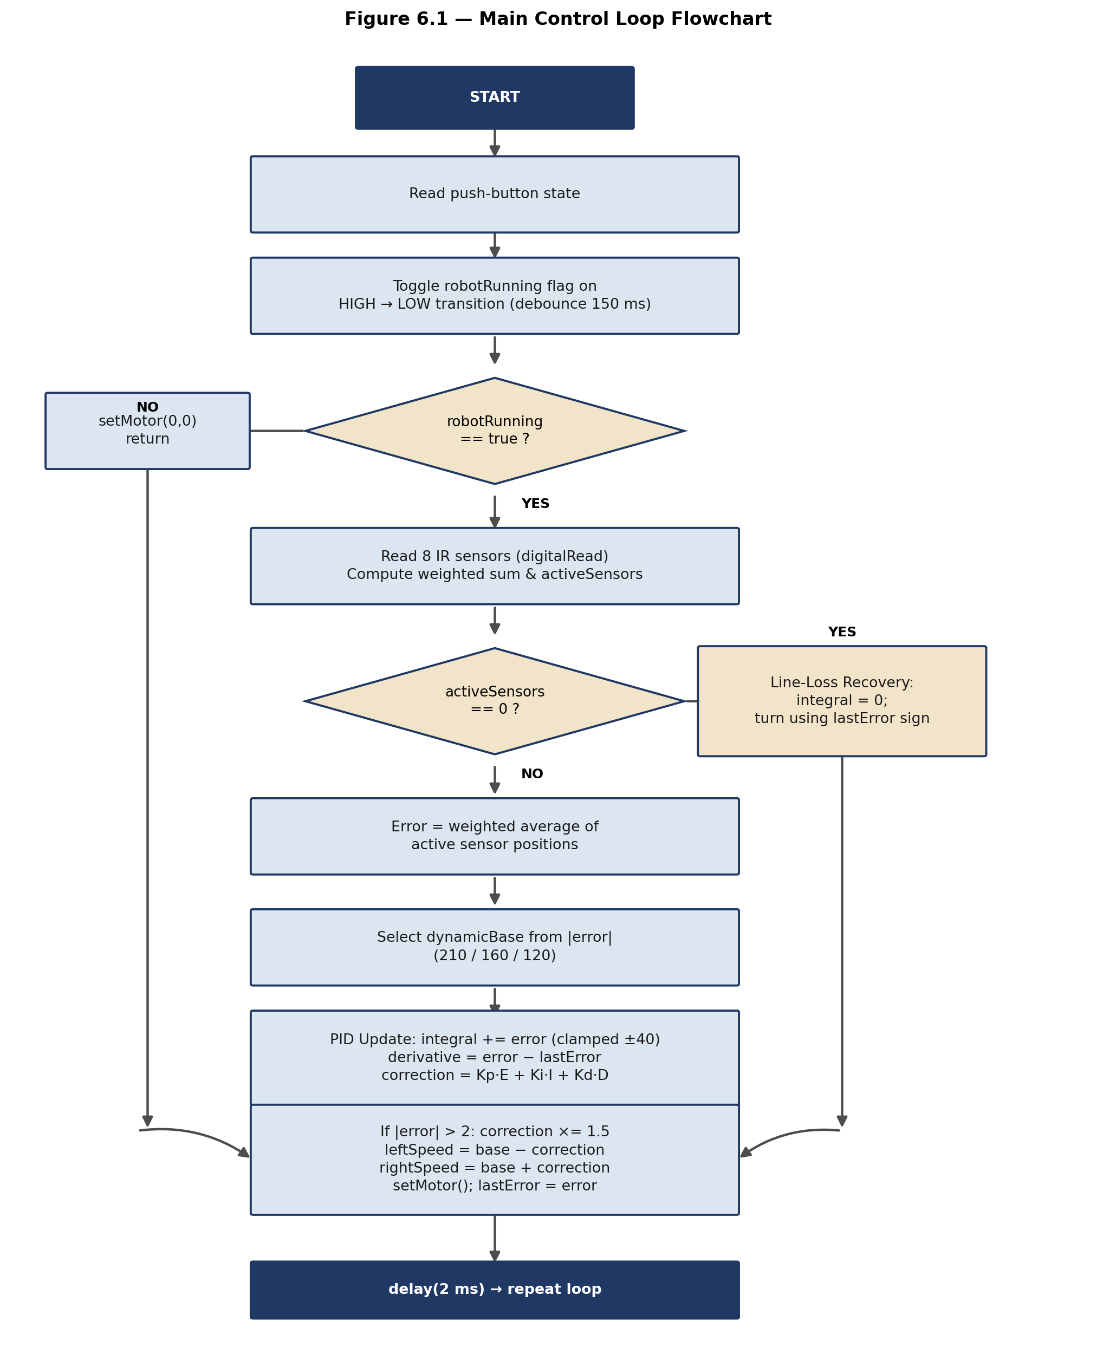
Figure 6.1 — Main Control Loop Flowchart

6.9 Loop Timing
At the end of each control-loop cycle (once motors have been commanded and lastError has been updated), the program executes delay(2);, i.e. a 2 millisecond software delay. The actual total loop execution period also depends on the processing time of the sensor-read, PID, and motor-control routines; this report does not state an exact control-loop frequency, since this was not experimentally measured in the supplied project data.

Chapter 7: PID Control Algorithm

7.1 PID Feedback Loop
The PID controller uses the line-position error derived from the eight-sensor IR array as its feedback variable. The overall feedback loop is illustrated in Figure 7.1.
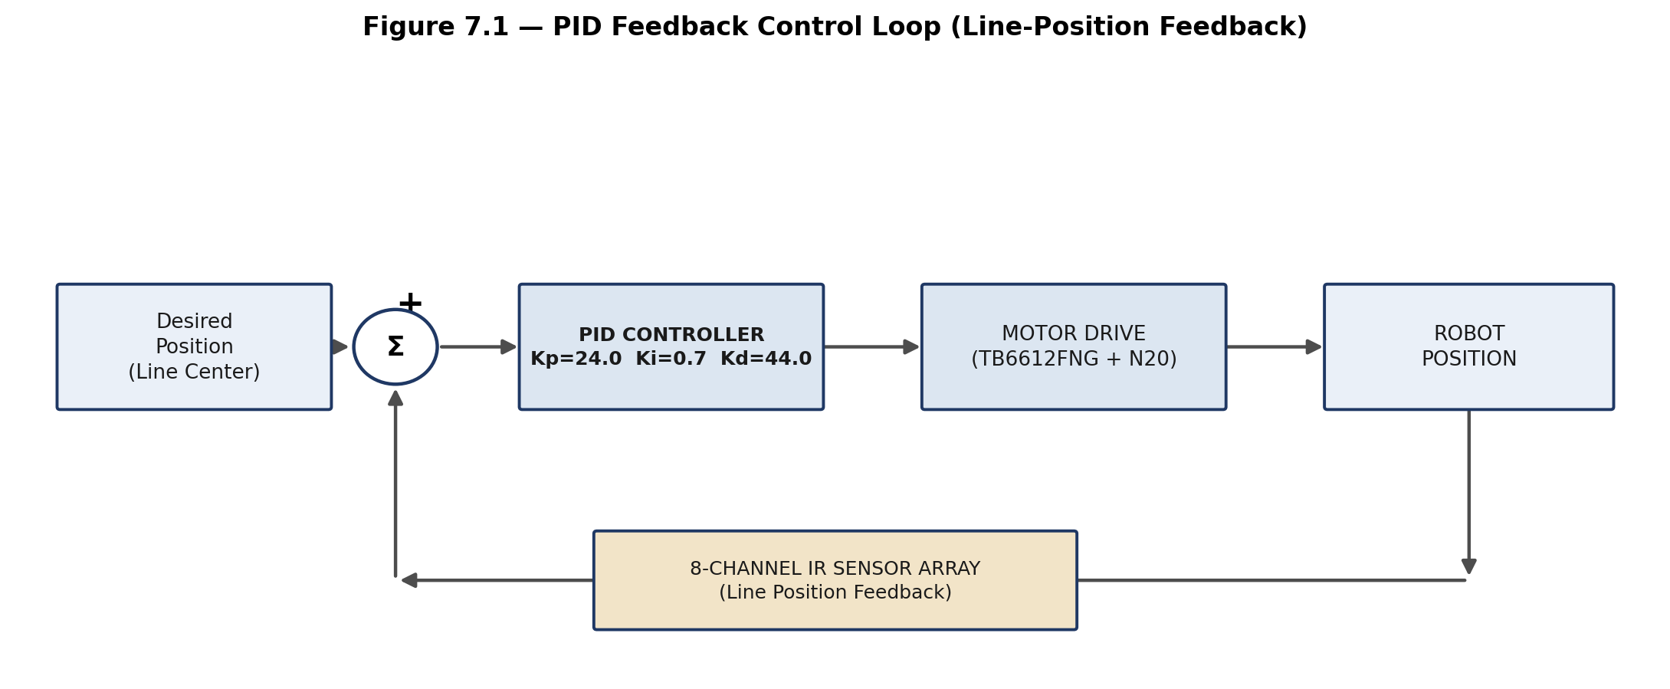
Figure 7.1 — PID Feedback Control Loop (Line-Position Feedback)

7.2 PID Controller Parameters
Parameter | Value
Kp (Proportional gain) | 24.0
Ki (Integral gain) | 0.7
Kd (Derivative gain) | 44.0
Integral limit | −40 to +40
Sharp-turn correction boost | × 1.5 (applied when |error| > 2)
Table 7.1 — PID Controller Parameters (as implemented in the supplied source code)
The supplied source code contains inline comments indicating that these values were experimentally adjusted from earlier trial values; this report documents the current/final tuned values present in the supplied code, since no separate tuning log or methodology was provided.

7.3 Error Calculation
Each of the eight IR sensors is assigned a positional weight:
Weights = [+4, +3, +2, +1, −1, −2, −3, −4] (for sensors D1–D8 respectively)
The line-position error is the average weight of the currently active (line-detecting) sensors:
E = ( Σ Weightᵢ ) / Nₐᵤₜᵢᵥₑ
where Weightᵢ is the weight of an active sensor and Nₐᵤₜᵢᵥₑ is the number of currently active sensors. For example, if the sensors with weights +2 and +1 are simultaneously active, the error evaluates to (2 + 1) / 2 = 1.5. A positive or negative error value indicates that the detected line is displaced toward one side of the sensor array relative to its centre.

7.4 Proportional Term
P = Kp × E
The proportional term responds directly and immediately to the instantaneous position error: a larger error produces a proportionally larger correction, allowing the robot to respond quickly when the line moves away from the centre of the sensor array.

7.5 Integral Term
The integral term accumulates the error over successive control-loop iterations:
Iₜ = Iₜ₋₁ + Eₜ , constrained to −40 ≤ Iₜ ≤ 40
I (contribution) = Ki × Iₜ
Limiting the accumulated integral value to the range −40 to +40 is an anti-windup measure that prevents the integral term from growing excessively large during sustained error conditions, which would otherwise cause large, delayed overcorrections once the error is reduced.

7.6 Derivative Term
Dₜ = Eₜ − Eₜ₋₁
D (contribution) = Kd × Dₜ
The derivative term measures the rate of change of the error between consecutive loop iterations. It helps the controller anticipate how quickly the robot is moving away from, or back toward, the desired line position, reducing overshoot and oscillatory behaviour during rapid changes in line position.

7.7 Complete PID Correction Equation
Correctionₜ = Kp·Eₜ + Ki·Iₜ + Kd·Dₜ
Substituting the tuned gain values used in the supplied firmware (Kp = 24.0, Ki = 0.7, Kd = 44.0):
Correctionₜ = 24·Eₜ + 0.7·Iₜ + 44·(Eₜ − Eₜ₋₁)

7.8 Sharp-Turn Correction Boost
For large tracking errors, the calculated correction is amplified to increase the steering response during sharp turns:
If |Eₜ| > 2, then Correctionₜ = 1.5 × Correctionₜ

7.9 Dynamic Base-Speed Selection
The base motor speed prior to applying the PID correction is selected according to the magnitude of the error, as follows:
|Error| Magnitude | Selected Base Speed (dynamicBase)
< 0.3 | 210 (“straight fast”)
< 1.5 | 160 (“curve medium”)
≥ 1.5 | 120 (“sharp turn slow”)
Table 7.2 — Dynamic Base-Speed Selection Logic
The maximum configured motor command value is int maxSpeed = 255; (corresponding to full-scale 8-bit PWM).

7.10 Motor Speed Calculation
LeftSpeed = BaseSpeed − Correction
RightSpeed = BaseSpeed + Correction
This differential relationship is the central steering mechanism of the robot: as the magnitude of the correction increases, the speed difference between the two motors increases correspondingly, causing the robot to turn. Both resulting speed values are constrained to the range 0–255 before being written to the motor driver.

7.11 Summary of the Control Sequence
- Current error is calculated from the weighted sensor readings.
- The integral term is updated and clamped to −40–40.
- The derivative term is calculated from the change in error.
- The PID correction is calculated from the three terms.
- The correction is amplified by 1.5× if |error| exceeds 2.
- The dynamic base speed is selected from the error magnitude.
- Left and right motor speeds are calculated and constrained.
- Motor commands are sent to the TB6612FNG driver.
- The current error is stored as lastError for the next iteration.

Chapter 8: Mechanical Design

8.1 Chassis Overview
The provided mechanical drawing (Figure 8.1) shows a custom robot chassis designed around the electronics and a two-wheel differential-drive arrangement. The drawing contains a main body/chassis plate, elongated central sections, multiple mounting holes, motor-mounting regions, front and rear structural portions, curved sections, bracket-like structures, and symmetrical mounting-hole patterns.
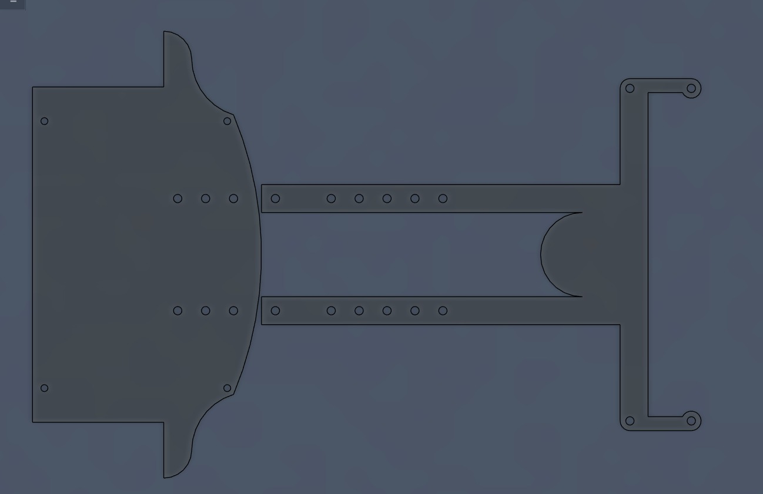
Figure 8.1 — Mechanical Chassis Design (CAD Drawing) of the PID Line-Following Robot

8.2 Design Purpose
The chassis is designed to support the electronics, mount the motors, provide structural rigidity, accommodate the sensor array, provide mounting locations for components, and maintain an appropriate physical arrangement for line tracking. The IR sensor array should be positioned toward the line-detection (leading) side of the robot so that the sensors can detect the track ahead of the robot's forward motion.

8.3 Motor and Sensor Placement
The mounting holes visible on the main body plate accommodate the primary electronics and battery/power components, while the elongated bracket sections on the right of the drawing appear to correspond to the motor-mounting region. The precise placement, orientation, and fastening scheme are as shown in the supplied CAD drawing.

8.4 Mechanical Specifications
Note: Chassis material, thickness, exact dimensions, wheel diameter, and total robot mass are not specified in the provided project data and are therefore not stated in this report. Any reproduction or fabrication of this chassis should reference the original CAD drawing/file directly for dimensional accuracy.

Chapter 9: Testing and Validation

9.1 Purpose
Since experimental test results were not supplied as part of the project source materials, this chapter presents the intended test methodology and the software/control parameters relevant to testing, rather than fabricated results. Sections 9.4 (Results and Discussion is presented separately as Chapter 10) should be completed once physical testing has been carried out.

9.2 Software / Control Parameters Under Test
Parameter | Value
Number of IR sensors | 8
Kp | 24.0
Ki | 0.7
Kd | 44.0
Integral limit | −40 to +40
Maximum motor command | 255
Straight base speed | 210
Moderate-curve base speed | 160
Sharp-turn base speed | 120
Sharp-turn correction boost | 1.5×
PWM frequency | 20 kHz
PWM resolution | 8-bit
Loop delay | 2 ms
Table 9.1 — Summary of Software / Control Parameters

9.3 Proposed Test Plan
Test | Objective
Test 1 — Sensor test | Verify that all eight IR sensors correctly detect the black line.
Test 2 — Button test | Verify press-to-start and press-to-stop toggle behaviour.
Test 3 — Motor direction test | Verify independent left/right motor direction control.
Test 4 — Straight-line test | Check whether the robot maintains the line at low error.
Test 5 — Moderate curve test | Check dynamic speed reduction and PID correction on curves.
Test 6 — Sharp-turn test | Check the additional 1.5× correction multiplier on sharp turns.
Test 7 — Line-loss test | Remove the line from the sensor array and verify recovery behaviour.
Test 8 — PID tuning test | Compare robot behaviour across different Kp, Ki, Kd combinations.
Test 9 — Encoder test | If encoder feedback is implemented in future work, verify pulse detection and wheel-speed measurement.
Table 9.2 — Proposed Test Plan
Note: No track dimensions, motor RPM, battery capacity, or measured PID-tuning methodology beyond the in-code comments were supplied. These should be documented once available, rather than assumed.

Chapter 10: Results and Discussion
This chapter is reserved for the presentation and discussion of results obtained once the test plan in Chapter 9 has been carried out on the physical robot.
Note: No experimental results, measured speeds, tracking-accuracy figures, or quantitative performance data were included in the project source materials supplied for this report. Accordingly, no results are fabricated or estimated here. Once testing is complete, this chapter should be populated with the observed outcomes of Tests 1–9 (Table 9.2), including any further PID re-tuning performed as a result of physical trials.

Chapter 11: Advantages and Limitations

11.1 Advantages of the Implemented Design
- Autonomous line tracking using continuous, weighted multi-sensor feedback rather than simple ON/OFF logic
- Eight-point line detection across the sensor array
- PID-based steering correction (proportional, integral, and derivative terms)
- Dynamic base-speed adjustment according to error magnitude
- Additional sharp-turn correction boost for large errors
- Dedicated line-loss recovery routine
- Push-button start/stop control
- Independent left/right motor control via a dedicated dual H-bridge driver
- Compact, single-microcontroller (ESP32) implementation
- Modular motor-driver architecture (TB6612FNG)
Note: Numerical performance improvements (e.g., “x% faster than ON/OFF control”) are not stated, since no experimental results were supplied to support such a claim.

11.2 Limitations of the Current Implementation
- Encoder hardware is wired but not used by the supplied firmware — the current system is not a closed-loop, wheel-speed encoder-feedback PID system.
- No experimental speed or tracking-accuracy data is supplied in the project materials.
- No track dimensions are specified in the provided project data.
- No chassis dimensions or material specification are provided.
- No motor RPM specification is provided.
- No battery capacity is specified.
- No documented PID-tuning methodology exists beyond the values and comments present in the supplied code.
- The firmware assumes BLACK = HIGH sensor logic; changing the track polarity would require a corresponding code change.
- The sensor system relies on digital (HIGH/LOW) detection rather than analog reflectance values.
- No wireless/IoT functionality is implemented in the supplied code.

Chapter 12: Future Scope
The following enhancements are proposed as future work. None of these are implemented in the currently supplied firmware.
Enhancement | Description
Encoder-based speed feedback | Use the already-wired encoder signals to measure actual wheel speed and improve left/right motor synchronisation.
Encoder-assisted PID | Introduce a secondary control loop that regulates actual wheel speed using the encoder feedback.
Analog IR sensing | Replace digital (HIGH/LOW) sensor reading with analog reflectance values for more precise line-position estimation.
Automatic PID tuning | Develop a systematic, repeatable procedure for tuning Kp, Ki, and Kd.
OLED display | Add a display to show sensor values, error, PID correction, motor speed, and robot state in real time.
Data logging | Record error, PID output, sensor state, motor commands, and (if implemented) encoder counts for offline performance analysis.
Wireless monitoring | Use the ESP32's built-in Wi-Fi capability for wireless monitoring or configuration, subject to future software implementation.

Chapter 13: Conclusion
This project demonstrates the design of an autonomous line-following robot using an ESP32 microcontroller and an eight-channel IR sensor array. The robot calculates the position of the line using weighted sensor information and uses this position as the feedback error for a discrete PID controller.
The controller combines proportional, integral, and derivative correction terms to determine the required speed difference between the left and right motors. The control strategy is further enhanced through dynamic base-speed selection, integral anti-windup limiting, a sharp-turn correction amplification factor, a dedicated line-loss recovery routine, and push-button start/stop control.
The hardware architecture uses a TB6612FNG dual motor driver to independently control two N20 motors in a differential-drive configuration, powered through an LM2596S buck converter and an AMS1117 linear regulator. Encoder connections are included in the hardware design, although encoder feedback is not currently implemented in the supplied software — this and the other enhancements discussed in Chapter 12 represent clear directions for extending the system.
Overall, the resulting system forms a compact, well-structured embedded control platform for autonomous line-following applications, built entirely from the hardware and firmware documented in this report.

References
The following sources are relevant to the components and control techniques used in this project. Only manufacturer datasheets and standard technical references are listed; no experimental or comparative claims in this report are attributed to these sources beyond general component and technique descriptions.
- Espressif Systems, “ESP32-WROOM-32D / 32U Datasheet,” Espressif Systems.
- Toshiba Electronic Devices & Storage Corporation, “TB6612FNG Dual DC Motor Driver Datasheet,” Toshiba.
- Texas Instruments, “LM2596 SIMPLE SWITCHER Power Converter, 150 kHz, 3A, Step-Down Voltage Regulator, Datasheet,” Texas Instruments.
- Advanced Analog Technology, “AMS1117 1A Low Dropout Voltage Regulator Datasheet.”
- Astrom, K. J., and Hagglund, T., “PID Controllers: Theory, Design, and Tuning,” International Society of Automation (ISA).
- Manufacturer documentation for N20 micro geared DC motors with quadrature encoder outputs.
- Arduino / Espressif Arduino-ESP32 Core documentation for the LEDC (PWM) peripheral API (ledcAttach, ledcWrite).
Note: Exact edition numbers, publication years, and URLs for the above references were not specified in the provided project data and should be added by the student prior to final submission.

Appendix A: Complete Arduino / ESP32 Source Code
The following listing reproduces the complete sensor1_pid_full.ino source file supplied as the authoritative firmware implementation for this project. It is included in full for reference and traceability, and corresponds exactly to the code described throughout Chapters 5–7.
Note: The pin assignments, PID gain values (Kp = 24.0, Ki = 0.7, Kd = 44.0), and all control logic in this listing are reproduced exactly as supplied, without modification.
// ================= MOTOR PINS =================
#define AIN1 0
#define AIN2 2
#define PWMA 15

#define BIN1 16
#define BIN2 17
#define PWMB 5

#define STBY 4

// ================= BUTTON =================
#define BUTTON 13

// ================= SENSOR PINS =================
int sensorPins[8] = {12, 14, 27, 26, 25, 33, 32, 35};

// ================= PID VALUES =================
float Kp = 24.0; //22 set 22.0
float Ki = 0.7; //1 set 0.6
float Kd = 44.0; //32 set 40.0

float error = 0;
float lastError = 0;
float integral = 0;

int maxSpeed = 255;

bool robotRunning = false;
bool lastButtonState = HIGH;

// ================= SETUP =================
void setup() {

pinMode(AIN1, OUTPUT);
pinMode(AIN2, OUTPUT);
pinMode(BIN1, OUTPUT);
pinMode(BIN2, OUTPUT);
pinMode(STBY, OUTPUT);

pinMode(BUTTON, INPUT_PULLUP);

for (int i = 0; i < 8; i++)
pinMode(sensorPins[i], INPUT);

digitalWrite(STBY, HIGH);

ledcAttach(PWMA, 20000, 8);
ledcAttach(PWMB, 20000, 8);
}

// ================= MOTOR FUNCTION =================
void setMotor(int leftSpeed, int rightSpeed)
{
if (leftSpeed >= 0) {
digitalWrite(AIN1, HIGH);
digitalWrite(AIN2, LOW);
} else {
digitalWrite(AIN1, LOW);
digitalWrite(AIN2, HIGH);
leftSpeed = -leftSpeed;
}

if (rightSpeed >= 0) {
digitalWrite(BIN1, HIGH);
digitalWrite(BIN2, LOW);
} else {
digitalWrite(BIN1, LOW);
digitalWrite(BIN2, HIGH);
rightSpeed = -rightSpeed;
}

leftSpeed = constrain(leftSpeed, 0, maxSpeed);
rightSpeed = constrain(rightSpeed, 0, maxSpeed);

ledcWrite(PWMA, leftSpeed);
ledcWrite(PWMB, rightSpeed);
}

// ================= SENSOR READ =================
float readSensors(int &activeSensors)
{
int weights[8] = {4, 3, 2, 1, -1, -2, -3, -4};

int sum = 0;
activeSensors = 0;

for (int i = 0; i < 8; i++) {
if (digitalRead(sensorPins[i]) == HIGH) { // BLACK = HIGH
sum += weights[i];
activeSensors++;
}
}

if (activeSensors == 0)
return lastError;

return (float)sum / activeSensors;
}

// ================= LOOP =================
void loop() {

// -------- BUTTON --------
bool currentButtonState = digitalRead(BUTTON);

if (lastButtonState == HIGH && currentButtonState == LOW) {
delay(150);
robotRunning = !robotRunning;
}

lastButtonState = currentButtonState;

if (!robotRunning) {
setMotor(0, 0);
return;
}

int activeSensors = 0;
error = readSensors(activeSensors);

// ================= LINE LOST =================
if (activeSensors == 0) {
integral = 0; // reset integral

if (lastError > 0)
setMotor(-80, 150);
else
setMotor(150, -80);

return;
}

// ================= SMART SPEED CONTROL =================
int dynamicBase;

if (abs(error) < 0.3)
dynamicBase = 210; // straight fast 185 set(210)
else if (abs(error) < 1.5)
dynamicBase = 160; // curve medium 145 set(160)
else
dynamicBase = 120; // sharp turn slow 110 set(120)

// ================= FULL PID =================
integral += error;
integral = constrain(integral, -40, 40);

float derivative = error - lastError;

float correction = (error * Kp) +
(integral * Ki) +
(derivative * Kd);

// Extra correction boost for sharp turn
if (abs(error) > 2)
correction *= 1.5; //set 1.5

int leftSpeed = dynamicBase - correction;
int rightSpeed = dynamicBase + correction;

setMotor(leftSpeed, rightSpeed);

lastError = error;

delay(2);
}

