**Assignment 4: Student Selection Evaluation System**

**Sun Ren, Yue Jian, Zeyuan Zhu**

**Northeastern University**

**Introduction**

Our group created a student selection and evaluation system Designed for the university. This system's primary function is to allow some graduates who have graduated from this school and started working to enter this system and evaluate the courses they have taken. Their evaluation will be returned to the course list and displayed on the course detail page. Students can check the course details and external assessment and decide whether they want to choose this course. In this way, graduates' evaluation of the course and students' trend of course selection can be used to calculate which type of course is more important and more valuable for the student to choose. Administrators can view all graduates, students, and courses and can modify or delete all properties. Administrators can also add new graduates, students, and courses.

**Object Model Diagram**

First of all, User is a parent class. The attributes of this class are inherited by the student class and the administrator class. Them owns all the attributes of the User class, which simplifies the programming and establishes connections. As a key class to control the whole system, the administrator class has a variety of methods to control the data of the whole system. Students are divided into two different kinds of class, one is the enrolled students, the other is the students who have graduated.

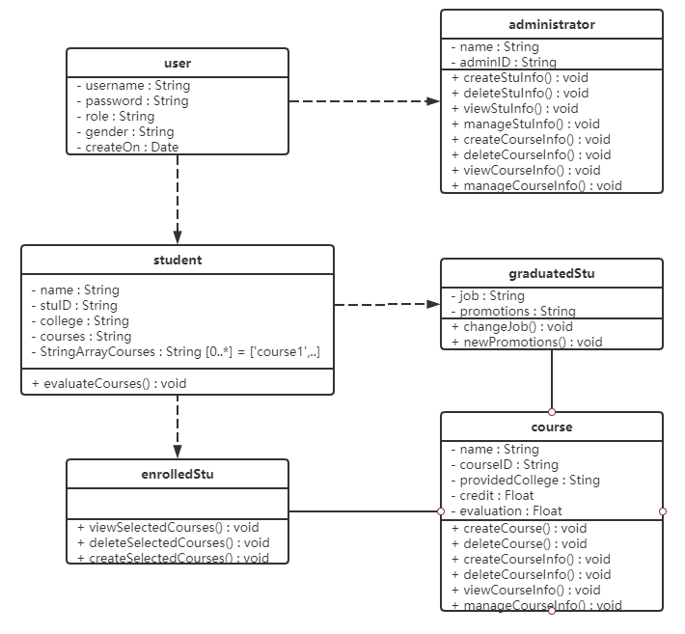

Figure1-1 UML

There are two categories of students because two different types of students have different methods of this system. The enrolled students need view the detail of each courses and select their courses, and after they finfish their study of the course they choice, they have to evaluate the course. While the graduate students only need to do the evaluation of the course they had studied. However, the evaluation methods and values in the two classes are not the same. The course class will contain all the specific information of the course and two kinds of students' evaluation, so as to facilitate the students to select the course, and also facilitate the data collection and analysis in order to figure out which type of course is the most valuable and popular.

**Sequence diagram**

As users, students need to log in in order to select their courses, so the students will input login information in the interface class and transfer it to the control class for verification that the username or password is correct. If the control class checks the information successfully by the method, it will return a successful method to the interface class to tell the student, which then goes to the main interface.

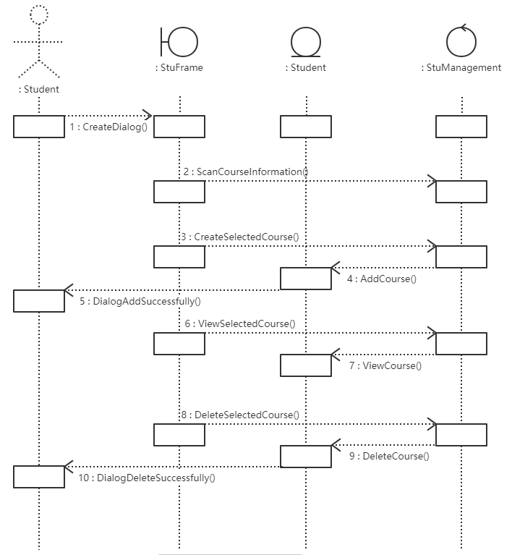

Figure2-1 Select Course Sequence diagram

As a control class, the main interface has different buttons representing different functions. The button for searching course information will transfer the request from the interface class to the control class, which will update and modify the data and return it to the entity class which namely the student class. After a successful message is returned to the interface class, the user will get feedback.

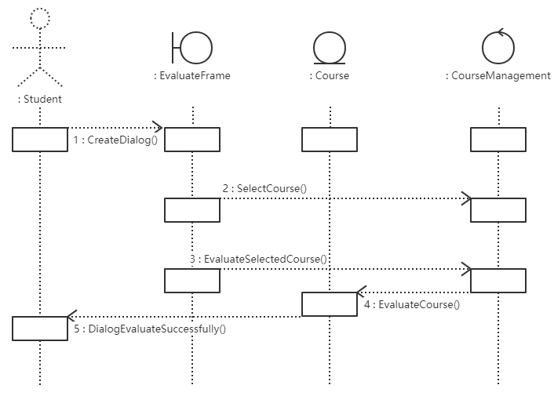

Figure2-2 Evaluation Sequence diagram

**MainFrame**

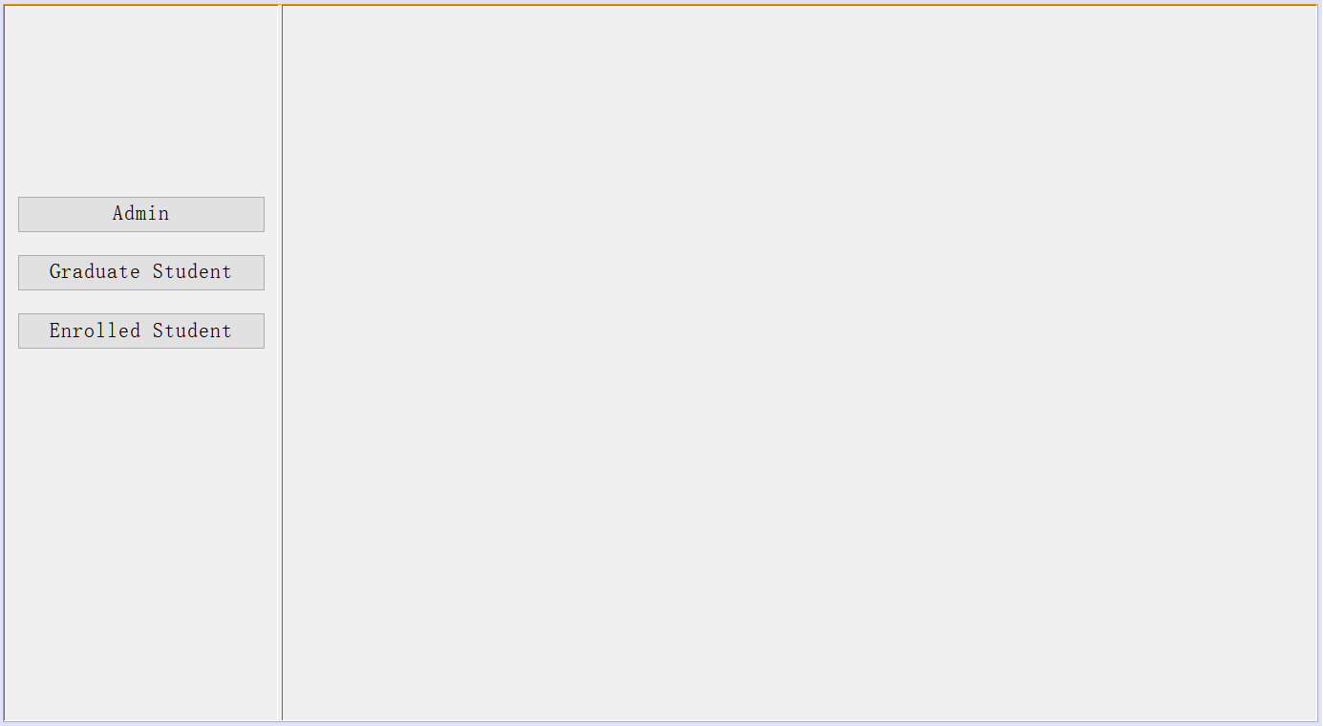  
Figure 3-1 Main Interface

The main interface has three function buttons, each of which represents the login function of the different users.

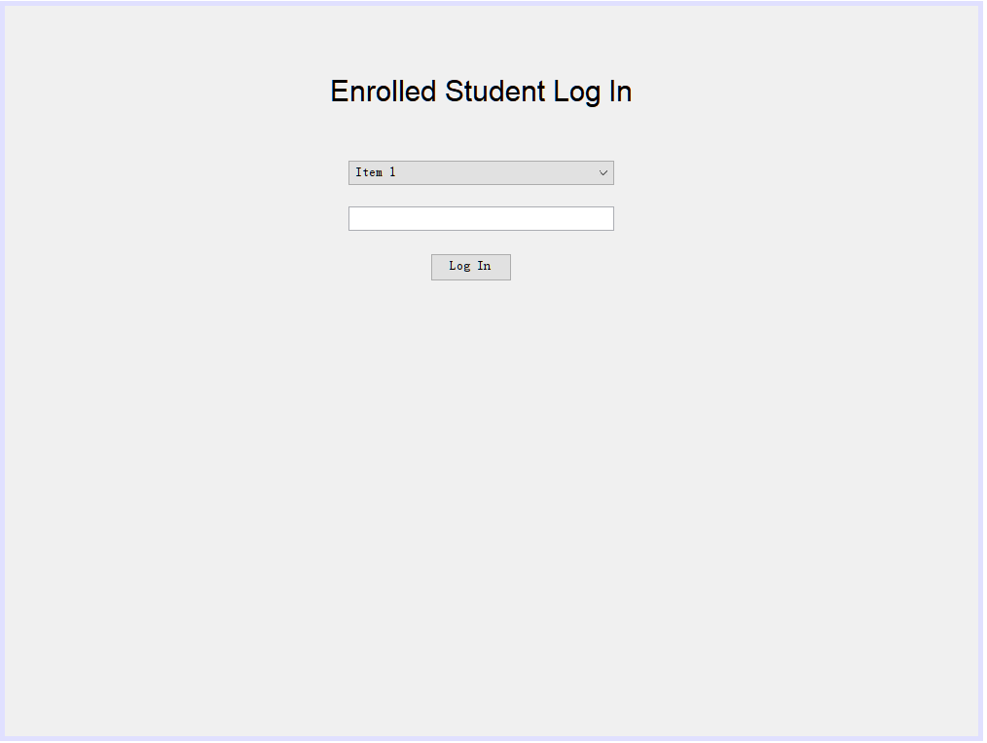

Figure 3-2 Enrolled Student Login Interface

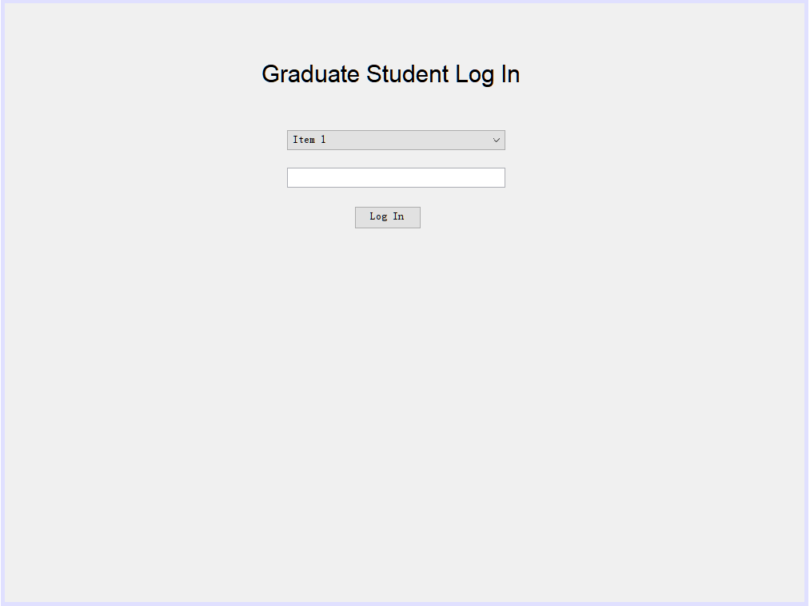

Figure 3-3 Graduate Student Login Interface

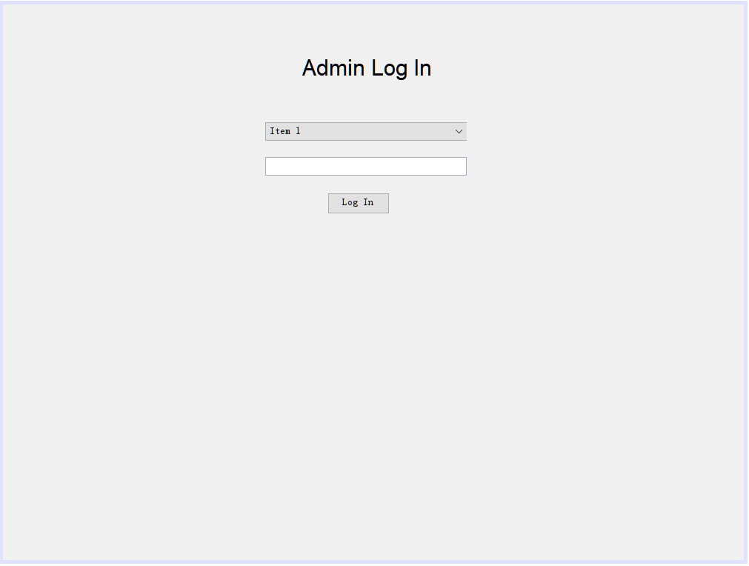

Figure 3-4 Administrators Login Interface

Users first select courses on the student interface, click the evaluation button to enter the evaluation interface, and then evaluate the selected courses and enter the evaluation control class. To complete the evaluation, click the evaluation button to return the information to the course entity class. Finally return a successful interface to the user.

**Administrator Function**

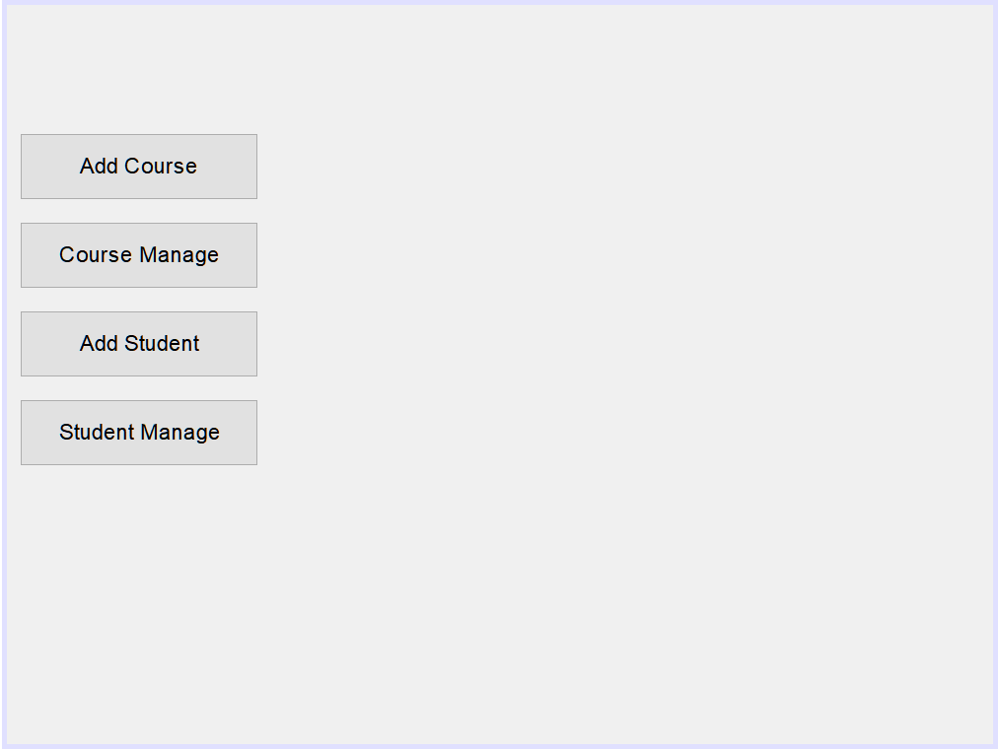

Figure 4-1 Administrators Control System Interface

After logging in successfully, administrators can add courses and students, and at the same time can see how many courses have been registered in the system and the specific information of each students.

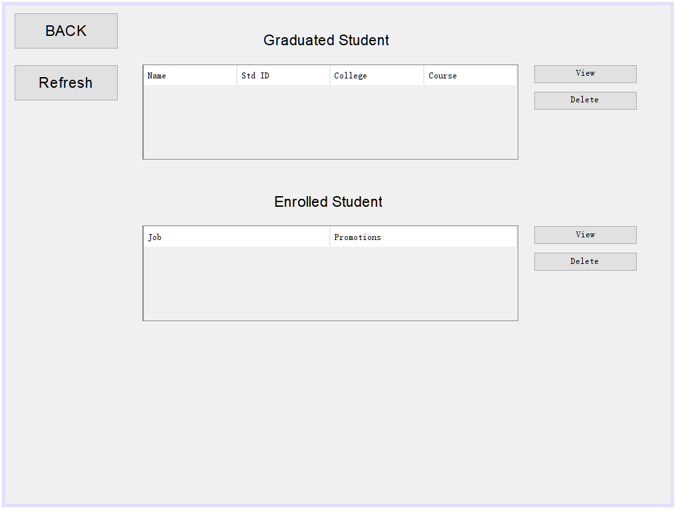

Figure 4-2 Student Management System Interface

In the student management interface, administrators can View the specific information of each student through Table, View and modify the student information, or delete the student information

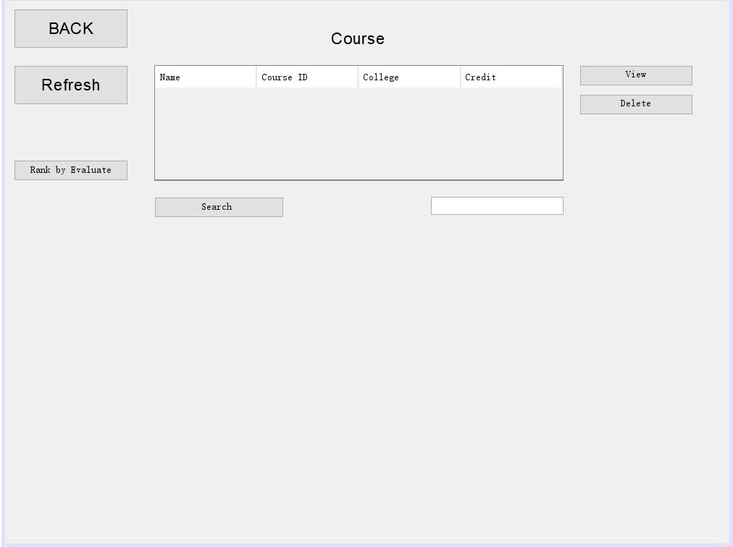

Figure 4-3 Course Management System Interface

In the course management interface, administrators can view the specific information of each course through Table, View and modify the course information, or delete the course information

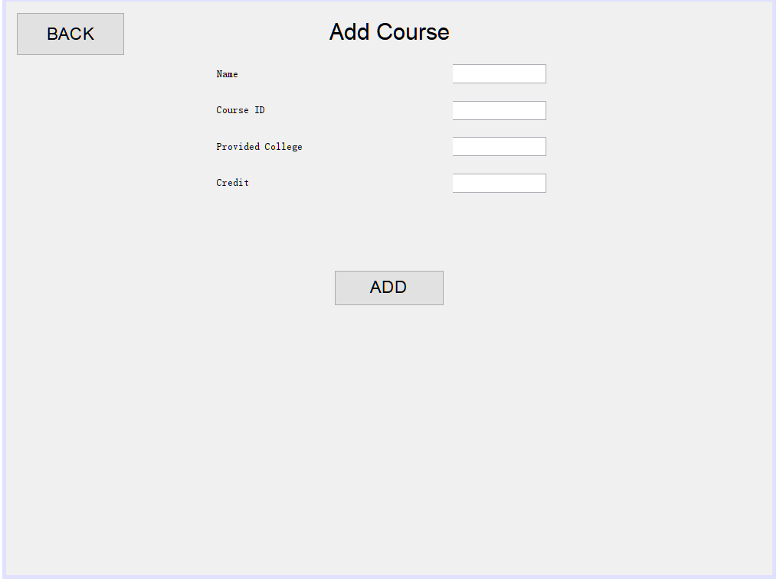

Figure 4-4 Course Detail System Interface

Administrators can add new courses for students to choose from.

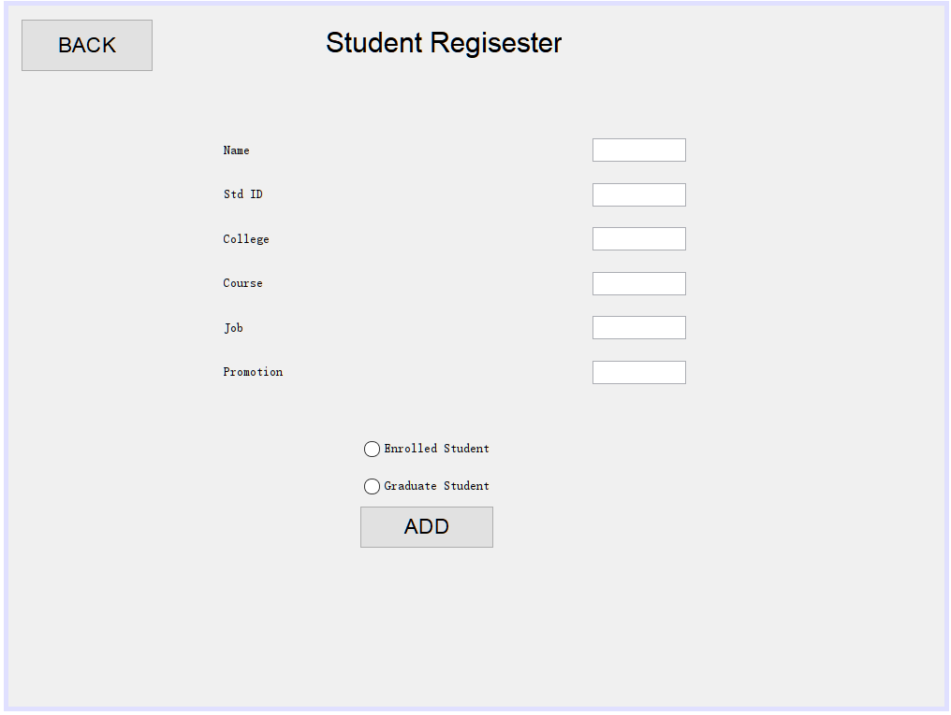

Figure 4-5 Student Regisester System Interface

Administrators can register students, and students can only get their own account through the administrator, students can not register themselves. At the same time, administrators can choose whether students graduate or not, thus giving different students different functions.

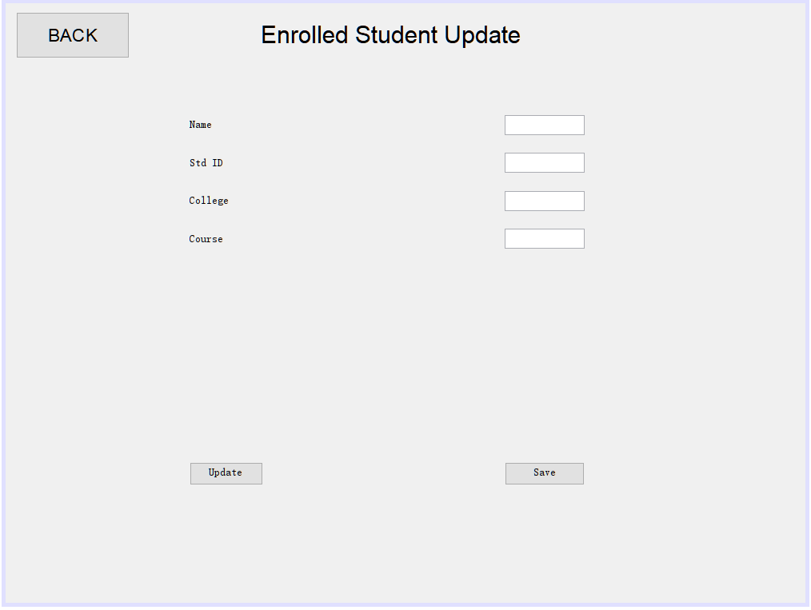

Figure 4-6 Enrolled Student Detail Interface

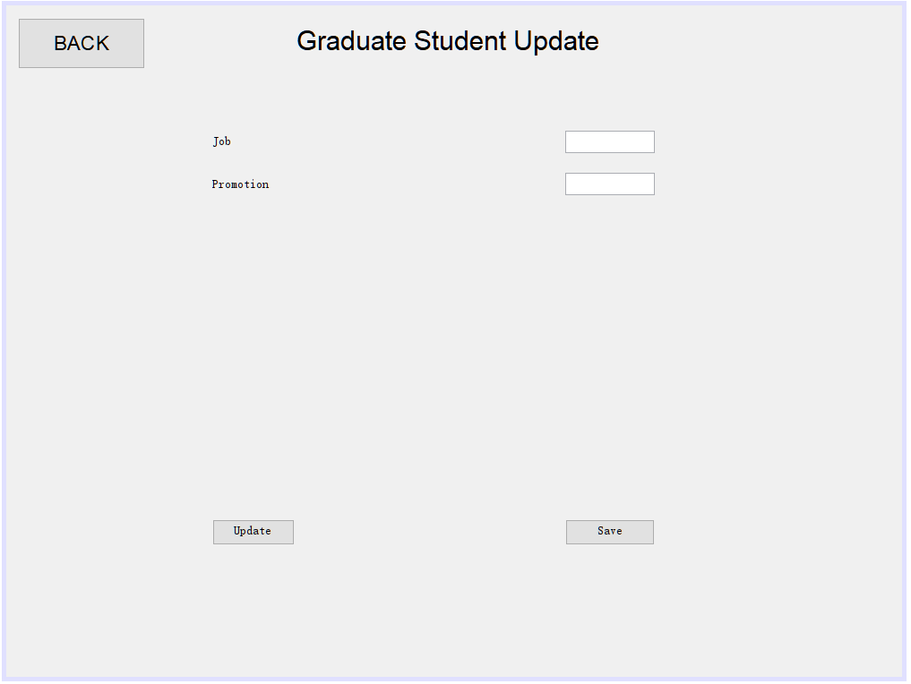

Figure 4-7 Graduate Student Detail Interface

The two kinds of data that students can update are different, so they are divided into two interfaces.

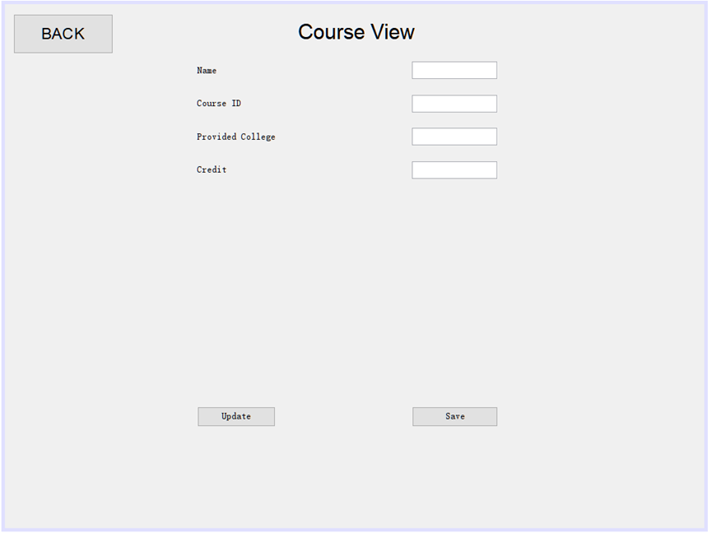

Figure 4-8 Course Detail Interface

Administrators can modify and save the specific information of the course.

**Enrolled Student Function**

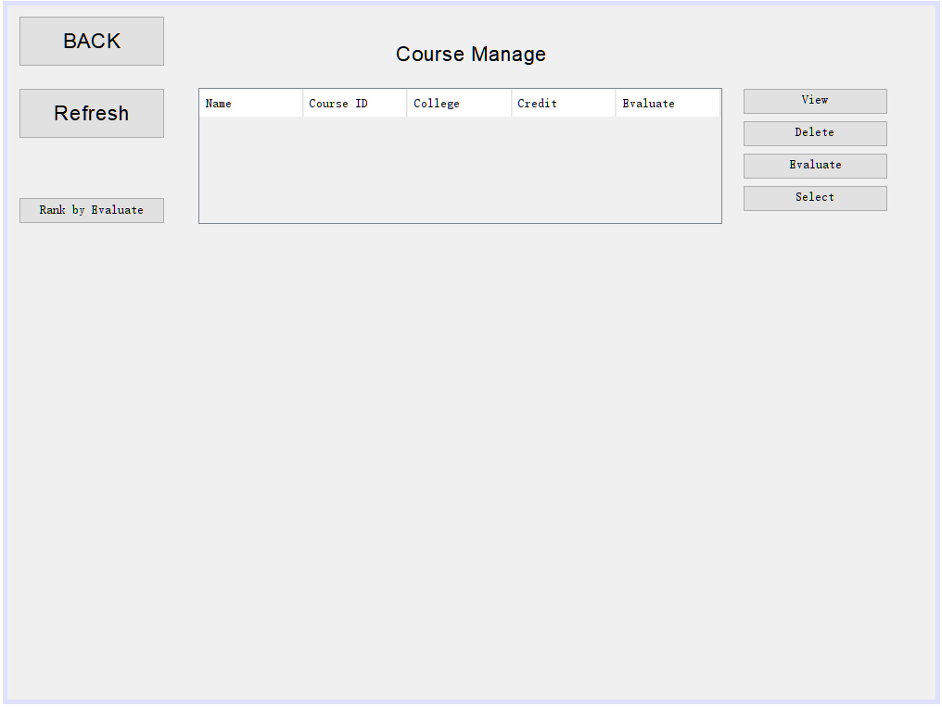

Figure 5-1 Enrolled Student Control Interface

Once students have successfully logged in, they can see all the course information in this interface. Students can use the button function to select courses, delete selected courses, evaluate courses, view course information and sort the course by evaluation point.

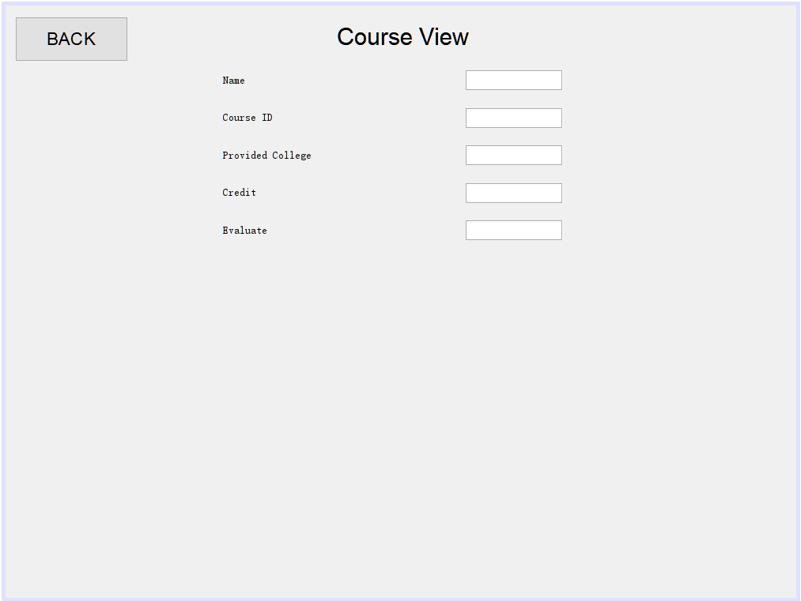

Figure 5-2 Enrolled Student View Course Interface

In this screen students can view the course introduction and other specific information.

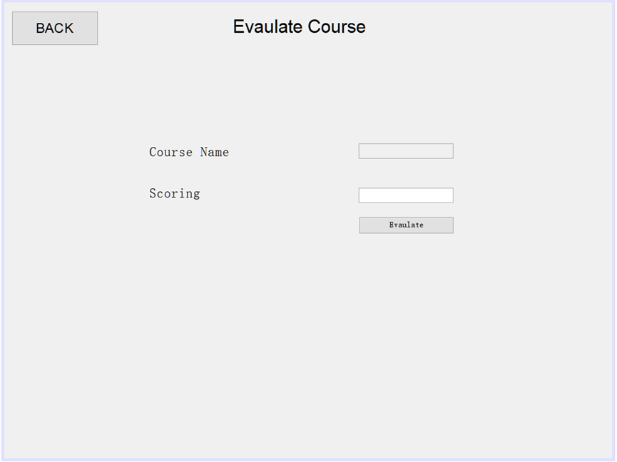

Figure 5-3 Enrolled Student Evaluation Interface

Students can evaluate the course in this interface, and the evaluation is presented temporarily in the form of scores.

**Graduate Student Function**

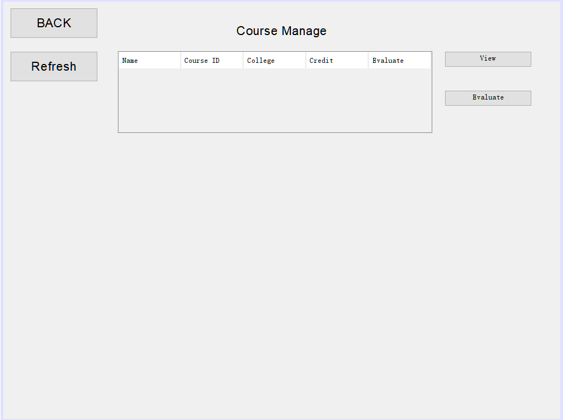

Figure 6-1 Graduate Student Control Interface

Once students have successfully logged in, they can see all the course information in this interface. Students can use the button function to evaluate courses and view course information. Because students have already graduated, they cannot select courses and delete courses they have already selected



Figure 6-2 Graduate Student Evaluation Interface

Students can evaluate the course in this interface, and the evaluation is presented temporarily in the form of scores.