Task3: Parallel Programming Skills

(5p) Define the following: Task, Pipelining, Shared Memory, Communications, Synchronization. (in your own words

* A task is a set of instructions that are executed by the processor and parallel program consists of many tasks.
* Pipelining is allowing multiple instructions to be processed at the same time.
* Shared Memory is a form of memory where all processors have direct access to a shared physical memory and parallel tasks can directly access that same logical memory.
* Communications is a form of data exchange between parallel tasks.
* synchronization is a point where a task may not proceed further until another task reaches that same point.

(8p) Classify parallel computers based on Flynn's taxonomy. Briefly describe every one of them

* Single Instruction, Single Data (SISD): executes exactly one instruction stream at a time
* Single Instruction, Multiple Data (SIMD): is an ISA that have a single CU and more than one PU, and it executes a single instruction stream over PU handled through the CU.
* Multiple Instruction, Single Data (MISD): is an ISA for parallel computing where multiple functional units execute different operations on the same data set.
* Multiple Instruction, Multiple Data (MIMD): is an ISA for parallel computing that is ideal for computers with multiprocessors and each processor may be executing a different instruction stream.

7p) What are the Parallel Programming Models?

* Shared Memory, Threads, Distributed Memory, Data Parallel, Hybrid, Single Program Multiple Data (SPMD), Multiple Program Multiple Data (MPMD)

(12p) List and briefly describe the types of Parallel Computer Memory Architectures. What type is used by OpenMP and why?

* General Characteristics: multiple processors that can run separately but share the same memory and all the processors have access to the memory as global address space.
* Uniform Memory Access (UMA): identical processors that have equal access times to memory and if you update a location in shared memory, all other processors know about the update.
* Non-Uniform Memory Access (NUMA): SMPs are linked, and SMP can directly access the memory of another SMP.
* Uniform Memory Access uses OpenMP because OpenMP targets shared-memory architectures.

(10p) Compare Shared Memory Model with Threads Model? (in your own words and show pictures)

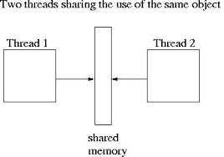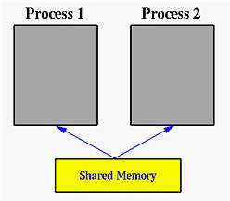

* Shared Memory is the simplest parallel programming model, and tasks share a common address space, without threads Model it's hard to manage data locality.

5p) What is Parallel Programming? (in your own words)

* Parallel Programming Is using multiple computing resources to solve problem concurrently.

(5p) What is system on chip (SoC)? Does Raspberry PI use system on SoC?

- SoC integrates all the components into a single chip.

- Yes, Raspberry PI uses system on SoC.

(5p) Explain what the advantages are of having a System on a Chip rather than separate CPU, GPU and RAM components

* System on a chip consumes less power and costs less. Also, System on a chip is small and lightweight compared to having separate CPU and RAM.