A Pirate Game

# Controls

|  |  |  |
| --- | --- | --- |
| **Key** | **Action** | **Notes** |
| W | Accelerates player |  |
| A | Turns player left | Can only turn when moving forward! (like a boat) |
| S | Decelerates player |  |
| D | Turns player right | Can only turn when moving forward! (like a boat) |
| Q | Opens Map (zoom) | As per documentation. |
| E | Go into the department shop and minigame | When the player near the department, he/she can go into the department shop. |
| SPACE | Pause the game |  |
| Left Mouse | Fires projectile | Firing projectiles subject to cooldown |

Current Game Objective

As questing is not implemented, the only objective in the game is to capture the 5 colleges on the map. A college is captured when it’s boss is defeated in combat. When a college has been captured, NPC boats that spawn there will not be hostile towards the player. The game end when the player defeats the last college, Derwent, but for that you need to defeat all other colleges first.

The players can upgrade their ship in departments.

In the computer science department, the player can buy triple shot and increase the bullet damage.

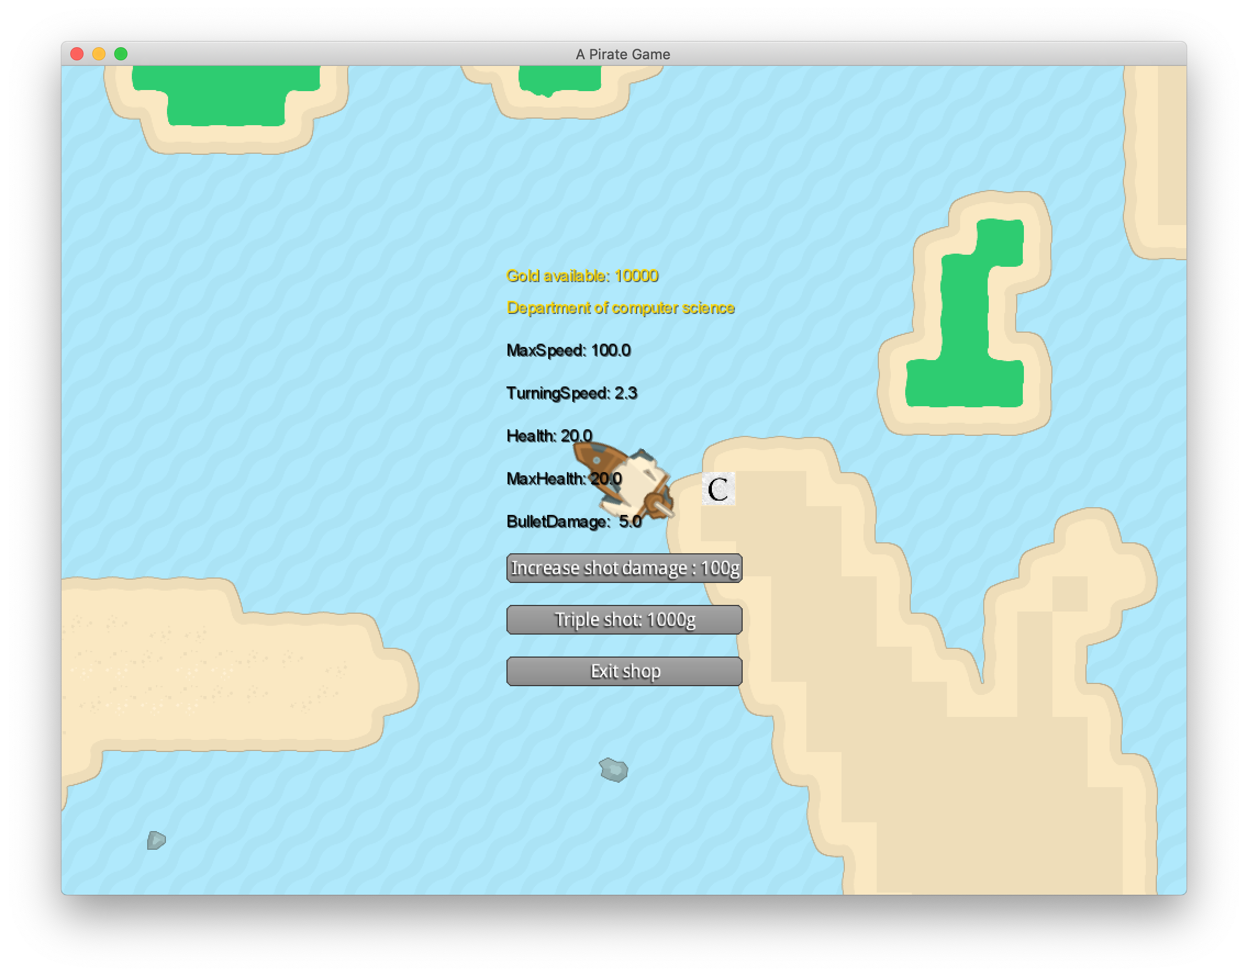

In the physics department, the player can use the gold to update the max speed, turning speed and acceleration.

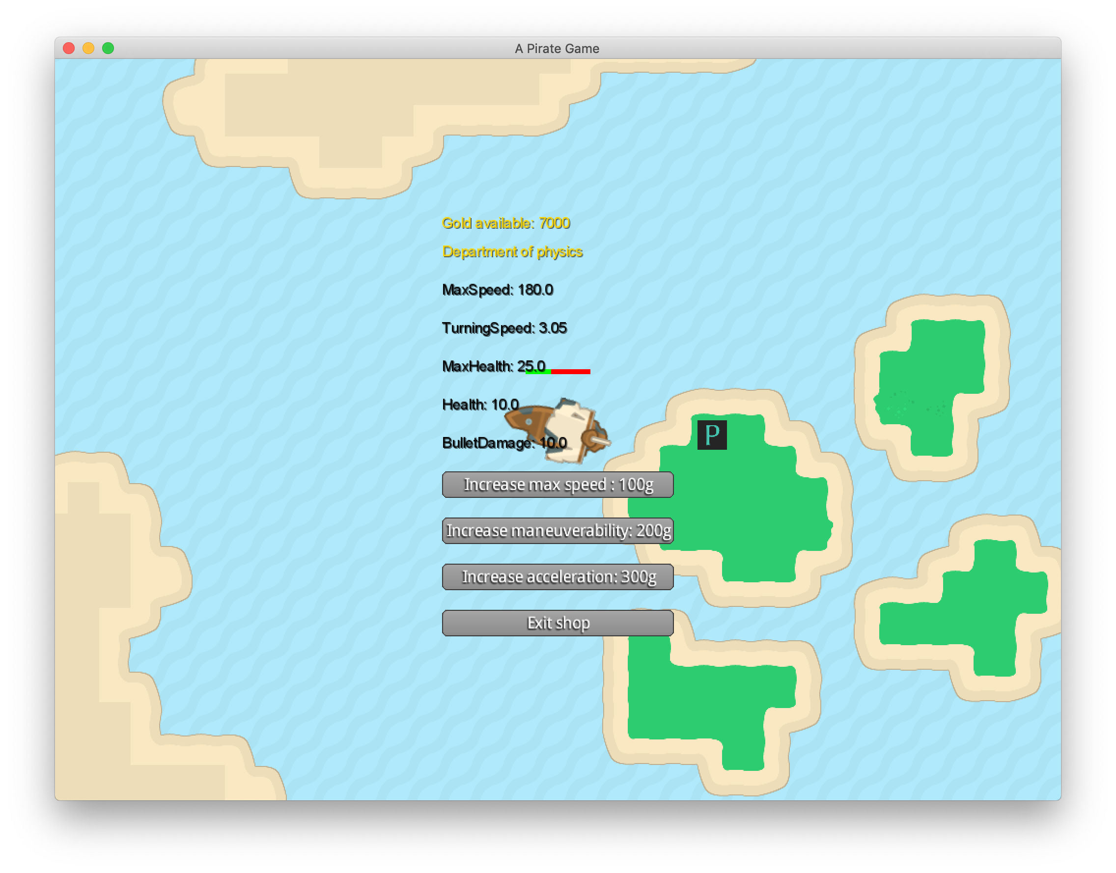

In the biology department, the player can get full heal and boost max health.

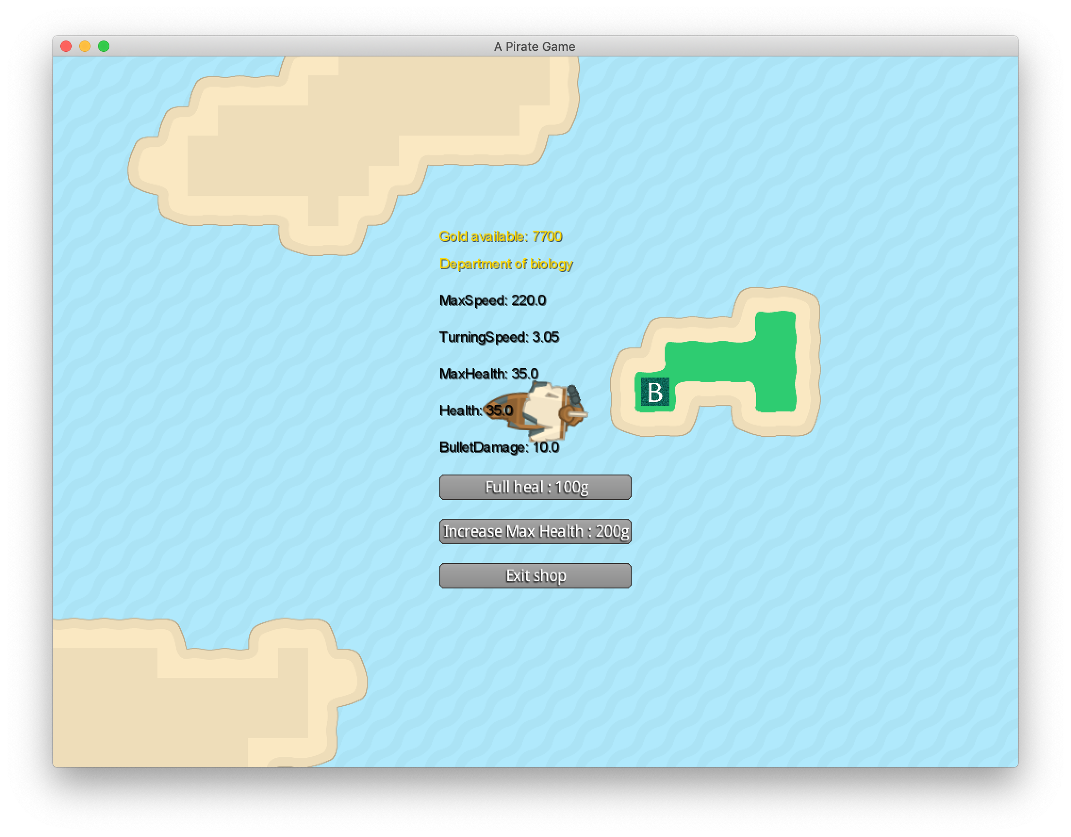

You can play the minigame when near the minigame area.

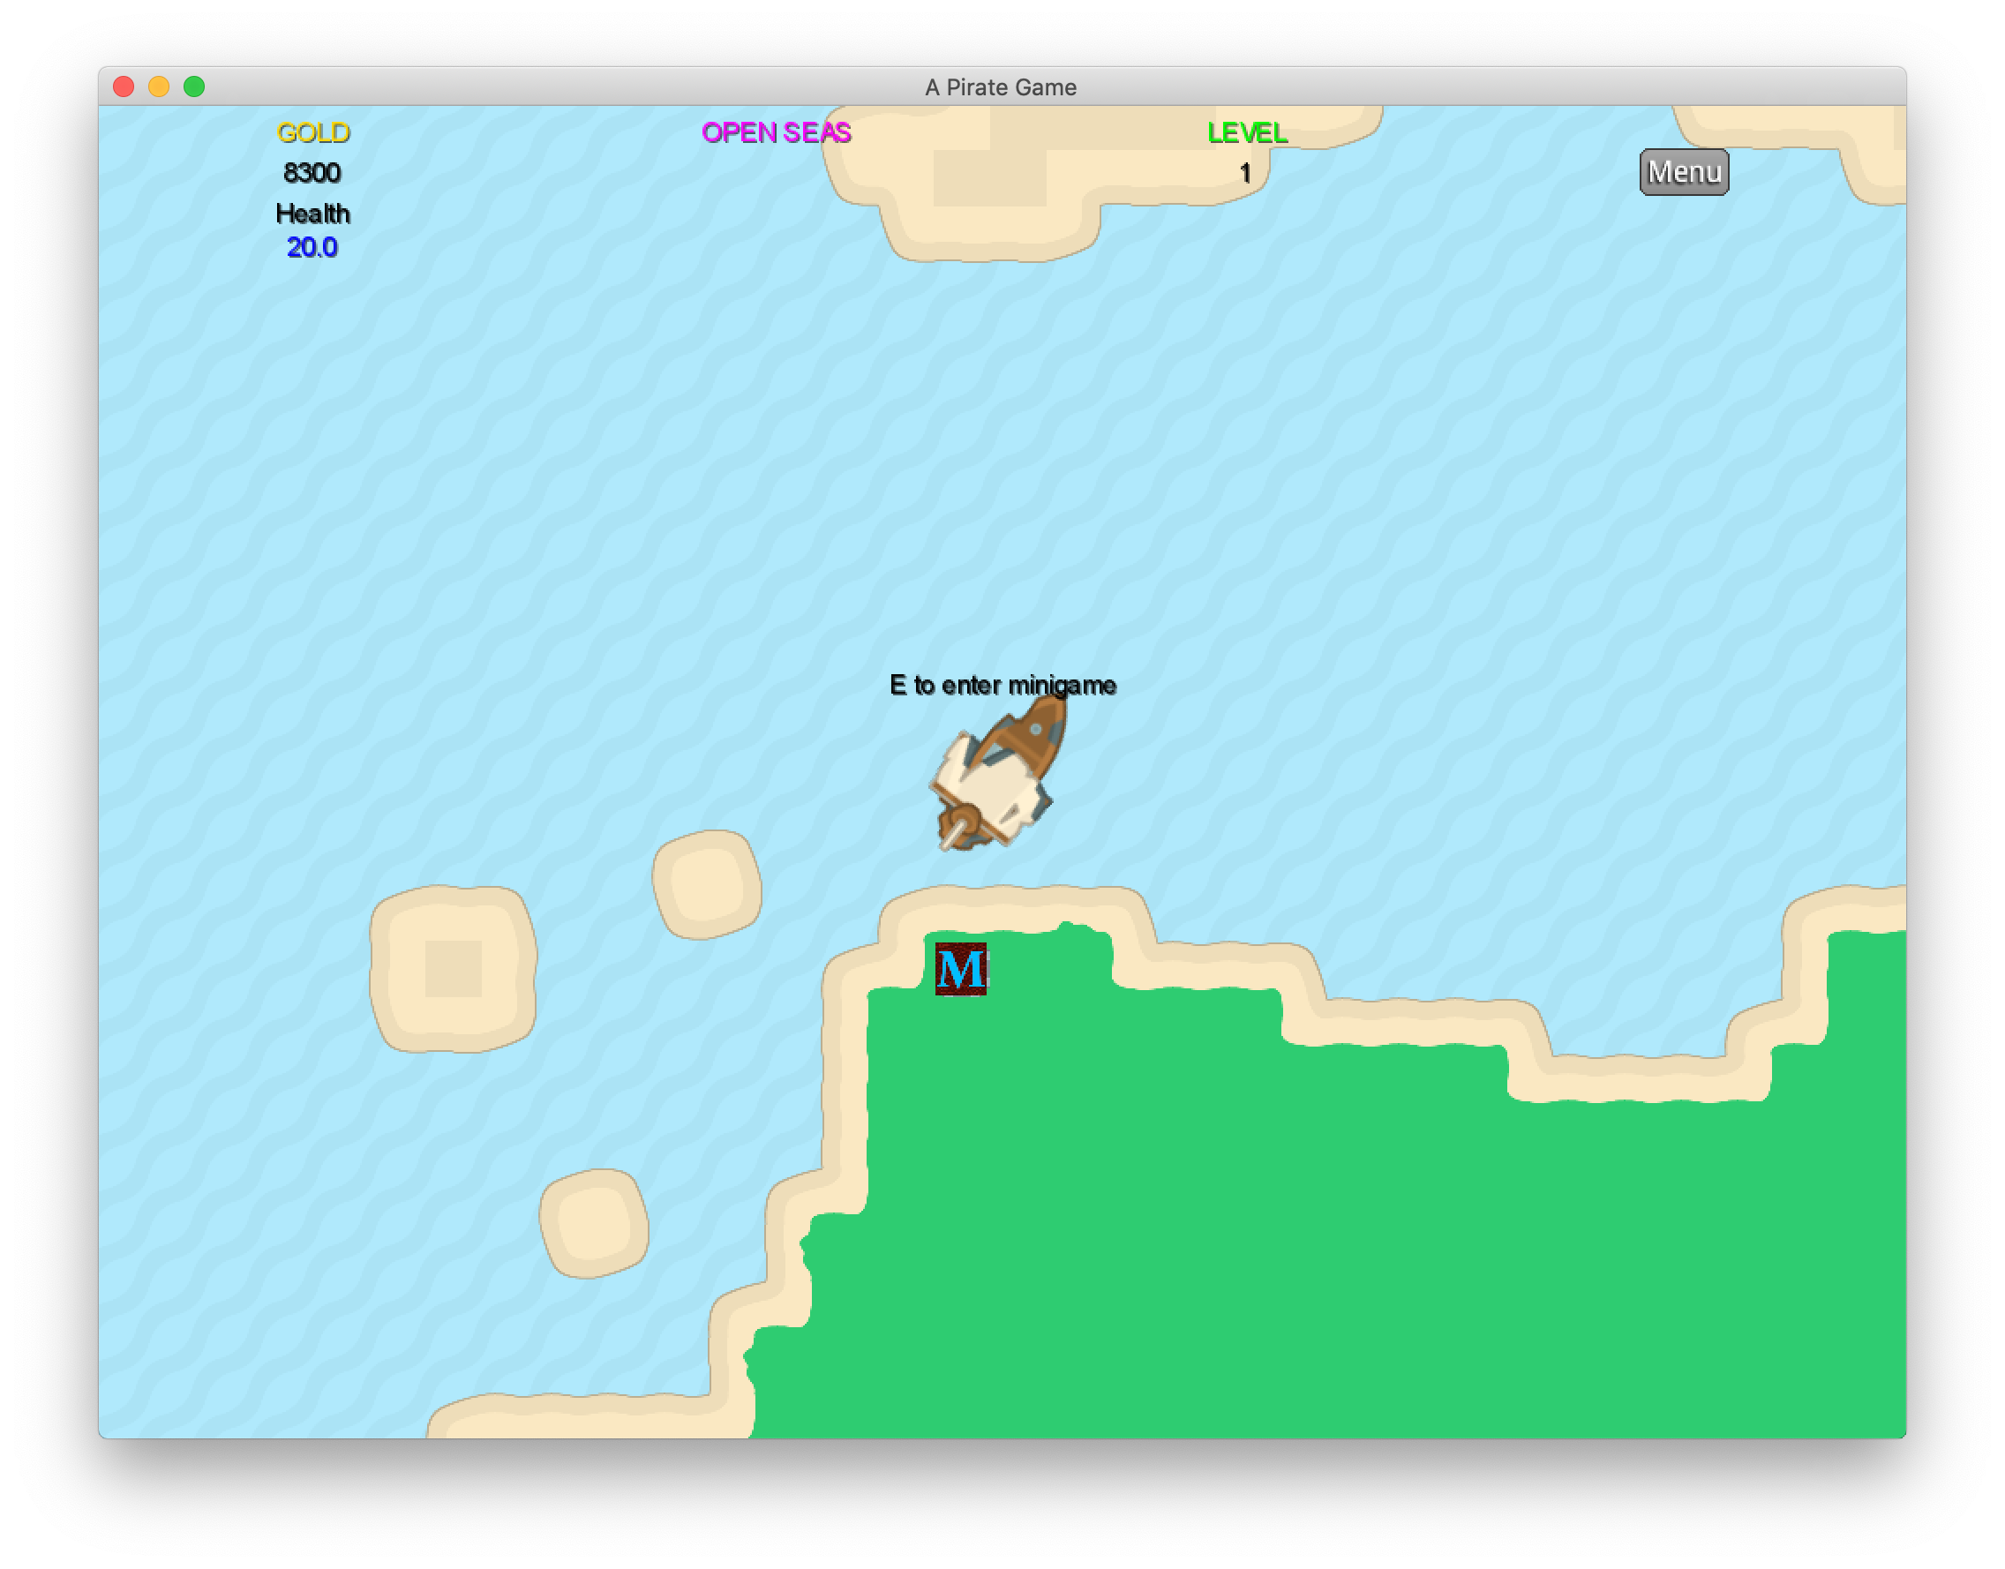

# Gameplay Notes

There is also a xp/levelling feature. You can gain xp by defeating enemies in combat. The base xp received is 10 per enemy and increases with the difficulty of the enemy. Your level increases as you gain more XP. Starting at level 1, the xp required for the next level increased by 100. For example, level 4 costs 60 total xp! Each level grants you a boost to max speed, max health and projectile damage.