Team iPatch Game - User Manual

You have taken on the quest of liberating the University of York from the tyrannical hands of the colleges. To do so you command a ship equipped with the latest shooting technology. Here is how you complete your quest:
Controls
Key | Action
W | Move forward
A | Turn left
S | Decelerate
D | Turn right
Left click | Fire projectile towards mouse (hold for automatic fire)
J | Show remaining colleges

As you travel the world, you will have to fight off enemy ships. They do not have the same cannon technology as you do, but they will try their best to sink your ship by crashing into it. If you shoot them down, you will collect loot from them in the form of gold, as well as gain points.

Throughout the map you will encounter departments and colleges

Colleges are equipped with heavy artillery, and will start firing from all cannons as soon as you engage them.
Whenever you defeat a college their commander will join you as a crew member, granting you increased shot count.
Be careful! The more colleges you defeat, the stronger they get.
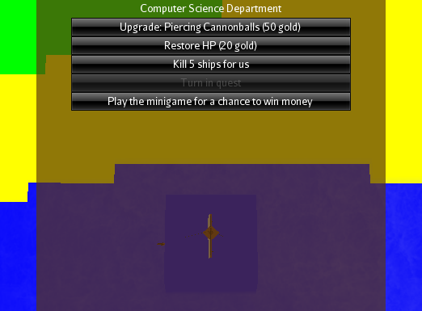
At departments you can spend your hard-earned gold by purchasing upgrades to your ship.
Every department has a different upgrade avaliable, but they will all provide repair services and quests to fulfill, as well as a fun minigame to play!

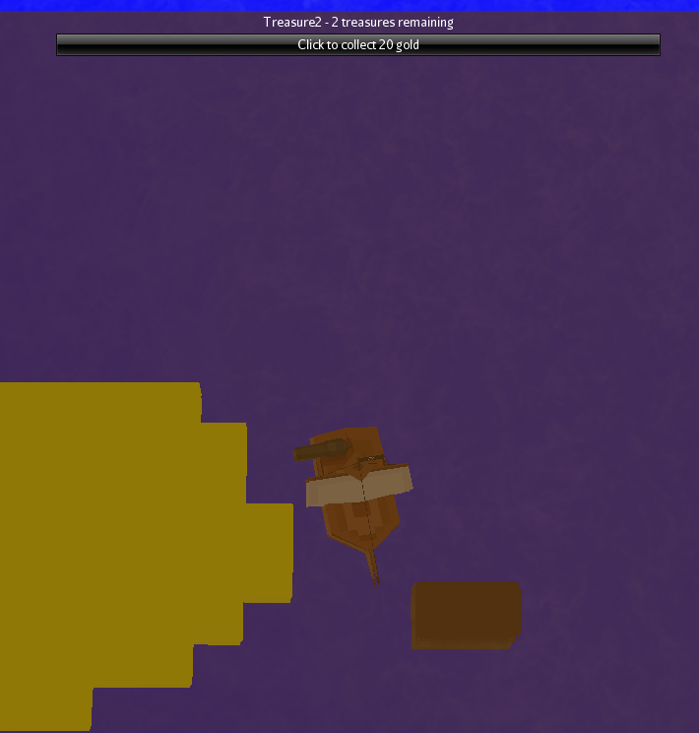
Spread around the map you will also find treasure. Sail up to it to collect it and gain a nice reward.

Watch out for whirlpools and bad weather. They will hinder your progress and make it difficult to complete your quest.
ENJOY THE GAME!

