SOFTWARE REQUIREMENTS SPECIFICATION (SRS)

Project: Hospital Management System

Version: 1.0

Authors:
VANISHREE, NISARGA, PARNIKA, SHLOKA
SECTION K

Date: 12-09-2026

Status: Draft

REVISION HISTORY

Version Date Author Change Summary
1.0 12-09-2026 TEAM 13 Initial SRS doc

Role | Name | Signature / Email | Date
Course Coordinator | Dhiroj Kumar Behera | __________________________
Project Team | TEAM 13 | TEAM 13 | SEP 13TH 2026

1. Introduction
1.1 Purpose
1.2 Scope
1.3 Audience
1.4 Definitions
2. Overall Description
2.1 Product Perspective
2.2 Major Product Functions
2.3 User Roles and Characteristics
2.4 Operating Environment
2.5 Constraints
3. External Interface Requirements
3.1 User Interfaces
3.2 Hardware Interfaces
3.3 Software Interfaces
3.4 Communications
4. System Features
4.1 User Authentication
4.2 Patient Management
4.3 Doctor Management
4.4 Appointment Management
4.5 Medical Records
4.6 Prescription Management
4.7 Billing and Payments
4.8 Reports and Notifications
5. Non-functional Requirements
5.1 Non-functional Requirements
5.2 Security
5.2.1 Security Objectives
5.2.2 Security Requirements
5.3 Summary
6. Quality Attributes & Acceptance Tests
7. UML Use-Case Diagrams
7.1 Patient and Doctor Use-Case Diagram
7.2 Receptionist, Pharmacist and Administrator Use-Case Diagram
8. Requirements Traceability Matrix (RTM)

1. Introduction
1.1 Purpose
This document is a Software Requirements Specification (SRS) for the Hospital Management System. It defines the functional and non-functional requirements, external interfaces, security requirements, and verification criteria of the system. The document is intended to provide a clear reference for developers, testers, hospital staff, administrators, and project evaluators.
1.2 Scope
The Hospital Management System provides computerized management of hospital operations including patient registration, doctor management, appointment scheduling, medical records, prescriptions, billing, payments, and notifications. The system allows authorized hospital staff and doctors to access and manage information according to their roles.
The system does not include the internal implementation of external payment gateways, external laboratory systems, or external insurance systems beyond their required interfaces.
1.3 Audience
The intended audience includes software developers, QA engineers, doctors, nurses, receptionists, pharmacists, hospital administrators, system administrators, and project evaluators.
1.4 Definitions
HMS – Hospital Management System
Patient – A person receiving medical services from the hospital.
Doctor – A medical professional who provides consultation, diagnosis, and treatment.
Administrator – An authorized user responsible for managing hospital users, departments, and system configuration.
Receptionist – A hospital staff member responsible for patient registration, appointment scheduling, and billing-related activities.
Pharmacist – A hospital staff member responsible for managing prescriptions and dispensing medicines.
Appointment – A scheduled consultation between a patient and a doctor.
EMR – Electronic Medical Record.
UI – User Interface.
API – Application Programming Interface.

2. Overall Description
2.1 Product Perspective
The Hospital Management System is a centralized software system used to manage hospital activities and patient information. It provides interfaces for patients, doctors, receptionists, pharmacists, and administrators. The system stores patient records, appointments, prescriptions, billing information, and other operational data in a centralized database.
2.2 Major Product Functions
The major functions of the Hospital Management System include user registration and authentication, patient registration and profile management, doctor profile and availability management, appointment scheduling and cancellation, patient medical record management, diagnosis and treatment recording, prescription management, billing and payment management, appointment notifications and reminders, and report generation.
2.3 User Roles and Characteristics
Patient: Can register, manage personal information, book appointments, view medical records, prescriptions, bills, and receive notifications.
Doctor: Can view scheduled appointments, access authorized patient medical records, record diagnosis and treatment details, and create prescriptions.
Receptionist: Can register patients, schedule appointments, manage basic patient information, and generate bills.
Pharmacist: Can view prescriptions, manage medicine availability, and update medicine dispensing records.
Administrator: Can manage users, doctors, hospital departments, system configuration, and generate reports.
System Administrator: Responsible for system maintenance, security, backups, monitoring, and technical administration.
2.4 Operating Environment
The system shall operate on hospital computers, laptops, tablets, or other supported devices using a modern web browser or supported application interface. The system shall use a centralized database server and a secure hospital network or Internet connection. The system shall support the operating systems, database management systems, and software platforms required for deployment.
2.5 Constraints
The system shall restrict access to patient medical information to authorized users. The system shall implement role-based access control. Personal and medical data shall be protected during storage and transmission. The system shall comply with applicable healthcare data protection and privacy requirements. The system shall depend on the availability of the hospital network and database server. External payment, laboratory, insurance, SMS, or email services may require third-party APIs.
3. External Interface Requirements
3.1 User Interfaces
The Hospital Management System shall provide a clear and user-friendly interface for patients, doctors, receptionists, pharmacists, and administrators. Each user shall be provided with a role-specific dashboard and access to functions permitted for that role. Forms shall provide validation messages for incorrect, incomplete, or invalid data. The interface shall allow users to easily navigate between patient records, appointments, prescriptions, billing, and other relevant functions.
3.2 Hardware Interfaces
The system shall support desktop computers, laptops, tablets, and other supported devices used by hospital staff. The system may interface with printers for printing bills, prescriptions, and reports. Barcode or QR-code scanners may be supported for patient identification, medicine management, or other applicable hospital operations.
3.3 Software Interfaces
The system shall interface with a centralized database for storing and retrieving hospital information. It may integrate with external payment gateway APIs for processing payments and SMS or email services for sending notifications. The system may also integrate with laboratory, pharmacy, or insurance systems through appropriate APIs where required.
3.4 Communications
HTTPS using TLS 1.2 or higher shall be used for secure transmission of sensitive information between clients and the Hospital Management System.

4. System Features

4.1 User Authentication
Description: Authenticate users and enforce role-based access to protected system functions.
Req ID | Requirement | Type | Priority | Source/Stakeholder | Acceptance Criteria / Test Case Ref | Comments / Dependencies
HMS-F-001 | The system shall authenticate users using a valid username or email and password. | Functional | High | Security / Hospital Administrator | Valid credentials create an authenticated session. TC-Auth-01 | Requires user account store and authentication service.
HMS-F-002 | The system shall provide role-based access for patients, doctors, receptionists, pharmacists, and administrators. | Functional | High | Security / Hospital Administrator | Users can access only functions permitted for their assigned role. TC-Auth-02 | RBAC configuration required.
HMS-F-003 | The system shall allow authenticated users to securely log out and terminate their active session. | Functional | High | Security / All Users | After logout, protected functions cannot be accessed without authentication. TC-Auth-03 | Requires session management.

4.2 Patient Management
Description: Manage patient registration, profiles, and authorized access to patient information.
Req ID | Requirement | Type | Priority | Source/Stakeholder | Acceptance Criteria / Test Case Ref | Comments / Dependencies
HMS-F-004 | The system shall allow patients or authorized receptionists to register a new patient and create a patient profile containing required personal and contact information. | Functional | High | Patient / Receptionist | A valid patient registration creates a unique patient profile. TC-Pat-01 | Requires patient database.
HMS-F-005 | The system shall allow authorized users to view and update permitted patient demographic and contact information. | Functional | High | Receptionist / Administrator / Patient | Authorized users can update permitted information and changes are saved correctly. TC-Pat-02 | Requires role-based permissions.
HMS-F-006 | The system shall allow authorized doctors and hospital staff to search for and access patient records according to their assigned permissions. | Functional | High | Doctor / Hospital Staff | Authorized users can retrieve permitted patient records while unauthorized users are denied access. TC-Pat-03 | Requires patient database and RBAC.

4.3 Doctor Management
Description: Manage doctor profiles, availability, and scheduled appointments.

Req ID | Requirement | Type | Priority | Source/Stakeholder | Acceptance Criteria / Test Case Ref | Comments / Dependencies
HMS-F-007 | The system shall allow administrators to create and manage doctor profiles, including specialization, department, and available consultation time slots. | Functional | High | Hospital Administrator | Administrator can create and update doctor information and availability. TC-Doc-01 | Requires doctor and department data.
HMS-F-008 | The system shall allow doctors to view their scheduled appointments and relevant patient information. | Functional | High | Doctor | Doctor can view upcoming appointments and permitted patient details. TC-Doc-02 | Depends on appointment and patient modules.

4.4 Appointment Management
Description: Schedule, validate, cancel, reschedule, and notify users about appointments.

Req ID | Requirement | Type | Priority | Source/Stakeholder | Acceptance Criteria / Test Case Ref | Comments / Dependencies
HMS-F-009 | The system shall allow patients or authorized receptionists to schedule an appointment with an available doctor by selecting a suitable date and time slot. | Functional | High | Patient / Receptionist / Doctor | A valid available time slot can be booked successfully. TC-Apt-01 | Requires doctor availability and patient records.
HMS-F-010 | The system shall validate doctor availability and prevent two appointments from being scheduled for the same doctor and time slot. | Functional | High | Hospital Administrator / Doctor / Receptionist | The system rejects an appointment when the selected doctor and time slot are already occupied. TC-Apt-02 | Depends on appointment database and scheduling logic.
HMS-F-011 | The system shall allow authorized users to cancel or reschedule an existing appointment according to hospital policies. | Functional | High | Patient / Receptionist / Doctor | Authorized users can cancel or reschedule appointments and the updated status is stored correctly. TC-Apt-03 | Requires appointment status management.
HMS-F-012 | The system shall send appointment confirmation and reminder notifications to patients. | Functional | Medium | Patient / Hospital Administration | Confirmation and reminder notifications are generated for scheduled appointments. TC-Apt-04 | Requires notification service such as email or SMS.

4.5 Medical Records
Description: Maintain patient medical records, diagnosis, treatment details, and authorized access to historical records.

Req ID | Requirement | Type | Priority | Source/Stakeholder | Acceptance Criteria / Test Case Ref | Comments / Dependencies
HMS-F-013 | The system shall allow authorized doctors to create and update patient medical records after a consultation. | Functional | High | Doctor / Hospital Administration | Doctor can create or update a patient's medical record and the information is stored successfully. TC-Med-01 | Requires patient record database and authorization.
HMS-F-014 | The system shall allow authorized doctors to record diagnosis, treatment details, consultation notes, and other relevant clinical information. | Functional | High | Doctor | Diagnosis and treatment information entered by an authorized doctor is stored against the correct patient record. TC-Med-02 | Requires medical record module.
HMS-F-015 | The system shall allow authorized doctors and permitted hospital staff to view a patient's previous medical records according to their access permissions. | Functional | High | Doctor / Hospital Staff | Authorized users can view previous records while unauthorized users are denied access. TC-Med-03 | Requires RBAC and medical record database.

4.6 Prescription Management
Description: Create electronic prescriptions and manage medicine dispensing

Req ID | Requirement | Type | Priority | Source/Stakeholder | Acceptance Criteria / Test Case Ref | Comments / Dependencies
HMS-F-016 | The system shall allow doctors to create electronic prescriptions containing medicines, dosage, frequency, duration, and instructions. | Functional | High | Doctor | Doctor can create and save a complete prescription for a patient. TC-Pres-01 | Requires patient and medicine information.
HMS-F-017 | The system shall allow pharmacists to view prescriptions authorized for dispensing and record the medicines that have been dispensed. | Functional | High | Pharmacist | Pharmacist can view an authorized prescription and record the medicines dispensed. TC-Pres-02 | Requires prescription and medicine inventory data.

4.7 Billing and Payments
Description: Generate hospital bills and record payments against outstanding charges.

Req ID | Requirement | Type | Priority | Source/Stakeholder | Acceptance Criteria / Test Case Ref | Comments / Dependencies
HMS-F-018 | The system shall allow authorized receptionists or billing staff to generate bills for consultations, medical services, laboratory tests, medicines, and other applicable hospital charges. | Functional | High | Receptionist / Billing Staff | A bill is generated with the correct patient details, services, charges, and total amount. TC-Bill-01 | Requires patient, service, and billing data.
HMS-F-019 | The system shall allow authorized staff to record payments against generated bills and update the payment status. | Functional | High | Receptionist / Billing Staff | A valid payment updates the corresponding bill status correctly. TC-Bill-02 | Requires billing module and payment records.

4.8 Reports and Notifications
Description: Provide administrators with operational reports for monitoring and management.

Req ID | Requirement | Type | Priority | Source/Stakeholder | Acceptance Criteria / Test Case Ref | Comments / Dependencies
HMS-F-020 | The system shall allow administrators to generate reports related to patients, appointments, billing, doctors, and other hospital operations. | Functional | Medium | Hospital Administrator | Administrator can select a report type and generate a report containing the relevant hospital data. TC-Rep-01 | Requires access to relevant hospital databases.

5. Non-functional Requirements (Detailed)
NFRs below are measurable and tied to test plans. IDs follow HMS-NF-###.

5.1 Non-functional Requirements

Req ID | Requirement | Category | Priority | Acceptance Criteria / Measurement
HMS-NF-001 | The system shall provide a response time of 3 seconds or less for at least 90% of transactions under normal operating load. | Performance | High | At least 90% of transactions complete within 3 seconds during production-like load testing. TC-Perf-01
HMS-NF-002 | The system shall provide at least 99.5% monthly availability, excluding scheduled maintenance. | Reliability | High | Monthly system uptime shall be at least 99.5%. TC-Rel-01
HMS-NF-003 | The system shall protect sensitive patient and user information and shall encrypt sensitive information during transmission. | Security / Compliance | High | Secure encrypted connections are used and unauthorized access attempts are rejected. TC-Sec-01
HMS-NF-004 | The system shall maintain data consistency and prevent loss or corruption of patient, appointment, medical, prescription, and billing records. | Data Integrity / Reliability | High | Records remain consistent after normal operations, failed transactions, and system recovery. TC-Data-01
HMS-NF-005 | The system shall provide a clear and consistent user interface that allows common hospital tasks to be completed with minimal training. | Usability / Accessibility | Medium | Representative users can complete common tasks with minimal training and without critical usability issues. TC-UX-01

5.2 Security

5.2.1 Security Objectives

Objective ID | Security Objective | Priority | Test Case
SO-001 | Confidentiality: The system shall protect patient personal and medical information from unauthorized access or disclosure. | High | TC-SEC-01
SO-002 | Integrity: The system shall prevent unauthorized modification or deletion of patient, medical, appointment, prescription, and billing information. | High | TC-SEC-02
SO-003 | Availability: The system shall ensure that authorized hospital users can access required system services and records when needed. | High | TC-SEC-03

5.2.2 Security Requirements

Req ID | Security Requirement | Category | Priority | Acceptance Criteria / Test Case Ref
HMS-SR-001 | The system shall enforce role-based access control for patients, doctors, receptionists, pharmacists, administrators, and system administrators. | Security | High | Users can access only functions permitted for their assigned role. TC-Sec-04
HMS-SR-002 | The system shall use TLS 1.2 or higher for transmitting sensitive information between clients and servers. | Security | High | Sensitive information is transmitted only through an approved secure connection. TC-Sec-05
HMS-SR-003 | The system shall store user passwords using strong one-way hashing and shall never store passwords in plain text. | Security | High | Password storage is verified to use secure one-way hashing. TC-Sec-06
HMS-SR-004 | The system shall maintain audit logs for authentication events, patient record modifications, billing changes, prescription changes, and administrative actions. | Security | High | Required security-sensitive actions are recorded in audit logs. TC-Sec-07
HMS-SR-005 | The system shall automatically terminate or lock inactive user sessions after a configured period of inactivity. | Security | High | An inactive session is automatically terminated or locked after the configured timeout. TC-Sec-08

5.3 Summary
The Hospital Management System defines functional, non-functional, and security requirements to ensure that hospital operations are managed efficiently and securely. The requirements cover user authentication, patient and doctor management, appointment scheduling, medical records, prescriptions, billing, payments, reports, and notifications.
The non-functional requirements specify measurable expectations for system performance, reliability, security, data integrity, and usability. The security objectives and security requirements ensure confidentiality, integrity, and availability of hospital and patient information through role-based access control, secure communication, password protection, audit logging, and session management.
These requirements provide the basis for system development, testing, security verification, and acceptance of the Hospital Management System.

6. Quality Attributes & Acceptance Tests

6.1 Quality Attributes
The Hospital Management System shall provide reliable, secure, usable, maintainable, and performant services to its authorized users.
The system shall satisfy the following quality attributes:
- Performance: The system should respond to user requests within the specified response-time requirements under normal operating conditions.
- Reliability: The system should remain available and operate consistently with minimal downtime.
- Security: Patient, medical, billing, prescription, and user information shall be protected from unauthorized access and modification.
- Data Integrity: The system shall maintain accurate and consistent hospital records and prevent data loss or corruption.
- Usability: The system shall provide a clear and consistent interface that allows hospital staff and patients to perform common tasks with minimal training.
- Maintainability: The system should be structured so that authorized technical staff can maintain, update, and troubleshoot the system efficiently.

6.2 Acceptance Criteria
The Hospital Management System shall be considered acceptable when:
- All specified functional requirements have been implemented and verified.
- All specified non-functional requirements have been tested against their defined measurements.
- All specified security requirements have passed their corresponding security tests.
- Patient, appointment, medical, prescription, and billing data are stored and retrieved correctly.
- Role-based access control correctly restricts users to their permitted functions.
- No critical defects remain unresolved at the time of acceptance.
- Each requirement can be traced to a corresponding test case through the Requirements Traceability Matrix (RTM).

6.3 Acceptance Test Suites

Test Suite ID | Test Suite | Purpose
TC-AUTH | Authentication and Authorization Tests | Verify user login, logout, authentication, and role-based access control.
TC-PAT | Patient Management Tests | Verify patient registration, profile management, and patient record access.
TC-DOC | Doctor Management Tests | Verify doctor profile, availability, and appointment-related functions.
TC-APT | Appointment Management Tests | Verify appointment scheduling, availability validation, cancellation, rescheduling, and notifications.
TC-MED | Medical Record Tests | Verify creation, modification, and authorized viewing of medical records.
TC-PRES | Prescription Tests | Verify prescription creation and medicine dispensing functions.
TC-BILL | Billing and Payment Tests | Verify bill generation, payment recording, and payment status updates.
TC-PERF | Performance Tests | Verify system response time and performance under normal load.
TC-SEC | Security Tests | Verify confidentiality, integrity, access control, secure communication, password protection, audit logging, and session security.
TC-UX | Usability Tests | Verify that representative users can perform common tasks with minimal training.

6.4 Acceptance Test Exit Criteria
The acceptance testing phase shall be considered complete when all specified requirements have passed their corresponding test cases, no critical defects remain unresolved, and the system satisfies the defined functional, non-functional, and security requirements.

7. UML Use-Case Diagrams

Diagram 7.1 — Patient and Doctor
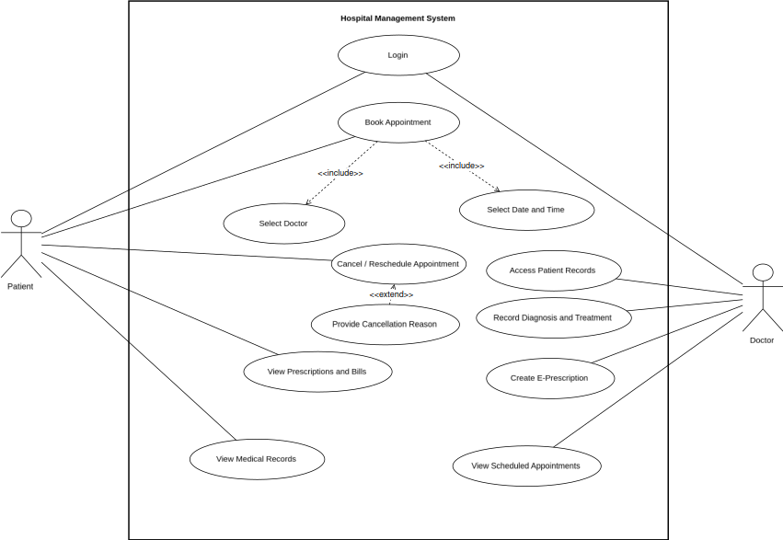
Diagram 7.2 — Receptionist, Pharmacist and Administrator
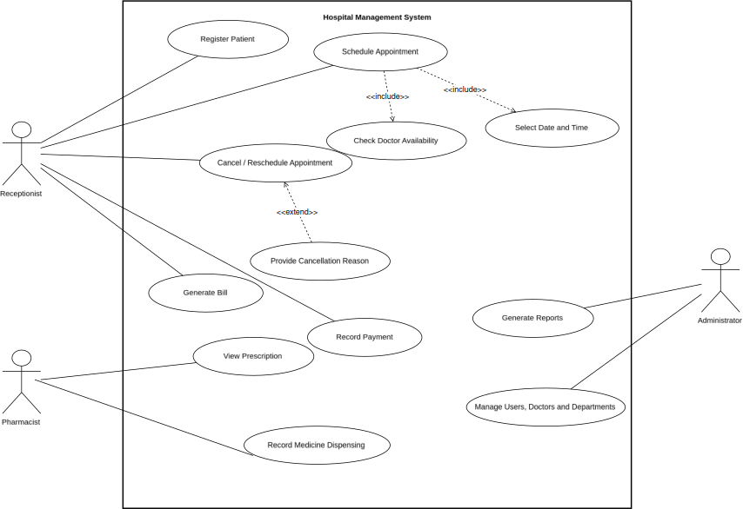
8. Requirements Traceability Matrix (RTM)
The Requirements Traceability Matrix maps each requirement to its corresponding system module and verification test case.

Req ID | Requirement Short | Section Ref / Design Spec | Module | Test Case(s) | Status (N/P/A) | Comments
HMS-F-001 | User authentication | 4.1 | Authentication | TC-Auth-01 | N | Depends on user account database.
HMS-F-002 | Role-based access | 4.1 | Authentication | TC-Auth-02 | N | Depends on role-based access configuration.
HMS-F-003 | Secure logout | 4.1 | Authentication | TC-Auth-03 | N | Requires secure session management.
HMS-F-004 | Patient registration | 4.2 | Patient Management | TC-Pat-01 | N | Requires patient database.
HMS-F-005 | Patient profile management | 4.2 | Patient Management | TC-Pat-02 | N | Access depends on assigned user role.
HMS-F-006 | Patient record access | 4.2 | Patient Management | TC-Pat-03 | N | Requires authorization and patient record access control.
HMS-F-007 | Doctor profile management | 4.3 | Doctor Management | TC-Doc-01 | N | Requires doctor and department information.
HMS-F-008 | Doctor appointment viewing | 4.3 | Doctor Management | TC-Doc-02 | N | Depends on appointment and patient modules.
HMS-F-009 | Appointment scheduling | 4.4 | Appointment Management | TC-Apt-01 | N | Requires doctor availability and patient information.
HMS-F-010 | Appointment availability validation | 4.4 | Appointment Management | TC-Apt-02 | N | Prevents conflicting appointment time slots.
HMS-F-011 | Appointment cancellation/rescheduling | 4.4 | Appointment Management | TC-Apt-03 | N | Subject to hospital appointment policies.
HMS-F-012 | Appointment notifications | 4.4 | Appointment Management | TC-Apt-04 | N | Requires email or SMS notification service.
HMS-F-013 | Medical record management | 4.5 | Medical Records | TC-Med-01 | N | Requires authorized doctor access.
HMS-F-014 | Diagnosis and treatment recording | 4.5 | Medical Records | TC-Med-02 | N | Requires medical record storage.
HMS-F-015 | Medical history access | 4.5 | Medical Records | TC-Med-03 | N | Access depends on user permissions.
HMS-F-016 | Electronic prescriptions | 4.6 | Prescription Management | TC-Pres-01 | N | Requires patient and medicine information.
HMS-F-017 | Medicine dispensing | 4.6 | Prescription Management | TC-Pres-02 | N | Requires prescription and medicine inventory data.
HMS-F-018 | Bill generation | 4.7 | Billing and Payments | TC-Bill-01 | N | Requires patient, service, and billing information.
HMS-F-019 | Payment recording | 4.7 | Billing and Payments | TC-Bill-02 | N | Requires billing and payment records.
HMS-F-020 | Hospital reports | 4.8 | Reports and Notifications | TC-Rep-01 | N | Requires access to relevant hospital data.
HMS-NF-001 | Response time | 5.1 | System | TC-Perf-01 | N | Verify under normal operating load.
HMS-NF-002 | System availability | 5.1 | System | TC-Rel-01 | N | Excludes scheduled maintenance periods.
HMS-NF-003 | Data security | 5.1 | Security | TC-Sec-01 | N | Sensitive data must use secure transmission.
HMS-NF-004 | Data integrity | 5.1 | System | TC-Data-01 | N | Verify during normal operation and recovery testing.
HMS-NF-005 | Usability | 5.1 | User Interface | TC-UX-01 | N | Evaluate using representative hospital users.
SO-001 | Confidentiality | 5.2.1 | Security | TC-SEC-01 | N | Applies to patient and medical information.
SO-002 | Integrity | 5.2.1 | Security | TC-SEC-02 | N | Applies to critical hospital records.
SO-003 | Availability | 5.2.1 | Security | TC-SEC-03 | N | Depends on system availability and recovery mechanisms.
HMS-SR-001 | Role-based security | 5.2.2 | Security | TC-Sec-04 | N | Applies to all defined user roles.
HMS-SR-002 | Secure communication | 5.2.2 | Security | TC-Sec-05 | N | Applies to client-server communication.
HMS-SR-003 | Password protection | 5.2.2 | Security | TC-Sec-06 | N | Passwords must never be stored in plain text.
HMS-SR-004 | Audit logging | 5.2.2 | Security | TC-Sec-07 | N | Security-sensitive actions must be recorded.
HMS-SR-005 | Session timeout | 5.2.2 | Security | TC-Sec-08 | N | Timeout duration should be configurable.
Status Legend:
- N – Not yet tested/implemented
- P – Partially tested/implemented
- A – Accepted/approved

