Software Requirements Specification (SRS)
Project: Hospital Management System (HMS)
Authors: Nisarga Goudar (PES2UG24CS643)
Parnika V Hallalli (PES2UG24CS645)
Shloka Shetty (PES2UG24CS659)
Vanishree (PES2UG24CS665)

Date: 10-08-2026
Status: Draft

Team Member | Responsibility | Contribution
Nisarga Goudar (PES2UG24CS643) | Introduction & Overall Description | Purpose, scope, user roles, operating environment
Parnika V Hallalli (PES2UG24CS645) | Functional Requirements | Patient registration, appointments, clinical records, pharmacy, billing, etc.
Shloka Shetty (PES2UG24CS659) | Non-Functional & Security Requirements | Performance, reliability, security objectives, security requirements
Vanishree (PES2UG24CS665) | UML Diagrams, Testing & RTM | Use-case diagrams, acceptance criteria, requirements traceability matrix

Approvals
Role | Name | Signature / Email | Date
Course Coordinator | Dr.Pradeep Kumar |  | 10-08-2026
Student / Author | Nisarga Goudar |  | 10-08-2026
Student / Author | Parnika V Hallall |  | 10-08-2026
Student / Author | Shloka Shetty |  | 10-08-2026
Student / Author | Vanishree |  | 10-08-2026

Table of Contents
1. Introduction
2. Overall description
3. External interfaces
4. System features (detailed)
5. Non-functional requirements (detailed)
6. Quality attributes & Acceptance tests
7. System models and diagrams (UML Use-Case Diagrams)
8. Requirements Traceability Matrix (RTM)

1. Introduction

1.1 Purpose
This document is the Software Requirements Specification (SRS) for the Hospital Management System (HMS). It defines the system's functional and non-functional requirements, external interfaces, security objectives and requirements, use-case models, and verification criteria. The HMS supports patient registration and identity management, OPD appointment scheduling, clinical consultations and electronic health records, laboratory test orders and results, inpatient admission and bed management, pharmacy and inventory operations, billing and payment recording, staff and access administration, and operational reporting. This document is intended for developers, testers, system integrators, hospital IT administrators, course instructors, and project evaluators.

1.2 Scope
The Hospital Management System (HMS) shall support outpatient (OPD) and inpatient (IPD) workflows, including patient registration and identity management, appointment scheduling, clinical consultation and electronic health records (EHR), bed/ward management, pharmacy and inventory tracking, billing and payments, and administrative reporting. The system is implemented as a client-server application (C/C++ back end with a relational database) accessed by hospital staff through desktop/kiosk front ends.
Out of scope: This SRS does not cover integration with external national health-data exchanges beyond a defined API stub, deep insurance-claim adjudication logic, medical-device driver development, or hospital financial/ERP accounting beyond bill generation and payment recording.

1.3 Audience
Software Developers, QA Engineers, System Integrators, Hospital IT Administrators, Course Instructors, and Project Evaluators.

1.4 Definitions, Acronyms and Abbreviations
- HMS – Hospital Management System
- EHR – Electronic Health Record
- UHID – Unique Hospital Identification (patient ID)
- OPD – Out-Patient Department
- IPD – In-Patient Department
- UI – User Interface
- API – Application Programming Interface
- DB – Database
- RBAC – Role-Based Access Control
- TLS – Transport Layer Security
- LIS – Laboratory Information System
- SMS – Short Message Service
- PII – Personally Identifiable Information
- RTM – Requirements Traceability Matrix
- NFR – Non-Functional Requirement

2. Overall description

2.1 Product perspective
The HMS is a standalone hospital information system comprising a central application server, a relational database, and multiple client front ends (reception desk, clinical workstation, pharmacy counter, billing counter, admin dashboard, and an optional patient self-service kiosk). It replaces manual/paper-based registers for patient records and appointment booking, and interfaces with peripheral hardware (barcode/RFID scanners, printers) and optional external services (SMS/e-mail gateway, payment gateway, laboratory systems).

2.2 Major product functions (detailed)
- Patient registration and UHID (Unique Hospital ID) management
- OPD appointment scheduling, rescheduling and cancellation
- Clinical consultation recording and Electronic Health Records (EHR)
- Electronic prescription generation
- Laboratory/radiology test ordering and results recording
- In-patient admission, bed/ward management and discharge summary generation
- Billing, payments and insurance/discount handling
- Pharmacy inventory management, dispensing and expiry tracking
- Staff and role/access management
- Operational and financial reporting

2.3 User roles and characteristics (expanded)
Patient: Books/cancels appointments, views own records and bills; assumed to have basic digital literacy.
Receptionist / Front-desk Staff: Registers patients, schedules appointments, generates bills; needs a fast, low-training UI for high daily transaction volume.
Doctor: Records diagnoses and vitals, writes prescriptions, orders tests, reviews patient history; needs quick access to EHR during consultations.
Nurse: Records vitals, administers treatment, updates ward/bed status for admitted patients.
Pharmacist: Dispenses medicines against prescriptions, manages stock levels and expiry alerts.
Lab Technician: Records laboratory/radiology test results against test orders.
Billing Clerk: Verifies charges, records payments, issues receipts and applies insurance/discount schemes.
Hospital Administrator: Manages staff accounts and roles, views operational reports, configures system parameters.

2.4 Operating environment
Server: Linux/Windows host running the C/C++ application server and a relational database (e.g., MySQL/PostgreSQL). Clients: desktop PCs at reception, clinical, pharmacy and billing counters, plus an optional touch-screen kiosk. Network: hospital LAN with secure remote access for administrators. Power: UPS-backed for server and critical counters. The system shall be deployable within a single hospital site with provision for future multi-branch deployment.

2.5 Constraints
- Core back-end services shall be implemented in C/C++.
- Patient health data handling shall follow applicable data-protection and healthcare-privacy regulations.
- The system shall use only approved cryptographic libraries for data protection.
- Hardware peripherals (scanners, printers) shall be accessed via vendor-supplied APIs/drivers.
- The system shall operate on the hospital's existing LAN infrastructure without requiring new external connectivity for core functions.

3. External interface requirements

3.1 User interfaces
Primary UI: desktop application screens for reception, clinical, pharmacy, billing and admin roles, with a menu-driven and form-based layout. An optional touch-enabled kiosk UI supports patient self-check-in. Accessibility: high-contrast display mode and keyboard-navigable forms for staff with visual constraints.

3.2 Hardware interfaces
- Barcode / RFID scanner for patient wristband and UHID lookup
- Biometric fingerprint reader for staff login (optional, configurable)
- Receipt / bill printer at billing and pharmacy counters
- Standard keyboard, mouse and touch-screen input devices at kiosks

3.3 Software interfaces
- Relational Database Management System (RDBMS) for persistent storage of patient, clinical, billing and inventory data
- Laboratory Information System (LIS) interface for transmitting test orders and receiving results
- Payment Gateway / UPI interface for electronic payment processing
- SMS / E-mail Gateway API for appointment confirmations and reminders
- Optional national health-data exchange API stub for future interoperability

3.4 Communications
- TLS 1.2 or higher shall be enforced for all network communication between client applications and the application server, between the application server and external services, and between the application server and the database. Connections that cannot negotiate TLS 1.2 or higher shall be rejected.
- REST/JSON APIs shall be used between client front ends and the application server.
- A retry/back-off strategy shall be applied for calls to external services (SMS gateway, payment gateway, LIS).
- Database connections shall use TLS 1.2 or higher. The selected database and deployment configuration shall be verified to support encrypted database connections; plaintext database connections shall not be permitted.

4. System features (detailed)
Each requirement below includes its acceptance criteria and a reference test case. IDs follow HMS-F-###.

4.1 Patient Registration & Identity Management
Description: Register new patients, assign a Unique Hospital ID (UHID), and authenticate staff logins.
Req ID | Requirement (shall...) | Type | Priority | Source / Stakeholder | Acceptance Criteria / Test Case Ref | Comments / Dependencies
HMS-F-001 | The system shall allow front-desk staff to register a new patient by capturing demographic details (name, DOB, gender, contact, address) and assign a unique UHID. | Functional | High | Business / Reception | AC-HMS-F-001: A new UHID is generated and the patient record is retrievable by that UHID. Test: TC-Reg-01 | None
HMS-F-002 | The system shall allow staff to search and retrieve an existing patient record by UHID, name, or phone number, supporting partial matches. | Functional | High | Reception / Clinical | AC-HMS-F-002: Searching by any of the three keys returns the correct patient within 2 seconds. Test: TC-Reg-02 | Requires indexed DB search
HMS-F-003 | The system shall maintain a longitudinal Electronic Health Record (EHR) per patient, including visit history, diagnoses, prescriptions and lab results. | Functional | High | Clinical / Compliance | AC-HMS-F-003: All prior visits for a UHID are listed in chronological order. Test: TC-Reg-03 | Depends on HMS-F-009, HMS-F-010, HMS-F-011
HMS-F-004 | The system shall authenticate staff logins via username/password and lock an account after 5 consecutive failed attempts, logging an audit event. | Functional | High | Security | AC-HMS-F-004: After 5 failures the account is locked and an audit entry is recorded. Test: TC-Auth-01 | See HMS-SR-006 for failed-login lockout; see HMS-SR-002 for role-based access control.

4.2 Appointment Scheduling
Description: Book, reschedule and cancel OPD appointments with real-time slot availability.
Req ID | Requirement (shall...) | Type | Priority | Source / Stakeholder | Acceptance Criteria / Test Case Ref | Comments / Dependencies
HMS-F-005 | The system shall allow a patient or receptionist to book an OPD appointment with a chosen doctor, department, date and time slot, subject to availability. | Functional | High | Patient / Reception | AC-HMS-F-005: Booking succeeds only for an available slot and the slot is then marked unavailable. Test: TC-Appt-01 | Requires doctor schedule config
HMS-F-006 | The system shall prevent double-booking of a doctor's time slot and display real-time slot availability to the user. | Functional | High | Operations | AC-HMS-F-006: Concurrent booking attempts for the same slot result in exactly one success. Test: TC-Appt-02 | Concurrency control required
HMS-F-007 | The system shall allow an appointment to be rescheduled or cancelled up to a configurable cutoff time, updating slot availability accordingly. | Functional | Medium | Patient / Reception | AC-HMS-F-007: Cancelling releases the slot; rescheduling moves the booking without creating a duplicate. Test: TC-Appt-03 | Cutoff time configurable by admin
HMS-F-008 | The system shall send appointment confirmation and reminder notifications to the patient via SMS/e-mail. | Functional | Medium | Patient Experience | AC-HMS-F-008: A confirmation is sent within 1 minute of booking and a reminder 24 hours prior. Test: TC-Appt-04 | Requires SMS/e-mail gateway

4.3 Consultation & Clinical Records
Description: Capture clinical notes, prescriptions and diagnostic test orders/results against a patient visit.
Req ID | Requirement (shall...) | Type | Priority | Source / Stakeholder | Acceptance Criteria / Test Case Ref | Comments / Dependencies
HMS-F-009 | The system shall allow a doctor to record diagnosis, vitals and clinical notes against a specific patient visit. | Functional | High | Clinical | AC-HMS-F-009: A saved consultation note is linked to the correct visit and UHID. Test: TC-Clin-01 | None
HMS-F-010 | The system shall allow a doctor to create an electronic prescription specifying drug name, dosage, frequency and duration. | Functional | High | Clinical / Pharmacy | AC-HMS-F-010: The prescription is viewable by pharmacy staff against the correct UHID. Test: TC-Clin-02 | Feeds HMS-F-017
HMS-F-011 | The system shall allow authorized staff to order laboratory/radiology tests and record results linked to the patient visit. | Functional | High | Clinical / Lab | AC-HMS-F-011: A test order status transitions Ordered → Completed with results attached. Test: TC-Clin-03 | Requires LIS interface

4.4 In-Patient (IPD) & Bed Management
Description: Manage bed/ward allocation for admitted patients and generate discharge summaries.
Req ID | Requirement (shall...) | Type | Priority | Source / Stakeholder | Acceptance Criteria / Test Case Ref | Comments / Dependencies
HMS-F-012 | The system shall track bed/ward availability and allow admission of a patient to a specific bed with an admission record. | Functional | High | Operations / Nursing | AC-HMS-F-012: An occupied bed cannot be assigned to a second patient. Test: TC-IPD-01 | None
HMS-F-013 | The system shall generate a discharge summary consolidating diagnosis, treatment given and follow-up instructions upon patient discharge. | Functional | Medium | Clinical | AC-HMS-F-013: The discharge summary is generated and printable within 1 minute of discharge confirmation. Test: TC-IPD-02 | Depends on HMS-F-009

4.5 Billing & Payments
Description: Consolidate charges, record payments and apply discount/insurance schemes.
Req ID | Requirement (shall...) | Type | Priority | Source / Stakeholder | Acceptance Criteria / Test Case Ref | Comments / Dependencies
HMS-F-014 | The system shall generate a consolidated bill covering consultation, tests, medication and room charges for a visit or admission. | Functional | High | Billing / Finance | AC-HMS-F-014: The bill total equals the sum of all itemized charges for the visit. Test: TC-Bill-01 | Depends on 4.1–4.4 data
HMS-F-015 | The system shall support recording of payments via cash, card and UPI; insurance/discount adjustments are recorded separately, and shall print or e-mail a receipt. | Functional | High | Billing / Patient | AC-HMS-F-015: A receipt is generated immediately after payment is recorded. Test: TC-Bill-02 | Payment gateway required for card/UPI; insurance and discounts are separate coverage/adjustment records.
HMS-F-016 | The system shall apply configured insurance or discount schemes to an eligible bill before final invoice generation. | Functional | Medium | Billing / Business | AC-HMS-F-016: The discounted total matches the configured scheme percentage/amount. Test: TC-Bill-03 | Scheme rules configurable by admin

4.6 Pharmacy & Inventory
Description: Track medicine stock, dispensing and expiry.
Req ID | Requirement (shall...) | Type | Priority | Source / Stakeholder | Acceptance Criteria / Test Case Ref | Comments / Dependencies
HMS-F-017 | The system shall decrement pharmacy stock automatically when a prescribed medicine is dispensed and flag items below a reorder threshold. | Functional | High | Pharmacy / Operations | AC-HMS-F-017: Stock count decreases by the dispensed quantity and a low-stock flag appears when below threshold. Test: TC-Pharm-01 | Depends on HMS-F-010
HMS-F-018 | The system shall alert pharmacy staff of medicines nearing expiry within a configurable window (e.g., 60 days). | Functional | Medium | Pharmacy / Compliance | AC-HMS-F-018: An expiry alert list is generated daily for batches expiring within the configured window. Test: TC-Pharm-02 | Window configurable by admin

4.7 Administration & Reporting
Description: Manage staff accounts/roles and generate operational reports.
Req ID | Requirement (shall...) | Type | Priority | Source / Stakeholder | Acceptance Criteria / Test Case Ref | Comments / Dependencies
HMS-F-019 | The system shall allow an administrator to create, modify and deactivate staff accounts and assign roles/permissions. | Functional | High | Admin / Security | AC-HMS-F-019: A deactivated account can no longer log in; role changes take effect on next login. Test: TC-Admin-01 | See HMS-SR-002
HMS-F-020 | The system shall generate operational reports (daily OPD footfall, revenue, bed occupancy) for a specified date range, exportable to PDF/CSV. | Functional | Medium | Admin / Management | AC-HMS-F-020: The exported report totals match underlying transaction records for the selected range. Test: TC-Admin-02 | None
Summary: 20 functional requirements (HMS-F-001 through HMS-F-020) are specified above, exceeding the required minimum of 15.

5. Non-functional requirements (detailed)
NFRs below are measurable and tied to test plans. IDs follow HMS-NF-###.
Req ID | Requirement (shall...) | Category | Priority | Acceptance Criteria / Measurement
HMS-NF-001 | 90% of appointment-booking transactions shall complete within 3 seconds under normal load (up to 200 concurrent users). | Performance | High | Load test shows P90 ≤ 3s at 200 concurrent users. Test: TC-Perf-01
HMS-NF-002 | The system shall provide 99.5% availability during hospital operating hours (06:00–23:00), excluding scheduled maintenance windows. | Reliability | High | Uptime monitoring reports ≥99.5% monthly. Test: Ops report review
HMS-NF-003 | All patient health information shall be encrypted at rest (AES-256) and in transit (TLS 1.2+). | Security / Compliance | High | Encryption audit / config review confirms AES-256 at rest and TLS 1.2+ in transit. Test: TC-Sec-01
HMS-NF-004 | Front-desk and clinical UI screens shall be operable by new staff after no more than 2 hours of training, and shall support a high-contrast display mode. | Usability / Accessibility | Medium | Usability test with new staff achieves task completion after ≤2 hours training. Test: TC-UX-01
HMS-NF-005 | The system shall be modular (separate patient, appointment, billing and pharmacy modules) such that any single module can be updated/redeployed with total downtime not exceeding 15 minutes. The 15-minute interruption limit applies to the affected module; other modules should remain available where their dependencies permit. | Maintainability | Medium | A module redeploy in staging completes with ≤15 min service interruption. Test: TC-Maint-01 The 15-minute interruption limit applies to the affected module; other modules should remain available where their dependencies permit.
HMS-NF-006 | The appointment and records modules shall support horizontal scaling to accommodate at least 3x current patient load without architectural change. This target is measured in a documented load test against the baseline workload, without violating the response-time target in HMS-NF-001. | Scalability | Medium | Load test at 3x baseline load meets HMS-NF-001 response-time targets after scaling out. Test: TC-Perf-02 This target is measured in a documented load test against the baseline workload, without violating the response-time target in HMS-NF-001.
Summary: 6 non-functional requirements are specified above, exceeding the required minimum of 5.

5.1 Security

5.1.1 Security Objectives
SO-1 (Confidentiality): Ensure that patient health records and personally identifiable information (PII) are accessible only to authorized roles on a strict need-to-know basis.
SO-2 (Integrity & Availability): Ensure that clinical, prescription and billing data cannot be altered without authorization and a recorded audit trail, and remain available to authorized clinical staff throughout hospital operating hours.

5.1.2 Security Requirements
Req ID | Requirement (shall...) | Type | Priority | Acceptance Criteria / Test Case Ref
HMS-SR-001 | TLS 1.2+ shall be mandatory for all network connections between client applications, the application server and the database. | Security | High | AC-HMS-SR-001: Connection attempts using TLS < 1.2 or plaintext are rejected. Test: TC-Sec-02
HMS-SR-002 | The system shall enforce role-based access control (RBAC) such that a receptionist cannot view clinical notes and a pharmacist cannot view billing details outside their scope. | Security | High | AC-HMS-SR-002: Access attempts outside a role's permitted scope are denied and logged. Test: TC-Sec-03
HMS-SR-003 | The system shall maintain an immutable audit log of all create/read/update/delete operations on patient health records, including user ID, timestamp and action. | Security | High | AC-HMS-SR-003: Every CRUD operation on an EHR record produces a corresponding audit-log entry. Test: TC-Sec-04
HMS-SR-004 | Passwords shall be stored using a salted one-way hash (e.g., bcrypt/Argon2) and shall never be stored or transmitted in plaintext. | Security | High | AC-HMS-SR-004: Database inspection shows only salted hashes; network capture shows no plaintext passwords. Test: TC-Sec-05
HMS-SR-005 | The system shall enforce automatic session timeout after 10 minutes of inactivity on clinical and administrative workstations. | Security | Medium | AC-HMS-SR-005: An idle session is terminated at 10 minutes and requires re-authentication. Test: TC-Sec-06
HMS-SR-006 | The system shall temporarily lock a staff account after five consecutive failed authentication attempts. The lockout duration or administrator-assisted recovery process shall be documented, and each lockout event shall be logged. Patient self-service accounts shall use the same or stronger configurable protection against repeated failed login attempts. | Security | High | AC-HMS-SR-006: The sixth consecutive failed attempt is blocked or requires the defined recovery process; a lockout event is recorded. Test: TC-Sec-06
Summary: 2 security objectives and 6 security requirements are specified above.

6. Quality attributes & Acceptance tests
Exit criteria for acceptance: All High-priority functional requirements are implemented and verified, no critical NFR or security-requirement failures remain open, and the RTM (Section 8) shows all associated test cases passed.
Acceptance test suites: Registration & Authentication, Appointment Scheduling, Clinical Consultation, IPD/Bed Management, Billing & Payments, Pharmacy & Inventory, Administration & Reporting, Performance, Security, and Accessibility.
Each functional and non-functional requirement's individual acceptance criterion and test-case reference is documented inline in its requirement table in Sections 4 and 5 above.

7. System models and diagrams

7.1 UML Use-Case Diagrams
Two UML use-case diagrams are provided below: one for patient-facing interactions, and one for clinical and administrative staff interactions. The diagrams are illustrative and show actor-to-use-case associations only; use-case-to-use-case relationships are shown only where a valid UML <<include>> or <<extend>> relationship is intended.
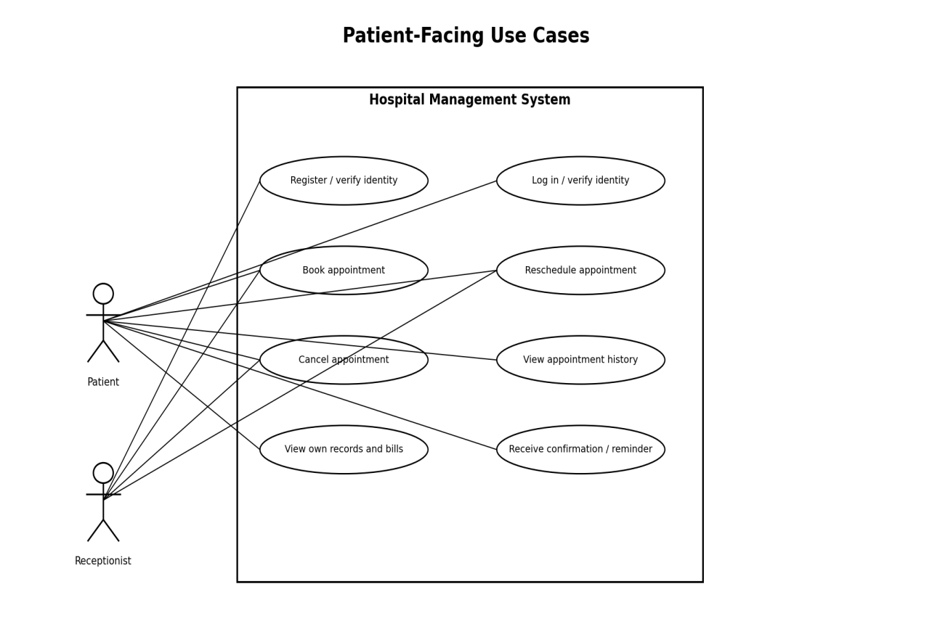
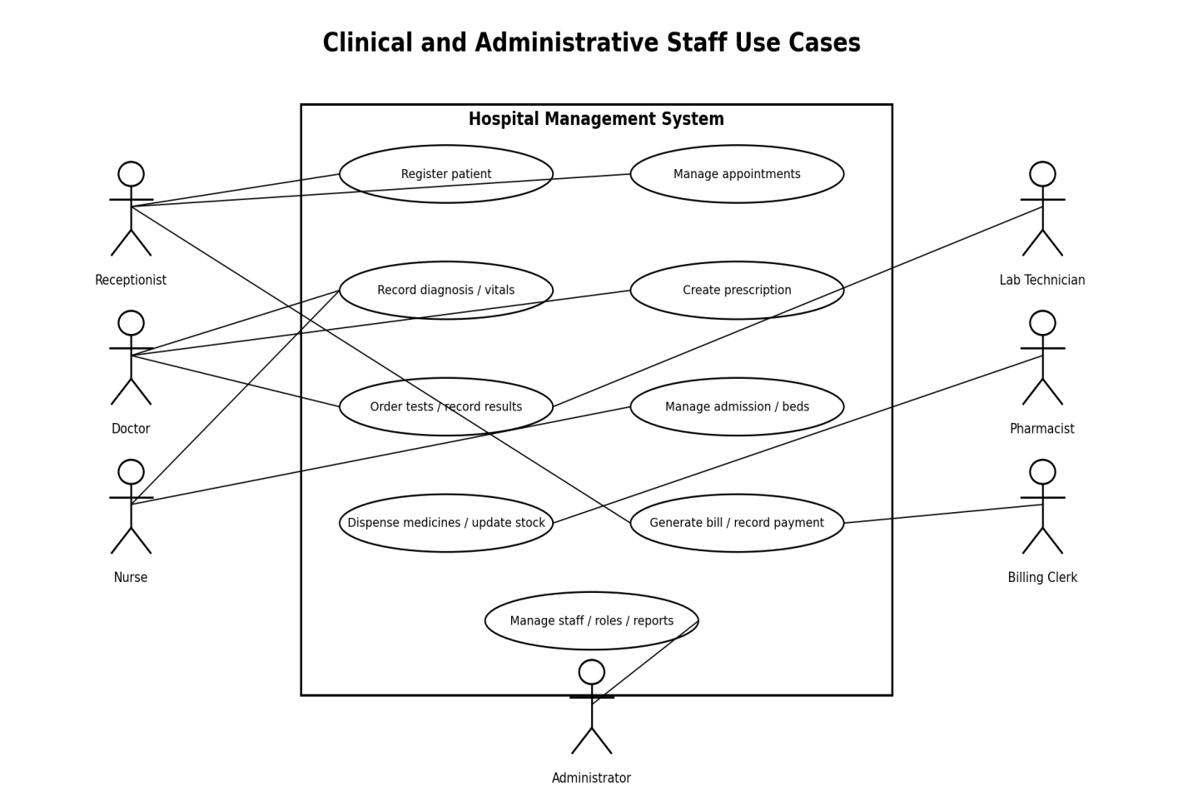

8. Requirements Traceability Matrix (RTM)
The RTM below traces every functional requirement, non-functional requirement and security requirement to its design/section reference, implementing module, and test case(s). Status: N = Not tested, P = Pass, A = deferred to future release.
Req ID | Requirement (short) | Section Ref / Design Spec | Module | Test Case(s) | Status (N/P/A) | Comments
HMS-F-001 | Register patient / assign UHID | 4.1 / DS-Reg-01 | RegistrationModule | TC-Reg-01 | N
HMS-F-002 | Search patient record | 4.1 / DS-Reg-02 | RegistrationModule | TC-Reg-02 | N
HMS-F-003 | Maintain EHR | 4.1 / DS-EHR-01 | EHRModule | TC-Reg-03 | N
HMS-F-004 | Staff login / lockout | 4.1 / DS-Auth-01 | AuthModule | TC-Auth-01 | N | See HMS-SR-006 for failed-login lockout; see HMS-SR-002 for role-based access control.
HMS-F-005 | Book OPD appointment | 4.2 / DS-Appt-01 | AppointmentModule | TC-Appt-01 | N
HMS-F-006 | Prevent double-booking | 4.2 / DS-Appt-02 | AppointmentModule | TC-Appt-02 | N
HMS-F-007 | Reschedule / cancel appointment | 4.2 / DS-Appt-03 | AppointmentModule | TC-Appt-03 | N
HMS-F-008 | Appointment notifications | 4.2 / DS-Appt-04 | NotificationModule | TC-Appt-04 | N | Requires SMS/e-mail gateway
HMS-F-009 | Record diagnosis / vitals | 4.3 / DS-Clin-01 | ClinicalModule | TC-Clin-01 | N
HMS-F-010 | Create prescription | 4.3 / DS-Clin-02 | ClinicalModule | TC-Clin-02 | N
HMS-F-011 | Order / record lab tests | 4.3 / DS-Clin-03 | LabModule | TC-Clin-03 | N | Requires LIS interface
HMS-F-012 | Bed admission | 4.4 / DS-IPD-01 | IPDModule | TC-IPD-01 | N
HMS-F-013 | Discharge summary | 4.4 / DS-IPD-02 | IPDModule | TC-IPD-02 | N
HMS-F-014 | Consolidated billing | 4.5 / DS-Bill-01 | BillingModule | TC-Bill-01 | N
HMS-F-015 | Record payment / receipt | 4.5 / DS-Bill-02 | BillingModule | TC-Bill-02 | N | Payment gateway required for card/UPI; insurance and discounts are separate coverage/adjustment records.
HMS-F-016 | Apply discount / insurance | 4.5 / DS-Bill-03 | BillingModule | TC-Bill-03 | N
HMS-F-017 | Dispense & decrement stock | 4.6 / DS-Pharm-01 | PharmacyModule | TC-Pharm-01 | N
HMS-F-018 | Expiry alerts | 4.6 / DS-Pharm-02 | PharmacyModule | TC-Pharm-02 | N
HMS-F-019 | Manage staff accounts/roles | 4.7 / DS-Admin-01 | AdminModule | TC-Admin-01 | N | See HMS-SR-002
HMS-F-020 | Operational reports | 4.7 / DS-Admin-02 | ReportingModule | TC-Admin-02 | N
HMS-NF-001 | Booking response time | 5 / DS-Perf-01 | AppointmentModule | TC-Perf-01 | N
HMS-NF-002 | 99.5% availability | 5 / DS-Ops-01 | Infra / Ops | Ops report review | N
HMS-NF-003 | Encryption at rest/in transit | 5 / DS-Sec-01 | Platform | TC-Sec-01 | N
HMS-NF-004 | Usability / training time | 5 / DS-UX-01 | UI Layer | TC-UX-01 | N
HMS-NF-005 | Modular redeploy downtime The 15-minute interruption limit applies to the affected module; other modules should remain available where their dependencies permit. | 5 / DS-Maint-01 | Platform | TC-Maint-01 | N
HMS-NF-006 | Horizontal scalability 3x This target is measured in a documented load test against the baseline workload, without violating the response-time target in HMS-NF-001. | 5 / DS-Perf-02 | AppointmentModule / EHRModule | TC-Perf-02 | N
HMS-SR-001 | TLS 1.2+ enforced | 5.1.2 / DS-Sec-02 | Platform | TC-Sec-02 | N
HMS-SR-002 | RBAC enforcement | 5.1.2 / DS-Sec-03 | AuthModule | TC-Sec-03 | N
HMS-SR-003 | Immutable audit log | 5.1.2 / DS-Sec-04 | AuditModule | TC-Sec-04 | N
HMS-SR-004 | Salted password hashing | 5.1.2 / DS-Sec-05 | AuthModule | TC-Sec-05 | N
HMS-SR-005 | Session timeout (10 min) | 5.1.2 / DS-Sec-06 | AuthModule | TC-Sec-06 | N
HMS-SR-006 | Failed-login lockout | 5.1.2 / DS-Sec-06 | AuthenticationModule | TC-Sec-06 | N | Added to define the account lockout behavior referenced by HMS-F-004.

