SOFTWARE REQUIREMENTS SPECIFICATION
Hospital Management System

Item | Details
Project | Hospital Management System
Team Number | 14
Version | 1.0
Date | 06-09-2026
Technology | C / C++
Project Description | A patient record and appointment management system for hospitals.

Team Members
SRN | Name
PESU2UG24CS323 | Nirav Choudhary
PESU2UG24CS363 | Pranav Kaushal
PESU2UG24CS332 | OP Medha
PESU2UG24CS365 | Pranav Swaroop

Revision History
Version | Date | Author | Change Summary
1.0 | 06-09-2026 | Team 14 | Initial SRS document
1.1 | 16-09-2026 | Team 14 | Updated RTM to match Test Plan test cases and cleaned up UML use-case diagrams.

Table of Contents
- 1. Introduction
- 2. Overall Description
- 3. External Interface Requirements
- 4. System Features and Functional Requirements
- 5. Non-Functional Requirements
- 6. Security
- 7. Quality Attributes and Acceptance Tests
- 8. UML Use-Case Diagrams
- 9. Requirements Traceability Matrix
- 10. Work Division

1. Introduction

1.1 Purpose
This document defines the software requirements for a simple Hospital Management System. The system is intended to manage patient records, doctor information, appointments, and basic hospital operations.

1.2 Scope
The system covers patient registration, patient record management, doctor management, appointment scheduling, appointment cancellation, search, billing information, and basic administrative functions. It does not cover advanced hospital equipment or external insurance systems.

1.3 Audience
The intended audience includes developers, testers, hospital staff, administrators, and project evaluators.

1.4 Definitions
Term | Meaning
HMS | Hospital Management System
Patient | Person receiving hospital services
Doctor | Medical professional providing consultation
Admin | User responsible for managing system data
Appointment | Scheduled consultation between a patient and doctor

2. Overall Description

2.1 Product Perspective
The Hospital Management System is a centralized application that stores and retrieves hospital information. It provides separate functions for administrators, doctors, reception staff, and patients.

2.2 Major Product Functions
- Register and update patient records
- Manage doctor details
- Schedule appointments
- Cancel and reschedule appointments
- Search patient and doctor records
- View appointment schedules
- Maintain basic billing information
- Generate simple reports
- Authenticate system users

2.3 User Roles and Characteristics
Role | Main Responsibilities
Patient | View personal details and appointments; request/cancel appointments.
Doctor | View assigned appointments and patient information.
Receptionist | Register patients and manage appointments.
Administrator | Manage users, doctors, records, and reports.

2.4 Operating Environment
The system can run on a standard desktop/laptop environment using C/C++ with file or database-based storage.

2.5 Constraints
Only authorized users should access protected information. Patient records must be stored consistently, and duplicate or invalid entries should be prevented.

3. External Interface Requirements

3.1 User Interface
The system shall provide simple menus/forms for login, patient registration, appointment management, doctor management, search, and reports.

3.2 Hardware Interface
The application requires a standard computer with keyboard, display, and storage.

3.3 Software Interface
The application shall use local files or a database for storing patient, doctor, appointment, and billing information.

3.4 Communication
For the basic version, communication is not required. If deployed on a network, authenticated communication shall be used.

4. System Features and Functional Requirements
Req ID | Requirement | Type | Priority
HMS-F-001 | The system shall allow authorized users to log in. | Authentication | High
HMS-F-002 | The system shall allow reception staff to register a new patient. | Patient Management | High
HMS-F-003 | The system shall allow authorized users to update patient details. | Patient Management | High
HMS-F-004 | The system shall allow authorized users to search for a patient by ID or name. | Patient Management | High
HMS-F-005 | The system shall allow administrators to add doctor details. | Doctor Management | High
HMS-F-006 | The system shall allow administrators to update doctor details. | Doctor Management | Medium
HMS-F-007 | The system shall display doctors available for appointment. | Doctor Management | Medium
HMS-F-008 | The system shall allow staff to create an appointment for a patient. | Appointment | High
HMS-F-009 | The system shall prevent double booking of the same doctor and time slot. | Appointment | High
HMS-F-010 | The system shall allow authorized users to cancel an appointment. | Appointment | High
HMS-F-011 | The system shall allow authorized users to reschedule an appointment. | Appointment | Medium
HMS-F-012 | The system shall allow doctors to view their appointment schedule. | Appointment | High
HMS-F-013 | The system shall store basic billing information for a patient visit. | Billing | Medium
HMS-F-014 | The system shall generate a simple patient/appointment report. | Reports | Medium
HMS-F-015 | The system shall allow administrators to create or disable user accounts. | Administration | High
Acceptance approach: each functional requirement is verified by executing a corresponding test case using valid and invalid inputs.

5. Non-Functional Requirements
Req ID | Requirement | Category | Priority
HMS-NF-001 | Common operations should respond within 3 seconds under normal load. | Performance | High
HMS-NF-002 | The system should be available during normal hospital working hours with minimal downtime. | Reliability | High
HMS-NF-003 | The system shall restrict patient information to authorized users. | Security | High
HMS-NF-004 | Patient and appointment data shall be stored consistently and recovered correctly after restart. | Data Integrity | High
HMS-NF-005 | Menus and messages shall be simple and understandable for hospital staff. | Usability | Medium

6. Security

6.1 Security Objectives
- Protect patient information from unauthorized access.
- Maintain integrity and confidentiality of hospital records.

6.2 Security Requirements
Req ID | Security Requirement | Priority
HMS-SR-001 | The system shall require username/password authentication for protected functions. | High
HMS-SR-002 | The system shall provide role-based access for patients, doctors, receptionists, and administrators. | High
HMS-SR-003 | The system shall not display patient records to unauthorized users. | High
HMS-SR-004 | The system shall validate input before storing patient and appointment data. | High
HMS-SR-005 | The system shall record important administrative actions such as user creation and record deletion. | High

7. Quality Attributes and Acceptance Tests
The project is accepted when all high-priority functional requirements work correctly, the five non-functional requirements are verified, security checks pass, and the use-case flows can be demonstrated.
Test Area | Example Acceptance Test
Login | Valid user logs in; invalid password is rejected.
Patient Registration | New patient is saved and receives a unique patient ID.
Appointment | Appointment is created only for an available slot.
Double Booking | Second booking for the same doctor/time is rejected.
Security | Unauthorized role cannot access restricted records.
Search | Existing patient can be found using patient ID/name.

8. UML Use-Case Diagrams
Two simple use-case diagrams are included to represent the main interactions with the system.
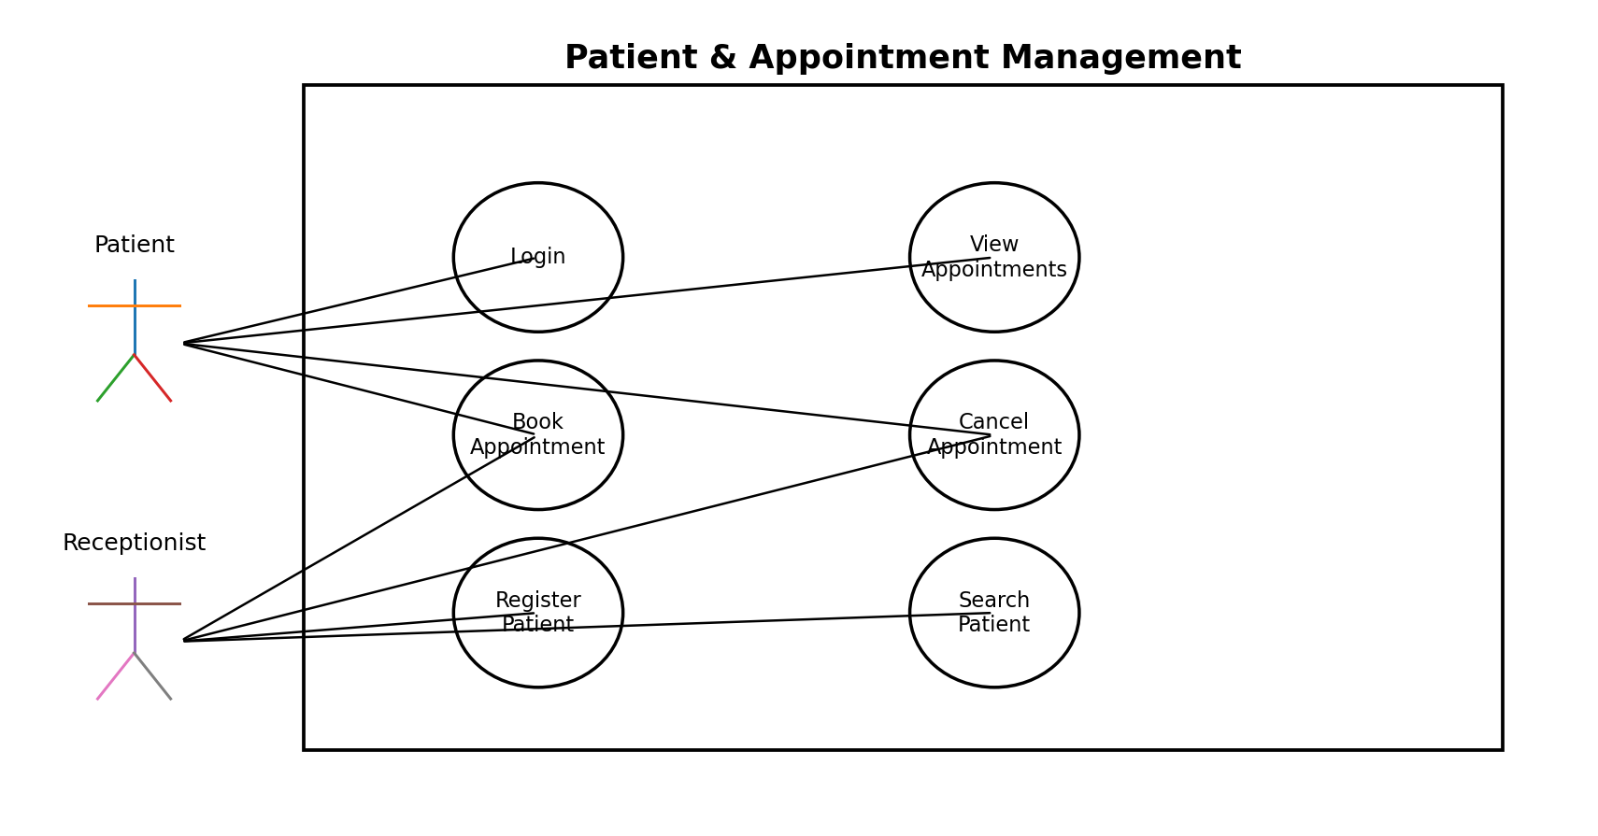
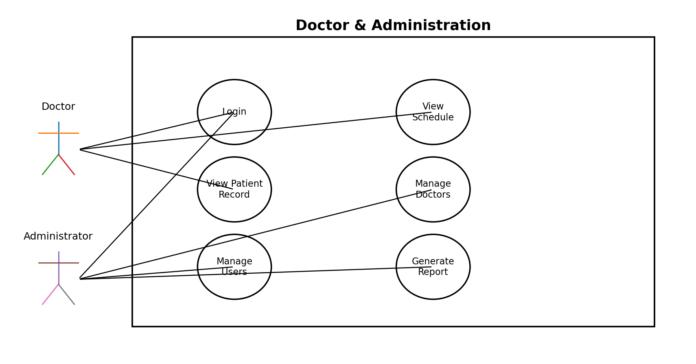

9. Requirements Traceability Matrix
Req ID | Requirement Short | Module | Test Case
HMS-F-001 | Login | Authentication | TC-01
HMS-F-001 | Login rejection | Authentication | TC-02
HMS-F-002 | Register patient | Patient Management | TC-03
HMS-F-003 | Update patient | Patient Management | TC-04
HMS-F-004 | Search patient | Patient Management | TC-03
HMS-F-008 | Create appointment | Appointment | TC-05
HMS-F-009 | Prevent double booking | Appointment | TC-06
HMS-F-010 | Cancel appointment | Appointment | TC-07
HMS-F-011 | Reschedule appointment | Appointment | TC-07
HMS-SR-002 | Role-based access | Security | TC-08
HMS-SR-003 | Restricted patient records | Security | TC-08
HMS-SR-004 | Input validation | Security | TC-09
HMS-NF-001 | Response time | Performance | TC-10
HMS-NF-004 | Data persistence | Data Integrity | TC-09
HMS-NF-005 | Usability | Usability | TC-10

10. Work Division
The work is divided equally across the four team members. Each member gets one major development/documentation area and one shared responsibility.
Member | Main Module | Responsibilities
Nirav Choudhary | Patient Management + Authentication | FR 001–004; patient registration/search/update; login module; related test cases.
Pranav Kaushal | Doctor Management + Reports | FR 005–007 and 014; doctor module; simple report generation; related test cases.
OP Medha | Appointment Management | FR 008–012; booking, cancellation, rescheduling, double-booking validation; related test cases.
Pranav Swaroop | Billing + Administration + Security | FR 013 and 015; billing/admin module; security requirements and security test cases.
Shared by all four members: final integration, debugging, UML diagrams, SRS review, and final demonstration. The module ownership is balanced so that each member has a comparable implementation and documentation load.

Approval
Role | Name | Signature/Email | Date
Team Member | Nirav Choudhary
Team Member | Pranav Kaushal
Team Member | OP Medha
Team Member | Pranav Swaroop

