**12: GCPS Live Bus Monitoring System**

**CS 4850 - Section 01 – Fall 2024**

**Aug 27, 2024**

|  |  |
| --- | --- |
| Sam Bostian (Team Leader) | Michael Rizig (Developer) |
| Charlie McLarty (Developer) | Brian Pruitt (Documentation) |

**Team Members:**

|  |  |  |
| --- | --- | --- |
| **Name** | **Role** | **Cell Phone / Alt Email** |
| Sam Bostian (Team Lead) | Developer | 404.555.1212  sbostian@students.kennesaw.edu |
| Michael Rizig | Developer | 678.668.3294 mrizig@students.kennesaw.edu |
| Charlie McLarty | Developer/QA | 470.303.9544  cmclarty21@gmail.com |
| Brian Pruitt | Documentation | 404.207.6548 bpruitt9@students.kennesaw.edu |

## 1. Project Overview / Abstract (Research):

The project aims to enhance the efficiency and safety of school bus operations for Gwinnett County Public Schools (GCPS) by transitioning from the current Samsara API polling method to a Kafka-based event streaming solution. Currently, GCPS uses Samsara APIs to poll data on school buses, including locations, speeds, and vehicle health, every 5 seconds. However, this method introduces latency and potential bottlenecks. To address these issues, the project involves developing a stand-alone application on a Linux (Ubuntu) environment that consumes events from the Kafka server, modeled similarly to the Samsara Kafka Connector. The application will process these events, perform data validation, and insert valid records into an SQL server database, where they can be accessed by various applications. Additionally, the solution will be containerized for consistent deployment, with optional monitoring functionality to track performance and manage backlogs.

## 2. Project website:

Team3-GwinnettBus.github.io

GitHub Pages Deployment (not yet public)

## 3. Deliverables:

The project deliverables expected, and their respective due dates are listed below.

3.1: Project Plan (this document).

The project plan contains a general outline of the project concept, deliverables, website, milestone events/deadlines, and more.

September 1st, 2024.

3.2: Software Requirements Specifications (SRS).

The Software Requirements Specifications (SRS) document contains a high-level description of the project, as well as specific requirements for platforms, language, and other aspects of the project.

September 1st, 2024.

3.3: Software Design Documentation (SDD).

Document detailing the design approach for this project.

September 1st, 2024.

3.4: Prototype Presentation.

Slide show presentation and demo of the project's main functionality.

October 15th, 2024

3.5 Development Document.

General documentation concerning development, notes on progress, bug reports, etc.

TBD.

3.6 Software Test Plan (STP).

A plan to thoroughly test and QA this project to find and eliminate bugs before deployment.

TBD.

3.7 Review Draft of Final Report.

Final draft of project report and all supporting documentation.

TBD.

3.8 Final Report Package.

Final report package including project source code, presentations, documentation, etc.

December 2nd, 2024

## 4. Milestone Events:

The below milestones serve as pacers and give the team a realistic idea of where they should be during each stage of development.

4.1: Initial Development:

Initial Development of Kafka Consumer, Producer, and Data Processing.

September 16th, 2024.

4.2: Database and Event Logging:

Development of database interaction and event logging.

October 14th, 2024

4.3: Containerization:

Containerization via Docker and deployment.

October 28th, 2024

4.4: Final Deliverable:

Fully functional and tested application with optional monitoring.

December 2nd, 2024

## 5. Meeting Schedule Date/Time:

Meetings are an essential part of communication and are required for information distribution and status updates.

5.1: Platform: Microsoft Teams:

Microsoft Teams is the primary communication platform for team-sponsor communication and meetings.

5.2: Project Sponsor Weekly Meeting Schedule:

Monday 4:45 pm - 5:45 pm

## 6. Collaboration and Communication Plan:

The plan for communication scheduling and meeting platforms are below.

6.1: Intra-team meetings:

Intrateam meetings are scheduled on a weekly basis, depending on factors such as team availability, project due dates, and milestones. Multiple meetings may occur within the span of any given week.

A weekly ‘Status Update’ meeting with the capstone coordinator will occur.

6.2: Communication Platforms:

6.2.1: Discord

Discord is the primary communication platform for intra-team communication and meetings.

6.2.2: Microsoft Teams / Outlook

Microsoft Teams is the primary communication platform for communication with the project coordinator. Outlook will also be employed for direct messaging.

## 7. Project Schedule and Task Planning

## 

## 8. Version Control Plan

Platform: 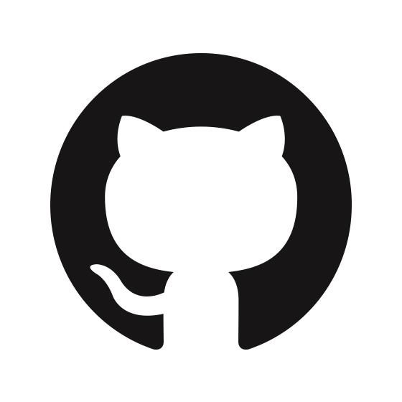 Github

Repository Link: <https://github.com/Team3-GwinnettBus/Gwinnett-Bus>