Sepsis Diagnostic RL: Final Report

Run: final_thr28 | Generated: 2025-08-29 20:07

Executive Summary
This document summarizes the final performance of the trained reinforcement-learning (RL) agent for sepsis mortality prediction and cost-aware test selection. The results below are taken directly from the evaluation artifacts in reports\final_thr28 and presented in a paper-style format.

Headline Metrics
Metric | Value
Diagnostic Accuracy | 82.00%
Precision (PPV) | 0.537
Recall (Sensitivity) | 0.551
Specificity | 0.885
F1-score | 0.544
AUROC | 0.749
AUPRC | 0.433
Avg Financial Cost / Patient | $125.29
Avg Number of Tests Ordered | 3.20
Episodes Evaluated | 800
Threshold Used | 0.280
Threshold Source | forced

Derived Metrics
Metric | Value
Prevalence (positives in set) | 19.50%
NPV | 0.891
PPV | 0.537
F1 per Dollar (F1/$) | 0.004344
TN / FP / FN / TP | 570 / 74 / 70 / 86

Agent Testing Strategy
The policy selects laboratory panels adaptively until it chooses to diagnose. Panel usage below reflects how often each named panel was ordered at least once per episode.
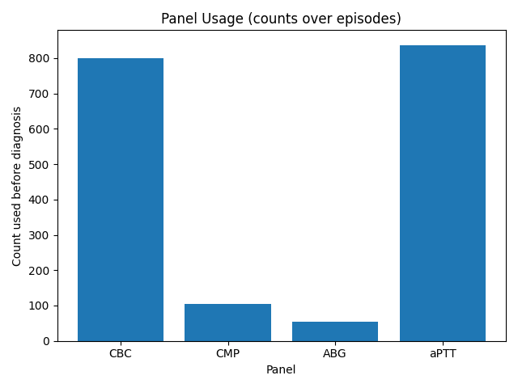
Figure: Panel usage (CBC, CMP, aPTT, ABG)

Performance Curves & Confusion Matrix
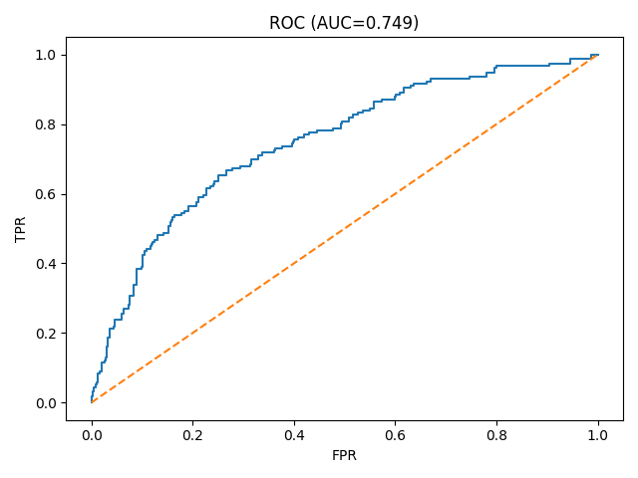
Figure: ROC Curve (AUC)

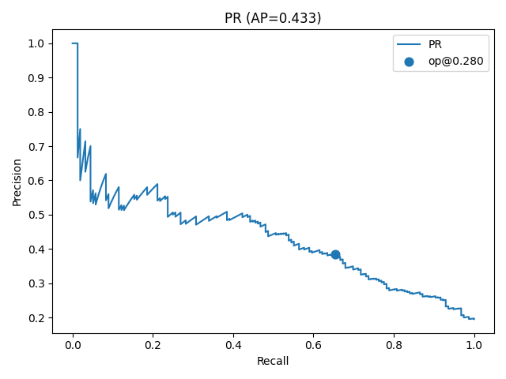
Figure: Precision–Recall Curve (AP)

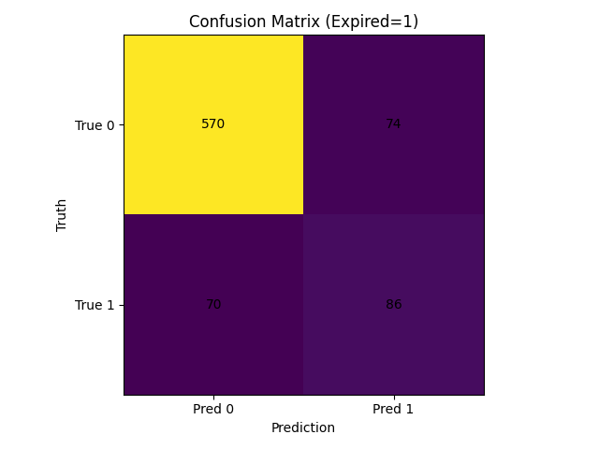
Figure: Confusion Matrix (Expired = 1)

Notes
• No calibration curves included (per request).
• This report contains only this run’s results; no baseline or cross-run comparison.
• Threshold source is recorded as reported by the evaluator; interpretation is unchanged.

Appendix: Case Studies
--------------------------------------------------
Episode 0
True outcome: Discharged (0)
Step 1: Ordered aPTT (#3) (p_before=0.190 → p_after=0.191) (≈$49.00)
Step 2: Ordered CBC (#0) (p_before=0.191 → p_after=0.150) (≈$30.86)
Step 3: Diagnose action (5) → Discharged (p=0.150)
Final p(expired)≈0.150 → Pred=0 @ thr=0.280
Total cost=$79.86 | steps=3
Result: CORRECT
--------------------------------------------------
Episode 1
True outcome: Discharged (0)
Step 1: Ordered aPTT (#3) (p_before=0.190 → p_after=0.162) (≈$49.00)
Step 2: Ordered CBC (#0) (p_before=0.162 → p_after=0.318) (≈$30.86)
Step 3: Diagnose action (5) → Discharged (p=0.318)
Final p(expired)≈0.318 → Pred=0 @ thr=0.280
Total cost=$79.86 | steps=3
Result: CORRECT
--------------------------------------------------
Episode 2
True outcome: Discharged (0)
Step 1: Ordered aPTT (#3) (p_before=0.190 → p_after=0.213) (≈$49.00)
Step 2: Ordered CBC (#0) (p_before=0.213 → p_after=0.305) (≈$30.86)
Step 3: Diagnose action (5) → Discharged (p=0.305)
Final p(expired)≈0.305 → Pred=0 @ thr=0.280
Total cost=$79.86 | steps=3
Result: CORRECT
--------------------------------------------------
Episode 3
True outcome: Discharged (0)
Step 1: Ordered aPTT (#3) (p_before=0.190 → p_after=0.181) (≈$49.00)
Step 2: Ordered CBC (#0) (p_before=0.181 → p_after=0.219) (≈$30.86)
Step 3: Diagnose action (5) → Discharged (p=0.219)
Final p(expired)≈0.219 → Pred=0 @ thr=0.280
Total cost=$79.86 | steps=3
Result: CORRECT
--------------------------------------------------
Episode 4
True outcome: Discharged (0)
Step 1: Ordered aPTT (#3) (p_before=0.190 → p_after=0.235) (≈$49.00)
Step 2: Ordered CBC (#0) (p_before=0.235 → p_after=0.256) (≈$30.86)
Step 3: Diagnose action (5) → Discharged (p=0.256)
Final p(expired)≈0.256 → Pred=0 @ thr=0.280
Total cost=$79.86 | steps=3
Result: CORRECT
--------------------------------------------------
Episode 5
True outcome: Discharged (0)
Step 1: Ordered aPTT (#3) (p_before=0.190 → p_after=0.395) (≈$49.00)
Step 2: Ordered CBC (#0) (p_before=0.395 → p_after=0.408) (≈$30.86)
Step 3: Ordered CMP (#1) (p_before=0.408 → p_after=0.401) (≈$67.73)
Step 4: Diagnose action (5) → Discharged (p=0.401)
Final p(expired)≈0.401 → Pred=0 @ thr=0.280
Total cost=$147.59 | steps=4
Result: CORRECT
--------------------------------------------------
Episode 6
True outcome: Discharged (0)
Step 1: Ordered aPTT (#3) (p_before=0.190 → p_after=0.159) (≈$49.00)
Step 2: Ordered CBC (#0) (p_before=0.159 → p_after=0.153) (≈$30.86)
Step 3: Diagnose action (5) → Discharged (p=0.153)
Final p(expired)≈0.153 → Pred=0 @ thr=0.280
Total cost=$79.86 | steps=3
Result: CORRECT
--------------------------------------------------
Episode 7
True outcome: Expired (1)
Step 1: Ordered aPTT (#3) (p_before=0.190 → p_after=0.246) (≈$49.00)
Step 2: Ordered CBC (#0) (p_before=0.246 → p_after=0.266) (≈$30.86)
Step 3: Diagnose action (5) → Discharged (p=0.266)
Final p(expired)≈0.266 → Pred=0 @ thr=0.280
Total cost=$79.86 | steps=3
Result: INCORRECT
--------------------------------------------------
Episode 8
True outcome: Expired (1)
Step 1: Ordered aPTT (#3) (p_before=0.190 → p_after=0.218) (≈$49.00)
Step 2: Ordered CBC (#0) (p_before=0.218 → p_after=0.311) (≈$30.86)
Step 3: Diagnose action (5) → Discharged (p=0.311)
Final p(expired)≈0.311 → Pred=0 @ thr=0.280
Total cost=$79.86 | steps=3
Result: INCORRECT
--------------------------------------------------
Episode 9
True outcome: Discharged (0)
Step 1: Ordered aPTT (#3) (p_before=0.190 → p_after=0.196) (≈$49.00)
Step 2: Ordered CBC (#0) (p_before=0.196 → p_after=0.184) (≈$30.86)
Step 3: Diagnose action (5) → Discharged (p=0.184)
Final p(expired)≈0.184 → Pred=0 @ thr=0.280
Total cost=$79.86 | steps=3
Result: CORRECT
--------------------------------------------------
Episode 10
True outcome: Discharged (0)
Step 1: Ordered aPTT (#3) (p_before=0.190 → p_after=0.328) (≈$49.00)
Step 2: Ordered CBC (#0) (p_before=0.328 → p_after=0.354) (≈$30.86)
Step 3: Diagnose action (5) → Discharged (p=0.354)
Final p(expired)≈0.354 → Pred=0 @ thr=0.280
Total cost=$79.86 | steps=3
Result: CORRECT
--------------------------------------------------
Episode 11
True outcome: Discharged (0)
Step 1: Ordered aPTT (#3) (p_before=0.190 → p_after=0.172) (≈$49.00)
Step 2: Ordered CBC (#0) (p_before=0.172 → p_after=0.203) (≈$30.86)
Step 3: Diagnose action (5) → Discharged (p=0.203)
Final p(expired)≈0.203 → Pred=0 @ thr=0.280
Total cost=$79.86 | steps=3
Result: CORRECT

