Software Requirements Specification
for

Travel agency Management System
Version 1.0 approved
Prepared by Team 3
Travelers™
30/10/2020
Table of Contents
Table of Contents ii
Revision History ii
1. Introduction 1
1.1 Purpose 1
1.2 Document Conventions 1
1.3 Intended Audience and Reading Suggestions 1
1.4 Product Scope 1
1.5 References 1
2. Overall Description 2
2.1 Product Perspective 2
2.2 Product Functions 2
2.3 User Classes and Characteristics 2
2.4 Operating Environment 2
2.5 Design and Implementation Constraints 2
2.6 User Documentation 2
2.7 Assumptions and Dependencies 2
3. External Interface Requirements 3
3.1 User Interfaces 3
3.2 Hardware Interfaces 3
3.3 Software Interfaces 3
3.4 Communications Interfaces 3
4. System Features 4
4.1 Search Features 4
4.2 Contact Features 4
4.3 Database editing………………………………………………………………………...…4
4.4 Find Traveling Companions……………………………………………………………….4
5. Other Nonfunctional Requirements 5
5.1 Performance Requirements 5
5.2 Safety Requirements 5
5.3 Security Requirements 5
5.4 Software Quality Attributes 5
5.5 Business Rules 5
6. Other Requirements 6
Appendix A: Glossary 6
Appendix B: Analysis Models 5
Appendix C: To Be Determined List 6

Revision History
Name | Date | Reason for Changes | Version
Team 3 | 30/10/20

Introduction

Purpose
The purpose of this SRS file is to describe all of the requirement and the development attributes in detail, so the developers the costumers and the investors will be able to know what to expect from the product.

Document Conventions
The programmer will be built in C++ the requirement order is from high priority to low priority.

Intended Audience and Reading Suggestions
This SRS document is intended to be read by developers, project managers, marketing staff, users, testers, and documentation writers.

Product Scope
The purpose of the software is to enable costumers to buy easily travel packages and for the travel agency to be able to monitor and control the Database of the reservations its benefits are that the travel agent will save a lot of time and man power by using the software, because the costumer can do most of the work themselves by filling the forms and "order requirements".

References
SRS template
Git Hub repository - https://github.com/Team3-SCE

Overall Description

Product Perspective
This system is a new system that will be using existing services including PayPal, airlines agencies, wire transfer systems via banks, hotels management services and more.

Searching for a deal

Waiting for travel agent approval

Airlines

Completing order
Banks
Hotels

Insurance

Product Functions

Sign-in and Sign-up screen:

The user can make new account or log in to an existing account.
2.2.2 The costumer menu will include the following options:

Search Engine:

There will be search engine for the costumer, the agency customers will be able to search package by many categories such as package dates/departure date/destination etc.

Deals Purchasing:

The customers will be able to make a reservation, and the quantity will be updated accordingly.

Search History:

The costumer will be able to see his order history in case he already purchased travel package.
2.2.4.1 Add or Remove Packages:

The traveler will be able to add/delete a package from the DB

Contact:

The agency customers will be able to fill a form to leave a message in a designated field and ask for the agent to contact.

The travel agency employee's menu will have the additional options:

Control Center:

The travel agent will be able to monitor the reservations and change status and specifications.

3rd Party communication:

The system will be able to contact hotels airlines and the banks automatically and make the needed arrangements.

Purchase Verification:

The system will have secure billing system.

Sign-in and Sign-up screen:

The user can make new account or log in to an existing account.
2.2.2 The costumer menu will include the following options:

Search Engine:

There will be search engine for the costumer, the agency customers will be able to search package by many categories such as package dates/departure date/destination etc.

Deals Purchasing:

The customers will be able to make a reservation, and the quantity will be updated accordingly.

Search History:

The costumer will be able to see his order history in case he already purchased travel package.
2.2.4.1 Add or Remove Packages:

The traveler will be able to add/delete a package from the DB

Contact:

The agency customers will be able to fill a form to leave a message in a designated field and ask for the agent to contact.

The travel agency employee's menu will have the additional options:

Control Center:

The travel agent will be able to monitor the reservations and change status and specifications.

3rd Party communication:

The system will be able to contact hotels airlines and the banks automatically and make the needed arrangements.

Purchase Verification:

The system will have secure billing system.

User Classes and Characteristics
The travel agent-can control the database change order statues (to approve or cancel the reservation) delete accounts add new traveling packages see and answer messages left by costumers.
The agency costumer- can find traveling packages and send reservation request can also leave a message for a travel agent can view information on the packages including hotel flight and more specifications.

Operating Environment
As for now the program for the travel agents is intended to run on windows OS, the costumer will be able to interact with the system through web browser and an app for android OS an iOS

Design and Implementation Constraints
The software depends on high internal memory of the computer, be it RAM or HDD and its permutations.
The developer must have access to the employee database.
There must be an established internet connection to secure payment transaction.
This software depends on external payment processing application services and relays to external database which is not maintained by the software.
This software depends on external hotel and flight reservation systems.
There is a limitation to the usage of its features by different users based on roles (manager/employee).
Software’s security must be assigned by the customer and customers own programming team as required by its own security protocols.
The customers organization will be responsible for Integrating/maintaining the delivered software.

User Documentation
The travel agents will be trained on how to operate the system and the database and there will be a manual specifying how to do every operation.
For the costumer there will be help button where needed beside that the UI will be straight forward and as easy to use and understands as possible.

Assumptions and Dependencies
- Our assumption that we have a server which will store the account and order database
- The database includes details of access for each user such as Travel Agent & Customer stated by Role.
- The system depends on outsourcing payment transactions to specified systems such as PayPal etc.
- The System will know how to communicate and order hotel and flight reservations.

External Interface Requirements

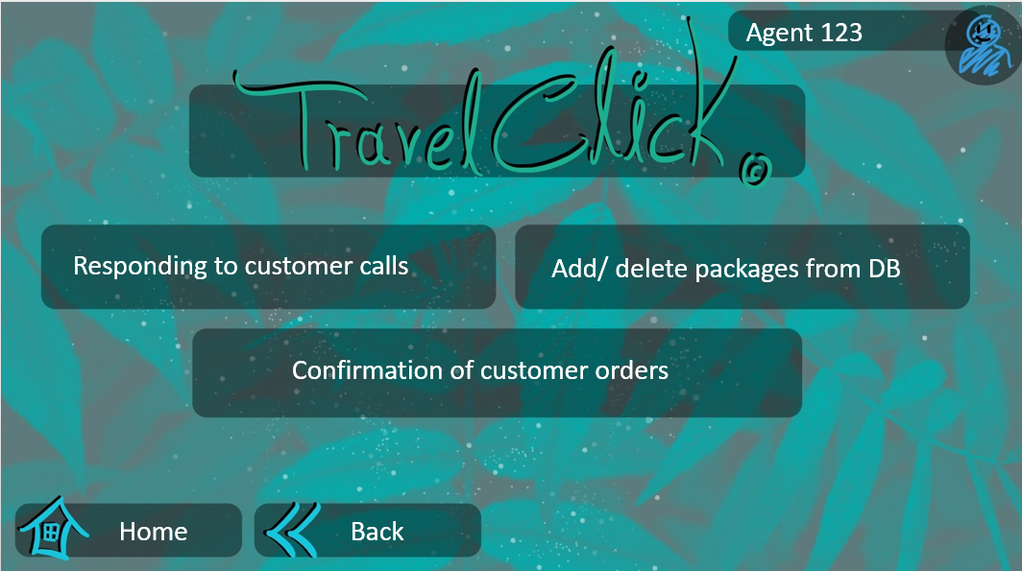
User Interfaces

The software will have user log in UI and for the costumer search engine
And for the travel agent menu for controlling the database.
See the prototype presentation (style may differ from the final product).

Hardware Interfaces
The application requires a monitor and working computer with Windows OS installed with mouse and keyboard and for the mobile app an updated version of android or IOS
and local internet access.

Software Interfaces
- The system will be linked with a payment system for subscribers, such as 'PayPal'
- The application will have access to data base that was written by a third-party software program (in a .txt format).
- The interface is as shown in the prototype.

Communications Interfaces
- The system requires local internet connection to access the services all the messages left by the costumer will be delivered via email to the traveling agent.
- Communication with human resources databases to transfer data into the software.
- The system will be able to communicate with banking, hotel and flight management systems.

System Features

4.1 Search Features:

4.1.1 Costumer Support Reply:
The search engine will provide us the deals we search for in the database according to the categories that will be selected by lists of options and will be ordered by the lowest price or reviews of the results.
4.1.2 Stimulus/Response Sequences:

The user will have to log in into the system order to access the database,

From the search menu we user will have the option to order packages after filling

His categories and then the search engine will display the deals by the lowest price

To most expensive that found from database.
4.1.3 Functional Requirements:
The error messages will appear as result of incorrect input in each field and briefly explain the error and then the system will ask the user for a valid input.

4.2 Contact Features:

4.2.1 Costumer Support Reply:
If the costumer filled a contact request the request will be sent to a general email
which all the travel agents will have access to be able make a faster reply to the
costumer.

4.2.2 Stimulus/Response Sequences:

In the costumer menu will be contact option in case the costumer will want to
Make a request about contacting him

4.2.3Functional Requirements:
The user must log in and fill valid email/phone number order to complete the task.

Database editing

4.3.1 Opportunity quality evaluation
This feature enables the travel agent to get into the database find specific orders change information (order status or departure date hotel rooms and more). Delete packages listings and add or remove costumer accounts.

Stimulus/Response Sequences
The travel agent will have to log in to his account on the main screen after that he will have a menu with operations he can do.
He will be able to edit the user database and the orders/reservations database
After he chooses one he can find specific account or order by searching by id or name or order serial number and after selecting specific search result have the option to edit the information.

Functional Requirements
Only travel agent can access the mentioned feature
The travel agent’s work flow will closely follow the sequence of actions shown in the Flow Chart (see Appendix B).
The travel agent must enter valid information and can't change sensitive information like billing information without the bank confirmation and will be able to change rooms or flight sitting and or departure date only after the hotel and/or flight companies approve the change.

Find Traveling Companions:

4.4.1 Opportunity quality evaluation:
This feature enables the costumers to be able to communicate and find other costumers who go to the same destination and help them have "soft landing" in the country they are flying to.
When a costumer orders a package, he needs to fill a checkbox if he wants to be able to be seen by other costumers, the list of the potential companions will be shown in the package details page.

Stimulus/Response Sequences:
The costumer will have to log in to his account on the main screen and get in the package details screen.
He will see a list of "potential companions" with contact information.
In order to be shown there he the costumer will have to check a checkbox that says " allow to share contact information with potential companions." on the payment page.

Functional Requirements:
Only costumer can access the mentioned feature
The costumer's work flow will closely follow the sequence of actions shown in the Flow Chart (see Appendix B).
The costumer will be able to see others details only if he shares his own contact information.

Other Nonfunctional Requirements

Performance Requirements

The product must contact the Internet to communicate with 'money transfer applications' such as PayPal and hotel sites. In addition, the product must link the customer's database.

Safety Requirements

The possible loss to damage that could result from communication gaps with hotels and flights agency. The significant damage is leakage of personal bank details, which is under responsibility of PayPal and other 3rd party secure Money Transfer App, the database will be backed up in several cloud servers every day at 9 PM.

Security Requirements

The product will contain a file of a large database containing personal details of potential customers. The users of the system will be have to use hard to crack code, they will be have to include uppercase letters and numeric characters. The internal database will be encrypted to prevent leakage of those personal details such id, sensitive data, passport etc.

Software Quality Attributes
- The product is easy to use.
- The product provides reliable information about every offer.
- Up to date technology.
- The product will be available to every member of the sales department and to every client.
- Flexible and modular system for changes according to future requirements

Business Rules
- Only a travel agent can update the packages and accesses all the available reports in the system.
- Only a travel agent can approve order, and have access to Data base of the clients.

Other Requirements
All requirements were mentioned above.

Appendix A: Glossary
DB- data base
OS- operation system
IOS- iPhone operation system
RAM- random access memory
HDD- hard disk drive
UI- user interface
ID- Identity number

Appendix B: Analysis Models

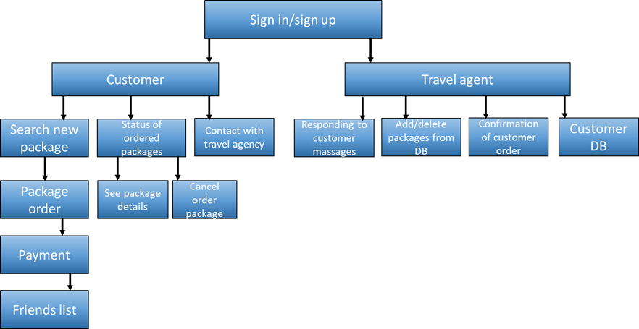

Appendix C: To Be Determined List
- Interface design
- Software menu
- Data encryption algorithm
- Secure payment
- Search Engine

