Bishop Blanchet 2022 FRC Rapid React Coding – Robot Control / Operation

This document outlines the general mechanisms intended to describe how people will interact with the robot and generally accomplish game movements and tasks.

# Setup Phase

This section outlines the key items that need to be done to the robot during the setup phase to prepare for a match.

<TBD>

# Autonomous Phase

This section outlines the key items that need to be done to the robot during the autonomous phase to prepare for a match.

<TBD>

# TeleOperated Phase - Driver and Co-Driver Control Actions

This section outlines how robot drivers will interact with the robot during the TeleOperated phase of the game.

## Xbox Controllers and Button Board

Two individuals will generally be controlling the robot during the manual operation phase of the competition. One individual, named the ‘driver’, will generally be responsible for maneuvering the robot to execute game strategy. The other individual, named the ‘co-driver’ will generally be responsible for operating the controls necessary to score within the game (shooting, hanging, etc.).

### Driver Controls

The driver will be using an Xbox One controller. This specific controller will be explicitly focused at maneuvering the robot around the game field. The primary movement approach will be to use arcade style movement on the left joystick as described in the picture below.

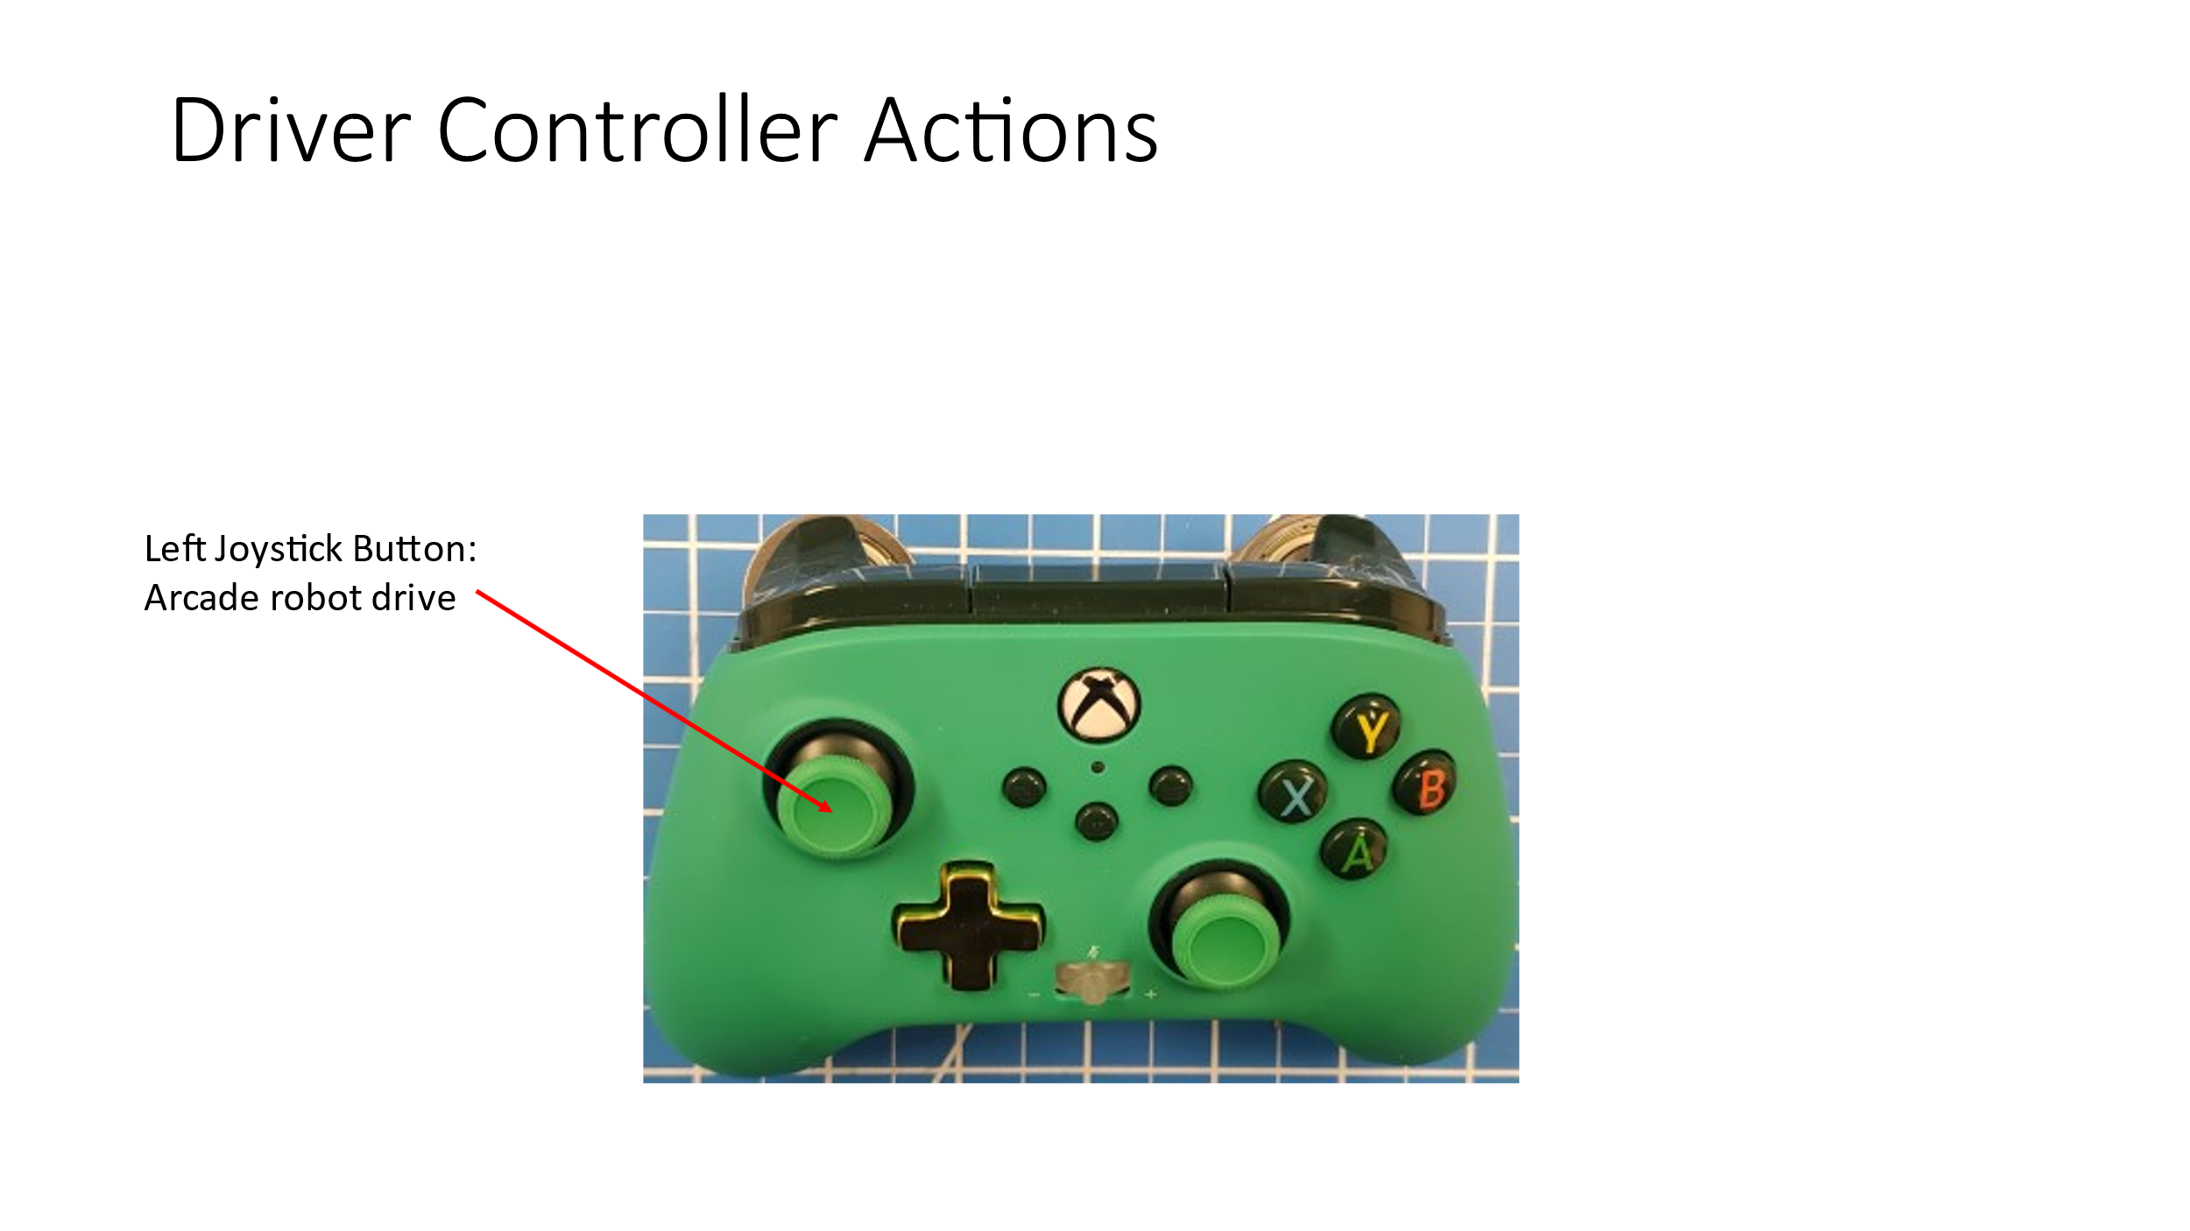

#### Questions

1. Should we split the right and left side drive motors into some form of tank drive for limp mode?

### Co-Driver Controls

The co-driver controls will focus on automating a succession of coordinated actions into a preset library. Each action will be started by a single button press using a constructed button board.

The automated controls are described in the following table.

|  |  |  |
| --- | --- | --- |
| **Category** | **Command Name** | **Description** |
| Angle Arms | Engauge Jaws | Will be triggered to connect the angle arms to the jaws and also disconnect the angle arms from the chassis storage mount. The operation here will be accomplished by initially moving the jaws to a preset angle, next actuating two pneumatics to engage the angle arms to the jaws. Once complete, two pneumatic will be used to disengage the angle arms from their chassis storage brackets. |
| Angle Arms | Engauge Chassis | Will be triggered to connect the angle arms to their chassis storage brackets and disconnect the angle arms from the jaws. The operation here will be accomplished by initially moving the jaws to a preset angle, next actuating two pneumatics to engage the angle arms to their chassis storage brackets. Once complete, two pneumatic will be used to disengage the angle arms from the jaws. |
| Climbing | Middle | Succession of automation that will accomplish middle rung hang starting with the robot on the playing surface. The telescoping arms will first deploy upward. This will be followed by forward movement of the robot. Next the hooks on the telescoping arms will engage the bar by retracting the telescoping arms. Retracting will stop at a preset so that the robot is hanging. The angle arms will then be swung into place such that the angle arm hooks engage the middle bar. At this point the telescoping arms will be extended to a point that they disengage the |
| Climbing | High | Succession of automation that will accomplish high hang starting with the robot hanging from the angle arm hooks on the middle rung. The operations start with orienting the jaws into a specific position such that the robot can hang so that the telescoping arms will have a clear path to extend to the high bar. Next the telescoping arms will be extended such that the hooks reach above the high bar. Next the jaws are moved such that the robot orientation can change to engage the telescoping arms hook on the high bar. Following this the telescoping arms are retracted to fully engage its hooks. After confident grasp on the high bar the jaws are moved to a new orientation to prepare the angle arm to be disengaged. Next the telescoping arms are further retracted which will disengage the angle arms from the middle bar. Lastly the jaws are moved to a new orientation to complete the angle arm move away from the middle bar. |
| Climbing | Traversal | Succession of automation that will accomplish traversal hang starting with the robot hanging from the angle arm hooks on the high rung. The succession of moves to the traversal hang are similar to the move between the medium and high bars. |
| Jaws | Reverse High Goal | Moves the jaws to the set point for scoring at the high goal in the ‘reverse’ direction. Once the proper angle is obtained the jaws clutch will be engaged. Ball intended to be sent toward the rear/aft of the robot. |
| Arm | Forward High Goal | Moves the jaws to the set point for scoring at the high goal in the ‘forward’ direction. Once the proper angle is obtained the jaws clutch will be engaged. Ball intended to be sent toward the front/fore of the robot. |
| Jaws | Forward Low Goal | Moves the jaws to the set point for scoring at the low goal in the ‘forward’ direction. Once the proper angle is obtained the jaws clutch will be engaged. Ball intended to be sent toward the front/fore of the robot. |
| Jaws | Forward Intake | Moves the jaws to the set point used to ingest balls. Once the proper angle is obtained the jaws clutch will be engaged. Ball consumed from the front/fore of the robot. |
| Ball Control | Shoot High | Will spin the motors to the right speed for the forward high jaws position and once the motors are at the proper speed ball storage motors will gently expel the ball into the shooting wheels. |
| Ball Control | Shoot Reverse High | Will spin the motors to the right speed for the reverse high jaws position and once the motors are at the proper speed ball storage motors will gently expel the ball into the shooting wheels. |
| Ball Control | Shoot Low | Will spin the motors to the right speed for the forward low jaws position and once the motors are at the proper speed ball storage motors will gently expel the ball into the shooting wheels. |
| Ball Control | Intake | Will spin the shooter/intake motors to intake a ball. Storage motors intake ball slightly to a ‘shooting position’ so the ball is a safe distance from intake/shooter wheels. |

The Button board layout is presented in the following diagram.

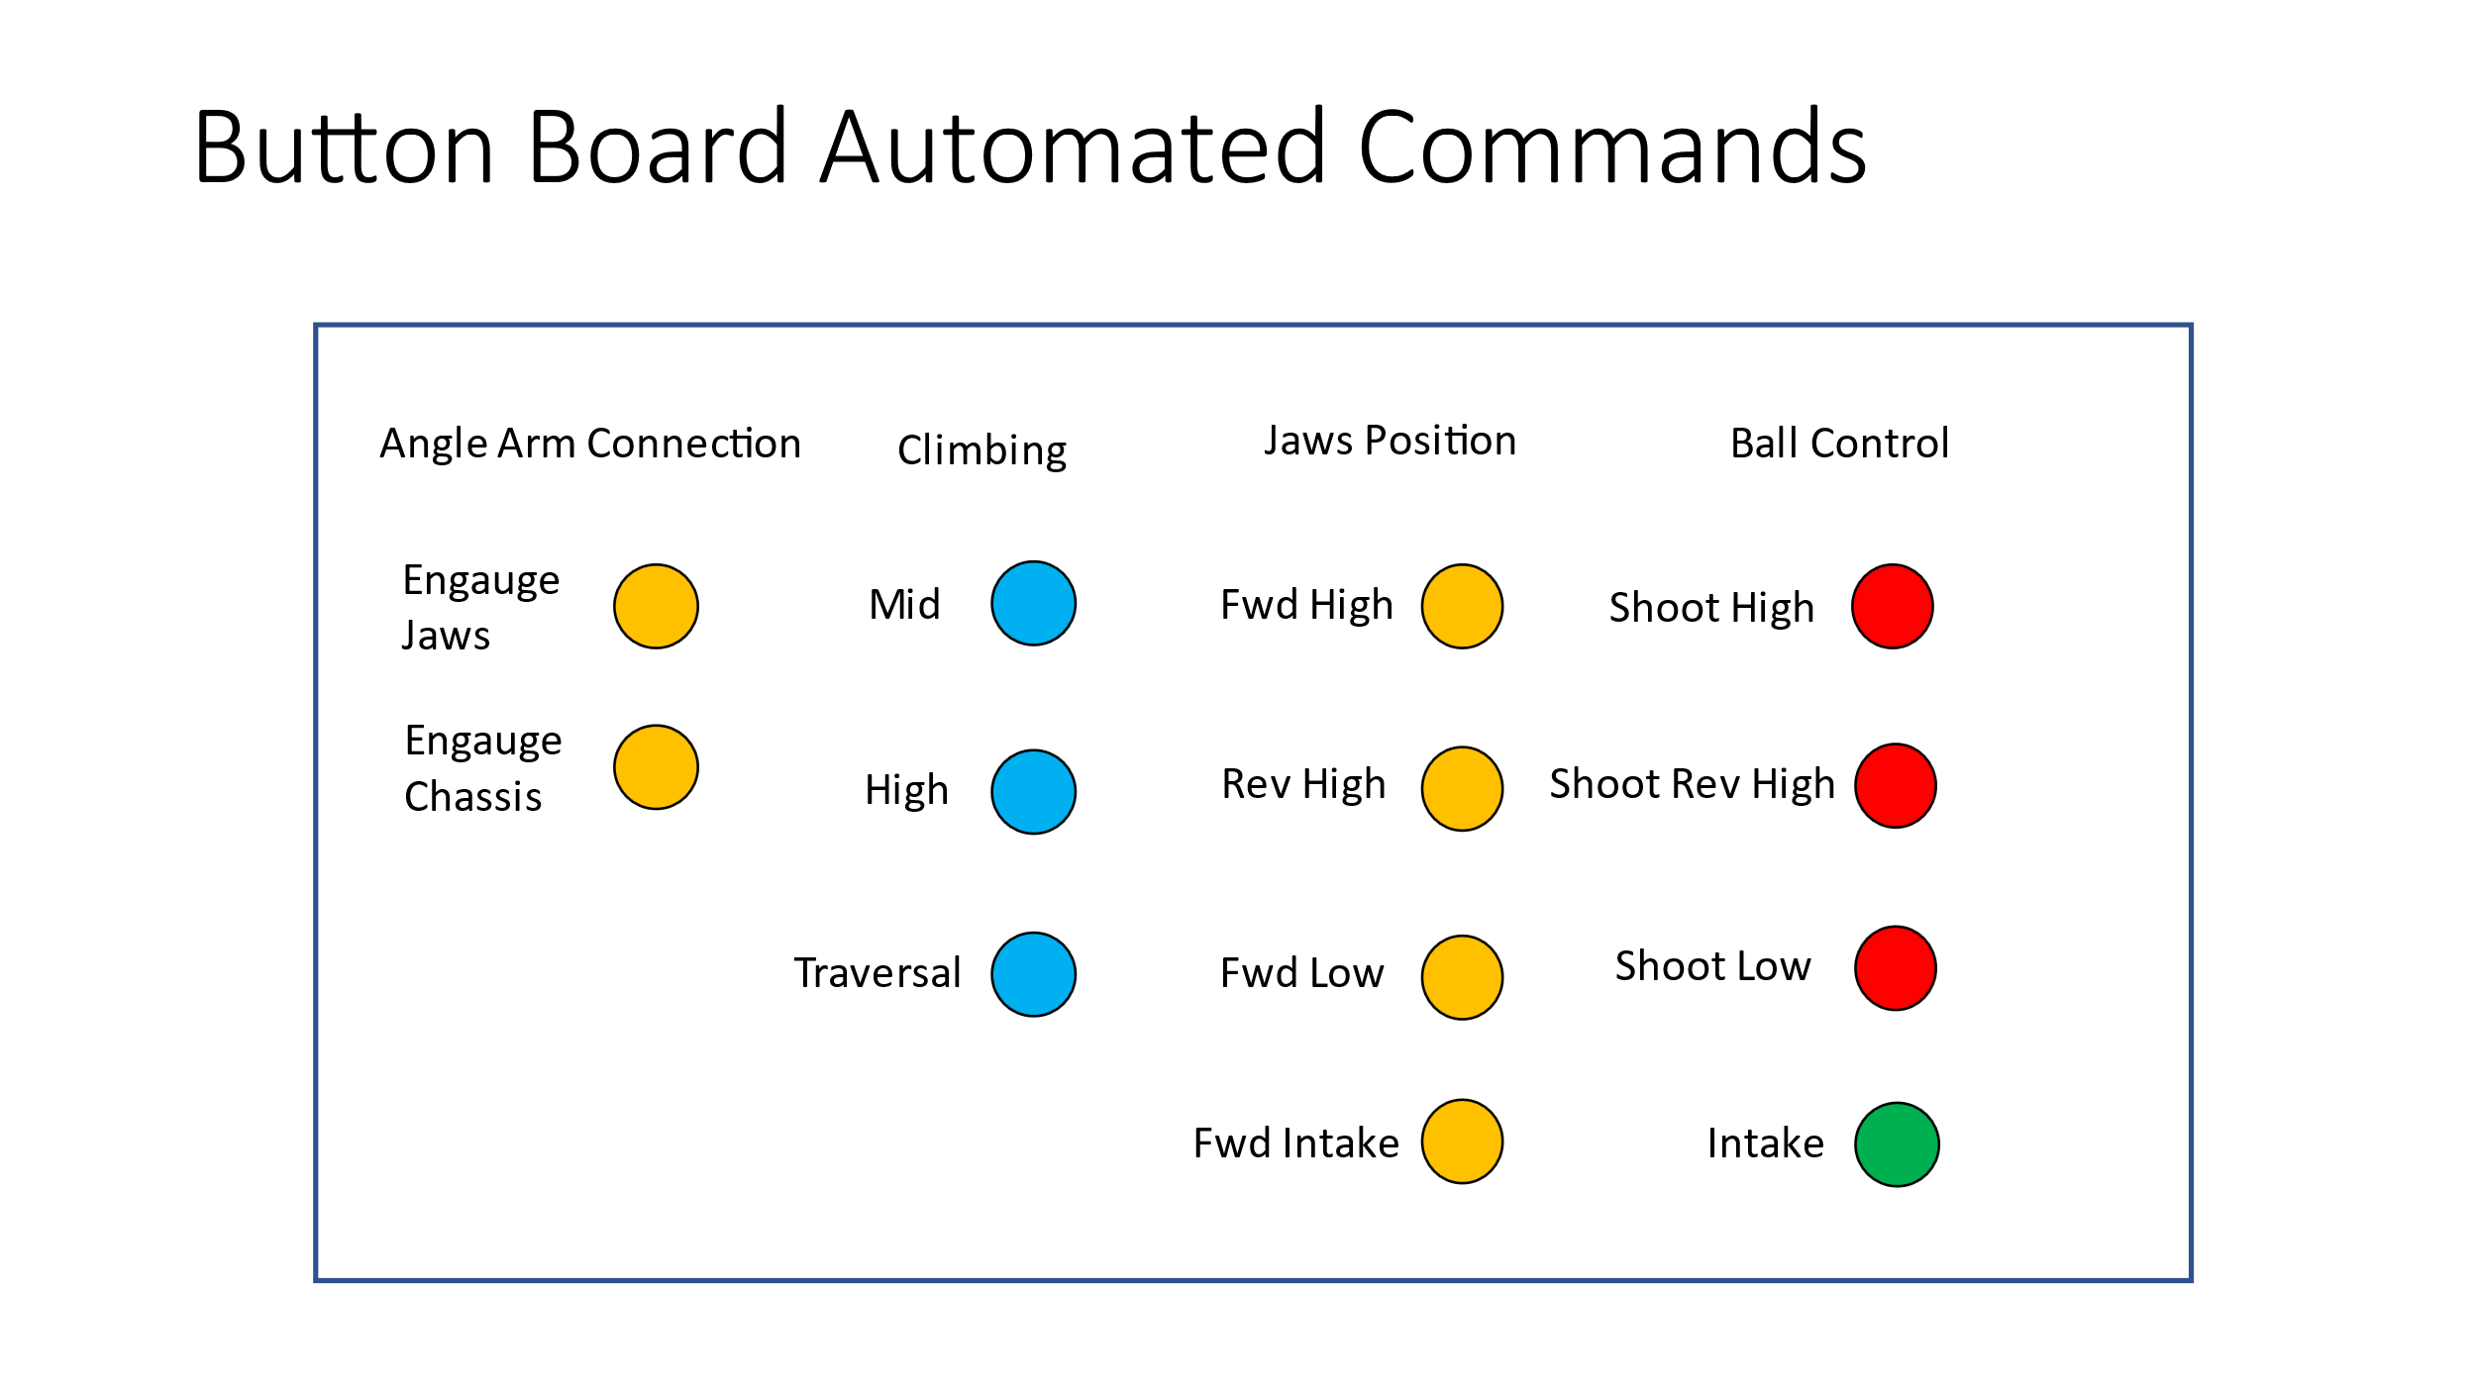

### Co-Driver Backup Controls

Because the automated actions grouped into the button board commonly include a succession of operations, they tend to be more error prone due to the actions generally not considering all variables. To mitigate unforeseen behavior/situations a set of lower-level motor / pneumatic are needed as overrides to the automated actions provided on the button board. The lower-level motor / pneumatic controls will be built into a second Xbox One controller.

Each lower-level action is described in the table below:

|  |  |  |
| --- | --- | --- |
| **Xbox Control** | **Category** | **Description / Notes** |
| Left Joystick | Jaws | Jaws motors operated in tandem (follower). Joystick up implies jaw should raise (move in an arc toward the back of the robot). Joystick down implies jaw should lower (move in an arc toward the front of robot). Variable speed based on magnitude of joystick up/down. |
| Left Joystick Button | Jaws | Left joystick button upon being pressed will trigger lock or unlock of the jaws clutch. Press once it will lock, press again and it will unlock. |
| Left Trigger | Ball Handling | Will control both motors moving them in the ‘intake’ direction. Variable speed based on magnitude of trigger up/down. |
| Left Bumper | Ball Handling | Ball storage **stage one** motor control when pressed it will run the motor in the intake direction at a single preset speed for as long as the bumper is depressed. When the bumper is released the ball storage motor will be stopped. |
| Right Bumper | Ball Handling | Ball storage **stage one** motor control while pressed it will run the motor in the shooting direction at a single preset speed for as long as the bumper is depressed. When the bumper is released the ball storage motor will be stopped. |
| Right Trigger | Ball Handling | Will control both motors moving them in the ‘shooting’ direction. Variable speed based on magnitude of trigger up/down. |
| Y Button | Angle Arms | Each release of the button will toggle both of the **top** angle arm pneumatics solenoids. If it was engaged it will disengage or vice versa. |
| B Button | Angle Arms | Each release of the button will toggle both of the **bottom** angle arm pneumatics solenoids. If it was engaged it will disengage or vice versa. |
| Right Joystick | Telescoping Arms | Telescoping arms motors operated in tandem (follower). Joystick up implies telescoping arms should extend. Joystick down implies telescoping arms should retract. Variable speed based on magnitude of joystick up/down. |

The operations are summarized in the table above are further described in the picture below. Freeze

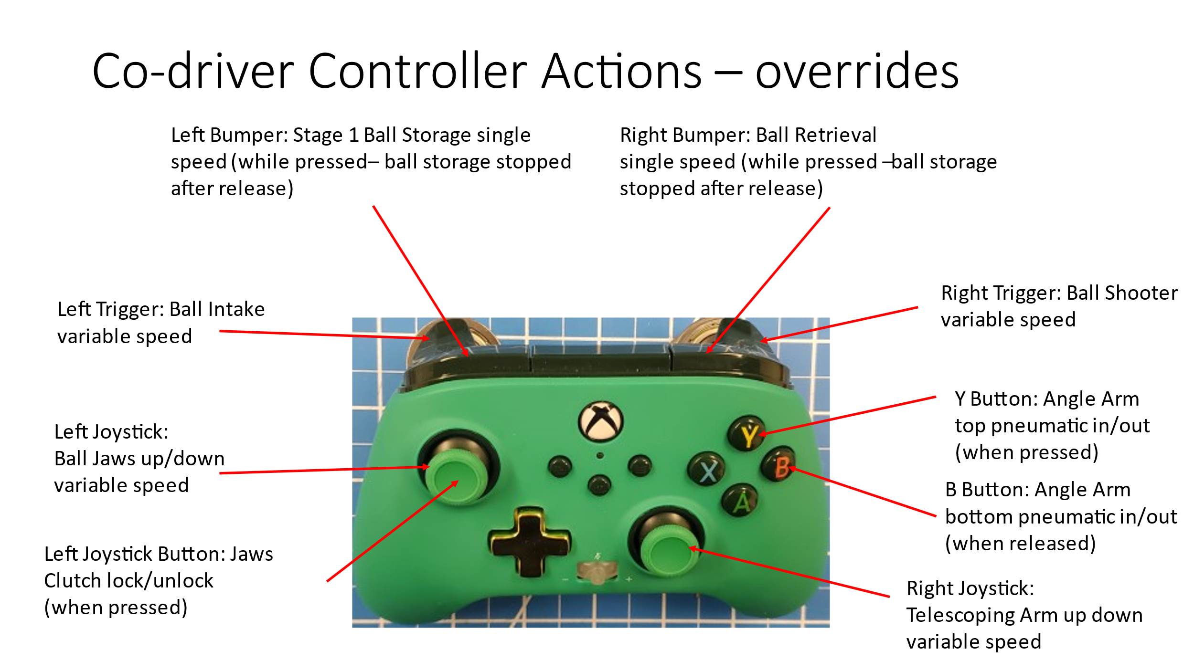

#### Questions

1. Should we split the right and left climbers to make them independently controlled

# Collect Phase

This section outlines the key items that need to be done to the robot after the match completes.

<TBD>