Bootcamp Detailed Steps for Creating Challenge Project

YouTube video examples give you example of what you need to do

1. <https://www.youtube.com/watch?v=C5DqnIu6g8k&pp=ygUnZnJjIDIwMjMgamF2YSBjb21tYW5kIGJhc2VkIHByb2dyYW1taW5n>
2. <https://www.youtube.com/watch?v=SLWOSvhonHA&pp=ygUnZnJjIDIwMjMgamF2YSBjb21tYW5kIGJhc2VkIHByb2dyYW1taW5n>

Full text based steps:

1. Create a **brand new** feature branch via Git Desktop

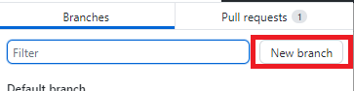

1. Open 2023 WPILib VS Code (windows should have a desktop icon, if not search for “WPILib VS Code”)

1. Open Command Palette (**WHEN IN DOBUT COME HERE**)

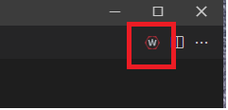

1. Create a new project

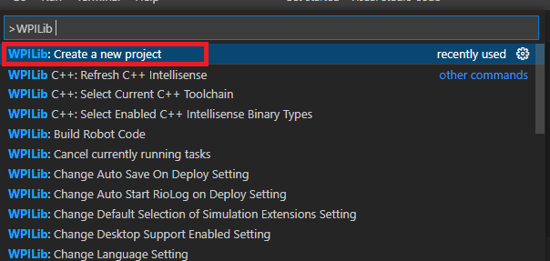

1. Select Template -> Java -> Command

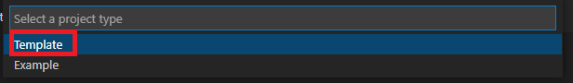

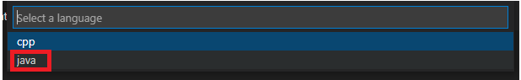

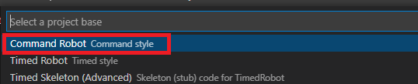

1. Select the proper folder to create the project in

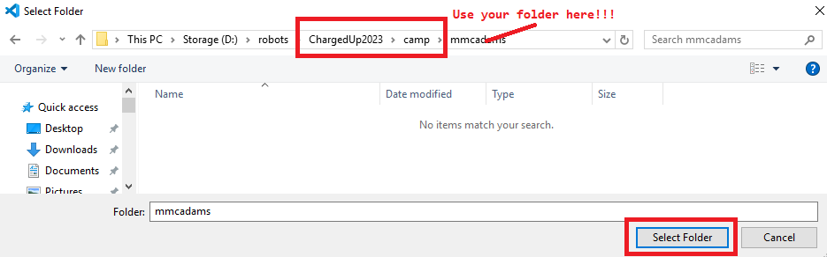

1. Generate the project

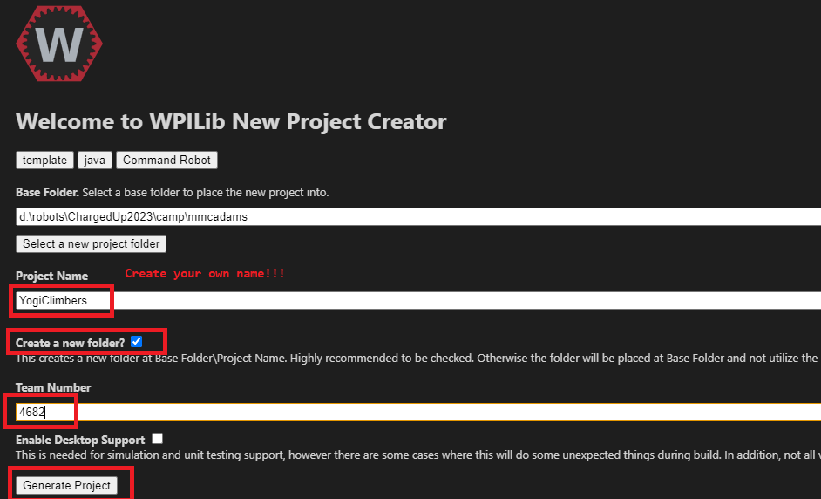

1. Click ‘Yes’ to open the project

1. Click on ‘Yes’ to trust them

1. After you open you project it should look something like:

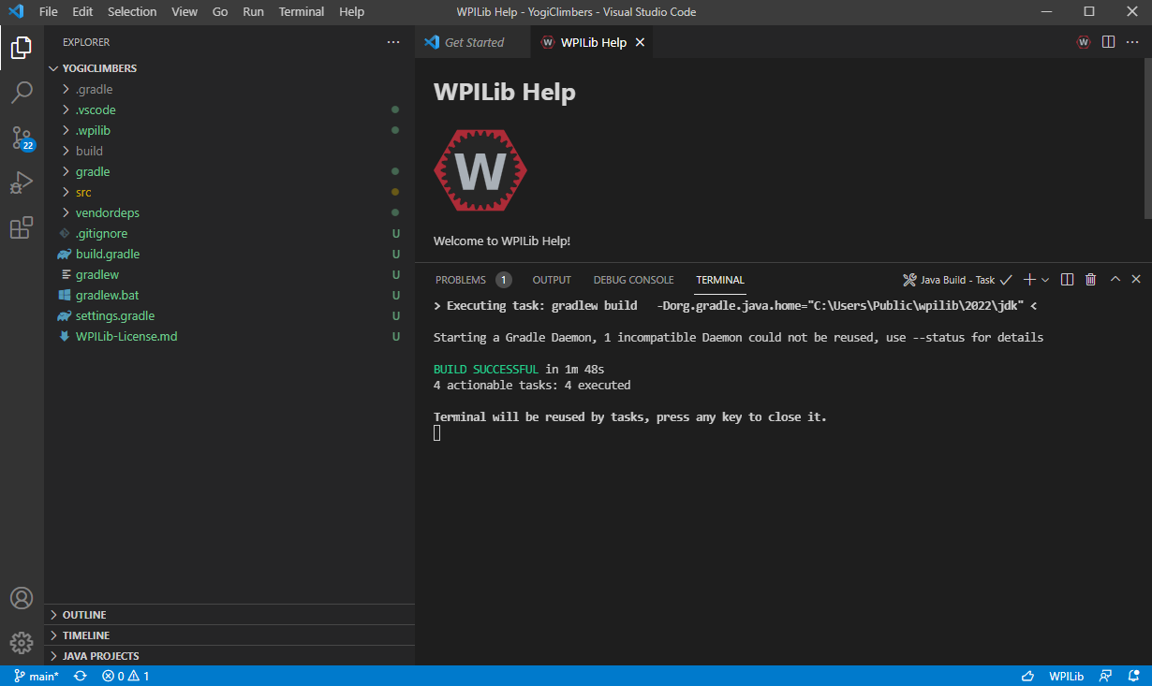

1. Add your vendor libraries (reference see: <https://docs.wpilib.org/en/stable/docs/software/vscode-overview/3rd-party-libraries.html#libraries>)

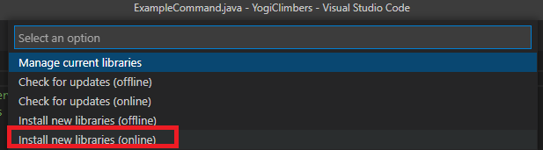

For REV …

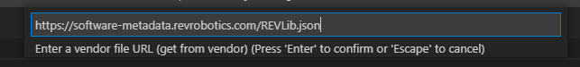

For CTRE/Phoenix …

For Navx …

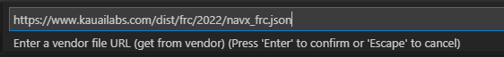

You should have a project where everything builds! Something like:

You should also see that vendor libs are now present:

Lets actually add some code next!

1. First add a subsystem (you could also choose to rename the ‘ExampleSubsystem.java’)

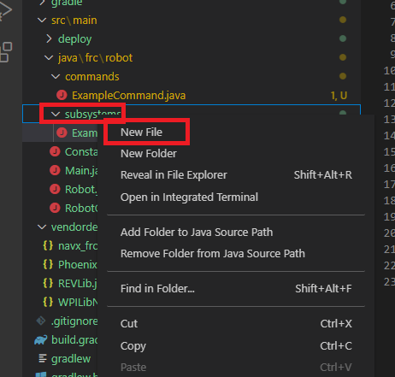

Your file should be a stub …

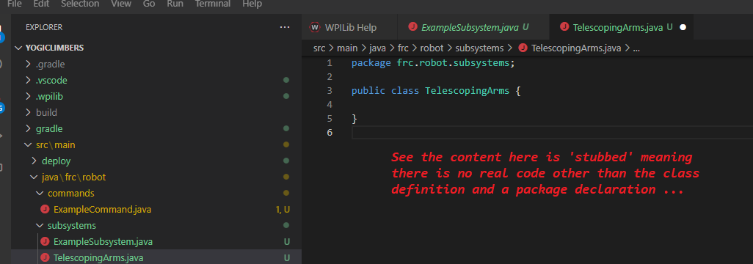

The next step is for you to add logic … expect this is where folks will have lots of freedom and will likely require help first time through …

1. Next add a command

Again the file will be stubbed …

The next step is for you to add logic … expect this is where folks will have lots of freedom and will likely require help first time through …

1. Next wire in the input – for the sake of this example that will happen in RobotContainer.java

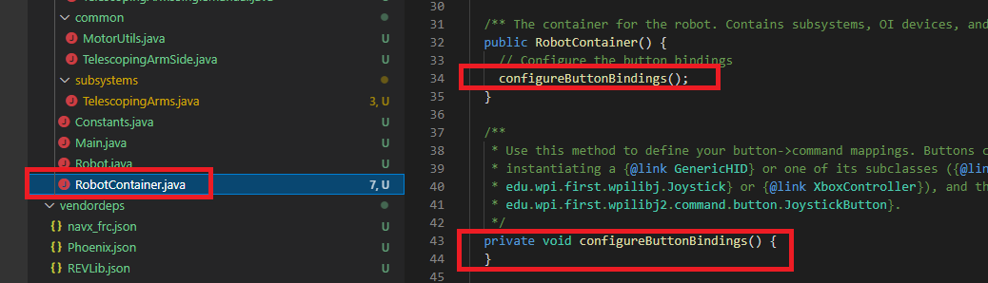

The next step is for you to add logic … expect this is where folks will have lots of freedom and will likely require help first time through …