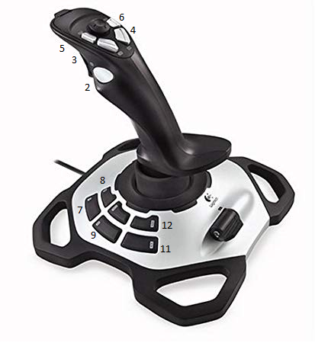

|  |  |  |  |  |  |  |
| --- | --- | --- | --- | --- | --- | --- |
| Operator2 | **ID** | **Action** |  | Operator | **ID** | **Action** |
| Stick Side |  |  |  | Stick Side | axis-x |  |
| Stick Fwd |  |  |  | Stick Fwd | axis-y |  |
| Stick Twist |  |  |  | Stick Twist | axis-z |  |
| Trigger |  |  |  | Trigger |  |  |
| Throttle |  |  |  | Throttle |  |  |
| Hat |  |  |  |  |  |  |
| Button 2 |  |  |  | Button 2 |  |  |
| Button 3 |  |  |  | Button 3 |  |  |
| Button 4 |  |  |  | Button 4 |  |  |
| Button 5 |  |  |  | Button 5 |  |  |
| Button 6 |  |  |  | Button 6 |  |  |
| Button 7 |  |  |  | Button 7 |  |  |
| Button 8 |  |  |  | Button 8 |  |  |
| Button 9 |  |  |  | Button 9 |  |  |
| Button 10 |  |  |  | Button 10 |  |  |
| Button 11 |  |  |  | Button 11 |  |  |
| Button 12 |  |  |  | Button 12 |  |  |