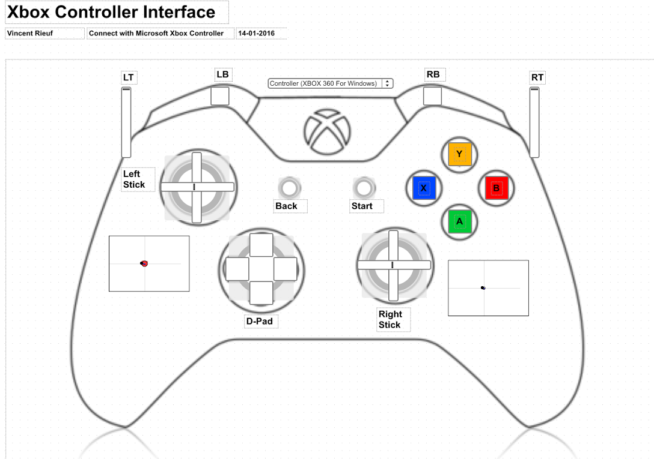

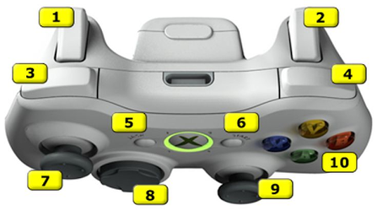

|  |  |  |
| --- | --- | --- |
|  | **ID** | **Action** |
| Stick Left | axis 5 |  |
| Stick Right | axis 1 |  |
| Button A | 1 | Conflicts |
| Button B | 2 | Conflicts |
| Button X | 3 |  |
| Button Y | 4 | Tailgate |
| Button Back  ( upper left) | 7 |  |
| Button Start  ( upper right) | 8 |  |
| Bumper Left | 5 | Hopper Motor Front |
| Bumper Right | 6 | Hopper Motor Back |
| Trigger Left | axis 2 |  |
| Trigger Right | axis 3 |  |
| D-Pad |  |  |