Hotel Revenue Management & Dynamic Pricing Dashboard

Team Contributions:
Team Member(s) | Role | Responsibilities
Mohamed Salah | SQL Database Design | • Designed the SQL schema.  • Organized data using fact and dimension tables.  • Established relationships between the tables.
Donia Ragab and Dalia Hamdy | Data Preparation and Measures | • Worked on data cleaning and preparation in Power BI.  • Developed analytical measures for the booking analysis.
Omar El-Zayat | Dynamic Pricing Scenario | • Implemented the What-If dynamic pricing scenario.  • Developed the related scenario measures.  • Added the slicer used to control the selected price-change percentage.
Menna Emad | Power BI Dashboard Development | • Built the Power BI dashboard.  • Arranged the KPI cards and charts.  • Developed the visual layout and dashboard presentation using the analytical measures and pricing scenario outputs.

Introduction:
This project develops an interactive hotel booking analytics dashboard using SQL Server and Microsoft Power BI. Its objective is to analyze booking patterns, cancellation behavior, Average Daily Rate (ADR), and hypothetical pricing scenarios to support hotel revenue management analysis.
The project uses the Hotel Booking Demand dataset from Kaggle. The original dataset contains 119,390 records and 32 columns. The project workflow includes dataset preparation, SQL Server schema design, data preparation and analytical measure development in Power BI, dynamic pricing scenario analysis, and dashboard development.
Both the original dataset and the prepared dataset are stored in the `Data/` directory. The original file, `hotel_bookings.csv`, contains 32 columns, while `Final_Data_File.csv` contains the 25 columns selected for project analysis.
The final dashboard contains six KPI cards, six charts, and five slicers. A What-If parameter enables users to explore hypothetical price changes and their effect on modeled revenue under a constant-demand assumption.

Project Overview:
Project title: Hotel Revenue Management & Dynamic Pricing Dashboard
Domain: Hospitality Analytics and Revenue Management
Technologies:
- SQL Server
- SQL
- Microsoft Power BI
- DAX
- Power BI What-If parameter
The project combines relational database design, data preparation, analytical measures, interactive visualization, and scenario analysis in one reporting solution.

Business Problem:
Hotels need to understand booking patterns, cancellation behavior, and room pricing to make informed revenue management decisions.
This project addresses the following business questions:
- What is the overall booking volume?
- How does cancellation behavior differ between City Hotel and Resort Hotel?
- How does ADR vary by hotel type?
- Which deposit types and market segments have high cancellation rates?
- How do booking and revenue indicators vary across categories and time?
- How does a hypothetical price adjustment affect the revenue displayed by the dashboard?

Project Objectives:
The project objectives are to:
Prepare the source dataset by selecting columns relevant to the analysis.
Design a SQL Server schema that organizes booking records and descriptive attributes.
Establish relationships between fact and dimension tables.
Prepare and clean data in Power BI.
Develop analytical measures and KPIs using DAX.
Implement a What-If parameter for dynamic pricing scenario analysis.
Build an interactive dashboard with KPI cards, charts, and slicers.
Present findings that help users explore hotel booking and cancellation behavior.

Dataset Description:
The project uses the Hotel Booking Demand dataset.
Source:[Hotel Booking Demand —Kaggle](https://www.kaggle.com/datasets/jessemostipak/hotel-booking-demand)
Attribute | Description
Original file | `hotel_bookings.csv`
Original records | 119,390
Original columns | 32
Prepared file | `Final_Data_File.csv`
Prepared records | 119,390
Prepared columns | 25
Storage location | `Data/`
Domain | Hotel reservations
Hotel categories | City Hotel and Resort Hotel
Main analytical areas | Bookings, cancellations, ADR, customer types, deposit types, market segments, and stay duration

Both `hotel_bookings.csv` and `Final_Data_File.csv` are stored in the repository's `Data/` directory.
The original file contains the source dataset with 32 columns. During the initial preparation stage, seven columns considered unnecessary for the project's analytical objectives were removed, producing `Final_Data_File.csv` with 25 columns.
The dataset contains reservation-related attributes such as hotel type, arrival information, lead time, stay duration, guest counts, booking channels, market segments, deposit types, ADR, and reservation status.

Project Workflow:
The project follows a sequence of database, data preparation, analytical, and visualization tasks.

Dataset Preparation
The original CSV was obtained from Kaggle and stored as `Data/hotel_bookings.csv`. Seven columns considered unnecessary for the project's analytical objectives were removed, and the resulting 25-column dataset was saved as `Data/Final_Data_File.csv`.

SQL Server Database Design
The database schema was designed to separate booking records from descriptive attributes. A fact table and related dimension tables provide the relational structure used in the analytical workflow.

Power BI Data Preparation
The prepared data was brought into Power BI for data preparation and cleaning. Analytical measures were developed to support booking, cancellation, ADR, and revenue analysis.

Dynamic Pricing Scenario
A What-If parameter was created to let users change a hypothetical price adjustment. Related measures calculate and display the scenario results, and a slicer provides interactive control over the selected percentage.

Dashboard Development
The resulting measures and scenario outputs were used to create KPI cards, charts, and slicers in an interactive Power BI dashboard.
Overall workflow:
Original Kaggle Dataset → Column Selection → `Final_Data_File.csv` → SQL Server Schema → Power BI Data Preparation and Measures → What-If Scenario → Interactive Dashboard

Data Quality and Initial Profiling:
Initial profiling of the original CSV identified the following characteristics.
Observation | Count or value
Original records | 119,390
Original columns | 32
Duplicate-looking rows | 31,994
Rows with zero guests | 180
Rows with zero nights | 715
Rows with ADR equal to zero | 1,959
Rows with negative ADR | 1
Maximum ADR | 5,400
Missing country values | 488
Missing agent values | 16,340
Missing company values | 112,593
Missing children values | 4
Undefined market segment values | 2
Undefined distribution channel values | 5
Undefined meal values | 1,169

These figures describe the original source data and provide context for the data preparation process. They should not automatically be interpreted as the corresponding counts in the prepared dataset or the final Power BI model.
Duplicate-looking records and unusual numerical values should be interpreted in the context of hotel bookings. For example, a zero ADR may reflect a particular booking condition rather than automatically indicating an invalid record.

Data Cleaning and Preparation in Power BI:
Power BI was used for data preparation and cleaning following the database design stage.
The preparation workflow focused on reviewing data characteristics relevant to analytical reporting, including:
- Column data types and field structure.
- Missing and placeholder values.
- Duplicate-looking records.
- Zero, negative, and unusually high ADR values.
- Guest counts and stay-duration fields.
- Fields required for booking, cancellation, pricing, and revenue analysis.
The prepared data was then used to support the development of analytical measures and dashboard visuals.
The initial column selection and subsequent data-cleaning activities are distinct stages of the workflow. Removing columns from the original dataset does not, by itself, resolve missing values, duplicate records, or unusual numerical observations.

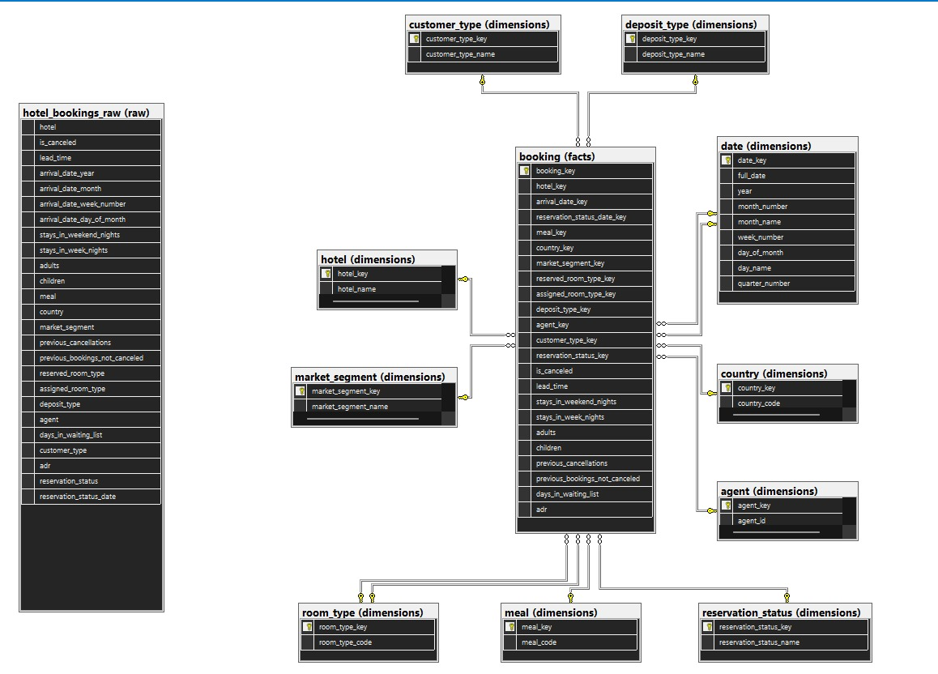
SQL Server Schema Design:

SQL Server provides the relational database structure used in the project.
The database design uses three main schema categories.
Schema | Purpose
`raw` | Organizes source-level booking data
`dimensions` | Stores descriptive attributes used for grouping and filtering
`facts` | Stores booking-related records for analysis

The database design separates descriptive entities from booking records, allowing analytical queries to use fact and dimension tables.
The SQL-related files included in the project are:
- `sql/HotelBookingDB.zip`
- `sql/hotel.sql`
The database setup and execution requirements depend on the SQL scripts and database files included in the repository.

Power BI Data Model:
The Power BI model supports analysis across booking attributes and descriptive categories.
The reported dimension tables are:
`agent`
`country`
`customer_type`
`date`
`deposit_type`
`hotel`
`market_segment`
`meal`
`reservation_status`
`room_type`
The model also includes booking-related records and a `_Measures` table for organizing DAX calculations.
This structure supports filtering and analysis by hotel, country, customer type, deposit type, market segment, meal, room type, agent, reservation status, and date.
The actual results depend on the relationships configured in the Power BI model and the fields available in the loaded tables.

DAX Measures and KPIs:
DAX measures were used to summarize booking performance and support the dashboard.

Main Measures
Measure | Purpose
`Total_Booking` | Reports the booking count according to the measure definition
`Confirmed_Booking` | Reports confirmed bookings according to the measure definition
`Canceled_Booking` | Reports canceled bookings according to the measure definition
`Cancellation_rate` | Calculates the cancellation rate
`Avg_ADR` | Reports Average Daily Rate
`Average Lead Time` | Summarizes the interval between booking and arrival
`Average Length of Stay` | Summarizes the duration of hotel stays
`Total Nights Stayed` | Reports total nights according to the measure definition
`Total Revenue` | Provides the revenue value displayed by the dashboard

Dynamic Pricing Measures
Measure | Purpose
`Price Change % Value` | Returns the selected price-change parameter value
`Revenue Change %` | Represents the relative revenue change calculated by the scenario
`Revenue Difference` | Displays the difference between scenario revenue and base revenue
`Scenario Revenue` | Displays revenue under the selected price-change scenario

The displayed results depend on the DAX definitions, data model, relationships, and current report filter context.

What-If Dynamic Pricing Scenario:
The dashboard includes a What-If parameter named `Price Change %`.
The parameter allows users to select a hypothetical price adjustment using a slicer. The selected value is used by the scenario measures to calculate and display the corresponding revenue indicators.

Scenario Components
- Base revenue: The revenue value displayed before applying the selected price change.
- Price change: The percentage selected by the user.
- Scenario revenue: The modeled revenue value under the selected scenario.
- Revenue difference: The difference between scenario revenue and base revenue.
- Revenue change percentage: The relative change represented by the scenario measures.

Example Scenario
At a selected price increase of 30%, the dashboard displays the following values.
Indicator | Displayed value
Base revenue | 31.26M
Scenario revenue | 40.64M
Revenue difference | 9.38M

These are the values displayed by the current dashboard scenario. They represent the output of the implemented measures and should not be interpreted as independently validated actual hotel revenue.
The scenario assumes demand remains constant. It illustrates the effect of the selected price adjustment under the implemented scenario assumptions. It does not model customer price sensitivity, changes in booking volume, occupancy changes, operating costs, or profit margins.

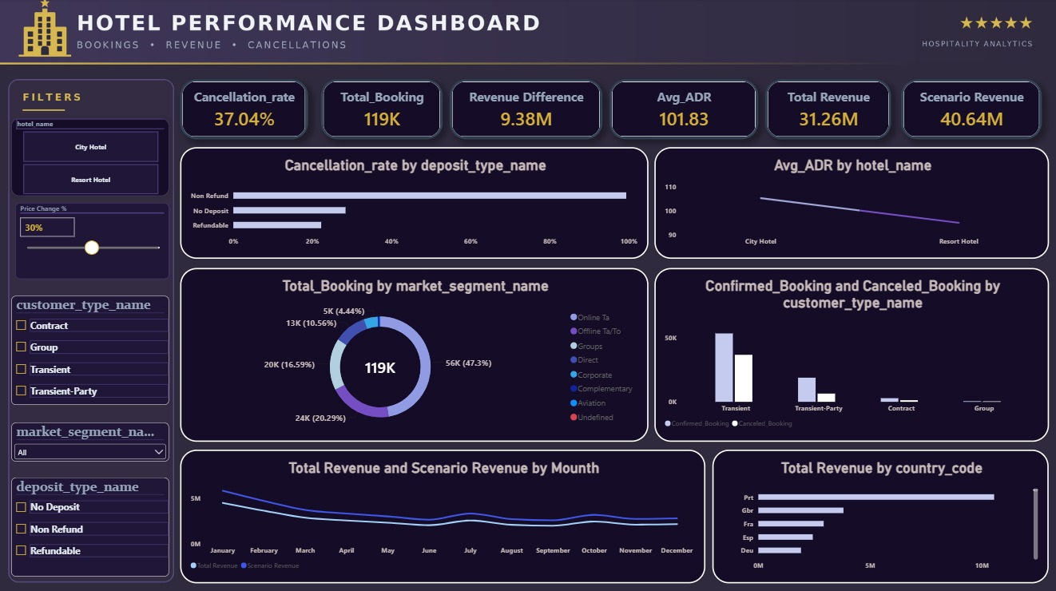
Dashboard Design and Interactivity:

The final Power BI dashboard contains 17 visuals, organized into KPI cards, charts, and slicers.

KPI Cards
The 6 KPI cards display:
- `Cancellation_rate`
- `Total_Booking`
- `Revenue Difference`
- `Avg_ADR`
- `Total Revenue`
- `Scenario Revenue`
These cards provide a high-level overview of booking activity, cancellations, ADR, and the pricing scenario.

Charts
The 6 charts cover:
- Cancellation by deposit type.
- ADR by hotel type.
- Bookings by market segment.
- Confirmed versus canceled bookings by customer type.
- Monthly base revenue versus scenario revenue.
- Revenue by country.

Slicers
The dashboard includes 5 slicers for interactive filtering. These allow users to explore subsets of the data according to the fields configured in the report.

Key Findings:
The following findings were calculated from the original CSV dataset. They describe the original data and may differ from results produced by the final Power BI model, depending on data preparation and measure definitions.

Booking and Cancellation Patterns
- The original dataset contains 119,390 bookings.
- The overall cancellation rate is approximately 37.04%.
- City Hotel has a cancellation rate of approximately 41.73%.
- Resort Hotel has a cancellation rate of approximately 27.76%.
The difference between hotel types indicates that cancellation behavior varies across the two categories.

Average Daily Rate
- Overall average ADR is approximately 101.83.
- City Hotel average ADR is approximately 105.30.
- Resort Hotel average ADR is approximately 94.95.
City Hotel has a higher average ADR than Resort Hotel in the original dataset.

Deposit Types and Market Segments
- The Non-Refund deposit category has a cancellation rate of approximately 99.36%.
- The Groups market segment has a cancellation rate of approximately 61.06%.
These findings identify categories that can be examined more closely when evaluating booking conditions and cancellation behavior.

Pricing Scenario
At a selected 30% price increase, the dashboard displays a scenario revenue of approximately 40.64M compared with a base revenue of approximately 31.26M.
The resulting displayed difference is approximately 9.38M under the scenario assumptions.
These scenario values represent the current dashboard output rather than a forecast validated against changes in actual customer demand.

Business Insights and Recommendations:

Cancellation Management
The higher cancellation rate observed for City Hotel suggests that hotel-specific cancellation patterns should be examined when evaluating reservation policies and booking behavior.

Deposit Policy Analysis
The high cancellation rate associated with the Non-Refund deposit category warrants further analysis of booking conditions, reservation timing, and the composition of this category before making operational decisions.

Market Segment Analysis
The cancellation rate for the Groups segment provides an opportunity to investigate group booking terms, lead times, and cancellation behavior.

Pricing Analysis
The WhatIf parameter enables users to explore hypothetical price adjustments. Operational pricing decisions should also consider demand, occupancy, seasonality, competitor pricing, and operating costs.

Dashboard-Based Decision Support
The dashboard brings multiple indicators into one interface, allowing users to explore patterns across hotel types, customer categories, deposit types, countries, and time periods.

Data Validation and KPI Interpretation:
The original CSV was used as the basis for initial profiling and the findings reported in this document.
The SQL Server and Power BI stages organize the data and present analytical results through measures, charts, and interactive filters.
When comparing KPI values, the following factors are relevant:
- The data population included in the calculation.
- The definition of a booking and a cancellation.
- The date and category filters applied.
- The definition of ADR and revenue.
- The measure logic and relationships in the Power BI model.
These factors determine how individual measures should be interpreted within the dashboard.
Revenue figures in particular should be checked against their DAX definitions and the underlying data before being used for financial reporting or business decisions.

Reproducibility Instructions
To reproduce the project workflow:
- Obtain the original Hotel Booking Demand dataset from the Kaggle source listed in Section 21, if needed.
- Locate `Data/hotel_bookings.csv` in the repository to access the original 32-column dataset.
- Use `Data/Final_Data_File.csv` for the prepared 25-column dataset.
- Set up SQL Server using the SQL files included in the `sql/` directory.
- Load the data and organize the fact and dimension tables according to the available database scripts.
- Open `Power BI & Dashboard/Final___Hotel.pbix` in Power BI Desktop.
- Configure the data source paths and database connection, then refresh the model as needed.
- Review the analytical measures and dashboard visuals.
- Use the `Price Change %` slicer to explore the dynamic pricing scenario.
The repository includes both the original and prepared CSV files in the `Data/` directory. SQL Server and Power BI Desktop may be required to reproduce the complete workflow.

Conclusion
The Hotel Revenue Management & Dynamic Pricing Dashboard combines SQL Server database design with Power BI data preparation, DAX measures, and interactive visualization.
The project explores booking volume, cancellation patterns, ADR, and revenue indicators using the Hotel Booking Demand dataset. Its dashboard brings these indicators together and includes a What-If parameter that enables users to examine hypothetical price changes.
The analysis highlights differences in cancellation behavior across hotel types and booking categories. The dynamic pricing scenario provides an additional way to explore revenue sensitivity under a constant-demand assumption.
The resulting solution provides a foundation for further hotel analytics work, including more detailed demand analysis, occupancy-based pricing, seasonality analysis, and cost-aware revenue optimization.

References
Antonio, N., de Almeida, A., & Nunes, L. (2019). *Hotel booking demand datasets*. Data in Brief, 22, 41–49.
[Hotel Booking Demand Dataset — Kaggle](https://www.kaggle.com/datasets/jessemostipak/hotel-booking-demand)

