Software Architecture and Design Specification
Project: Project Management System (PMS)
Version: 1.0
Authors: Team 7
Date: 03-10-2026
Status: Draft

Revision History
Version | Date | Author | Change Summary
1.0 | 03-10-2026 | Team 7 | Initial SAD

Approval
Role | Name | Date/Signature
QA/Test Lead | PES2UG24CS315: Nidhi Raghuraman
Test Engineer | PES2UG24CS360: Prajwal R
Developer | PES2UG24CS356: Prabhanjana P Hegde
Project Manager | PES2UG24CS336: Padarthi Seshank

1. Introduction
1.1 Purpose
This document specifies the software architecture and detailed design of the Project Management System (PMS).

1.2 Scope
The PMS is a web-based application for managing projects, users, and tasks. The system supports user authentication, project management, project membership, task creation and assignment, task status tracking, task priorities and deadlines, and project progress monitoring.

1.3 Audience
This document is intended for developers, testers, project managers, project members, instructors, and maintenance teams.

1.4 Definitions
PMS – Project Management System
UI – User Interface
DB – Database
API – Application Programming Interface
RBAC – Role-Based Access Control
SRS – Software Requirements Specification
STP – Software Test Plan
RTM – Requirements Traceability Matrix

2. Document Overview

2.1 How to Use This Document
This document provides the architectural and design information required to understand, develop, test, and maintain the PMS.

2.2 Related Documents
Project Management System SRS v1.0
Project Management System STP v1.0
Requirements Traceability Matrix (RTM)
UML Use-Case Diagrams
Test Cases and Test Reports

3. Architecture

3.1 Goals & Constraints
Goals
Provide a modular web-based project management system.
Maintain secure authentication and authorization.
Maintain consistent project and task data.
Support multiple users simultaneously.
Provide simple and easy-to-navigate interfaces.
Provide normal request responses within 3 seconds under normal load.
Allow the system to be maintained and extended easily.
Constraints
The system uses a web browser as the primary client.
The application uses Next.js.
PostgreSQL is used as the database.
Access to projects and tasks must be controlled according to user roles and membership.

3.2 Stakeholders & Concerns
Stakeholder | Main Concerns
Users | Ease of use, task visibility, profile management
Administrators | Project management and system control
Project Managers | Project tasks, project progress, task creation
Task Managers | Task assignment and user management
Developers | Modularity, maintainability, database consistency
Testers | Testability, reliability, requirement coverage
Evaluators | Correctness, architecture, security, and requirement compliance

3.3 Component (UML) Diagram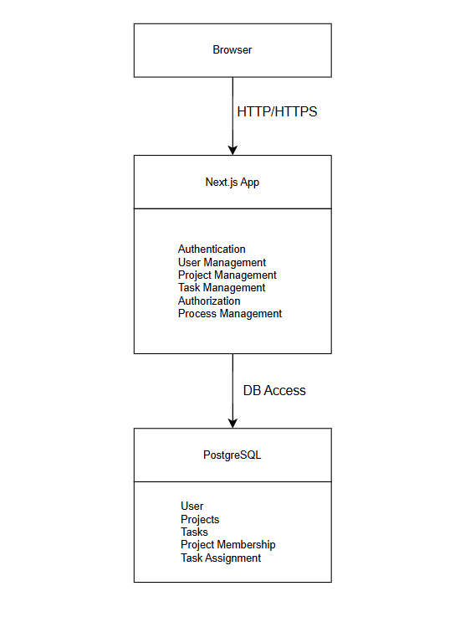

3.4 Component Descriptions
Browser: Provides the user interface for interacting with the PMS
Authentication Module: Handles user registration and login.
User Management Module: Handles user profiles and user-related information.
Project Management Module: Handles project creation, project information, project membership, and project viewing.
Task Management Module: Handles task creation, task assignment, task status, priorities, and deadlines.
Authorization Module: Checks whether a user has permission to access or modify a particular project, task.
Progress Management Module: Calculates and displays project progress based on the status of tasks belonging to the project.
Database: PostgreSQL stores persistent system data including users, projects, tasks.

3.5 Chosen Architecture Pattern and Rationale
A layered architecture is used for the PMS.
The main layers are:
- Presentation Layer – Web pages and UI components.
- Application/API Layer – Next.js API route handlers responsible for processing requests.
- Business Logic Layer – Authentication, authorization, project, task, and progress-related logic.
- Data Access Layer – Database queries and database connection handling.
- Database Layer – PostgreSQL persistent storage.
Layered architecture was selected because it provides clear separation of responsibilities and makes the system easier to understand, test, maintain, and modify.

3.6 Technology Stack & Data Stores
Component | Technology
Frontend | Next.js
Backend | Next.js Route Handlers
Runtime | Node.js
Database | ProstgreSQL
Communication | HTTP/HTTPS
API testing | Postman
UML diagram | Draw.io

Main Data Stores
The PostgreSQL database stores:
User information
Project information
Task information
Project membership information
Task assignment information
Task status
Task priority
Task deadlines

3.7 Risks & Mitigations
Risk | Mitigation
Unauthorized access to projects/tasks | Implement authentication and authorization checks
Database failure | Use database backup and recovery procedures
Inconsistent project/task data | Use database constraints and transactions where required
Slow response time | Optimize database queries and avoid unnecessary requests
Invalid user input | Validate input before processing database operations
Application failure | Use standardized error handling and logging
Concurrent user operations | Use database constraints and appropriate transaction handling

3.8 Traceability to Requirements
SRS Requirement | Architectural Component
PMS-F-001 User registration and login | Authentication Module
PMS-F-002 Profile management | User Management Module
PMS-F-003 Create projects | Project Management Module
PMS-F-004 View projects | Project Management + Authorization
PMS-F-005 Create tasks | Task Management Module
PMS-F-006 Assign tasks | Task Management Module + Authorization
PMS-F-007 View assigned tasks | Task Management + Authorization
PMS-F-008 Update task status | Task Management Module
PMS-F-009 Priority and deadlines | Task Management Module
PMS-F-010 Project progress | Progress Management Module
PMS-NF-001 Response time | API + Database Design
PMS-NF-002 Access control | Authentication + Authorization
PMS-NF-003 Data consistency | PostgreSQL + Validation
PMS-NF-004 Multiple users | Next.js + PostgreSQL
PMS-NF-005 Usability | Presentation Layer

3.9 Security Architecture
The PMS uses authentication and authorization to protect system resources.
Authentication: Users must authenticate before accessing protected PMS functionality.
Authorization: Access is controlled according to the user's role and relationship with projects and tasks.

The main roles are:
Administrator – manages projects.
Project Manager – manages tasks within projects.
Task Manager – manages users assigned to tasks.
User – views assigned projects/tasks and updates permitted task information.

Security Measures
Authentication for protected operations.
Authorization checks for projects and tasks.
Input validation for API requests.
HTTPS for client-server communication in deployment.
Passwords stored using secure password hashing rather than plaintext.
Sensitive information excluded from application logs.
Database constraints used to maintain data integrity.

4. Design
4.1 Design Overview
A typical request follows this flow:
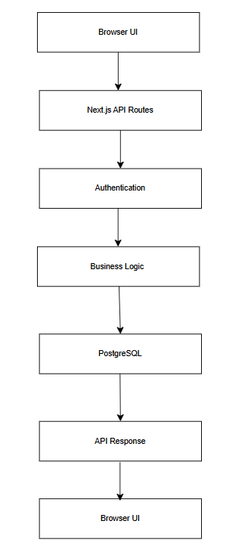

4.2 UML Sequence Diagrams
Sequence Diagram 1 – Create Task
Sequence Diagram 2 – User Login
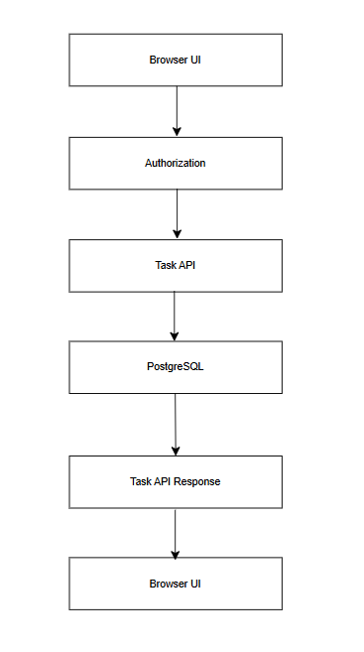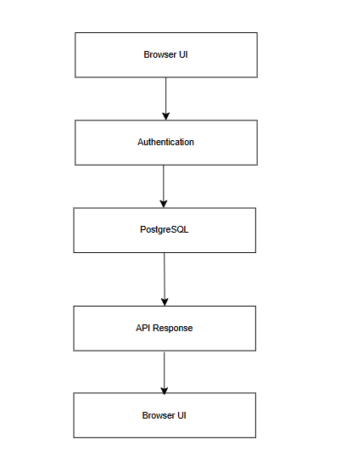

4.3 API Design
The PMS exposes API endpoints through Next.js route handlers.
Create Task API
Endpoint: /api/tasks
Method: POST
Request:{
projectId,
title,
description,
priority,
deadline
}
Response:{
status,
task
}

Update Task Status API
Endpoint: /api/tasks/{taskId}
Method: PUT
Request:{
status
}
Response:{
status,
task
}

4.4 Error Handling, Logging & Monitoring
Error Handling: The system uses standardized HTTP status codes and error responses.
Logging
The system should log authentication failures, server errors, database errors
Monitoring
API response time, Request failure rate, Database errors may be monitored:

4.5 UX Design
The PMS provides a web-based dashboard designed for simple navigation.
The interface includes:
Login and registration pages
User profile page
Project dashboard
Project details
Task list
Task details
Task status controls
Priority and deadline information
Project progress display

4.6 Open Issues & Next Steps
The following items may be considered for future versions:
Advanced project reporting.
Search and filtering of projects and tasks.
Activity/history tracking.
Real-time task updates.

