**Team 7**

Members (Alphabetically):

Aaron Mayo

Bailey Nicholas

Charles Funk, Jr.

Chelsea Hall

Montana Hodges

Philip Davies

Stephanie Foster

Tyler Thorell

Software Specification

Due: February 19th, 2014

Turned in: February 19th, 2014

**Software Specifications for *Gate of Gabethulu***

**Table of Contents**

Section 1: Introduction

* 1. Purpose
  2. Intended Audience and Reading Suggestions
  3. Project Scope
  4. Team Members/Contact Information

Section 2: General Overview

2.1 Product Perspective

2.2 Product Features

2.3 User Classes and Characteristics

2.4 Operating Environment

2.5 Design and Implementation Constraints

2.6 User Documentation

2.7 Assumptions and Dependencies

Section 3: Product Features

3.1 Core Features

3.2 Additional Features

Section 4: External Interface Requirements

Section 5: Other Non-Functional Requirements

Section 6: Milestones

Section 7: Key Resource Requirements

Section 8: Other Requirements

Section 9: Appendix/Glossary

Section 10: Project Proposal

**1. Intro:**

* 1. **Purpose:**

The purpose of this Software Requirements Specification document (SRS) is to provide a detailed description of the functionality and intended features of the created videogame *Gate of Gabethulu*.

* 1. **Intended Audience and Reading Suggestions:**

This document is intended for those in the working team on this project. The intro will cover a brief overview of the software. Some terms that a reader may not be familiar with are covered in section 9. Section 1 covers the basic information involved with the project. Section 2 will provide a general overview of the product. Section 3 provides an in-depth look at the system features. Sections 4, 5, 7, and 8 cover all requirements that pertain to this software.

* 1. **Project Scope:**

The software will be composed of two parts: a client and a server with a database. The server will contain the processing of the input from multiple players, along with any processing required for the game play (I.E. movement, fighting, any A.I., and inventory management). The clients will take user input from the keyboard, along with data sent from the server over the network, and generate the presentation and interface.

**1.4 Team Members/Contact Information:**

|  |  |  |
| --- | --- | --- |
| Name | Phone Number | Email |
| Bailey Nicole Nicholas | (936) 203-0030 | bnn003@shsu.edu |
| Montana Buck Hodges | (936) 650-8334 | mbh022@shsu.edu |
| Charles Mark Funk Jr. | (832) 248-1106 | cmf028@shsu.edu |
| Tyler Alan Thorell | (936) 524-8722 | tat016@shsu.edu |
| Stephanie Joan Foster | (832) 797-8026 | sjf007@shsu.edu |
| Aaron Matthew Mayo | (832) 620-9592 | amm073@shsu.edu |
| Philip David Davies | (281) 799-6394 | pdd003@shsu.edu |
| Chelsea Marie Hall | (385) 282-6621 | cmh010@shsu.edu |

**2. General Overview**

**2.1 Product perspective:**

The main focus of our efforts will be establishing the user program to be able to run completely by itself with only the local users input being processed in a complete game environment.

Our second focus will be on Networking: getting our database hosting server established and running properly, with all user to user connections and each user to database connections fully functional and secure.

For more information on the project and its goals, please see Section 10.

**2.2 Product features**

**2.2.1 Core Features**

-Hack and slash

-Dungeon-eering

-Top-down

-Networking

-Tutorial

-Customizable Appearance

-4-Areas of exploration

-Item drops and chests

-Customizable Character Stats

-Increasing difficulty level based on number of players

**2.2.2 Additional Features**

-Configurable Controls

-Ports to other Platforms (I.E. other Operating Systems or game systems)

-Character Classes

-A multi-weapon system

-Competitive Leaderboard

-Account creation has connectivity with Facebook and Google+

For definitions on these features, please see Section 9, Glossary.

**2.3 User classes and characteristics:**

End users will fall into teen to adult category. Younger audiences will not be expected as the game will contain simulated gore and other concepts that may be inappropriate for younger ages based on ESRB ratings. It will be assumed that users have at least basic literacy. The software will be designed so that anyone who has a basic knowledge of computer input (i.e. using a mouse and keyboard) can use it. There will be user documentation to provide help to new users.

**2.4 Operating Environment**:

The main component of the *Gate of Gabethulu* project is the game software. It will be developed for the Windows operating system. The application will also frequently communicate with the dedicated server.

**2.5 Design and Implementation Constraints:**

Considering that this is not a turn-based game, both the client and server must maintain a minimum playable frame rate of 30 frames per second (33.3 milliseconds per frame or less) or higher for a moderate amount of action. Select in-game objects cannot occupy the same space as other in-game objects (Character v. Character, Character v. Obstacle, Obstacle v. Obstacle, etc.). The characters will also have a level maximum of 10, in order to make the game shorter and provide for quick re-playability and full demonstration to groups.

**2.6 User documentation:**

The software will have multiple forms of documentation to help the user. Besides an in-game tutorial that will help acclimate users to the game, there will also be two forms of help documentation packaged with the software. This will be a file called How_To_Install.txt that will provide the user with simple instructions to install the software. There will also be a document called Help.txt; this document will cover controls, troubleshooting, and any other relevant information that will help a user use the software to its fullest extent.

**2.7 Assumptions and dependencies:**

Hardware Dependencies and Assumptions:

We will assume that the user has a keyboard and a mouse. If the user is interested in utilizing the local area network functionalities, they will need to possess an Ethernet cord or shared wireless router. We are not interested in the direct use of a touch screen.

Time Dependencies and Assumptions:

There will be a time constraint of the design being returned to the company by March 24th, 2014. There is also a deadline for the entire software to be completed by April 28th, 2014. Those items and features listed in section 2.2.2 will be added if the time constraints set allow.

**3. System Features**

We would like for the product to allow the client to host a server that would allow the users to allow other clients to join the local area network. The server will hold all of the data for the attributes for different equipment. Allow for interaction from the user to support client-side features. The system is designed to be used on pc. Potential scenarios are playing a single-player version of the game, or hosting a multiplayer game.

**3.1 Core Features**

-Hack and Slash: The gameplay will be combat focused. Main weapon of a sword as the starter, and then as you level forward, you eventually gain a scythe at the end of tutorial.

-Dungeon-eering: Gameplay that focuses on progressing through closed established environments, with a focus on exploration. Movement will be 8 directional.

-Top-down perspective: Game will be shown with an “eye in the sky” perspective. From above the user as he traverses the area. The game will also be two dimensional in design, with a health bar above the avatar’s head.

-Networking: Client/Server model

Encryption will need to be utilized.

Game server will host the monsters and weapon information along with leaderboard stats.

-Tutorial: The intro level to the game, a stage 0 ideally, would be focused on walking the user through the controls of the game.

-Customizable Appearance: The user will be able to choose gender, class, and hair color.

-4-Areas of exploration: There needs to be multiple areas that the user traverses through. They can be divided as follows:

Stage 0: Tutorial.

Stage 1: Traversal to main dungeon.

Stage 2: The main dungeon.

Stage 3: Final stage

-Item drops and chests: Healing will be dropped for the character to boost survivability. With different difficulty levels, as the character progressed, as difficulty increased the amount of healing aids would be decreased. Chests would be found that are necessary for story progression, such as a keys to unlock doors to advance to the next stage, not to different rooms on each level. (Monster dies, health orb comes out, and user walks over it to use it. Philip wants them to look like little souls) Item drops will **rarely** occur from enemies. Most weapon obtaining will come from treasure chests. So the treasure chests will have weapons and keys. Keys will only open doors and chests will open whenever you open them. As far as chest variety goes the weapon type that comes out of the chests will be randomized. Drop trades will be utilized. Each chest is separately opened to each player. Client side will see that the chest is opened ONLY WHEN THEY OPEN IT. A locked way to not have repeats on the chest prizes should be utilized. When a person gets their chest prize, the random generator needs to account for that person receiving that specific genre of weapon and take it out of the possibilities of a weapon gained from that specific chest prize.

-Customizable Character Stats: Character name will be chosen by the user along with starter stats that the user is able to specify by a point system. Where the user must be given a set number of points to distribute between: health (vitality), defense (lowers damage done by outside forces; monsters, spikes, or fire) attack (damage done to other characters), and speed (how fast is the character able to move).

-Increasing difficulty level based on number of players in game: The more players in your game, the more enemies appear. With an algorithm similar to “When player number is x, number of monsters = 4x.”

-Default input system: 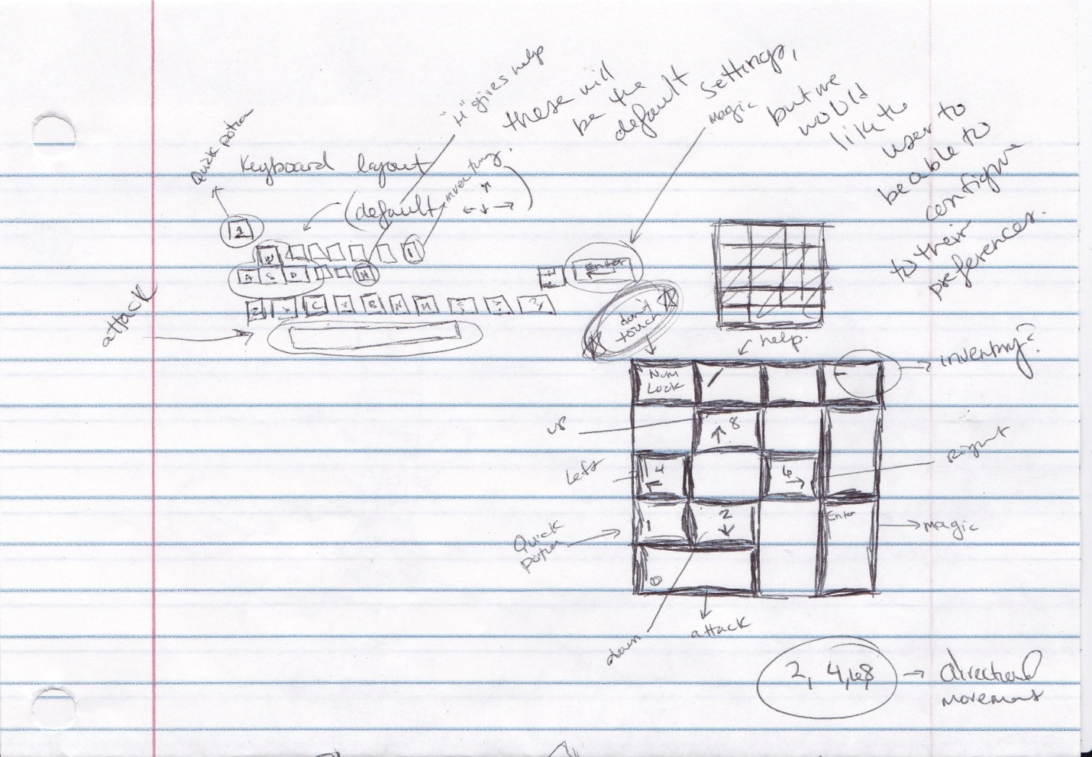

Fig 1.1.

The keyboard will default to the arrow keys and “w”, “a”, “s”, “d” for movement. “Spacebar” will be for the default attack. “ **’** ” will be for the healing process, via potions. “I” will be for the user to access their inventory. “H” is to access a help menu. “Enter” will be the default long ranged attack, “magic” for the user. (Magic ability for long ranged attack will be gained later in game, not immediately.)

**3.2 Additional Features**

-Configurable Controls: We would like a configurable input system. The keyboard will default to the arrow keys and “w”, “a”, “s”, “d”, and more as listed above. However, as stated, it would be optimal for our users to be able to change their input method as they see fit, as far as keyboard mapping goes.

-Ports to other Platforms: (I.E. other Operating Systems or game systems)

-Character Classes: There will preferably be character classes that change weapon proficiency/default and drop weapon types. This will also be based off of our ability and time constraints that affect the multi-weapon system being built. If the multi-weapon system is unable to be completed, we will just use character classes for appearance customization.

-A multi-weapon system: May add different weapons if time allows. The weapons we would like include:

**Staff –** Slow attack speed, but high damage. Ranged attack.

**Scythe –** Long reach, slow speed, high damage. Possible one hit KO since it’s the stereotypical grim reaper weapon.

**Ax –** Average reach, high damage, sort of slow speed, but not that slow, and high damage

**Bow and Arrow-** Average attack speed and Average damage. Ranged Attack.

**Blaster (Cyborg mage-like blast) –** Fast attack speed, but lower damage. Also Ranged.

**Sword –** Average Reach, fast attack speed, lowish damage

**Bear hand (Literally bear hands, not bare hands. You will be using fists that belong to bears.) –** Short Reach, high damage (Glass cannon) Strong, but you will be highly likely to be hit by the enemy.(Another variety could have a bear’s face.) VERY FAST.

**Trident –** Long reach medium attack speed, medium damage

-Competitive Leaderboard: There will a competitive leaderboard that shows largest number of kills, fastest run through times, most number of plays, date joined game, and other things that increase the competitive edge of the game. We would like for our users to have high levels of competitiveness.

-Account creation has connectivity with Facebook and Google+: Can automatically link the game to Facebook, Google+, or other social media.

**4. External Interface Requirements**

The user’s avatar cannot pass certain items that are set as obstacles in the environment. If there is an obstacle possessing elements that is spanning multiple units, the portion deemed obstacle is the only area a character would not be able to walk through(I.E. the base of a tree would be an obstacle, and the trunk and canopy would allow the character to walk behind them). There will be no jumping in this game, only 8 directional movements; up, down, left, right, and diagonal. We hope to implement a chat feature in the game that will show in one of the corners of the game’s window. There will be an occasional treasure chest, set as an interactive obstacle, Innocent bystanders will be accessible and will be interactive as either helpful conversations, or victims. There will also be enemies that the main character is able to enter combat with.

Main Character:

The main character is generally seen as negative in our culture. There has not been a specific decision on what species our main character is, especially with the high probability of character creation classes. We do know the main character is not going to be a “good” entity in anyway. His best way to live survive is the suffering of others. NPCs and other characters will refer to him by name, which is able to be chosen by the user and will not have to be unique. The NPC to character interaction will be in text boxes and text box dialogues. Any storyline text box references will also mention him by name. There will be voice-acting in the game, but no one will directly address the main character by name, mainly due to the ability to name the character freely. Avoidances will be used such as “The Demon” Or “Death spawn” or something along those lines. Also, grunting will be recorded for attacks which will be associated with a specific sound each time they’re performed. i.e. “Hiyah” “Huuuah!” ”NOOOO!” (Dying) We will need both male and female voice acting, since gender selecting is available.

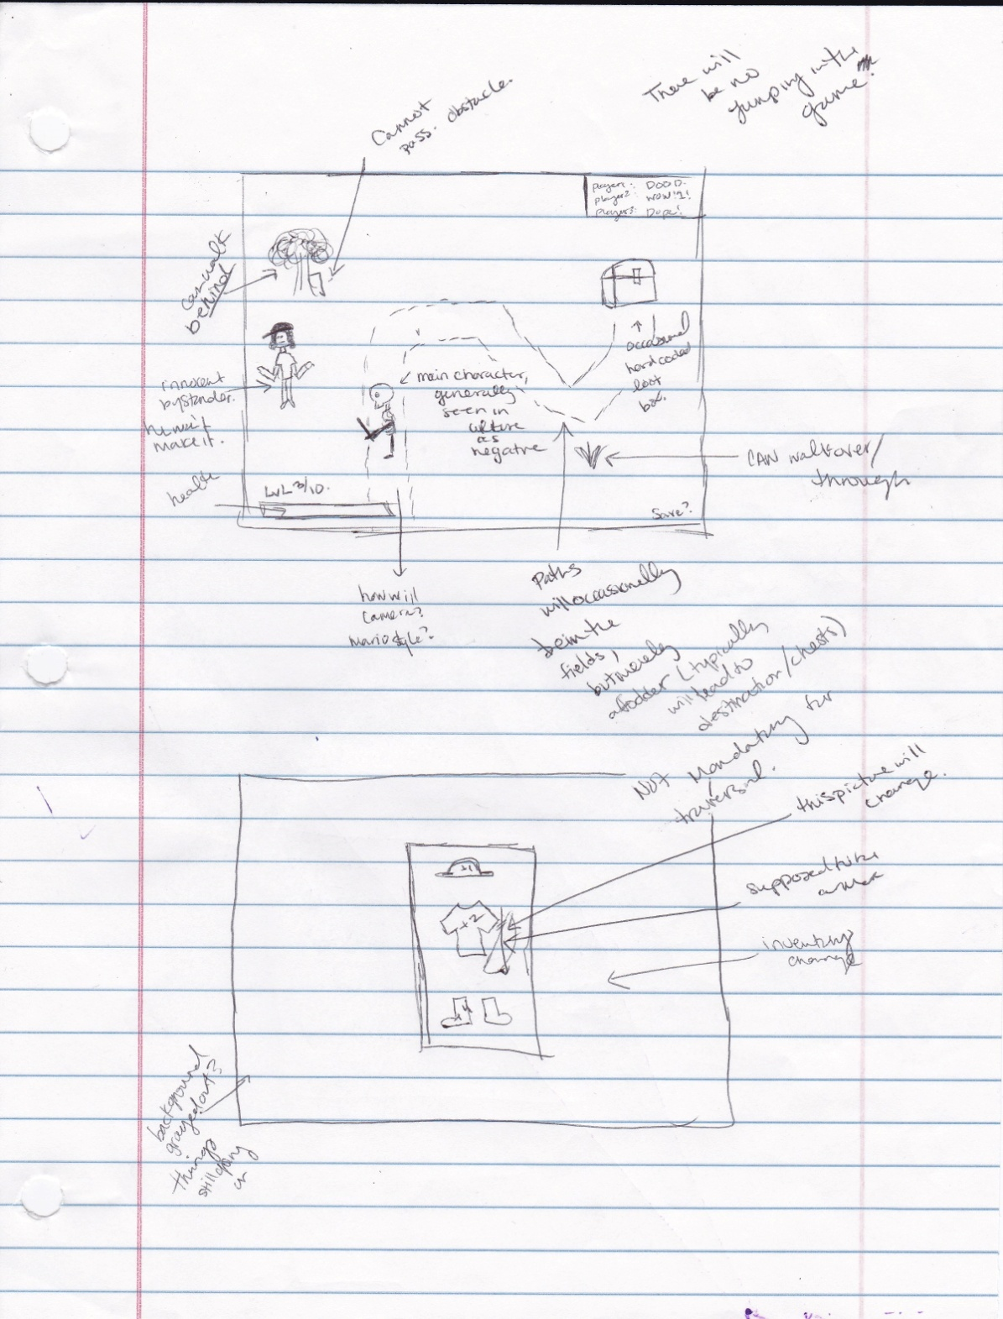

(Fig 1.2)

Another relevant note is that the equipment will not change appearance. There will only be a change of sprite appearance when the weapon changes if we make it to the point of a multi-weapon system.

The launcher should work as according to this flowchart: 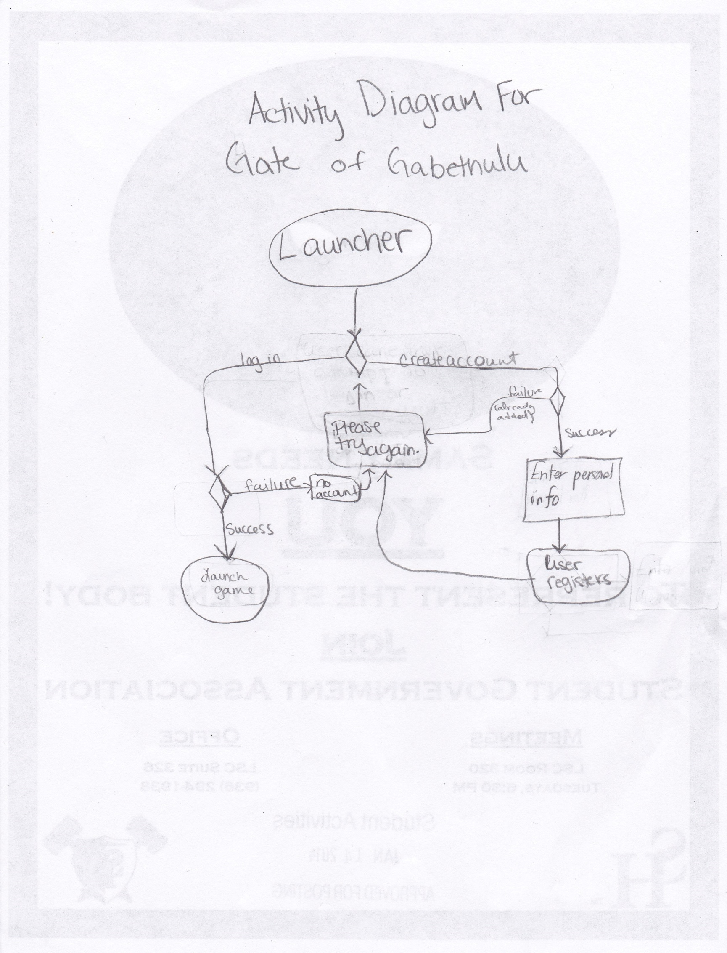(Fig 1.3)

The launcher will be a separate screen that is the graphical user interface between the user and accessing the server.

**5. Other Non-Functional Requirements**

High attention should be paid to security due to the possible future connection to a user’s Facebook or Google+ accounts. The software should be created in a way that no harm should come to the user’s PC. The only way this software will bring harm to a user is the misuse of their hardware in general, such as utilization while walk, driving, or doing any other activity that requires one’s full attention.

**6. Milestones**

Deadlines are of March 24th, 2014 for the Software Design an April 28th, 2014 for the final presentation of the Software.

Milestones in creation would include:

Creation of each level //This is important because it allows the game creators to finally see the world that was envisioned and gives an area for the character sprite to be tested on.

Creation of each character sprite, playable and interactive //Once the character sprite is created the test stages can finally lead to the testing of user input.

Character sprites first steps and actions with his environments

Character sprites first words and overlaid audio of actions

Game completion

Following updates after game completion and launches to other devices

**7. Key Resource Requirements**

Team members that take on this project will be required to have an understanding of database creation, maintenance, and modification. There will also be a need for the team members to either utilize a game engine or coding in any program language adequate enough to create a game of the caliber described in this specification. Understanding of networks and security will be required of some members of the group. Graphical user interface design and creation will be necessary along with the ability to create sprites. An understanding of general software design will be useful for the creation of a game that allows for proper space saving and time management of project completion that meets with the companies deadlines.

**8. Other requirements**

Registered users and their detailed information, monsters, and weapon information along with leaderboard stats and specific user stats will be held on the database. The database should be hosted on the master/ authentication server.

**9. Appendix/glossary**

-Hack and slash: Type of gameplay that focuses primarily on combat. “Hack and slash has its roots in "pen and paper" RPGs such as [Dungeons & Dragons](https://en.wikipedia.org/wiki/Dungeons_%26_Dragons), denoting [campaigns](https://en.wikipedia.org/wiki/Campaign_(role-playing_games)) of violence with no other plot elements or significant goal [1].”

-Dungeon-eering- Adventure gameplay with a focus on exploring a typically dungeon environment, during which you will encounter monsters, chests, treasure, etc.

-Top-down- The “eye in the sky” view. The world is seen from above the main character, watching over all the character does.

-Tutorial- Teaches the user how to play, walks the user through movement and actions necessary to gameplay.

-Customizable Appearance- Ability to change how one’s characters look.

-Areas of exploration- Areas that differ enough to be considered separate environments. Separated by style of terrain and types of enemies encountered.

-item drops and chests- Two methods by which items are obtained for the user. The item drops tend to drop non-story mandatory items; chests are typically designed to provide items necessary for story, or progressing forward in the game.

-Configurable Controls- controls that can be changed by the user to fit their preferences.

-Customizable Character Stats- The characters’ abilities to take hits, deal damage, and speed of movement can have points assigned to them at the beginning of character customization.

-Increasing difficulty level based on number of players- In order to prevent the game being too easy in the event of multiplayer, difficulty level increasing based on the number of characters is a concept that has been made popular in the gaming industry.

-Gameplay- The style of interaction with the game, its environment, and its non-playable characters.

-Leaderboard- A location for users to display the highest scores amongst all users who have played.

**10. Project Proposal**

Team 7 Software Proposal

Motivation: To provide an enjoyable hack and slash dungeon-eering adventure to the end user(s). We also want to allow for users to play together to further increases the factors of fun and enjoyment from this software.

Problem statement: This software is to be designed as a solution to the quickly growing problem of boredom.

Objectives: Populate our servers with data. Here are some examples of the processes our company expects to happen between our company’s product and our users:

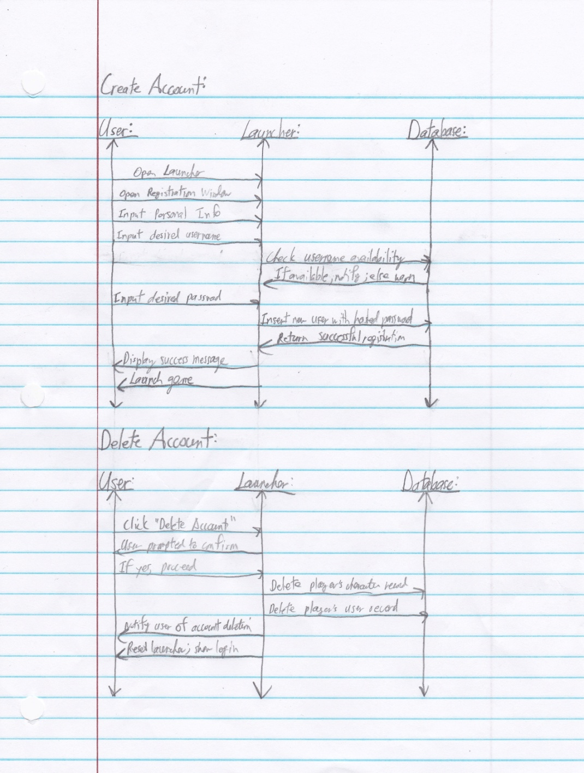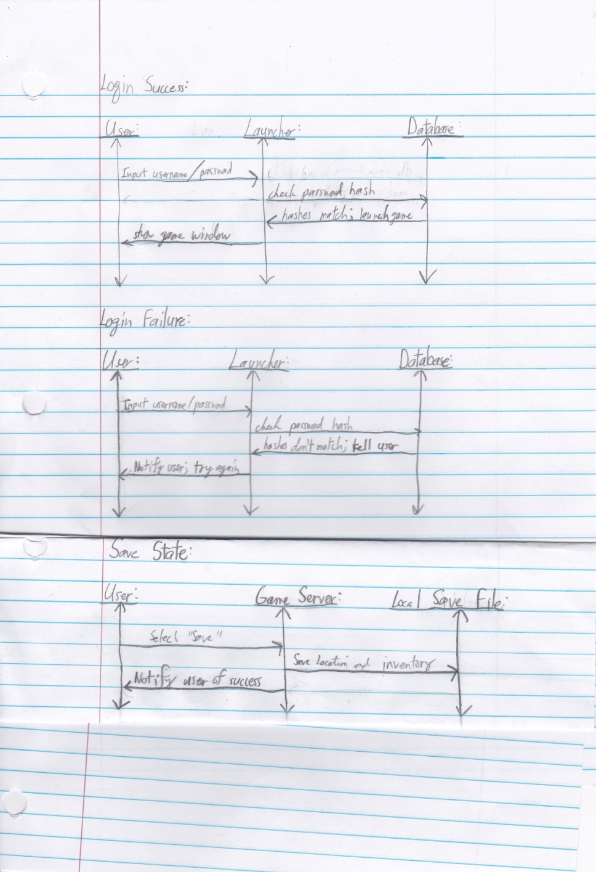

(Fig 1.4 and 1.5, respectively)

State Diagram (The processes as seen by the user)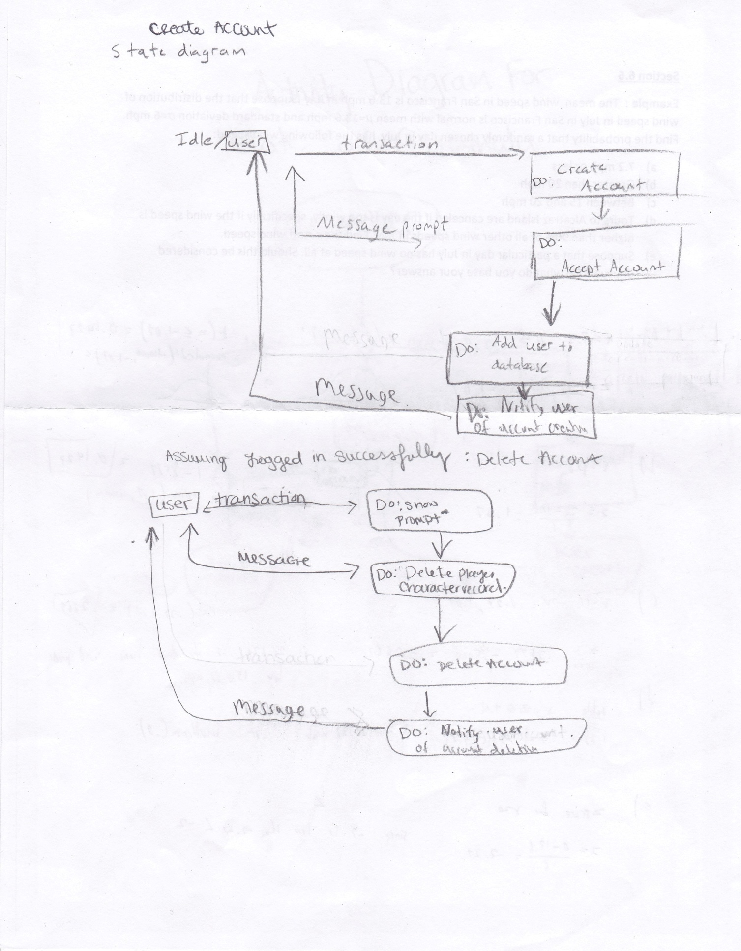

(Fig 1.6)

History*: Evoland, Diablo II, Legend of Zelda*. Our game differs by trying to attract users over the internet and through social networks. We would like for users to compare their stats on a leaderboard. Our project also plans on switching how the protagonist is portrayed. Most games show the protagonist as a “hero” or “good guy”. The characters ethical code will pretty much be the reverse of that of a normal person.

**GENERAL PLOT:**

Portal is opened bottom of map and our character comes out (If multiplayer all players would come out from same spawn location). Scientific experiment, so portal is going to be in one location anyway. The level progression will be a “go forth” style. You can just progress smoothly and the only notification you will get of change is the scenery and maybe a text box of information. Level #tutorial will be in a science lab with Dr. Yourdon Constantine as the enemy. Dr. Yourdon Constantine is purveyor of all things good. The world is now free from war and world hunger has been cured. Humanity is now so chaotically good that they are trying to open a portal to another world just so they can perfect it and make it just as pain free as Earth is. Open portal to our evil realm and we pop out and start slaughtering innocents. **The way the enemies get harder is thanks to the media on the first level (That we slaughter) filming our character murdering the scientists.** The fear that is put into the hearts of the people is what increases their strength and defenses. **It’s a sort of evolution of fear and paranoia.** The Enemies that we fight will hold household weapons. Like bleach and vinegar tossed at us dealing steady damage, fire of sticks, pointy sticks, lawn mowers. There will occasionally be the enemy that only runs from the main character, thus bringing challenge to the speed complete. (**Remember one of our leaderboard statistics will be speed of completion. By having 1-3 of these wildcard “run only” characters, we increase the difficulty of quickly completing the game.**) The design of the character that is running away peacefully will be in the category of utmost innocence without being overly offensive. An idea could be Richard Simmons, if we do not have him as our final boss, a bunny, and maybe finally a very well known character like a Teletubby (**But done satirically. If using Teletubby, please name it telebubby or something, we don’t want to be sued.**)

*Inventory management - 5 slot inventory system displayed vertically along the right border and it will be displayed on the right side of the screen. The user will be able to cycle through it. There will be a GUI overlay and there will be the ability to switchusing 1 -5 for the different weapons.

*Database details and relationships need to be explained.

*HUD-- how are we displaying the user's health? Above the user's head.

Design:

*Disclaimer that the prototype launcher and the prototype game are created in Java and Javascript respetively. The program used will probably change to a language that the entire team can utilize easily in respect to both systems.

**Works Cited:**

[1]Hack and Slash, https://en.wikipedia.org/wiki/Hack_and_slash: February 18, 2014.