***FIRST* Team 846:**

**Implementation of CAD in Robot Design**

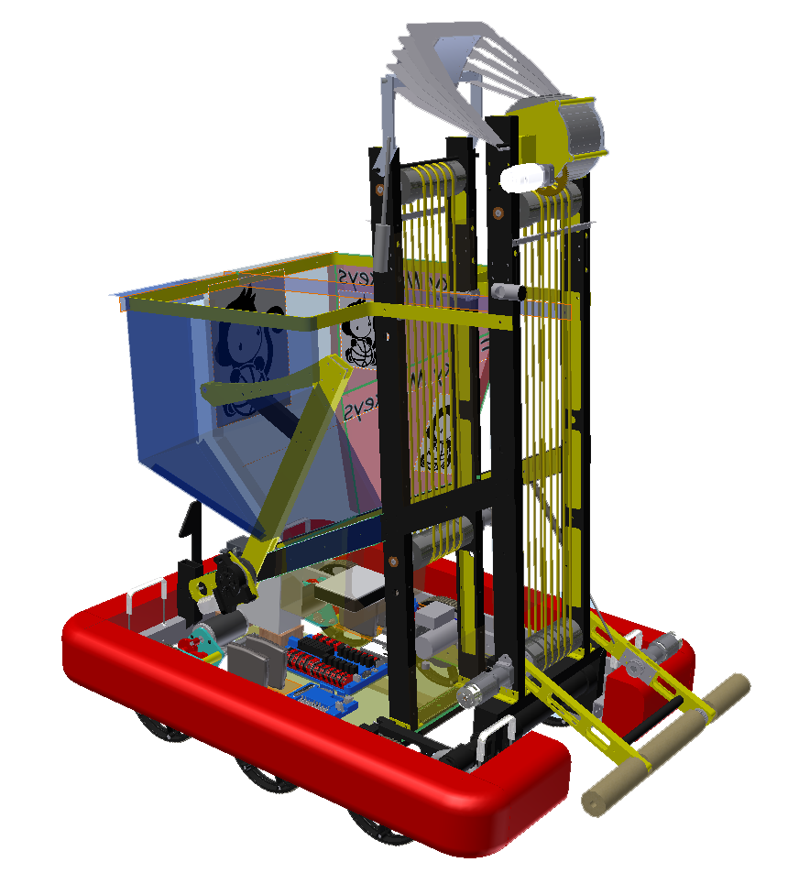

*Lynbrook Robotics uses the Autodesk Inventor software for many aspects of our robot. Amongst them is the design of the color scheme for our robot, which turns our robot from merely a decent creation into a refined and presentable product.*

Training to Use CAD

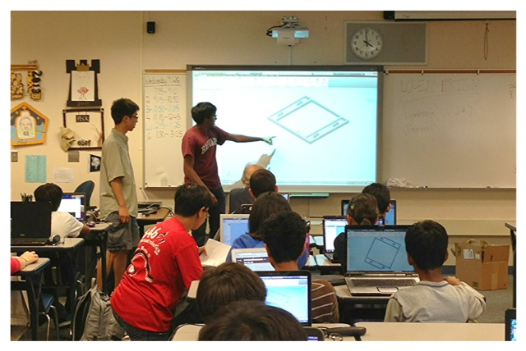

An important part of CAD on our team is making sure the next generation of students knows how to use it. For the past three years, our team has been teaching over 50 new members annually about how to use the Autodesk Inventor software and how it relates to our robot. Our veteran members pass on their experience to new members in two ways. First, we walk the entire group through a series of tutorials, such as the “make your own drivetrain” activity that our two student Hardware Leads are presenting above.



Second, if any students need more specific help, one of our many experienced members steps in to teach them the concept in a personalized way. Our team takes great pride in making sure that the vast majority of our new members have the basic skills in Autodesk Inventor necessary to contribute to robot design by the time the January-February build period comes around. Now, we will take a look at how our students have implemented their knowledge of CAD to enhance their design of our 2012 robot.

Crossing the Bump

In order to succeed at Rebound Rumble, our team prioritized having a drivetrain that could cross the bump at the midfield mark. Since the bump is less like a smooth speed bump and more like an obtrusive rectangular prism, we knew that achieving this goal would require very careful design. The Autodesk Inventor CAD software lent itself perfectly to that effort.

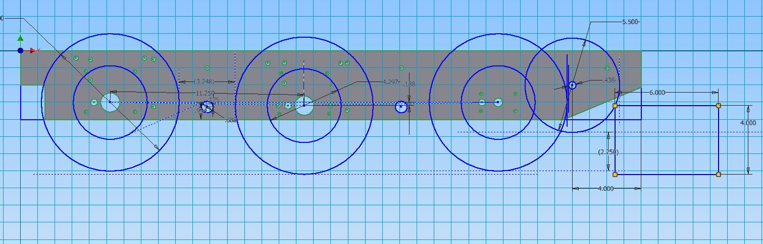

The first innovation our team dreamt up to tackle the bump was the two idler wheels placed ahead of the 6 drive wheels. As first parts of the robot to touch the bump, the idlers smoothly ride up on the bump and elevate the front of the robot by 1.75 inches. This allows the front pair of driven wheels to impact the bump below their axes of rotation, ensuring that our robot rides smoothly up over the bump rather than merely impacting hard and staying firmly planted on the ground. By using the Inventor software, we were able to quickly get a feel for the problem, and thus identify a commonly available polyurethane wheel that would do the job, a wheel position so the idler would be most effective, and requisite cut outs on the front and rear of the frame to clear the bump and idler wheels

.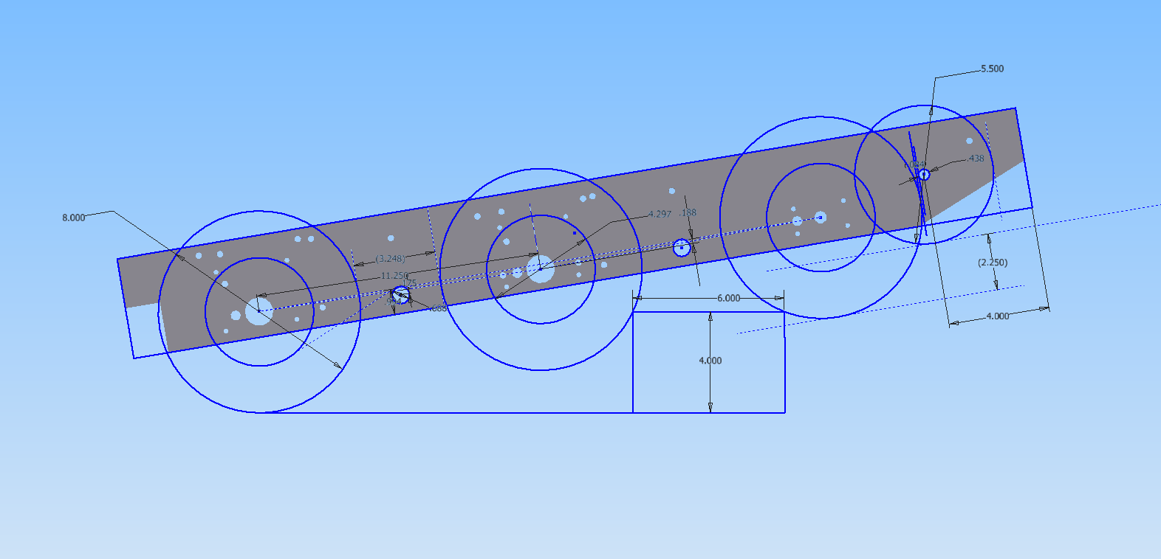

However, that idea only got our front wheels up and over the bump. Keeping the robot moving over the bump without getting stuck would be our second problem. We solved this by ensuring that the wheels never come out of contact with the bump while the robot is traversing over it and that the frame never impacts the bump. By using the Inventor CAD sketches on the robot side plate, we were able to tweak dimensions quickly to result in a wheel placement that would never allow our robot to be stuck.

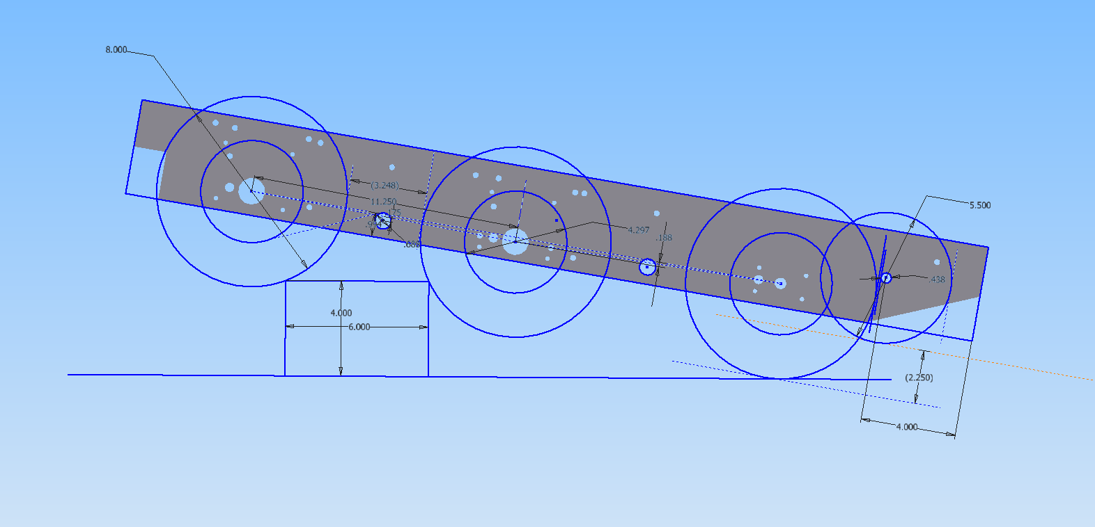

However, after that, there was one final problem; the chain that runs between our sprockets would interfere with traversing the bump if they were allowed to hang below the frame. With the use of the CAD software, we were able to quickly draw in chain paths over two idlers on each side of the drivetrain in order to verify that we could lift the chain runs sufficiently to cross the bump.

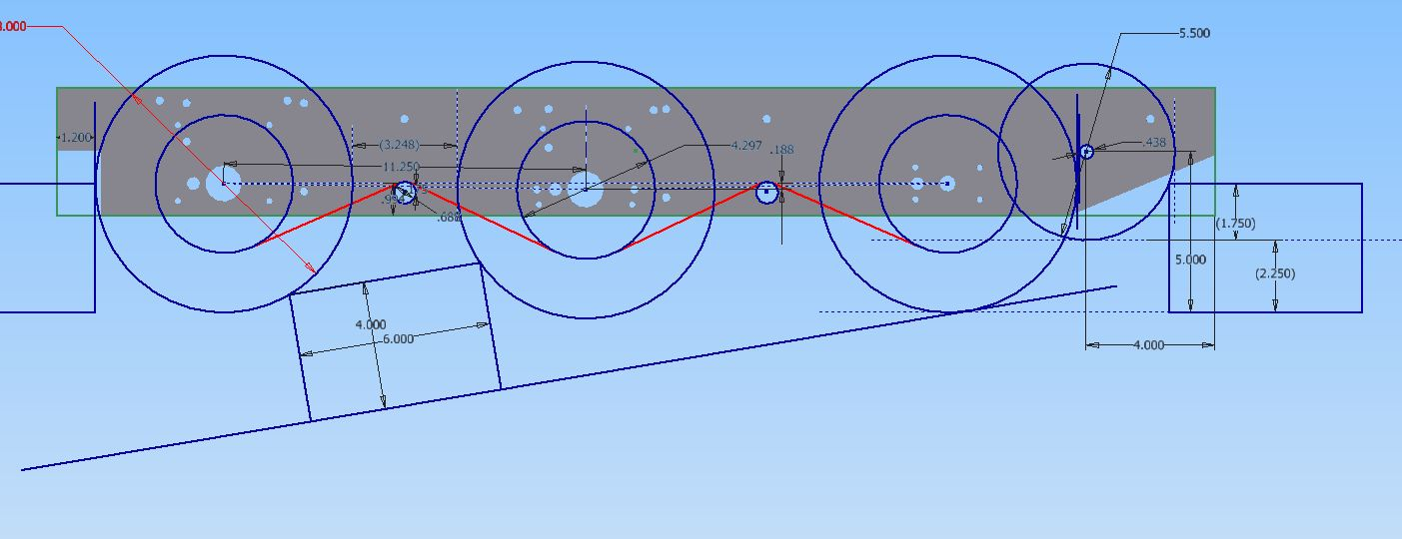

Through our innovative usage of the Autodesk Inventor design software, our team was able to create an effective solution to cross the midfield bump on the Rebound Rumble field.

Broach Press Stress Analysis

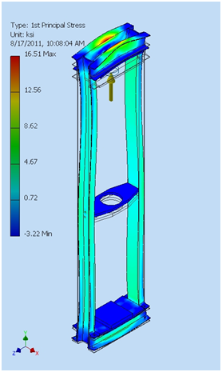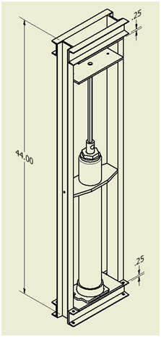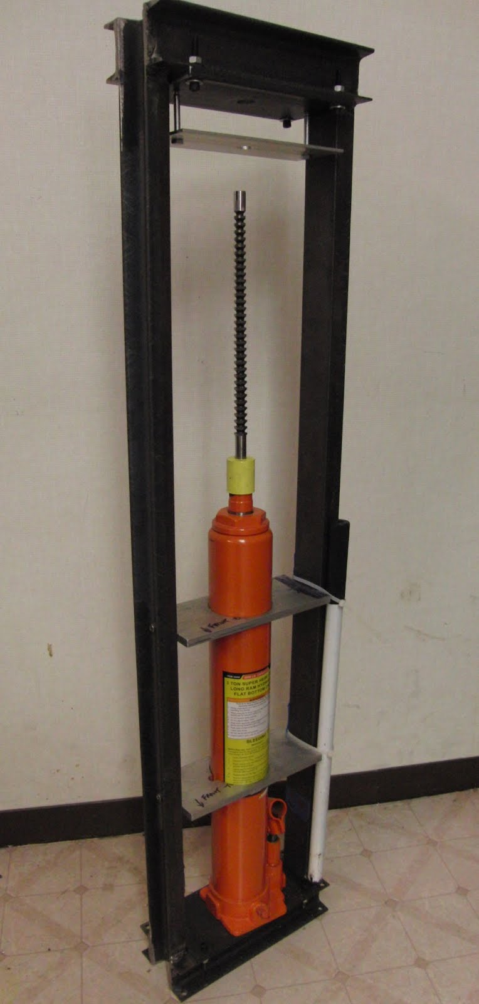

Whenever we need to turn a wheel by rotating its shaft, we need to ensure that the wheel and shaft remain firmly engaged to prevent slipping. For most applications, we must use a keyed or hexagonal ½ in. shaft, which requires keyways or hexagonal holes to be bored into the part interfacing with the shaft. One of the methods of creating this irregularly shaped hole is to apply 3 tons of force to push a broach through the part.   
 Most teams purchase a commercially available arbor press or hydraulic press to perform their broaching. However, arbor presses that deliver the required force often weigh in excess of 200 lbs, making them extremely difficult to move around. Meanwhile, hydraulic presses are not rigidly constructed and allow parts to slide around, creating imprecision in broached parts.  
 Instead of dealing with the problems of commercially available presses, we designed our own broach press rig in Autodesk Inventor. In order to create the strongest and lightest structure that could withstand the forces applied to it in the process of broaching, our students used the stress analysis feature of the Autodesk Inventor CAD software. In this way, we were able to test several different frame designs and choose the press design that handled the forces best, without actually having to build these designs and physically test them (and risk personal injury in the process).  
 After we managed to create an optimal frame design, which could withstand the high forces exerted while being lighter and more rigid than its commercially available counterparts, we then needed to actually build the rig. Through our use of the weld annotating features in Autodesk Inventor, we were able to create machinist drawings that clearly defined the welds that would be used to hold our structure together. This allowed us to leave our parts in the hands of a machinist who had never welded anything before and have confidence that they would come back welded correctly.  
 The result was a great broaching machine. Many real-life trials have proven that the design is not only safe, but also more precise than other broaching solutions commonly available. It also ended up easier to use; the student designer’s 12-year-old sister was able to broach a half inch hexagonal profile hole in a 1 inch thick piece of steel, operating the press with only her thumbs.  
  
Overall robot concept sketch

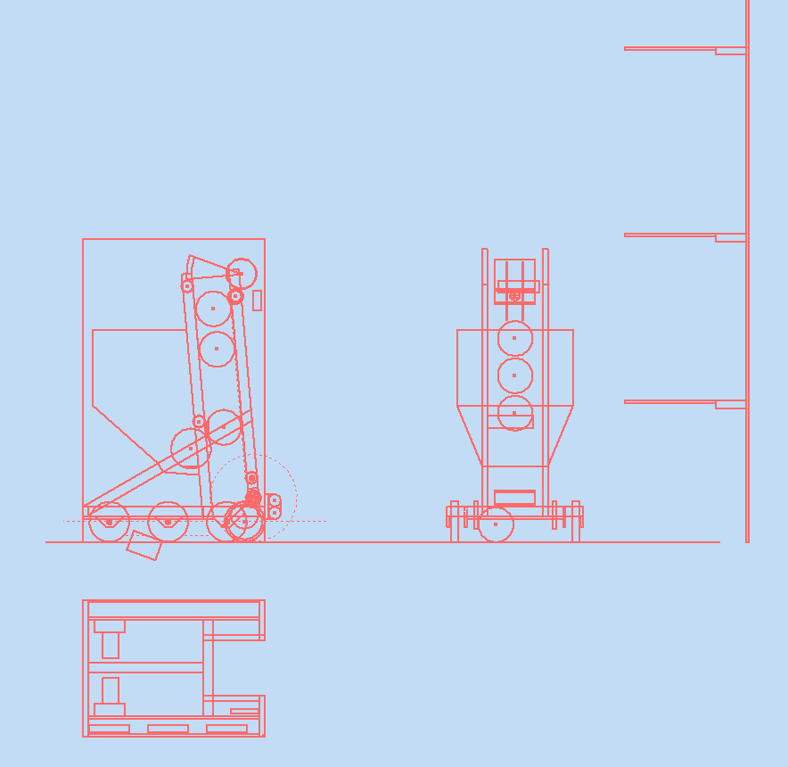

We knew after a few days of strategic consideration what we wanted our robot to be able to accomplish on the field. From this, we developed a concept; a forward mounted shooter on top of a conveyor with ground intake, with a hopper in the rear for our partners to feed us.   
 But we needed to make sure that we could get it all to fit in the 60 inch maximum height envelope with room to spare. We also needed to quickly see what the dimensions and details of our final design would end up being; how big our hopper could be, where our gearboxes needed to be mounted to balance out the weight, and how large of a ground intake we would have. By making a conceptual sketch in Autodesk Inventor, we were able to determine our overall direction in the building of our robot while having more specific dimensions and specifications than we would have had without formalizing our design concept using Autodesk Inventor. With a direction determined with the aid of the CAD software, our team was able to quickly organize itself and our members began the detailed design process.

Center of Gravity

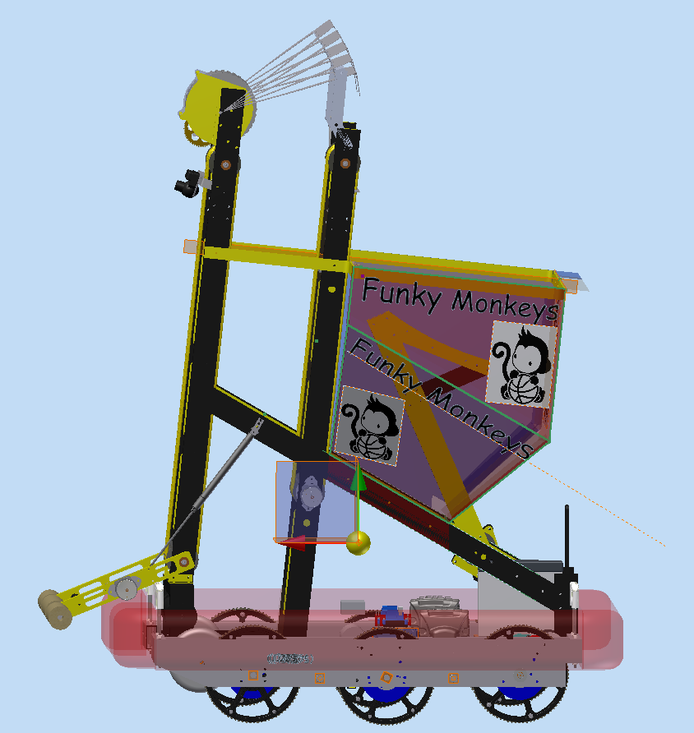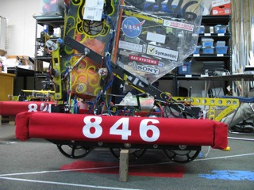  
   
 The position of the center of gravity on a robot is particularly important, as it determines around which point the robot attempts to rotate when it turns. It also matters if one does not want the robot to flip off the bridge during an attempt at balancing.  
 Our robot was designed with a forward mounted shooter to allow a hopper and to place the shooter closer to the hoop to improve consistency. However, the inherent nature of that design is that much of the robot’s mass is concentrated forward. This was a trait that we noticed because of our usage of the Autodesk Inventor Center of Gravity feature, which gave us a good idea of the problem we faced.  
 As a result, we were able to implement a solution that worked the first time around. Many teams tweak the location of the different components of their robot after it is built to put the center of gravity where they want it for best performance. We were able to position the battery and gearboxes towards the rear just right with the aid of the Inventor CAD software, resulting in a robot that balances almost perfectly over its center wheels. This allowed our robot to turn very quickly while maintaining great precision.

CAD in Manufacturing  
  
 While CAD is often thought of as primarily a design tool, we find that it is useful in other stages of our robot’s development. This season, we were able to use CAD to enhance and speed up the production of our robot, and create designs that would not be possible to make by hand.

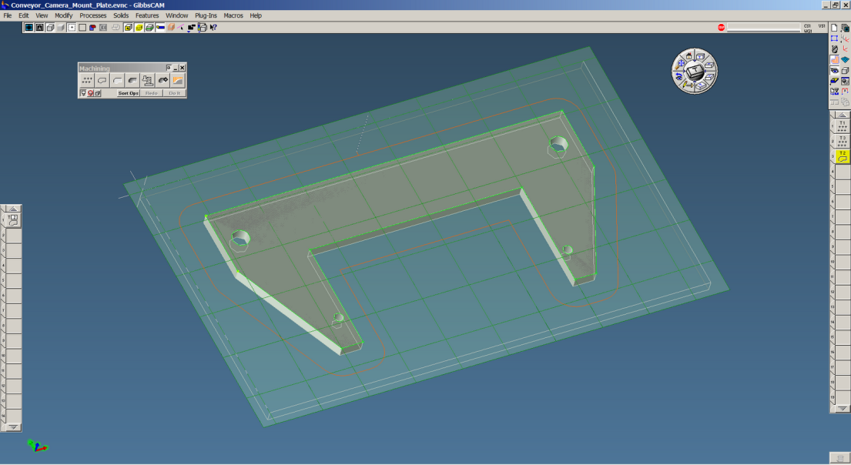  
*Selecting geometry in GibbsCAM.*

This year, we acquired a CNC mill, and a CAM suite to accompany it. First, parts on our robot are first conceived and designed using CAD. Next, these CAD models are imported into the GibbsCAM program, where the appropriate geometry is selected and the machining processes is created. GibbsCAM then creates a set of instructions written in “G-Code,” which gets exported to our CNC mill to be cut.

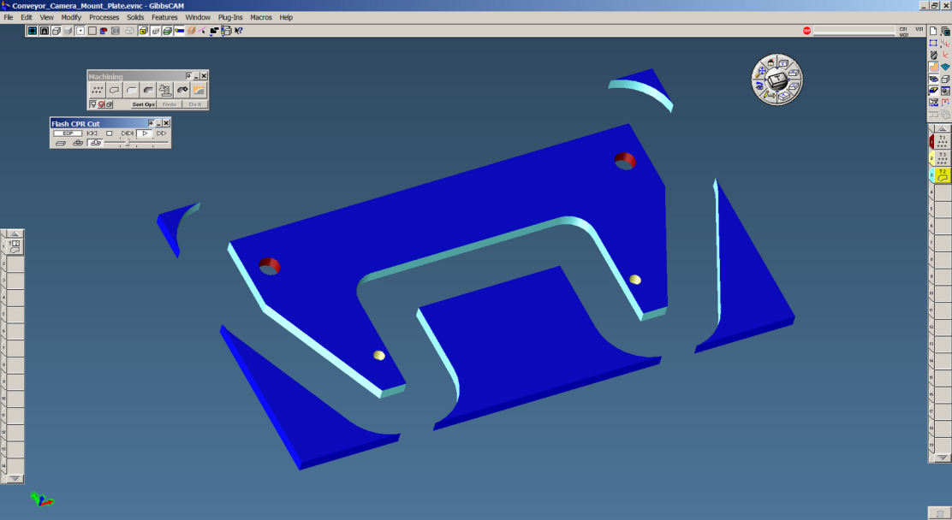

*Simulating a machine run in GibbsCAM.*

By being able to export our CAD model directly to GibbsCAM and generate machine code, we were able to drastically speed up the manufacturing of our robot. Additionally, our use of CAD in manufacturing enabled us to make parts that we could not have created by hand. For example, through this approach, we designed and created our bridge tipping appendage, the “Tail of the Monkey,” for our 2012 robot.

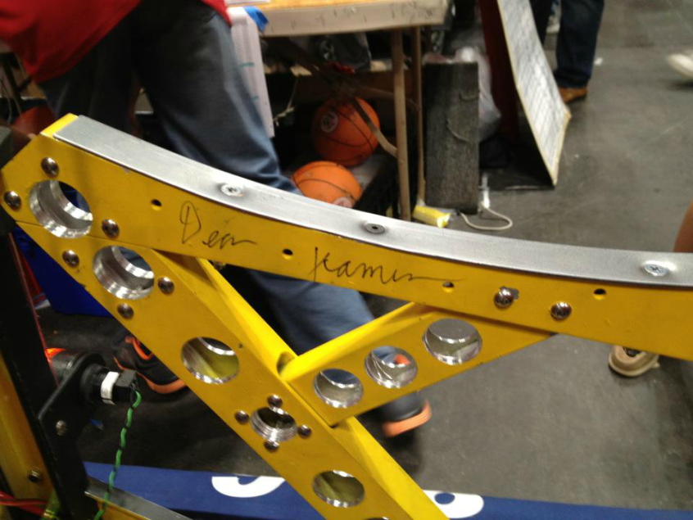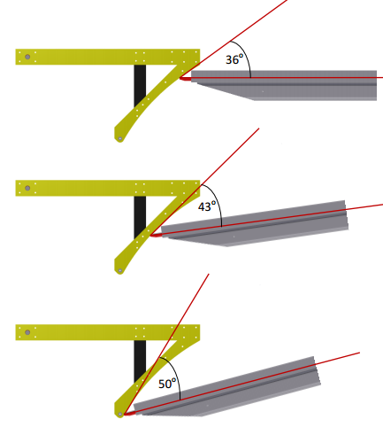

We were able to cut a precise curve into the “Tail”, which allows it to have a shallow initial contact angle to easily overcome the original rotational inertia of the static bridge and gradually increases to a steeper angle as the bridge begins to tip. Throughout the 2012 season, our Tail performed spectacularly, effortlessly bringing the bridge down in front of our robot time and time again. This performance wouldn’t have been possible without our usage of CAD in the manufacturing process.