

Lynbrook Robotics
FIRST Championship Event
April 15th – April 19th, 2009
Georgia Dome – Atlanta, GA
TABLE OF CONTENTS:
Item: Page #
Trip Schedule 2
Contact Information 4
What to Bring 5
Room Assignments 6
Downtown Map 7
Important Links 8

TRIP SCHEDULE
Wednesday, April 15, 2009
8:45AM Team meets at the Lynbrook parking lot
9:00AM Team leaves for SJC from the Lynbrook parking lot
11:35AM Flights departs from the Mineta San José International Airport (Delta Flight #1190)
7:10PM Flight arrives at the Hartsfield-Jackson Atlanta International Airport
Team takes MARTA from airport to hotel
(S7 Airport 7:30PM train, to N1 Peachtree Center, 7:49PM)
6:00-9:00PM FRC Pits Open to 3 Team Reps to uncrate robots, then depart
10:30PM Team meeting
11:00PM Lights out
Thursday, April 16, 2009
6:30AM Wake up and eat breakfast
7:30AM Georgia Dome and FRC Pits Open, Team arrives (1.2 mile walk from hotel, ~20 minutes walking, 15 minutes metro)
9:30AM Practice Rounds
12:15PM Lunch
1:00-5:30PM Practice Rounds (cont.)
6:30PM Team Drivers Meeting
8:00PM Pits and Machine Shop close
10:30PM Team meeting
11:00PM Lights out
Friday, April 17, 2009
6:30AM Wake up and eat breakfast
7:00AM Georgia Dome and FRC Pits Open, Team arrives
8:30AM FIRST Championship Welcome and FRC Opening Ceremonies
9:25AM Qualification Rounds
12:15PM Lunch
1:00-5:30PM Qualification Rounds (cont.)
6:00PM Pits and Machine Shop Close
7:30PM Team Dinner
10:30PM Team meeting
11:00PM Lights out
Saturday, April 17, 2009
6:30AM Wake up and eat breakfast
7:00AM Georgia Dome and FRC Pits Open, Team arrives
8:45AM Qualification Rounds
11:45AM Alliance Selections
12:15PM Lunch
1:00PM Division Elimination Final Rounds
3:30PM Division Ceremonies and Awards
4:00PM Final Rounds and Awards
7:30PM Team Dinner
10:30PM Team meeting
12:00AM Lights out
Sunday, April 18, 2009
5:00AM Wake up and eat breakfast
5:35AM Team meets in hotel lobby
5:50AM Team departs from hotel to airport:
MARTA, N1 Peachtree Center, 6:08AM train to S7 Airport, 6:28AM
8:28AM Team departs from Hartsfield-Jackson Atlanta International Airport (Delta Flight #1579)
10:44AM Team arrives at Mineta San José International Airport. Parents may come directly to the airport to pick up their students.

CONTACT INFORMATION
Name |  | Grade | Cell # | Emergency # | Relation
Akane | Bessho | 9 | 439-4008 | 446-0393 | Home
Yuchen | Mou | 9 | 324-6698 | 252-8965 | Home
Huan | Zhi | 10 | 431-7766 | 996-9566 | Home
Haochuan | Ni | 10 | 650-828-7186 | 446-0850 | Home
Chinmay | Jaju | 10 | 568-4877 | 257-2537 | Home
Eric | Jan | 10 | 568-5373 | 253-6609 | Home
Kirstie | Yu | 10 | 406-3994 | 973-0710 | Home
Zack | Birnbaum | 10 | 402-2414 | 257-7374 | Home
Karena | Cai | 10 | 772-0755 | 253-4831 | Home
Steven | Hatton | 11 |  | 252-8575 | Home
Matthew | Hong | 11 | 316-2477 | 777-1235 | Home
David | Liu | 11 | 828-3890 | 621-5340 | Dad Cell
Yuya | Bessho | 11 | 250-0029 | 446-0393 | Home
Brandon | Liu | 11 | 489-2245 | 863-0686 | Home
Boris | Poutivski | 11 | 368-5298 | 996-1930 | Home
Yusuke | Sato | 11 | 386-2681 | 257-7329 | Home
Toshitaka | Tachibana | 11 | 207-8923 | 777-9318 | Home
Jonathan | Xie | 11 |  | 725-7901 | Home
Manami | Yokoyama | 11 | 472-2286 | 996-7154 | Home
Kevin | Gan | 11 | 666-3218 | 996-7951 | Home
Alan | Tsao | 11 | 931-5608 | 252-8848 | Home
Dennis | Liaw | 11 | 892-0052 | 255-8805 | Home
Johnathan | Chai | 12 | 858-7421 | 252-5661 | Home
Thomas | Deng | 12 | 887-4873 | 887-4873 | Home
Daiwei | Li | 12 | 497-9899 | 255-5294 | Home
Aashish | Sreedharan | 12 | 203-2011 | 255-5159 | Home
Edward | Lu | 12 | 568-7371 | 996-7792 | Home
Michael | Wachenschwanz | 12 | 489-4980 | 257-5424 | Home
David | Wachenschwanz | Adult | 655-2174 | 489-4919 | Young Hee (spouse)
David | Giandomenico | Adult | 348-7623 | 582-2779 | Jean Chang (spouse)
Yang | Xie | Adult | 644-7428 | 225-1933 | Home
Gerald | Haas | Adult | 530-320-2144
Nancy | Haas | Adult | 530-320-2144

WHAT TO BRING
The temperature in Atlanta during April should be reasonably comfortable. It would be wise to pack light, with a few long sleeves.
Clothing (pack for five days):
Sweaters
Shirts
Robotics Shirt(s) ← Bring ones from previous years in addition to this year’s. They come in handy.
Socks/Underwear
Comfortable walking shoes (close toed for the pits)
Pants and shorts
Swimming gear (if you want to swim in the hotel swimming pool)
Other:
Student ID / Driver’s License
Money
Cell Phone/ Charger
Camera
Sunscreen
Bath products

Please refrain from bringing:
Computers/Laptops (unless for Robotics purposes)
Expensive items
Laser pointers
Knives or weapons in any shape or form (the Zero Tolerance policy still holds)
Flammable items

Notes: Robotics will not be held accountable for any items lost, stolen, or broken during this trip.

ROOM ASSIGNMENTS
Room leaders need to know where their roommates are at all times, to make sure their roommates are there for all events listed on the trip schedule, and need to have their cell phones on at all times.
Room 1 |  |  | Room 5 |  |  | Room 9
Daiwei* | 12 |  | John* | 12 |  | Mr. Wachenschwanz
Kevin | 11 |  | David | 11
Haochuan | 10 |  | Brandon | 11
 |  |  | Eric | 10
Room 2 |  |  | Room 6 |  |  | Room 10
Aashish* | 12 |  | Michael* | 12 |  | Mr. Giandomenico
Boris | 11 |  | Dennis | 11
Chinmay | 10 |  | Matt | 11
 |  |  | Zack | 10
Room 3 |  |  | Room 7 |  |  | Room 11
Edward* | 12 |  | Manami* | 11 |  | Mr. Xie
Jonathan | 11 |  | Huan | 10
Yusuke | 11 |  | Akane | 9
Alan | 11
Room 4 |  |  | Room 8 |  |  | Room 12
Thomas* | 12 |  | Karena* | 10 |  | Mr. Haas
Toshi | 11 |  | Kirstie | 10 |  | Mrs. Haas
Steven | 11 |  | Lucy | 9
Yuya | 11
*Room Leader

Notes: Please exercise sound judgment. Chronically disruptive students will be sent home at their own expense.
[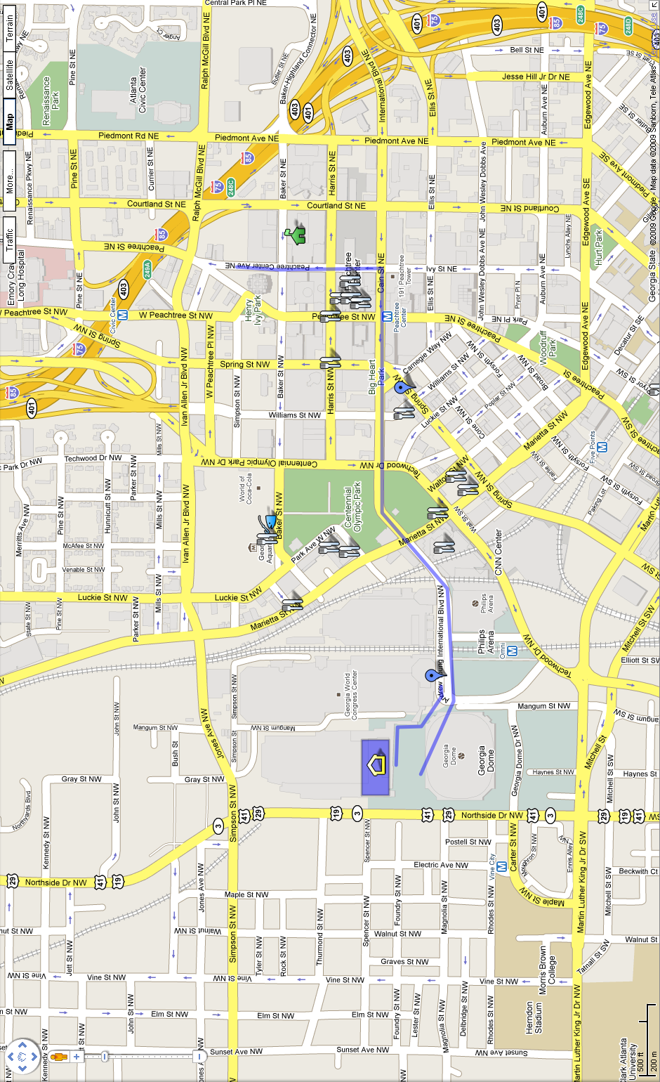
IMPORTANT LINKS
Custom Atlanta Map put together by the team with important landmarks:
http://tinyurl.com/frc846atl1
Atlanta website specifically put together for the FIRST Championship:
http://www.atlanta.net/first2/index.aspx
Event information from FIRST (pdf)
http://tinyurl.com/frc846atl2
MARTA schedules and map
http://tinyurl.com/frc846atl3
Atlanta Marquis Hotel website
http://tinyurl.com/frc846atl4

