DOCUMENTATION: **ENCODER**

An encoder is a device that is used in many industries to provide feedback. In the most basic terms, an encoder, regardless of the type, senses “position”, “direction”, “speed”, or “counts”. Encoders will use motion, under a variety of technologies, and translate it into an electrical signal.

That signal is then sent back to a controlling device, such as a PLC, and is interpreted, meaning scaled, to represent a value that will then be used within the program.

**The Most Common Types of Encoders:**

Encoders are most often used to measure linear or rotational motion. Everything from how they are constructed to the signaling method can vary based on their environment, application and budget.

### Linear Encoders:

These measure straight-line motion. Sensor heads that attach to the moving piece of machinery run along guideways. Those sensors are linked to a scale inside of the encoder that sends digital or analog signals to the control system.

### Rotary Encoders:

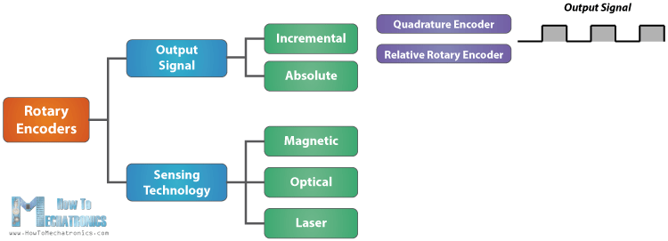

A rotary encoder is a type of position sensor which is used for determining the angular position of a rotating shaft. It generates an electrical signal, either analog or digital, according to the rotational movement.

Here’s how the square wave pulses are generated: The encoder has a disk with evenly spaced contact zones that are connected to the common pin C and two other separate contact pins A and B, as illustrated below.

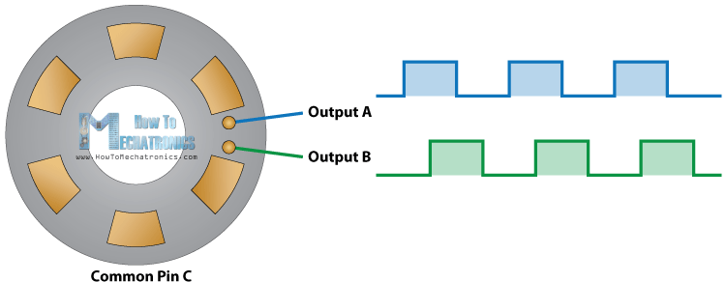

When the disk will start rotating step by step, the pins A and B will start making contact with the common pin and the two square wave output signals will be generated accordingly.

Any of the two outputs can be used for determining the rotated position if we just count the pulses of the signal. However, if we want to determine the rotation direction as well, we need to consider both signals at the same time.

We can notice that the two output signals are displaced at 90 degrees out of phase from each other. If the encoder is rotating clockwise the output A will be ahead of output B.

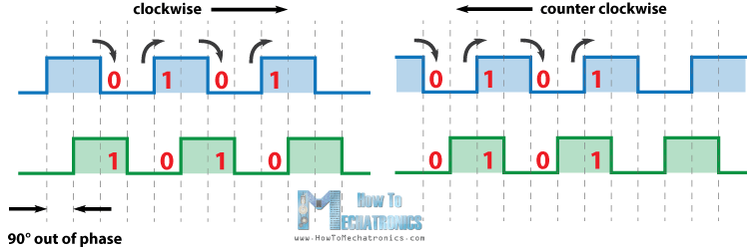

So if we count the steps each time the signal changes, from High to Low or from Low to High, we can notice at that time the two output signals have opposite values. Vice versa, if the encoder is rotating counter clockwise, the output signals have equal values. So considering this, we can easily program our controller to read the encoder position and the rotation direction.

### The Difference between Absolute and Incremental Output:

Incremental encoders measure in relation to a starting point. Every time a system is turned on a new zero reference point is established, or a new one will need to be reestablished by the user. Markings or steps are spaced equally apart on the scale, or disc in the case of rotary encoders. The encoder generates a pulse-like signal based on each marking, which is translated to a signal.

On the other hand, absolute encoders recognize a distinct location at all times. It’s not relative to another and there’s no need for reestablishing a zero point. Instead of equally spaced marks, distinct tracks or markings transmit a unique code at each location to a serial control.

### The Difference between Magnetic and Optical Encoders:

How encoders recognize and process the various coding or markings is different. Magnetic encoders use the relation between static and/or dynamic magnetic fields or distinct tracks and translate those into signals. The other common design is optical, which uses light that’s passed through glass and recognized by a receiver. Magnetic assemblies are generally more simple, compact and durable, while optical encoders are extremely accurate and able to function in areas with other magnetic forces.

### The Difference between Sealed and Exposed Encoders:

Encoders are critical to the proper function of their mechanical system. The slightest inaccuracy or malfunction can cause a significant ripple effect on whatever the larger operation may be. Those systems and operations take place in widely different environments, from machine tools where coolant and/or metal chips may be moving around at high speeds and pressures to sterile medical labs.

Sealed and exposed encoders provide options that suit whichever type of environment in which they’ll be deployed. Sealed encoders encase the most delicate components of the encoder, protecting them from whatever contamination may be present. Exposed encoders take up less space, generally excel in high-speed scenarios and are often deployed in high-precision measuring applications.

## Applications of Encoders:

Encoders are critical components in all kinds of mechanical systems. They are especially prevalent in industrial settings where large machinery performs repeatable tasks, high-precision prototyping or delicate work.

## Reference:

## *Applications*: <http://encoder.com/applications/by-function/>

## *Applications*: <http://encoder.com/applications/by-industry/>

## *working:* <https://www.youtube.com/watch?v=v4BbSzJ-hz4>