“Just Disc Battle” game

Team “Baracuda”

# Introduction

The game “Just Disc Battle” was developed as a team project for the JavaScript UI & DOM course in Telerik Academy using kiteticjs and requirejs. The following description contains information about the team members, screenshots, brief gameplay details, and the URL of the team repository.

# Team “Baracuda” members

The team's members have been chosen by the Academy and include the following students:

* Mihail Yankov ([M.Yankov](https://telerikacademy.com/Users/M.Yankov))
* Emilia Georghieva ([Emiliya93](https://telerikacademy.com/Users/Emiliya93))
* Martin Ali ([Beardhammer](https://telerikacademy.com/Users/Beardhammer))
* Adrian Apostolov ([Adrian.Apostolov](https://telerikacademy.com/Users/Adrian.Apostolov))
* Alexis Sideriss ([a.sideriss](https://telerikacademy.com/Users/a.sideriss))
* Georgi Enchev ([enchev93](https://telerikacademy.com/Users/enchev93))
* Dimitar Lachkov ([dlachkov](https://telerikacademy.com/Users/dlachkov))
* Andrey Traykov ([andrei_pl](https://telerikacademy.com/Users/andrei_pl))

# Project purpose

The player controls the red ninja puck with the mouse. The player and the computer are bound to their fields and can’t cross the middle of the playground. The player must hit the ball puck and score a goal while defending his goal line.

The purpose of the game is to first score 3 goals. If the computer scores 3 goals before you, you lose. The amount of goals are displayed in the top bar.

# Source code

[Git repository](https://github.com/TeamBarracuda-Telerik/JustDiscBattle)

# Screenshot

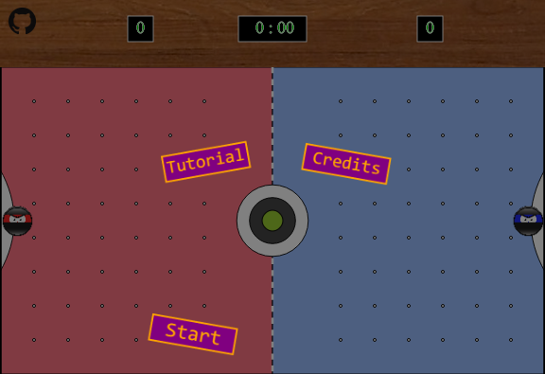

# General Requirements

* Use the HTML5 canvas or a canvas framework

Canvas is used for drawing the participants like player and enemy (computer) and for drawing the ball puck.

And for the start menu is used KineticJS framework.

* Use SVG or a SVG framework

SVG is used for drawing the playfield, scores and github logo link.

* Create animations either for the canvas, SVG or both

Used requestAnimationFrame function for running the game and used for both canvas and SVG.

# Additional Requirements

* Correct naming

Following the principles of high quality code, there are used suitable and well named variables.

* Data encapsulation

There are used OOP and modules principles for data encapsulation.

* Strong cohesion and loose coupling

The modules are separated logically and every function or object has his own purpose.

* Use GIT as a source control system

Done.