**User Story: Employer can submit Student Evaluation Form (Iteration 1)**

Task: Write user documentation for submitting a Student Evaluation form by Employer.

Coop Advisor will provide a URL to the Employer for Student Evaluation Form via Email. In order to submit Student Evaluation form, Employer must select open that link. Once Employer selects that URL, the system will be redirected to Student Evaluation Form, wherein Employer has to fill out various information regarding the skills and activities of a student during their Coop Term. Next, populating the form with required information Employer must hit the submit button to send the information; however, Employer may hit cancel to cancel the submission or later submission. Below is the list of information that the Employer should consider:

Student ID (required) Student Name (required)  
Organization (required) Job Title (required)  
Work Term (required) Year (required)  
Supervisor Name (required) Manager Name(required)

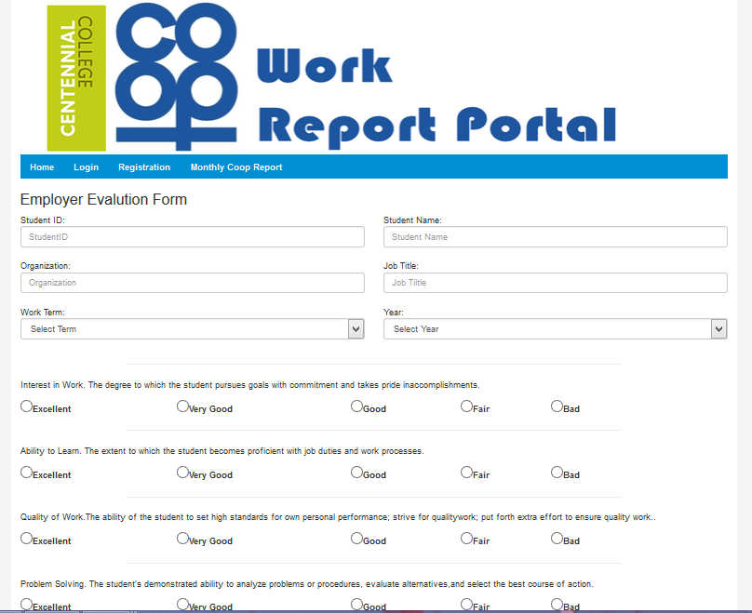

*Figure .. CoopReporting application: Employer can submit Student Evaluation Form*

After Employer successfully complete Evaluation Form submission, the system will display message (see figure…. ) regarding submission “Thank you for submitting Form”. This message will only display if Employer have successfully submitted form. Further, you can verify your submission by viewing previous report under the reports tab.

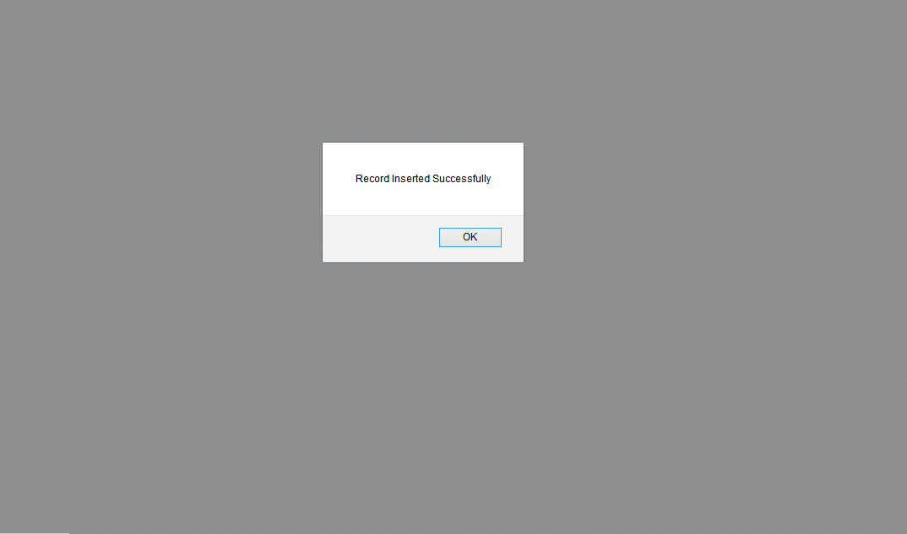

*Figure CoopReporting application: message on successful Evaluation Form submission*