**User Story: Student can view and edit profile**

This user story give permission to student can view and edit their profile. Valid student has to login into site to view profile. On navigation click on profile tab to view profile.

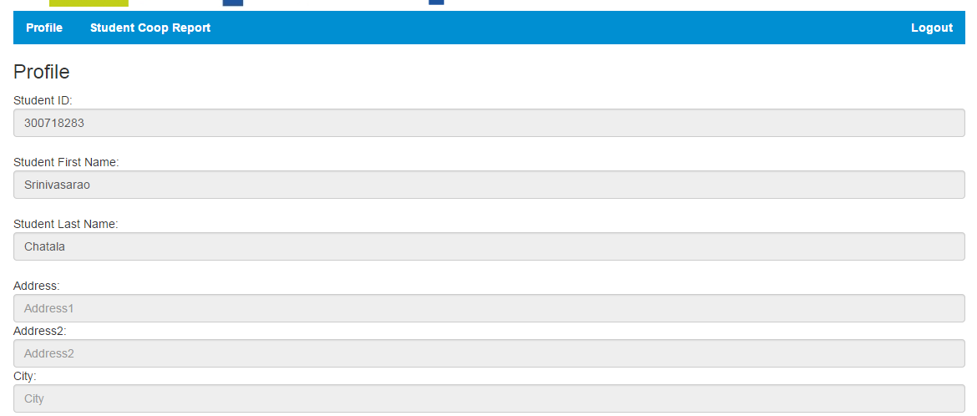

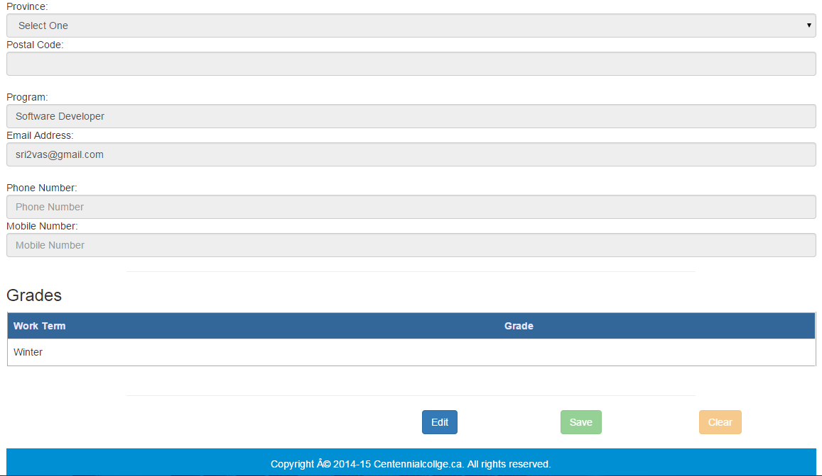

By default all the fields in profile page are in read only mode, once student clicks on edit button student will get permission to change profile information. Student can change first name, last name, email address, phone number, mobile number, address and city, province, and postal code these are the standard fields that a student can change. In the list there are some of the mandatory fields like student first name, student last name, student program, and email address.

By clicking the save button student can save profile with updated information. When student clicks on clear button all the fields, save, and clear buttons will turn into read only mode.

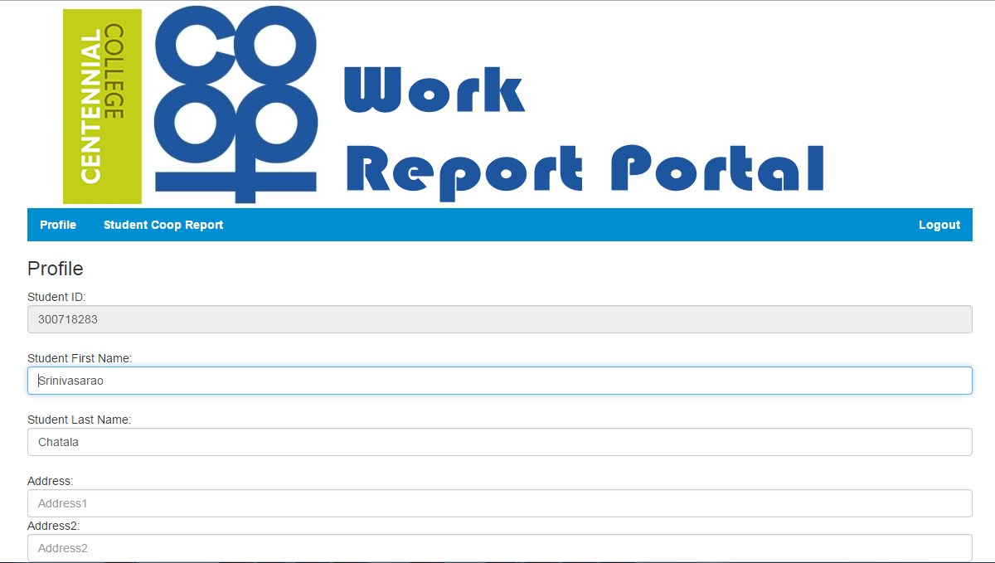

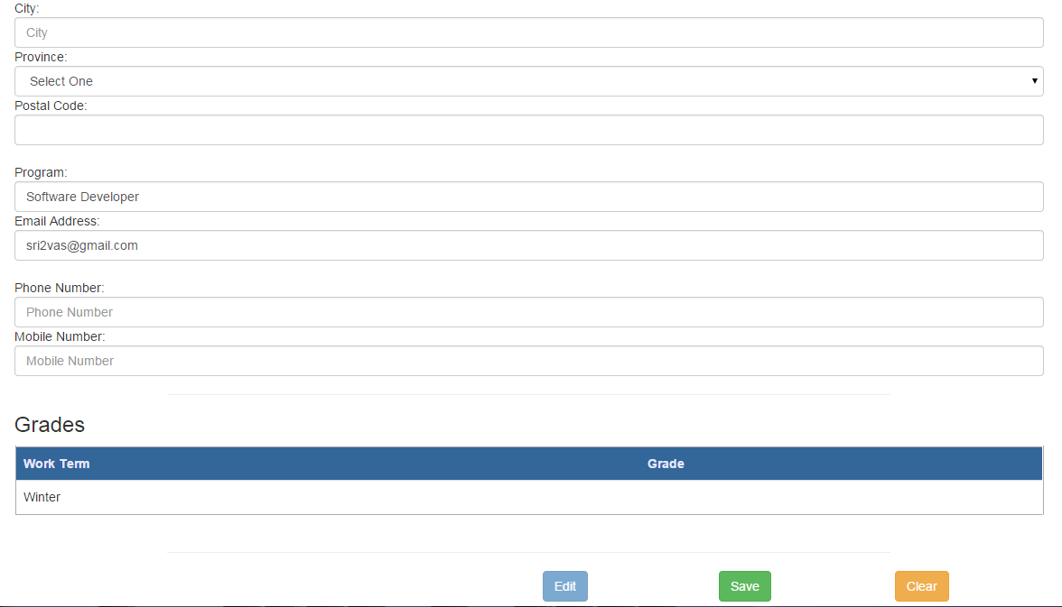

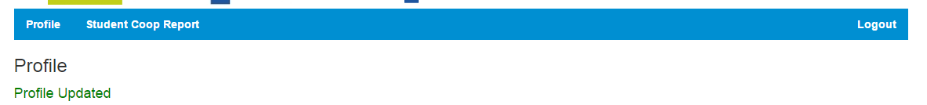

At the bottom of the page student can view his or her grades, these grades information student cannot change, and it’s just for view purpose.

