A Synopsis

Of

Project

On

DeskPilot
Privacy Preserving Offline File Automation Using Local Language Models

Submitted in partial fulfilment of the requirement for the award of the degree of

BACHELOR OF TECHNOLOGY

IN

COMPUTER SCIENCE & ENGINEERING

Under the Guidance of

Dr. Akansha Gupta
(Professor)

Project Team ID: MP2026CSE58


Submitted By

Name of Student1: Naman Kumar Enrollment No.: GE-232023472
Name of Student2: Abhishek Sharma Enrollment No.: GE-232023744
Name of Student3: Anshika Rawat Enrollment No.: GE-232023841

DEPARTMENT OF COMPUTER SCIENCE & ENGINEERING
GRAPHIC ERA DEEMED TO BE UNIVERSITY
DEHRADUN
SEPTEMBER 2026
CERTIFICATE
This is to certify that the project synopsis entitled “DeskPilot” is being submitted by Naman Kumar(GE-232023472), Abhishek Sharma(GE-232023744) and Anshika Rawat(GE-232023841) for the partial fulfillment of the requirement for the award of the degree of B. Tech-CSE in Department of Computer Science & Engineering, Graphic Era Deemed to be University, Dehradun, and is a record of his/her own work carried out under my supervision. The matter embodied in the synopsis has not been submitted in any other university or institution for the award of any degree.

Name of the Supervisor : Dr. Akansha Gupta
Designation : Professor
Department of Computer Science and Engineering,
Graphic Era Deemed to be University, Dehradun, India

DECLARATION
I/we hereby declare that the project synopsis entitled “DeskPilot” is being submitted for the partial fulfillment of the requirement for the award of the degree of B. Tech-CSE in Department of Computer Science & Engineering, Graphic Era Deemed to be University, Dehradun, is my/our original work and has not been submitted to any other university or institution for the award of any degree or diploma.


Naman Kumar (23011020) Signature


Abhishek Sharma (230213914) Signature


Anshika Rawat (230223817) Signature

TABLE OF CONTENTS

S.No. CONTENT PAGE NO.

1. | Abstract | 5
2. | Introduction | 6
3. | Literature Review | 7-9
4. | Problem Statement & Objectives | 10
5.  6.  7. | Proposed Methodology  Workflow Architecture  Hardware and Software Requirements | 11  12  13
8.  9. | Expected Outcomes  Conclusion | 14  15
10. | References | 16-17

ABSTRACT
Everyday computer tasks such as merging documents, reformatting spreadsheets, or extracting information from files are repetitive but still require manual effort. Automating such tasks currently relies on large, cloud-hosted language models, raising concerns around data privacy, since files may contain sensitive information, and around resource use, since simple tasks are processed using disproportionately large models. This project proposes a lightweight, locally deployable system that uses a small language model to interpret user instructions in plain language and identify the required file operation. Actual execution, such as merging images into a document or formatting spreadsheet data, is handled by a fixed set of reliable local functions built for each supported file type, keeping the model's role limited to understanding intent. By processing everything on the user's own device, the system eliminates the need for an internet connection, protects user data, and reduces computational overhead, offering a practical, privacy-preserving alternative to online models for routine file-related tasks.

INTRODUCTION
Everyday computer use often involves repetitive file-related tasks, merging documents, converting formats, extracting information, or reorganizing spreadsheet data. While each task is simple to describe, completing it manually still takes time and requires familiarity with specific software. Recent advances in language models have made it possible to describe such tasks in plain language and have a system perform them automatically. However, most tools offering this capability rely on large, cloud-hosted models, which introduces two key concerns. First, privacy: many files contain personal or sensitive information, and sending them to an external server raises legitimate confidentiality concerns. Second, efficiency: large models consume significant computational resources for every request, regardless of task complexity, making them a disproportionate and often costly choice for simple operations like merging images or renaming files.
Since most everyday file tasks are repetitive and follow predictable patterns, it is worth examining whether they truly require large, general-purpose online models, or whether a smaller, locally run model paired with a defined set of supporting tools can achieve the same result. If a compact model is used only to interpret user intent, while dedicated local functions handle the actual file operations, the drawbacks of online dependency can be avoided without losing the convenience of natural language instructions.
This project explores that possibility by proposing a lightweight, locally deployable system that interprets everyday instructions and performs common operations across formats such as Word, Excel, PDF, and images, entirely offline, preserving privacy and reducing computational cost.

LITERATURE REVIEW
3.1 Existing Problem
Routine file tasks such as merging documents, reformatting spreadsheets, or extracting data from PDFs are simple but still require manual effort or reliance on large, cloud-hosted language models. Průcha et al. [2] show in a controlled 2025 study that traditional RPA still beats an LLM-driven “computer-use” agent on speed and reliability for standard enterprise tasks, though the agent needs far less setup time; and Wang et al. [3], with OdysseyBench, show that current LLM agents frequently fail on long-horizon office workflows spanning Word, Excel, PDF, and email once a task requires several coordinated steps. Recent surveys of small and on-device language models [6], [7] confirm that the usual alternative, routing this kind of task to a large cloud-hosted model, still carries two familiar costs: sensitive files and instructions must leave the user's device, and disproportionate compute is spent on operations, such as merging two files or renaming a batch of images, that are simple by nature. This combination, natural-language file tasks too varied for a hand-built RPA script yet too simple to justify a cloud-scale model, motivates a locally deployable, intent-parsing approach.
3.2 How the Solution Was Identified
Belcák et al. [5], in a 2025 NVIDIA position paper, argue that agentic systems performing a small number of specialized, repetitive tasks, exactly the profile of everyday file operations, do not need a large general-purpose model and are better served by small language models (SLMs); this is supported by the surveys in [6], [7]. A cluster of 2025-2026 work shows that such small models can be made to reliably call the correct function with valid parameters on constrained hardware: Haque et al. [8] (TinyLLM) and Paprunia et al. [9] show fine-tuned small models can match or exceed larger ones on agentic tool-calling; Sowti Khiabani et al. [10] and Jafarzadeh Asl et al. [13] demonstrate the same for in-vehicle function-calling assistants; Vijayvargiya and Lokesh [11] show an on-device agent can be made to manage its context efficiently enough for sustained use; and Oliveira [12] documents the practical engineering effort of integrating an SLM into a real mobile application. Separately, Chuang et al. [14] show that uncertainty-based routing between a small and a stronger model generalises well, and Husom et al. [15] and Prieto and Abad [16] show quantized SLMs can run on ordinary edge hardware, CPU, GPU, or NPU, with measured, acceptable trade-offs in accuracy, latency, and energy. Separately, Zhang et al. [1], with UFO2, show that a desktop automation agent benefits from a clean separation between a planning or intent layer and a set of native, application-specific execution primitives, rather than screenshot-driven improvisation, while Zhang et al. [4] show that API-level control of desktop office applications is lighter-weight than GUI-level control for the same tasks. Combining these findings pointed to the present approach: a small, locally run model, served through Ollama [17], limited to interpreting intent, paired with deterministic local tools for execution, extending the on-device function-calling paradigm of [8]-[14] and the intent/execution separation of [1], [4] to everyday desktop file operations.
3.3 Existing Solutions
Four categories were studied. Robotic Process Automation remains reliable but rigid, requiring a predefined workflow and unable to interpret natural language; Průcha et al. [2] confirm it still beats an LLM computer-use agent on speed and reliability for standard tasks. Cloud- and GUI-driven desktop and office-application agents, exemplified by UFO2 [1], OdysseyBench [3], and the API-versus-GUI comparison of [4], achieve strong task comprehension and can operate real applications, including Word, Excel, and PDF workflows, but either depend on a large multimodal model and screenshot-level control, or, per [3], still struggle with long-horizon, multi-step office tasks. Small, on-device language models, argued in [5] and surveyed in [6], [7] to be sufficient and more economical for narrow, repetitive agentic work, and shown deployable on ordinary consumer hardware by 2025-2026 edge-inference studies [15], [16] and served locally via Ollama [17], remove the cloud dependency but, used alone, still risk unreliable output if asked to generate file content directly. On-device function-calling agents [8]-[14] solve exactly this reliability problem by constraining a model's output to valid function calls rather than free-form generation, but this recent body of work targets mobile, in-vehicle, and generic edge-agent APIs rather than everyday desktop document, spreadsheet, image, and PDF operations. No existing work was found combining a small, locally run model restricted to intent-parsing with an RPA-style deterministic tool set for offline file automation across these formats; this is the gap addressed here.
3.4 Proposed Solution
This project proposes DeskPilot: a small, instruction-tuned model, chosen in line with the position argued in [5] and the surveys in [6], [7], optionally routed or optimised using 2025-2026 edge-deployment methods [14]-[16] and served locally via Ollama [17], interprets user instructions and identifies the required operation and parameters, using the intent-to-tool-call approach validated for edge, mobile, and in-vehicle agents in [8]-[13]. Execution is handled by a fixed set of deterministic local functions, adopting the reliable rule-based execution principle of RPA shown to remain competitive against LLM-driven computer-use agents [2], but triggered by natural language instead of a manual workflow, and adopting from UFO2 [1] and the API-agent study [4] the architectural idea of separating a planning or intent layer from native, application-specific execution rather than screenshot-driven or purely conversational control. Running entirely on-device, the system avoids the heavier compute footprint of a large multimodal desktop agent [1] and the cloud dependence documented in [6], [7], while extending the mobile-, vehicle-, and office-oriented automation studied in [3], [4], [8]-[13] to fully offline document, spreadsheet, image, and PDF automation.
3.5 Summary of the Research Gap
The four categories reviewed above relate to the present work as follows. RPA is reliable but rigid, and a 2025 comparative study [2] confirms it still outperforms LLM-driven computer-use agents on speed and reliability for standard tasks. Multimodal-LLM-powered desktop and office agents such as UFO2 [1] and OdysseyBench [3] are flexible and can operate real applications, but either keep the user dependent on a large model and GUI-level control, or, per [3], still struggle with long-horizon multi-step office workflows. On-device small language models, argued in [5] and surveyed in [6], [7] to be sufficient and more economical for narrow, repetitive agentic work, and made practical through 2025-2026 edge-deployment studies [14]-[16] and local serving via Ollama [17], remove the cloud dependency but, used alone, still risk unreliable output if asked to generate file content directly. On-device function-calling agents [8]-[13] solve exactly this reliability problem by constraining a model's output to valid function calls rather than free-form generation, but this recent body of work is built and evaluated for mobile, in-vehicle, and generic edge-agent APIs, not for orchestrating Word, Excel, PDF, and image operations on a desktop.
DeskPilot occupies the space these four categories leave open: it keeps the RPA property of deterministic, testable execution shown to remain competitive against LLM-driven computer-use agents [2], the on-device privacy and cost profile argued for and surveyed in [5]-[7], the practicality of consumer-hardware deployment shown by 2025-2026 edge-inference and routing methods [14]-[17], and the constrained, tool-calling reliability demonstrated for mobile, vehicle, and edge agents by [8]-[13], and applies this combination, for the first time as far as this review found, to everyday offline document, spreadsheet, image, and PDF automation on personal computers rather than smartphones, vehicles, or GUI-level desktop control as in [1], [3], [4].

PROBLEM STATEMENT & OBJECTIVES
Everyday computer tasks such as merging files, reformatting spreadsheet data, extracting information from documents, or organizing images into a structured file are repetitive and simple in nature, yet still require manual effort or reliance on large, cloud-based language models to automate. This dependence on online models raises two key concerns: sensitive files must be transmitted to external servers, compromising user privacy, and substantial computational resources are consumed even for trivial tasks, making the approach inefficient and often costly. There is a need for a locally deployable solution that can understand natural language instructions and perform such tasks without depending on internet connectivity or large-scale models.

Objectives :

1. To design a system that uses a small, locally run language model to interpret user instructions written in plain language and identify the corresponding file operation.
2. To develop a set of reliable, deterministic tools for common file operations across formats such as Word, Excel, PDF, and images.
3. To integrate the language model with these tools so that user intent is accurately mapped to the correct operation and parameters.
4. To ensure all processing occurs entirely on the local device, preserving data privacy and eliminating dependency on an internet connection.
5. To evaluate the system's accuracy and efficiency in performing routine file-handling tasks compared to existing solutions.

PROPOSED METHODOLOGY
The system will be developed in three main stages. In the first stage, a small, instruction-tuned language model capable of running locally, such as a quantized variant compatible with CPU or limited GPU environments, will be selected and configured. This model will be responsible solely for interpreting user instructions and converting them into a structured representation of intent, rather than directly generating or modifying file content.

In the second stage, a set of deterministic tool functions will be developed for common file operations, including merging and formatting Word documents, editing spreadsheet data, extracting content from PDFs, and combining or organizing images. Each tool will accept clearly defined parameters derived from the model's output.

In the third stage, an integration layer will connect the language model to the tool set, using constrained output generation to ensure the model's responses reliably map to valid operations and parameters. This layer will validate the extracted intent, execute the corresponding function, and handle errors or ambiguous instructions.

The complete system will then be tested on a range of representative tasks to evaluate its accuracy, reliability, and processing efficiency in an offline environment.

WORKFLOW ARCHITECTURE
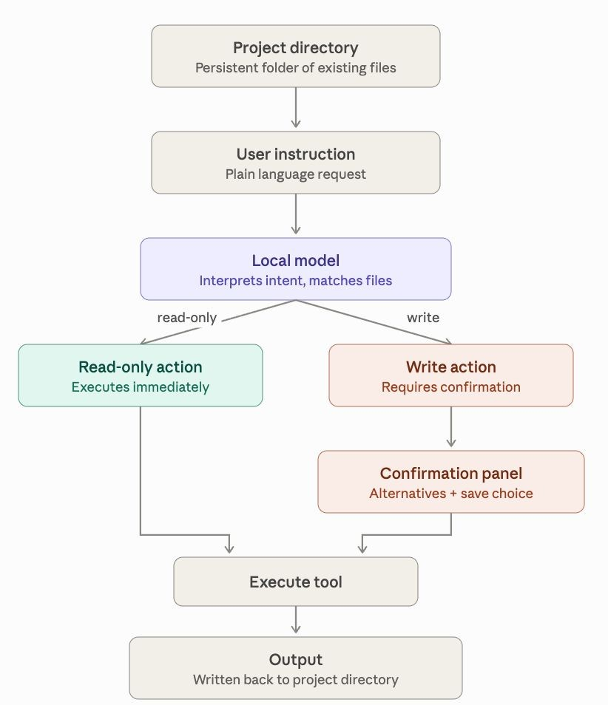

HARDWARE AND SOFTWARE REQUIREMENTS
Component | Basic Requirement
Computer | A laptop or desktop computer with a modern 64-bit processor.
Memory | At least 8 GB RAM for basic study; 16 GB or more is preferable for running local models.
Storage | At least 10 GB of free storage for software, model files, and project outputs.
GPU (optional) | A compatible GPU with sufficient VRAM improves local inference speed; smaller models may also run on a CPU.
Operating System | Windows, macOS, or Linux.
Software | Python 3.x, Jupyter Notebook or VS Code, and an LLM runtime such as Ollama; a hosted LLM interface or API may be used as an alternative.
Internet | Required for hosted services and initial model downloads; optional after a local model is downloaded.

EXPECTED OUTCOMES
- A working, locally deployable system that interprets natural language instructions and performs common file-handling tasks without requiring an internet connection

- Support for routine operations such as merging documents, formatting spreadsheet data, extracting information from files, and organizing images into structured outputs

- Demonstration that a small, locally run language model, when paired with a defined set of dedicated tools, can reliably perform well-defined tasks with accuracy comparable to solutions using large online models

- Improved data privacy, since all files and user instructions remain on the local device throughout processing

- Reduced computational and monetary cost compared to using large-scale cloud-hosted models for simple, repetitive tasks

- A modular tool framework that can be extended to support additional file formats or operations in the future

- A practical, resource-conscious alternative to existing automation tools, suitable for use in offline or resource-limited environments

CONCLUSION
Everyday computer tasks involving documents, spreadsheets, and images are often repetitive and simple in nature, yet automating them currently depends heavily on large, cloud-hosted language models. This dependence raises genuine concerns around data privacy, since sensitive files must be sent to external servers, and around efficiency, since substantial computational resources are used even for trivial operations. This project addresses these concerns by proposing a lightweight, locally deployable system in which a small language model is used only to interpret user instructions, while the actual file operations are carried out through a set of reliable, dedicated tools running entirely on the local device. By separating language understanding from task execution, the system aims to remain accurate and predictable while eliminating the need for internet connectivity. If successful, this project will demonstrate that small, locally run models can effectively automate routine digital tasks, offering a practical, privacy-preserving, and resource-efficient alternative to existing online-dependent automation solutions.

REFERENCES
[1] C. Zhang, H. Huang, C. Ni, J. Mu, S. Qin, S. He, L. Wang, F. Yang, P. Zhao, B. Qiao, C. Du, L. Li, Y. Kang, Z. Jiang, S. Zheng, R. Wang, J. Qian, M. Ma, J.-G. Lou, Q. Lin, S. Rajmohan, and D. Zhang, “UFO2: The Desktop AgentOS,” arXiv preprint arXiv:2504.14603, 2025.
[2] P. Průcha, M. Matoušková, and J. Strnad, “Are LLM Agents the New RPA? A Comparative Study with RPA Across Enterprise Workflows,” arXiv preprint arXiv:2509.04198, 2025.
[3] W. Wang, D. Han, D. Madrigal Diaz, J. Xu, V. Rühle, and S. Rajmohan, “OdysseyBench: Evaluating LLM Agents on Long-Horizon Complex Office Application Workflows,” arXiv preprint arXiv:2508.09124, 2025.
[4] C. Zhang, S. He, L. Li, S. Qin, Y. Kang, Q. Lin, S. Rajmohan, and D. Zhang, “API Agents vs. GUI Agents: Divergence and Convergence,” arXiv preprint arXiv:2503.11069, 2025.
[5] P. Belcak, G. Heinrich, S. Diao, Y. Fu, X. Dong, S. Muralidharan, Y. C. Lin, and P. Molchanov, “Small Language Models are the Future of Agentic AI,” arXiv preprint arXiv:2506.02153, 2025.
[6] Z. Lu, X. Li, D. Cai, R. Yi, F. Liu, W. Liu, J. Luan, X. Zhang, N. D. Lane, and M. Xu, “Demystifying Small Language Models for Edge Deployment,” in Proc. Association for Computational Linguistics (ACL), 2025.
[7] A. Gupta, B. Thomas, H. Asnani, P. R. Madduru, S. Feroze, S. Subramanian, V. Elango, and M. Gungor, “Small Language Models (SLMs) Can Still Pack a Punch: A Survey (updated 2026),” arXiv preprint arXiv:2501.05465, 2025.
[8] M. A. Haque, F. Rahman, K. D. Gupta, K. Shujaee, and R. George, “TinyLLM: Evaluation and Optimization of Small Language Models for Agentic Tasks on Edge Devices,” arXiv preprint arXiv:2511.22138, 2025.
[9] D. Paprunia, V. Kharidia, and P. Doshi, “Advancing SLM Tool-Use Capability using Reinforcement Learning,” arXiv preprint arXiv:2509.04518, 2025.
[10] Y. Sowti Khiabani, F. Atif, C. Hsu, S. Stahlmann, T. Michels, S. Kramer, B. Heidrich, M. S. Sarfraz, J. Merten, and F. Tafazzoli, “Optimizing Small Language Models for In-Vehicle Function-Calling,” arXiv preprint arXiv:2501.02342, 2025.
[11] S. Vijayvargiya and R. Lokesh, “Efficient On-Device Agents via Adaptive Context Management,” arXiv preprint arXiv:2511.03728, 2025.
[12] W. Oliveira, “Less Is More: Engineering Challenges of On-Device Small Language Model Integration in a Mobile Application,” arXiv preprint arXiv:2604.24636, 2026.
[13] H. Jafarzadeh Asl, Y. Yu, and V. Partovi Nia, “From Fixed Keys to Readable Schemas: Small Language Models for Vehicle Agent Function Calls,” arXiv preprint arXiv:2609.09476, 2026.
[14] Y.-N. Chuang, L. Yu, G. Wang, L. Zhang, Z. Liu, X. Cai, Y. Sui, V. Braverman, and X. Hu, “Confident or Seek Stronger: Exploring Uncertainty-Based On-Device LLM Routing From Benchmarking to Generalization,” arXiv preprint arXiv:2502.04428, 2025.
[15] E. J. Husom, A. Goknil, M. Astekin, L. K. Shar, A. Kåsen, S. Sen, B. A. Mithassel, and A. Soylu, “Sustainable LLM Inference for Edge AI: Evaluating Quantized LLMs for Energy Efficiency, Output Accuracy, and Inference Latency,” arXiv preprint arXiv:2504.03360, 2025.
[16] P. Prieto and P. Abad, “Edge Deployment of Small Language Models: A Comprehensive Comparison of CPU, GPU and NPU Backends,” arXiv preprint arXiv:2511.22334, 2025.
[17] Ollama, “Ollama Documentation,” Ollama. [Online]. Available: https://ollama.com/ (accessed 2026).

