**TEAMCODE47:**

PROBLEM: **Know Your Customer (KYC)**

a)*Background information of the solution*

Our solution is detailed to verifying and confirming that our customer is the one. We started at obtaining the biometric i.e. fingerprint of customer. This is the most accurate way of knowing customer. Each time our customer come to us for transactions or loan inquiry, fingerprint is verified and an additional security is added whereby an OTP (one time password) is sent to mobile through an api called Twillio which offer the service of sending OTP.

Our solution is built in python programming language with powerful modules for better identity of our customers.

*b) Objectives of the solution*

(i)To accurate identify the customer

(ii) To know customer better by accessing other transactions like airtime purchase.

(iii) To make transaction easier

(iv) To enable solve problem of theft and inaccurate transactions e.g. sending someone to make transaction on ‘behalf’

*c) Justification of the solution*

1. Solution is accurate and secured as per the CIA(confidentiality, Integrity and Availability)
2. Well précised to give solution to actual problem

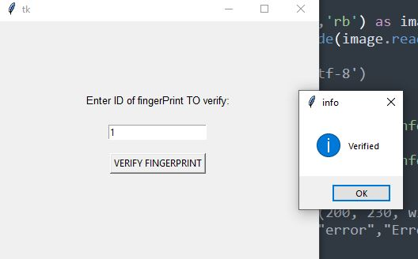

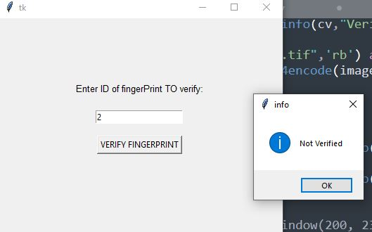

*d) Detailed Description of the solution*

* Customer take a record of fingerprint and is stored

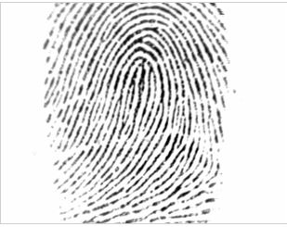

* Recorded fingerprint is used to authorize transactions
* OTP is sent also to the customer number to further verify identity.

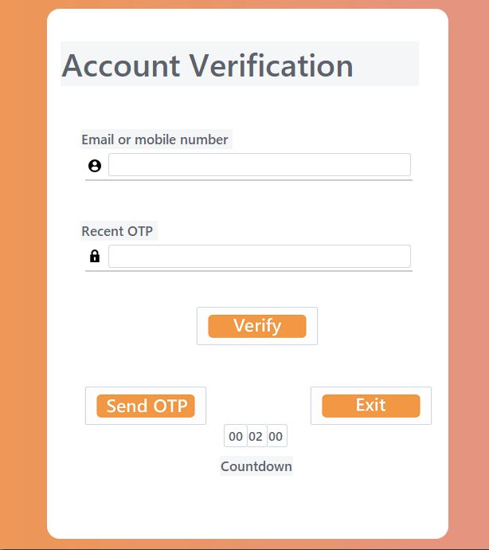

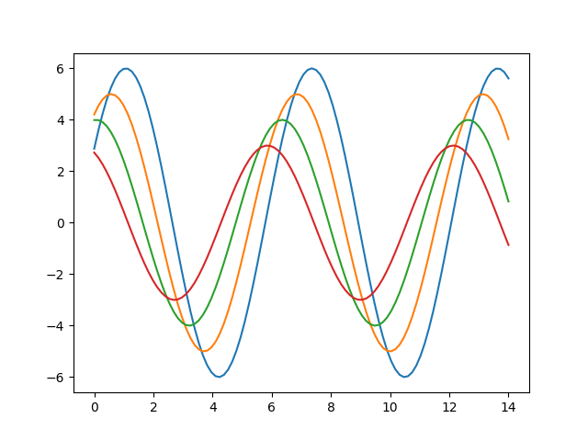

*e) Benefits*

1. Incase our customer is not able to verify fingerprint, OTP token help authorize transaction.

2. Increase of customers since this process can be done online and verify identity with smart phone’s fingerprint sensor or OTP.

3. Processing of key transactions e.g. loan, is made simple since we now know the customer better by accessing airtime purchase, CRB, Mpesa transactions etc.

4. Fewer risk of doubtful debts is incurred since when loan is awarded, the customer is well known of financial status

*f) Assumptions*

(1) Customer is not handicapped to verify fingerprint

(2) Customer understand as per data privacy act that airtime, mpesa transactions are accessed securely.

*g) Conclusion*

* Our solution is accurate and has ability to satisfy our customer to use our services remotely and more friendly.
* An accurate equity system that identify own customers correctly.