How to Use the Classification Package

The classification package is for using minorthird without text. This can be useful when you want to classify groups that has a class and a list of features. For example: consider this data for whether to play tennis or not:

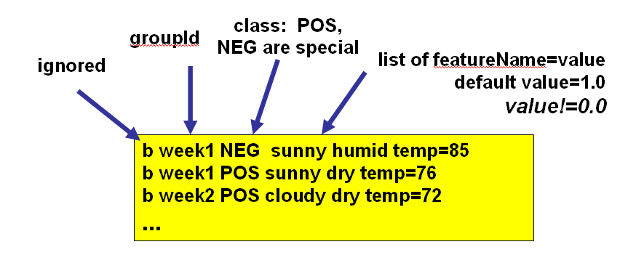

Training and Testing using one Dataset

Using the command line:
To learn what options are available from the command line type:
% java –Xmx500M edu.cmu.minorthird.classify.UI –help

Lets first try running a classification experiment on a sequential dataset. When using a sequential dataset, it is important to use the –seq option so that the program can properly process the data. Make sure the –seq option is declared before the dataset.

To run an experiment, type this command:
% java –Xmx500M edu.cmu.minorthird.classify.UI –op trainTest –seq –data sub_sig.data

Note: If you get a java.lang.reflect.InvocationTargetException it probably means that you did not specify the –seq option before the dataset.

The output of the program should look like this:
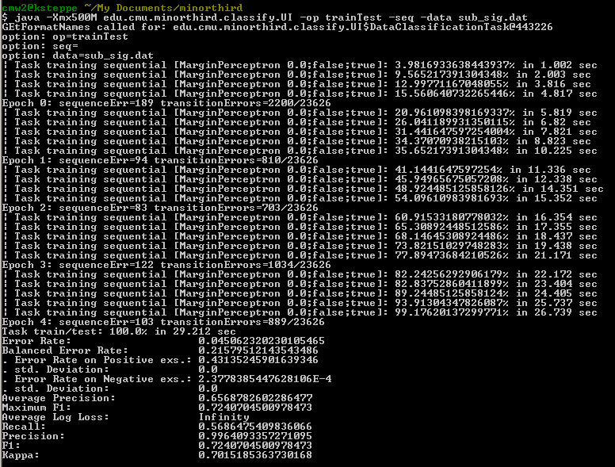

Using the gui:
To run an experiment in the gui, first type the command:
% java –Xmx500M edu.cmu.minorthird.classify.UI –gui

When the window appears, click the Edit button under Parameter Modification. This will make the Property Editor window appear. The _operation: field for the property editor should already be set to trainTest, which is what you want for this experiment. The next very important step is the check the sequentialMode checkbox towards the bottom of the window… if this button is not checked, you will not be able to properly load your data.
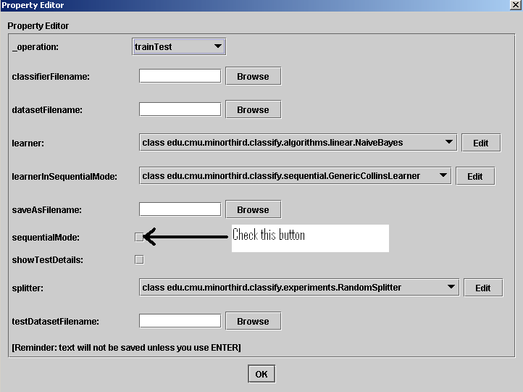

Note: If the data is taking a long time to load, the sequentialMode box is most likely inappropriately checked. Try closing the window and trying again.

Next specify the datasetFilename by clicking the Browse button next to the text field. Find the directory where you saved the file, select the file, and click the Open button.

These next fields have defaults, but can be changed:
- Learner: You can specify the learner for this experiment by clicking on the pull down menu next to learnerInSequentialMode NOT next to learner. Since this is a sequential experiment, only the learner from the learnerInSequentialMode menu will be used.
- Splitter: Specify the splitter by choosing one from the pull down menu next to splitter. You can change any of the splitter options by clicking the Edit button to the right of the pull down menu.

Click the OK button to close the Property Editor and press the “Start Task” button to begin the experiment.
Training and Testing on Different Datasets

Using the Command Line:

Train:
To train a classifier try the command:
% java edu.cmu.minorthird.classify.UI –seq –op train –data sub_sig.train –saveAs sub_sig_class.eval

Note: To see what other options you have, to using the –help command

The output should look like this:
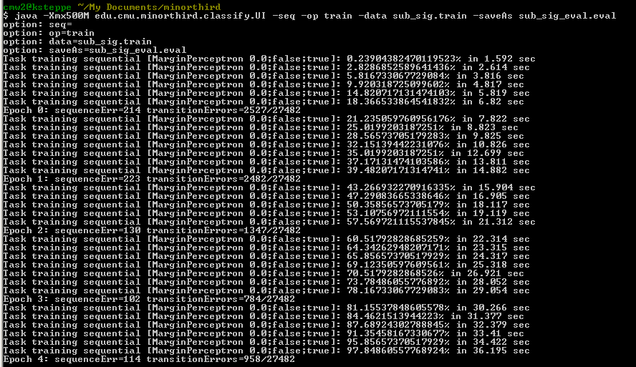

Notice that there are no results since this is a train.

Test:
% java edu.cmu.minorthird.classify.UI –seq –op test –data sub_sig.test –classifierFile sub_sig_class.eval

