**Craig**

**User Manual**

Oh no! The University of York Campus has been overrun by Zombies and you’re an unlucky survivor. Navigate your way around Campus East to collect the keys and unlock the golden lock to escape. Luckily for you, special power-ups can be obtained on your journey to give you extra abilities and perks. Good luck!

**Let’s Get Started**

Double click on the Craig.exe file to load the game.

**Menu Screen**

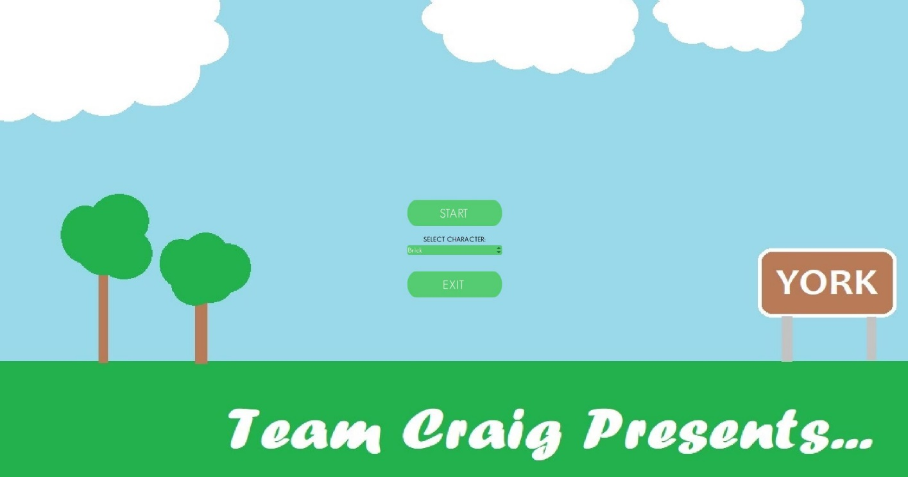On loading the game, you will be presented with a menu screen as follows:

If beginning a new game, first select your character from the drop-down menu. You can select either ‘Brick’ who has a boosted health attribute or ‘Whiz’ who has double speed. On selecting a character press ‘Start’ to begin a new game.

To leave the game please press the ‘Exit’ button.

**How to Play**

**Movement**

On loading the game your character will be dropped on to the University of York campus.

Press ‘W’ to move upwards

Press ‘S’ to move downwards

Press ‘A’ to move left

Press ‘D’ to move right.

Place you mouse cursor at different positions on the map to change the orientation of your character.

**Shooting**

Place cursor on target position on the map and left click once to fire a bullet. One click produces one bullet. Holding the left mouse button will not fire multiple bullets unless you possess the rapid-fire power up.

**Power-ups**

On your journey around the campus you may come across power-up items which give you extra abilities or perks. To obtain each power-up simply move your character over the power-up on the map.

Once you’ve obtained the power-up it will be removed from the map. There are 9 total power-up items spread randomly across the map- 3 of each type. Power-up types are as follows:

Health Pack: Health packs are represented by red hearts. On obtaining a Health pack your character’s health will increase by 10 points.



Health Pack

Rapid-Fire: Rapid-Fire power-ups are represented by an orange flame with yellow highlighting. On obtaining rapid-fire your character’s weapon will become fully automated for 20 seconds. You cannot obtain another Rapid-Fire power-up until after these 20 seconds have finished. Holding down the left mouse button will spray multiple bullets. Release the left mouse button to stop shooting.

Rapid-Fire

Coffee: Coffee power-ups are represented as white coffee mugs. On obtaining a Coffee power-up your character will have double speed for 20 seconds. You cannot obtain another Coffee until after these 20 seconds have finished. After 20 seconds your character’s speed will return to normal.

Coffee

**How to win**

In order to win the game, you must collect the 3 Keys located at each of the 3 locations (Computer Science department, Ron-Cooke Hub and Goodricke College).

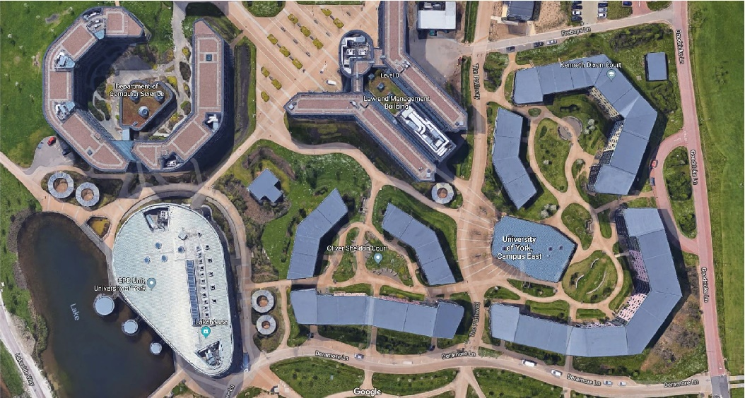

Campus Map

You start outside the Computer Science department and only have access to this location. Collect the key located somewhere around the department. On collecting the key, a new location will be unblocked to which you can now travel. Collect the keys at each location to unlock a new location until all 3 locations have been unlocked.

Key

Once you have collected all the keys and each location has been unlocked, you must search for the Golden Lock. When you find the Golden Lock, move your character over the Lock’s position. You will then be taken to the Winning screen.

The Golden Lock

**End/Winning Screen**

On winning the game you will be presented with an ending screen where you will be congratulated. Press the ‘Exit to menu’ button to exit to menu. At this point you can either begin a new game or exit the game.



**Pause Menu**

At any point during the game press ‘Esc’ to open the Pause Menu. You can either press the ‘Resume’ button to return to the game at the same point as when paused or press the ‘Exit’ to exit to the main menu. Pause screen will appear as follows:

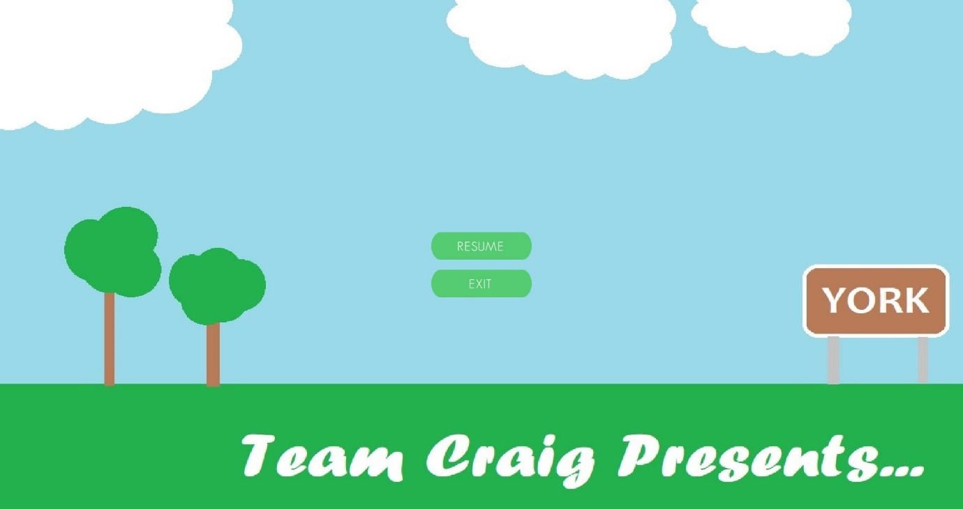

**Enjoy playing our game!**