Zepr - Zombie Engineering Project

User Manual

## 

## Contents

## 

#### Introduction ..………………………………………………………………………………...02

#### Main Menu ..…………………………………………………………………………………03

#### Stage and Character Selection ……………………………………………………………….04

#### Pause Menu ………………………………………………………………………………….05

#### Saving and loading a game

#### Gameplay …………………………………………………………………………………….06

## 

#### Full list of characters and power ups zombies and evil bosses…...…………………………07

#### Mini game

#### The Mini-game can be played by selecting the mini-game button from the Stage select screen. On clicking this, you will be taken to our ‘Goose Shooting’ mini-game. The aim of the this game is to shoot as many geese as you can, gaining a point for each goose hit and losing a point if the goose reaches the other side. With limited ammo you best take your shots carefully. Once you’re out of ammo the game will end. But be careful if you miss 5 shots GAME OVER! Hope you have a good aim.

## Introduction

#### Scenario

After a hard night of partying after the dreaded POPL exam, you wake up to find yourself in the middle of town, your friends nowhere to be found.

As you try and recall how you ended up here, you hear a low rumbling sound coming from the alleyway near you.

A horde of decaying zombies suddenly appears out from the alleyway, their clothes tattered, blood and bone sticking out of their bodies.

Not soon after, the zombies notice you and charge towards you, trampling over each other, their rumbles turning into screams and cries.

But in the spur of the movement, you suddenly realize...

You forgot to hand in your SEPR assessment!

Your goal is to survive and defeat the horde of zombies and get back to your accommodation, to hand in your SEPR assessment before the deadline is over.



## Main Menu

## 

After launching the game, you will be navigated to the main menu.

Click “Start” to begin the game.

Click “Exit” to close the game.

## Stage and Character Selection

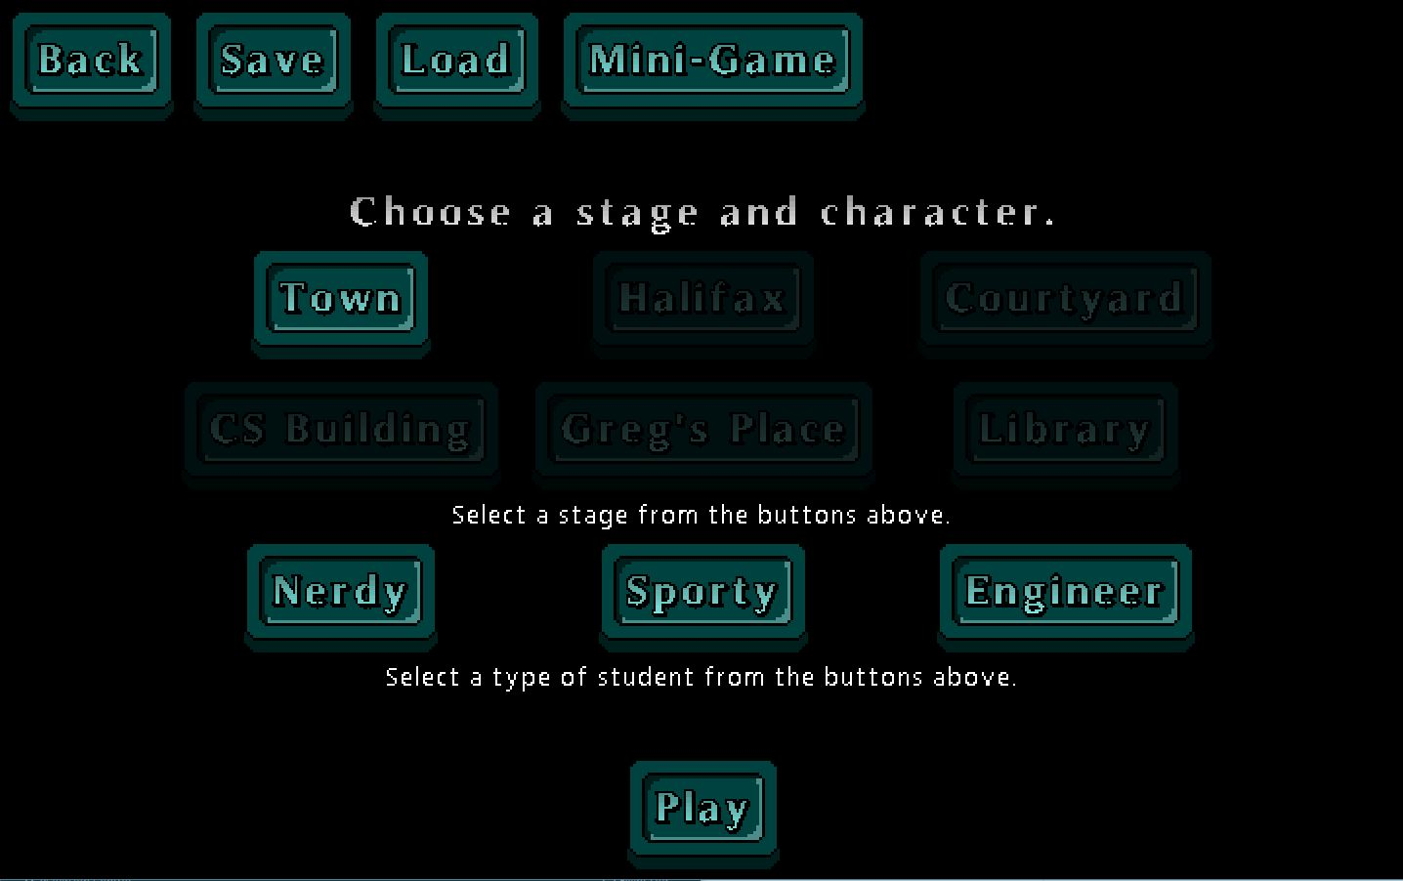

#### Stage

Stage selection allows you to select which stage you wish to play in, where each stage will offer different obstacles and hence require different strategies to overcome.

Select either one of the “Town”, “Halifax”, “Courtyard” “Library”, “Greg’s Place” or “Computer Science” buttons. (“Halifax” will be locked until “Town” is completed, and “Courtyard” will be locked until “Town” and “Halifax” is completed and so on.)

At the end of each level you will return to the Stage select screen where you can save your progress using the ‘Save’ button. You can load your previous game’s using the ‘Load’ button. This will load your game starting from the last level you unlocked.

#### Characters

Character selection allows you to play as a different character, where each character will offer unique strengths over the other.

Select either one of “Nerdy”, “Sporty” or “Generic”

## Pause Menu

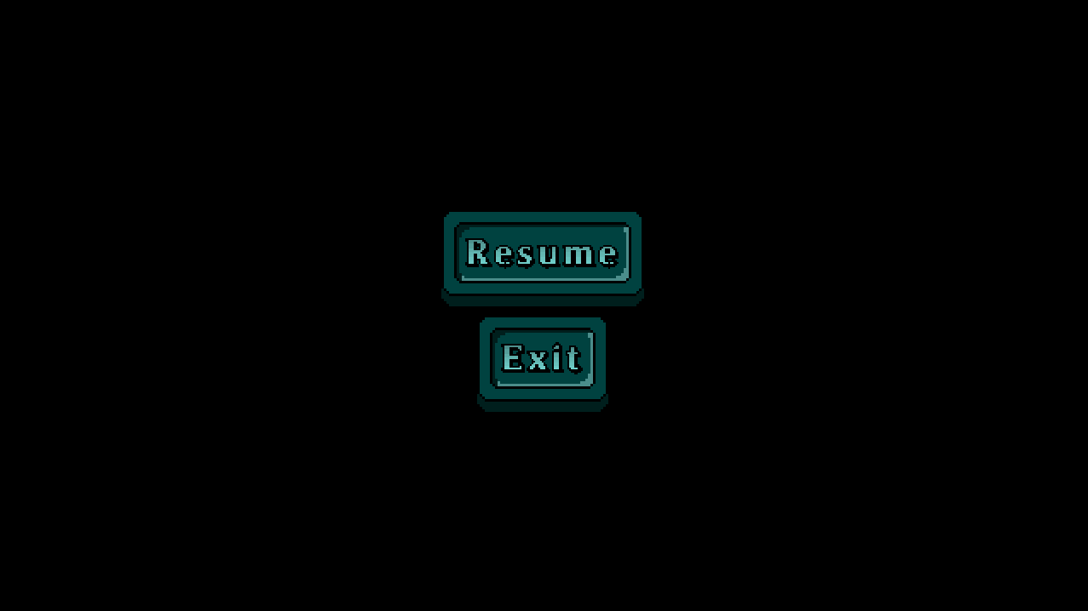

You can pause the game by pressing the “Esc” button.

To return to the game, click the “Resume” button.

To close the game, click the “Exit” button.

## Gameplay

#### Controls

|  |  |
| --- | --- |
| **Key** | **Action** |
| W | Moves the character up the screen |
| A | Moves the character left on the screen |
| S | Moves the character right on the screen |
| D | Moves the character down on the screen |
| LMB (Left Mouse Button) | The character attacks. |
| Escape | Brings up the Pause Menu |

#### Graphical Interface

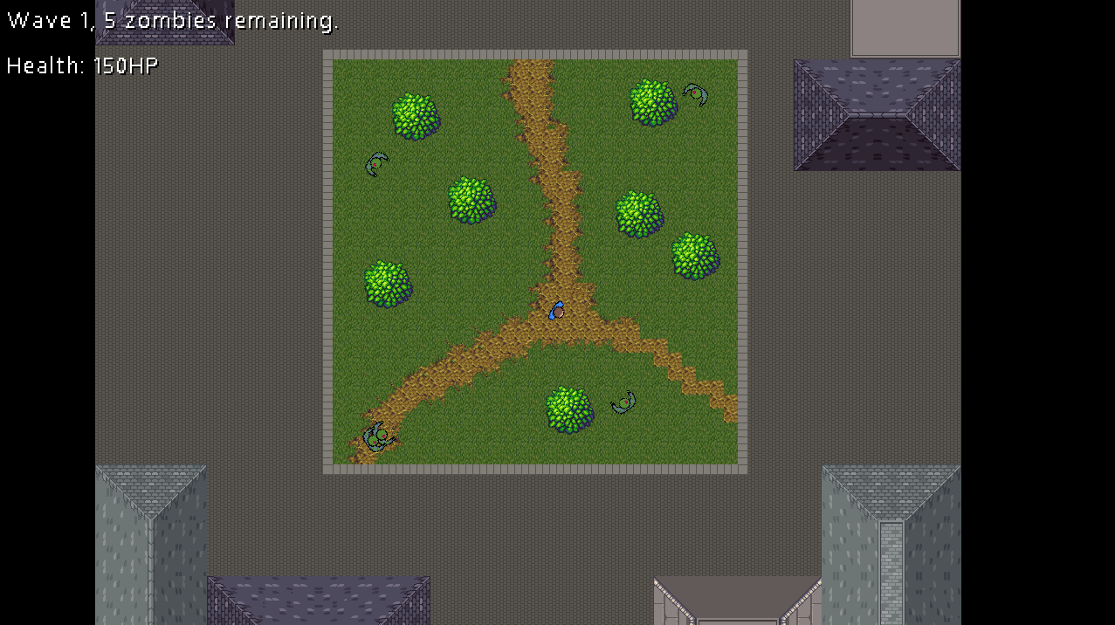

Information on the wave number, the number of zombies remaining in the wave, and the player’s health total is shown on the top left of the screen.

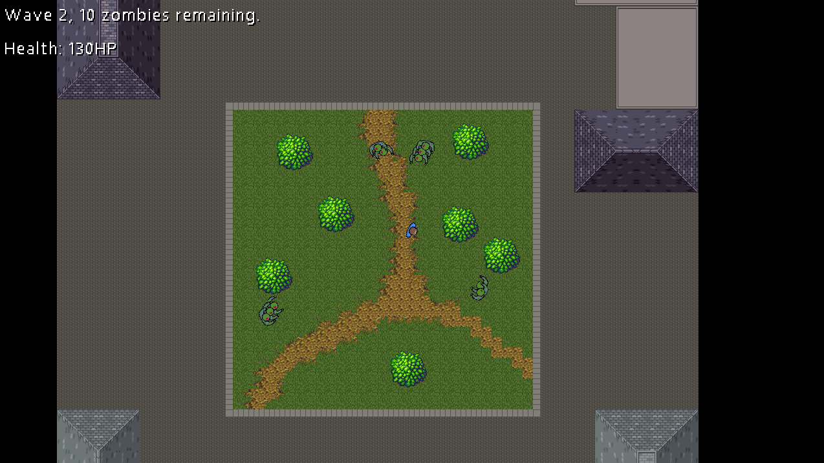

Players must defeat all of the zombies in the wave to progress to the next wave. After completing 3 waves, the stage is complete, and the next stage is unlocked (if available).

To complete the game, the player must complete all six stages, “Town”, “Halifax” and “Courtyard” “Library”, “Greg’s Place” “Computer Science building’, defeat the two evil bosses in Library and Courtyard level and complete the mini game.

However if the player’s health drops down to 0 before completing all three stages, the player loses the game and must start again.

## Full list of characters, power ups zombies and evil bosses:

#### Characters:

**Generic**

player03.png

Has greater range

**Nerdy**



Has higher health.

**Sporty**



Has greater mobility.

#### Power Ups:

**Heal**



Heals the player.

**Speed up**



For the next 10 seconds, increases the movement speed of the player.

**Immunity**



For the next 5 seconds, makes the player immune to zombie attacks.

**Insta Kill**

**insta.png**

Player kills all zombies within one hit.

**Nuke**

**nuke.png**

All zombies within the current wave are eliminated

#### Zombies

**Zombie**

zombie01.png

This is the standard zombie type.

**Sporty**

#### zombie02.png

This zombie type travels faster.

**Medic**

zombie03.png

This zombie type has extra health.

#### Evil bosses

Both bosses have the same characteristics. They are slower than zombies but have a lot more health.

**Library’s boss**



**Courtyard’s boss**

