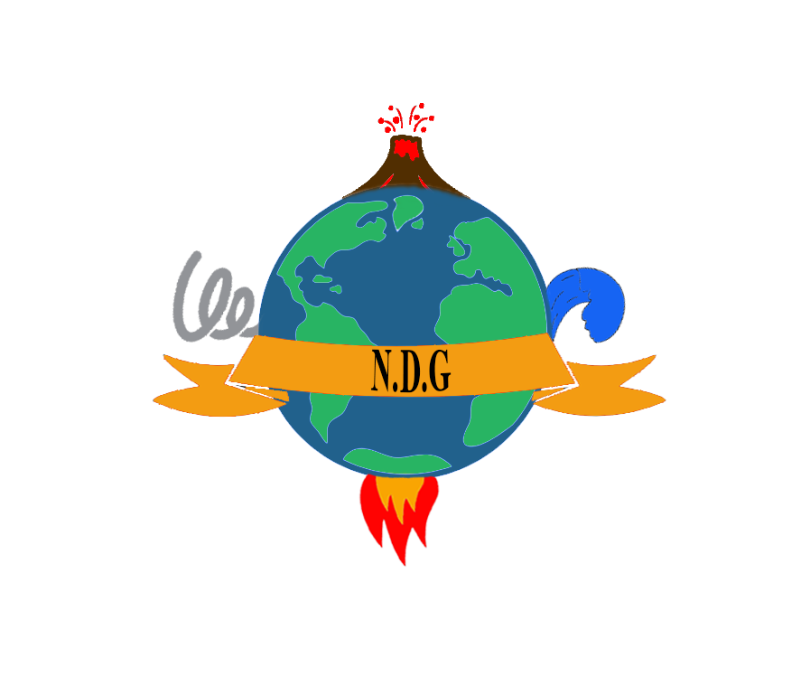

E711

**Challenge**: Don’t forget the can opener.

**Team members:**

* Hasnaoui Fadia.
* Brahimi Osama.
* Malia Mehdi.
* Kaci Samy.
* Kermoun Faïza.
* Halitim Rima.

**Introduction:**

Each Year Nearly 90,000 people die in natural disasters, after analysing the numbers we came up with this equation to represent the situation:

Natural disasters + People’s ignorance of Emergency scenarios=High rate of human loss.

So, **how can we reduce the human loss?**

Since we can’t change nature the only solution we have is to teach people how to react in case of natural disasters.

We at E711 came up with the perfect way to do so, which is creating a **mobile application** called N.D.G**(Natural Disasters Guide**).

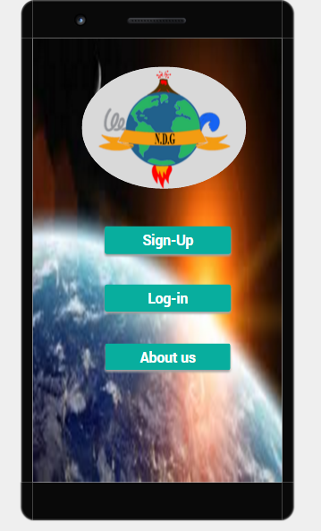

**N.D.G** is a tool that helps people to:

* Learn More About Naturel Disasters in an entertaining way (Quizzes, …).
* Prepare themselves to face disasters in the most complete way possible (First Aid, Don’t Panic, …).
* N.D.G is very Interactive with the user (smart notifying,).
* N.D.G provides A helping social network that allows people to get help and contribute to their community

To use our application, you must create a profile, filling up your personal information most importantly blood Type, Diseases, profession and your family members number phones.

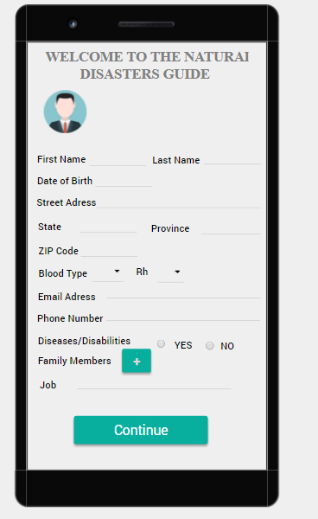

Once you have created an account you can access your profile and choose a safe location (a place where you and your family members can meet after the disaster) an SMS will be sent automatically to your family members indicating them the safe location.

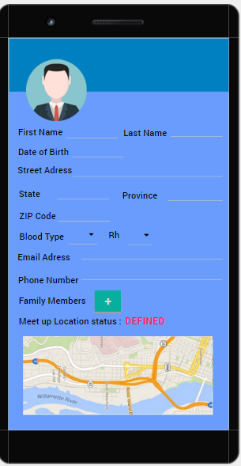

N.D.G Features:

When you access N.D.G you find the following features:

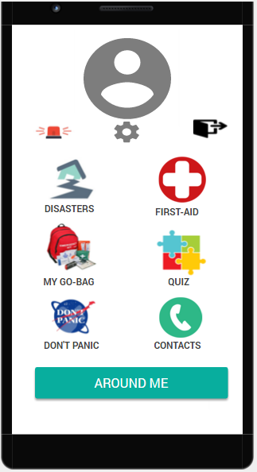

* **Disasters:** This section contains information about natural disasters when u click on one, it shows you a short description about the disaster ,it’s risques and the perfect Emergency plan illustrated with pictures.

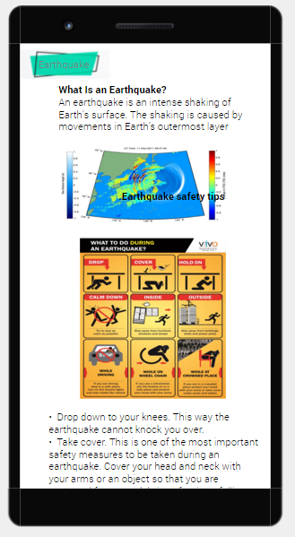

**Quiz:** if you are not a fan of reading don’t worry N.D.G offers you a very entertaining way to learn about natural disasters through interactive fun quizzes .

Each week you will receive a reminder to pass the quiz this way u will remember your emergency plan effortlessly.

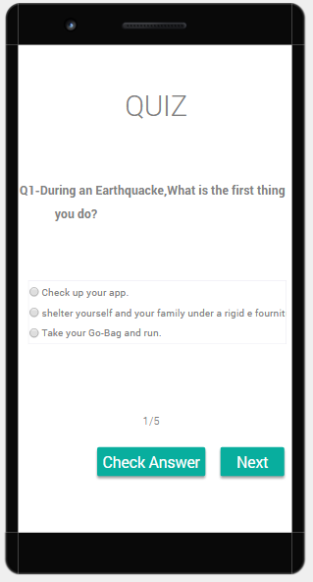

* **My go-back:** Our team E711 worked hard to design the ultimate emergency bag, it contains what u need in case of any emergency like water, food cans and a can opener….

What’s more great about this list that u can customize it by adding other items as longs it doesn’t exceeds 8kg (if the weight of the bag after u add your items exceeds 8 kg you will get a warning in the application).

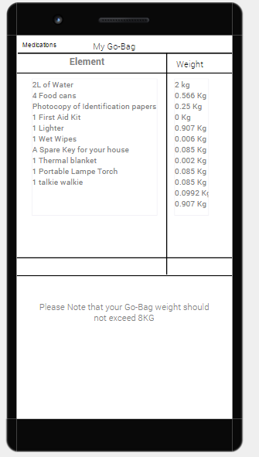

* Don’t Panic: the most important thing in case of an emergency is remaining calm and not panicking so u can remember the steps of the emergency plan, but if u are a person who suffers from anxiety or stress this can be very difficult for you, our application helps you to get over your panic attacks by teaching you meditation techniques end breathing exercises …..

you will receive notification daily to remind u of the exercises.

We will work with a team of psychologists to develop this section.

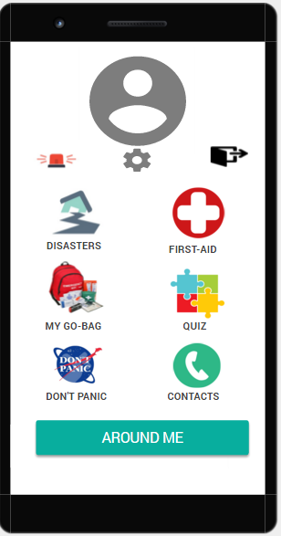

**First-Aid:** this section contains instruction to do in case of any medical emergency like how to stop a bleeding, how to perform CPR.

We will work with a team of doctors and rescuers to create this section

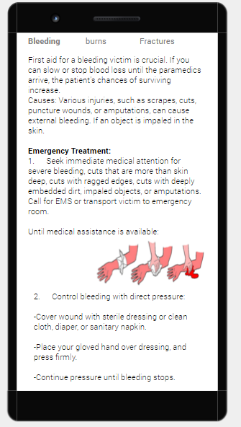

* **Contact:** This section contains emergency numbers of your country like the fire department number, police number ……

you can customize the list by adding personal contacts if you want.

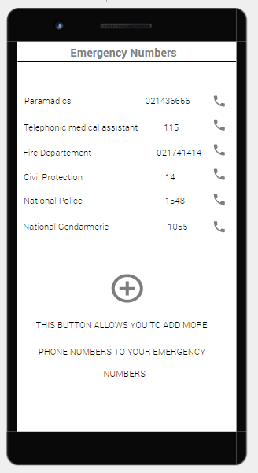

**Around-Me:** around-me is a helping network that can be visualised through this map, it shows the users of N.D.G around you in 1km radius using GPS.

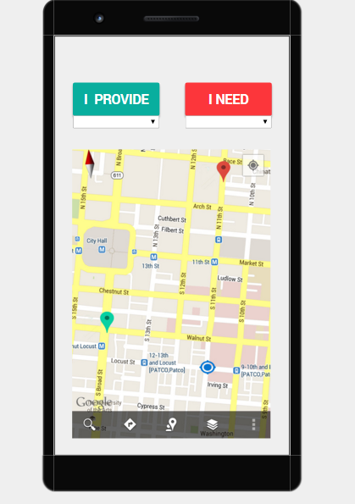

In case of a natural disasters official authorities take up until 2 hours to arrive at the location sometimes, which can lead to high rate of deaths.

We at E711 tried to find a solution for this by providing a tool that gives civilians a chance to help each other in case of an emergency in an very organized way.

A user of our app can use the “I need” option and indicate if he is in need of something (food, shelter, a doctor) once he click he will automatically be shown on the map so other users can see him and help him if they can.

if a user needs a doctor, as soon as he indicates that in our app, a notification will be sent to users who are doctors (users who have indicated their profession as a doctor in the sign-up) who are close to him.

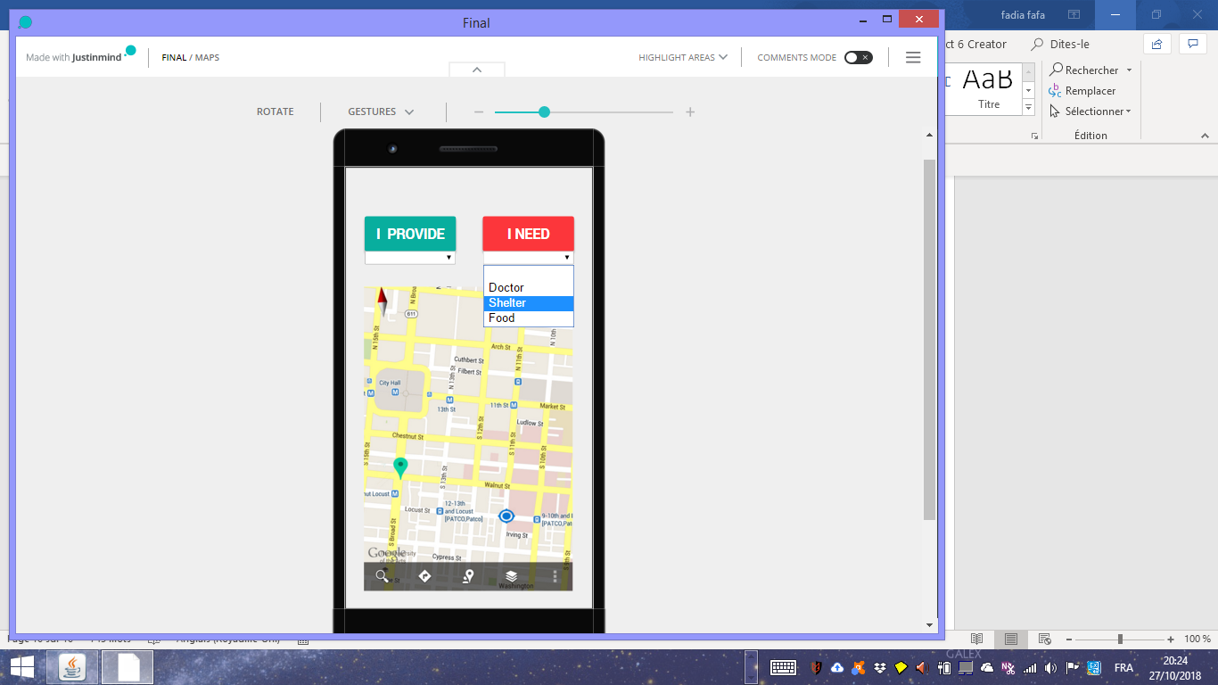

If a user wants to help others he can use the “I provide” option to indicates that he is providing food or shelter and he will appear on the map.

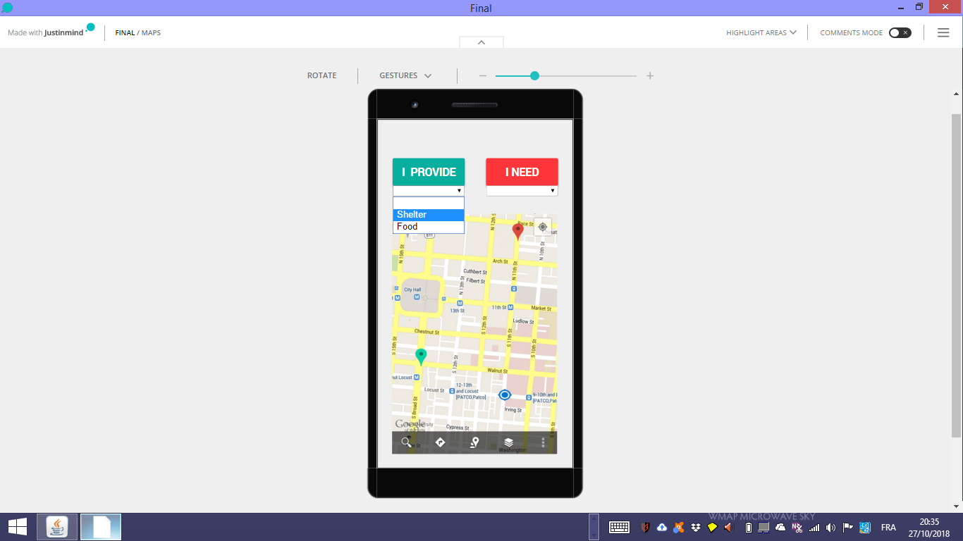

In case of an critical emergency (like a person being trapped) he can click on around-me button for 2S and a notification will be sent to people around him indicating that someone is in danger and he needs help.

* **Siren:** imagine you are being trapped and you can’t move nor you can scream for help, in this situation you can use the siren feature in our application which will release a siren indicating that you need help, people who are to close to your location can hear the help call an come to rescue.



**We will use the prediction data from NASA and use it to send alerting notification to our users of natural disasters before it happens with a convenient time .**

**Conclusion:**

One of the Nasa Space Apps challenge mottos is Create a world where you want to live , we in E711 want to live in a world where people don’t die just because they don’t know or nobody have ever told them what to do in emergencies.

With our app we aim to save people life’s and help them to save each other

We want to reinforce the community by spreading solidarity sprit among its members .

And we won’t stop here we have high ambitious we will go beyond by a creating kid’s version of our application which contains fun games and special version for blind people using voice guiding.