Department of Information Technology

**Academic Year: 2024-25 Name of Student:**

**Semester: VI Student ID:**

**Class / Branch / Div: TE- IT C Roll No.**

**Subject: MAD & PWA Lab Date of Submission: Name of Instructor: Prof. Sujata Oak**

Experiment No.11

**Aim:** To implement deployment of Ecommerce PWA to Github Pages.

**Prerequisites:** Basic Knowledge of ReactJS, JavaScript & ES6+, Node.js & npm Installed, Git & GitHub Account, Knowledge of PWA

**Software:** Node.js & npm, React.js Framework, Git, GitHub Account, VSCode, Google Chrome & Lighthouse Extension

**Problem Statement:** Deploying a Responsive E-commerce Progressive Web Application (PWA) using ReactJS and GitHub Pages (experiment:9)

**Objective:**

To design, develop, and deploy a **fully functional e-commerce web application** that works **offline**, is **responsive**, and is **hosted on GitHub Pages**.

Step 1: Install gh-pages Package

GitHub Pages does not natively support React apps built with create-react-app. To deploy it, install the gh-pages package by running:

npm install --save gh-pages

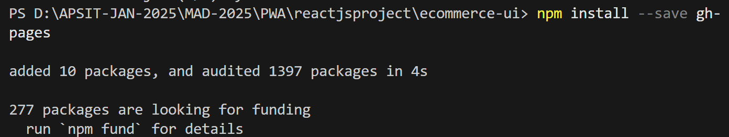

Goto your Github Account and create new repository:

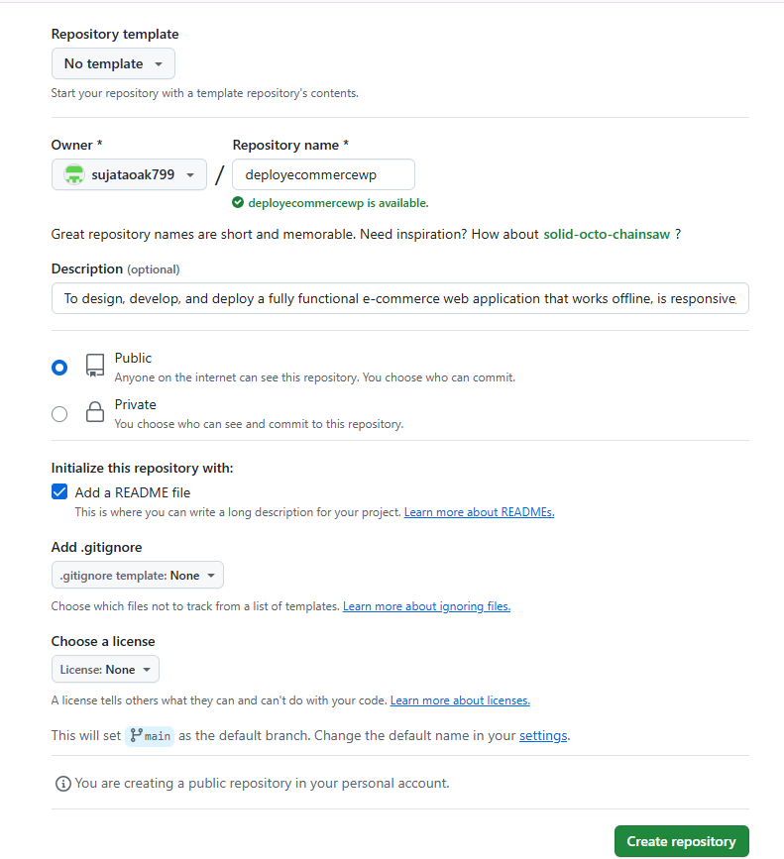

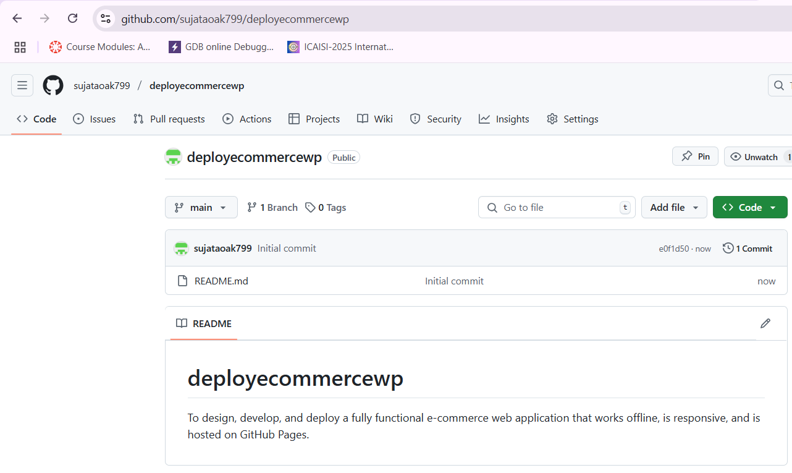

Ensure Your Git Repository Is Set Up Correctly

Check if your local repository is connected to GitHub:

git remote -v



If no remote is listed, add one:

git remote add origin <https://github.com/your-username/your-repo-name.git>



Then, commit any changes before deploying:

git add .

git commit -m "Initial commit"

git push origin master

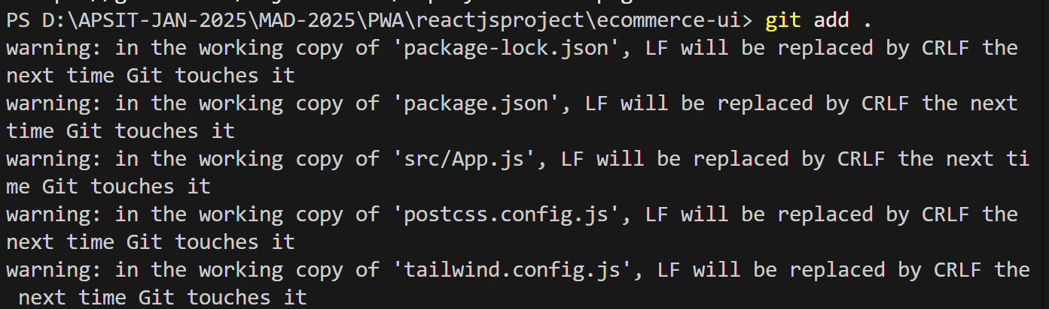

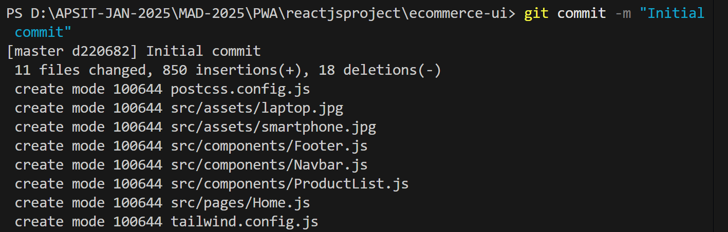

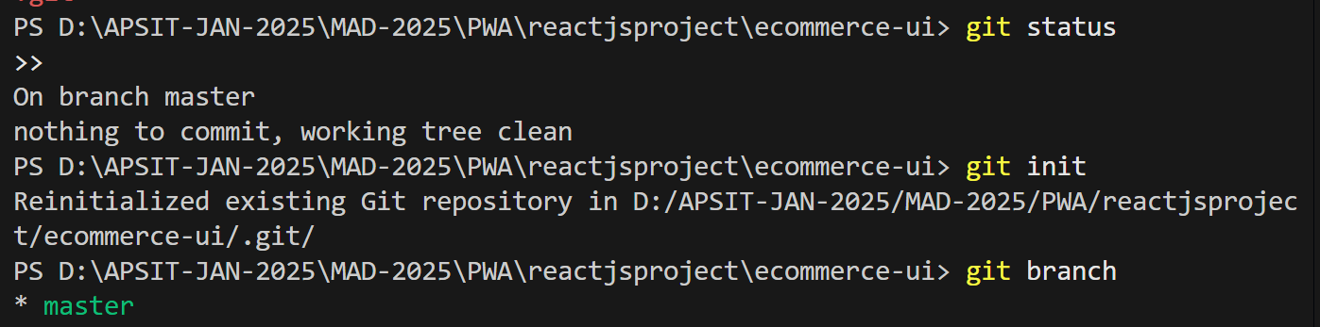

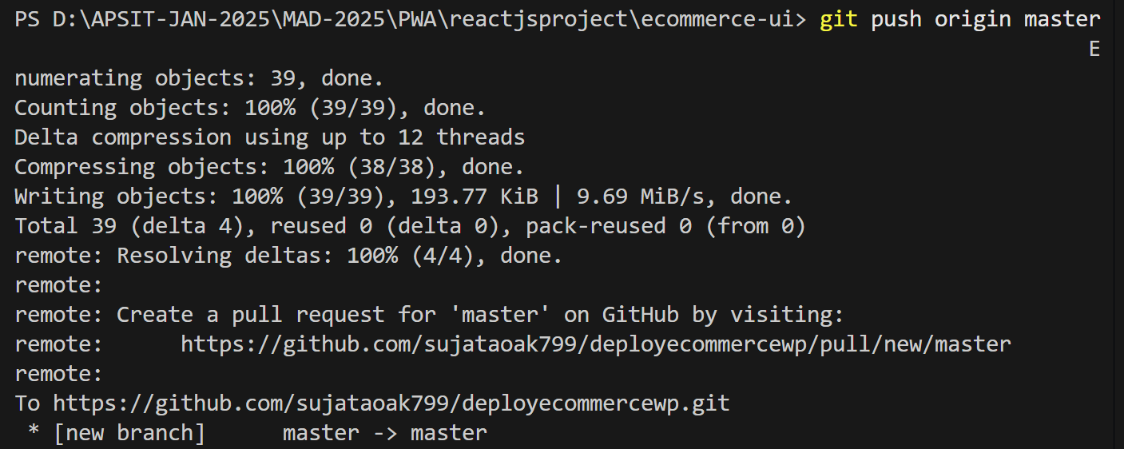

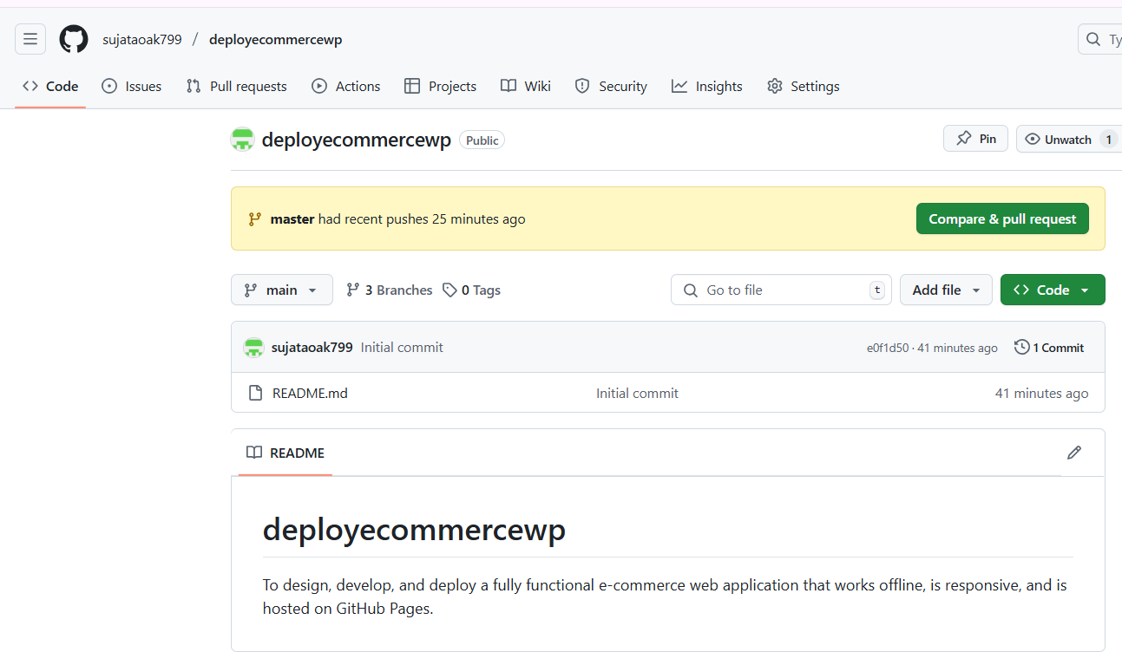

Step 2: Update package.json

Modify your package.json file to include the following:

1. Add the homepage URL (Replace your-username and your-repo-name with your GitHub details):

"homepage": <https://your-username.github.io/your-repo-name/>

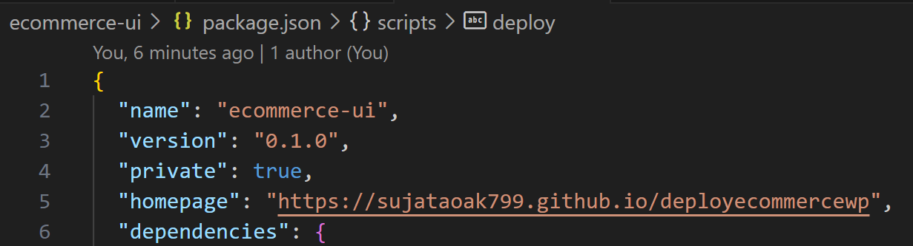

Modify scripts:  
Add the following deployment scripts under "scripts":

"predeploy": "npm run build",

"deploy": "gh-pages -d build"

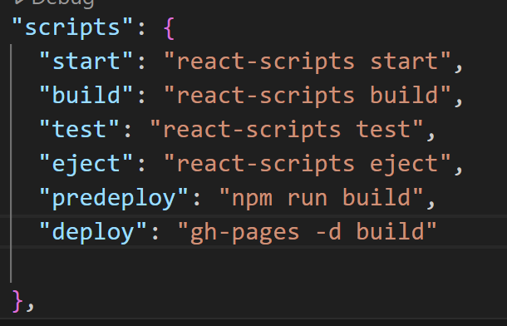

Step 3: Build the Project

Before deploying, make sure the project is built properly:

npm run build

This will generate a build/ folder, which contains optimized files for deployment.

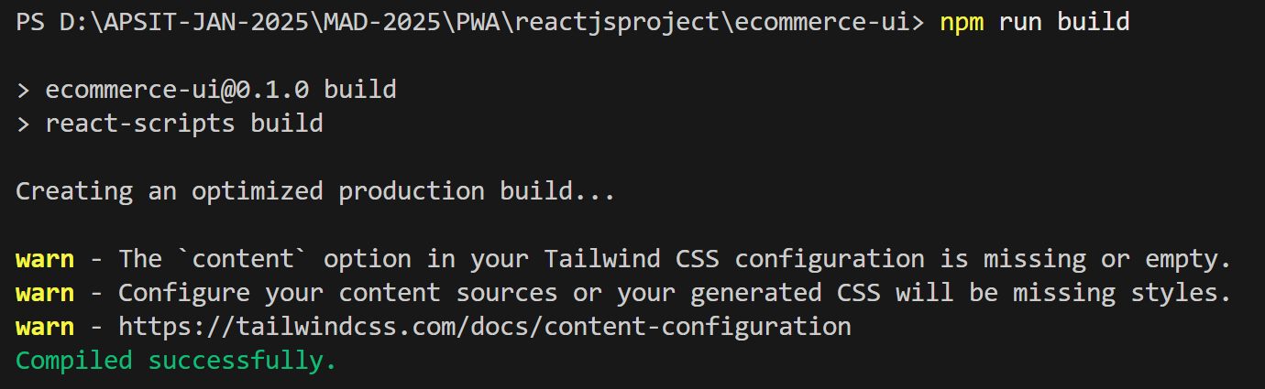

Step 4: Deploy to GitHub Pages

Run the following command to deploy:

npm run deploy

This will publish the build/ folder to the gh-pages branch of your GitHub repository.

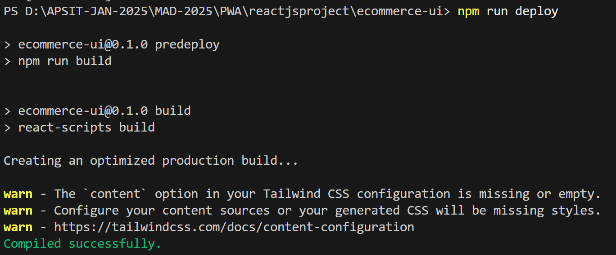

Step 5: Configure GitHub Pages

1. Go to your GitHub Repository
2. Click on Settings → Scroll down to Pages
3. Under Source, select gh-pages branch and click Save

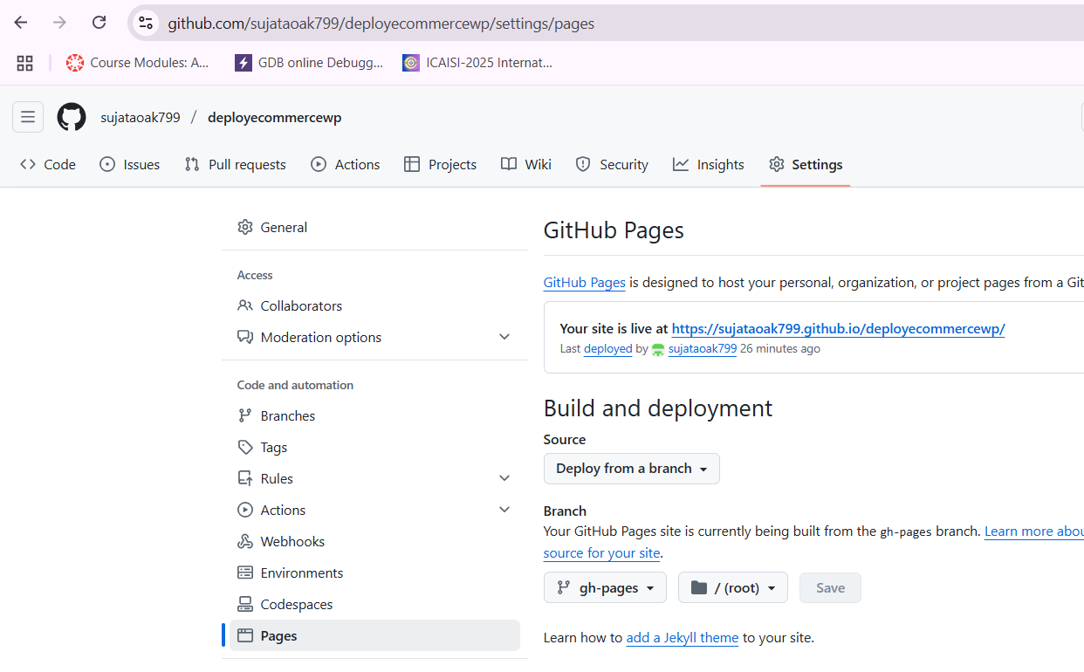

Step 6: Verify Deployment

* Wait for a few minutes and visit your PWA at: https://your-username.github.io/your-repo-name/

<https://sujataoak799.github.io/deployecommercewp/>

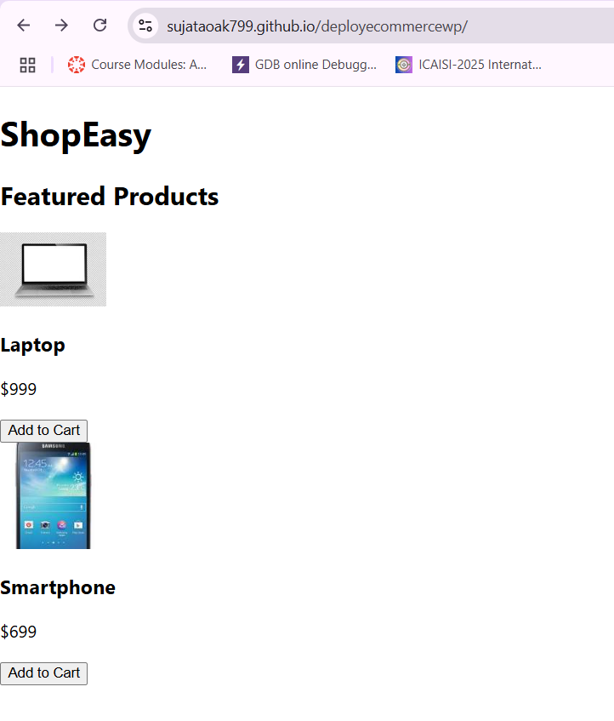

Open Chrome DevTools → Lighthouse to verify PWA performance.

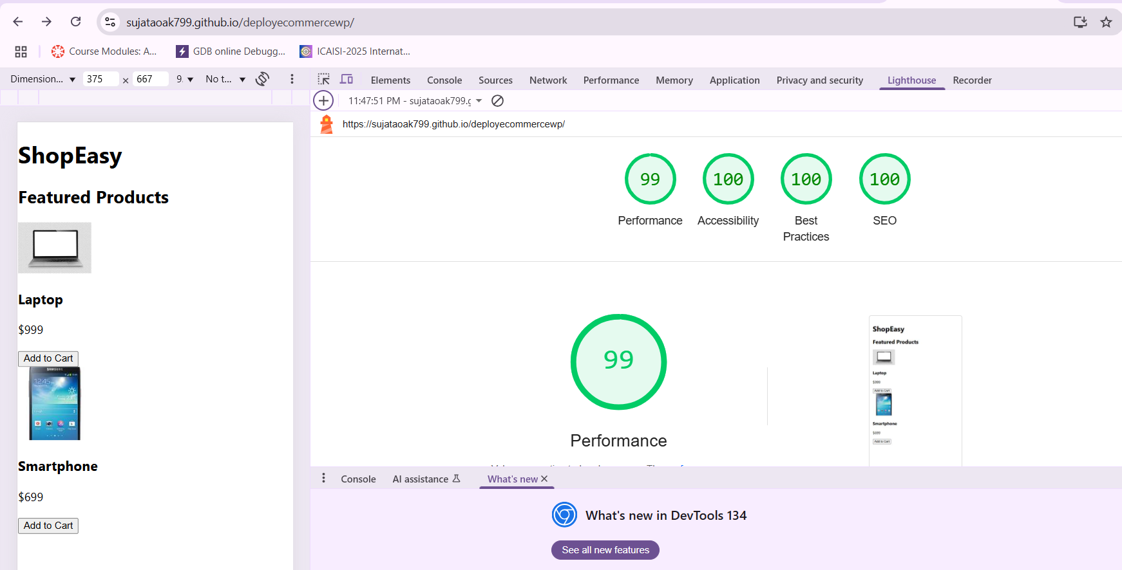

Conclusion:

By following these steps, your E-commerce PWA is successfully deployed to GitHub Pages. Users can install it like a native app, access it offline, and enjoy a fast & smooth shopping experience.