# Department of Information Technology

Academic Year: 2024-25 Name of Student:

Semester: VI Student ID:

Class / Branch / Div: TE- IT C Roll No.

Subject: MAD & PWA Lab Date of Submission:

Name of Instructor: Prof. Sujata Oak

# Experiment No.8

**Aim:** To Construct meta data for PWA in a Web app manifest file to enable “add to homescreen feature”

**Prerequisites:** HTML, JavaScript, JSON**. Software:** VS code, Browser**.**

1. **Enable Flutter.**

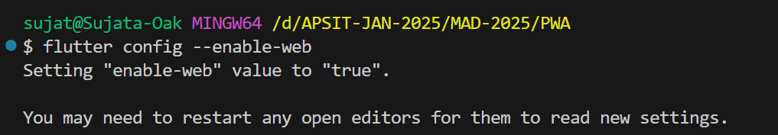

Verify Flutter Web support:

* flutter devices
* If Chrome is listed, Flutter Web is enabled

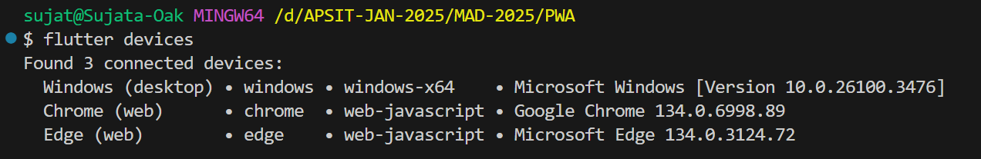

1. **Create flutter project.**

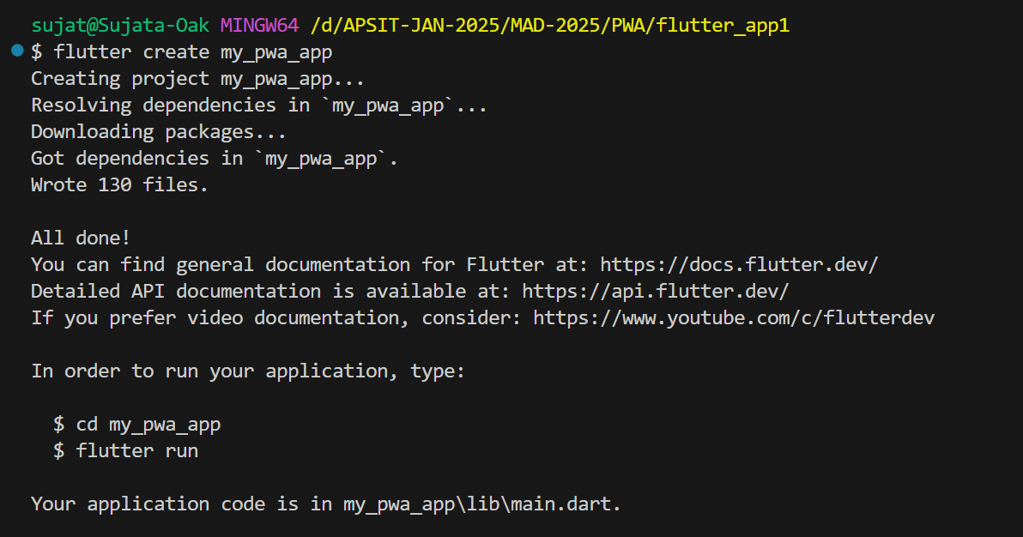

* Navigate to the project directory:
* cd my_pwa_app

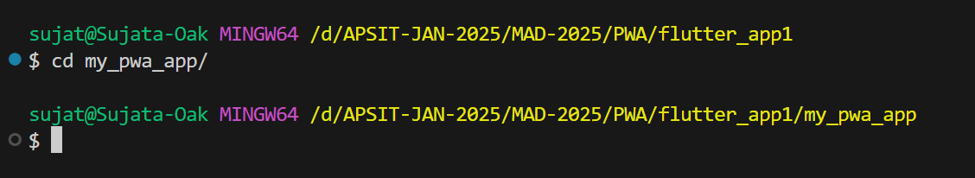

* Run the project in Chrome:
* flutter run -d chrome
* 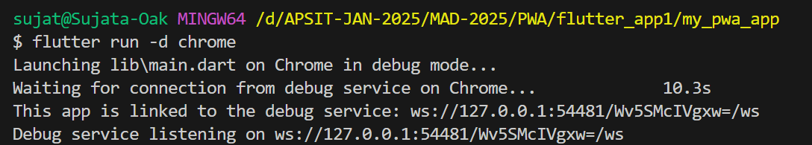

The app will open at http://localhost:xxxxx.

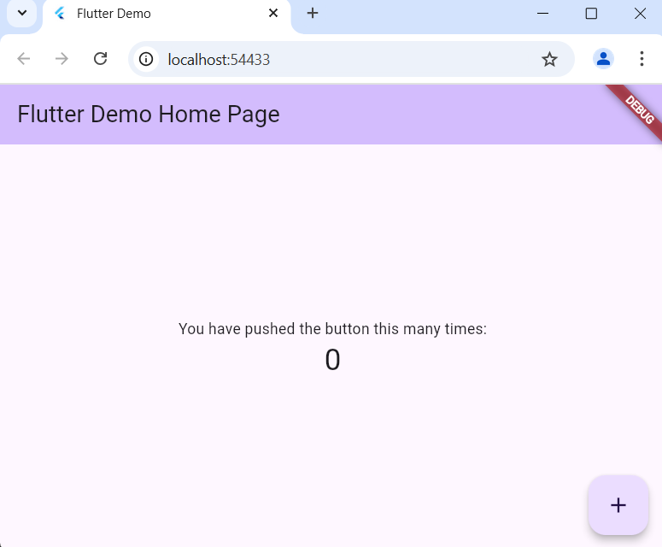

1. **Generate web build.**

* **Generate a web build with PWA support:**
* **flutter build web**
* **This creates a build/web/ directory with PWA files.**

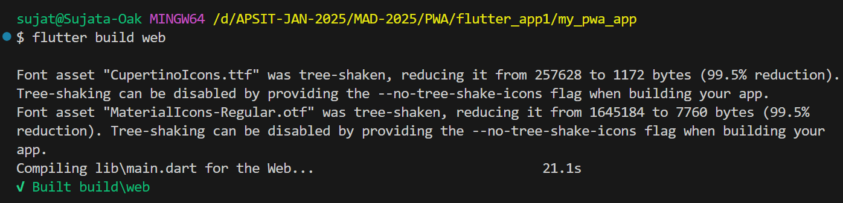

1. 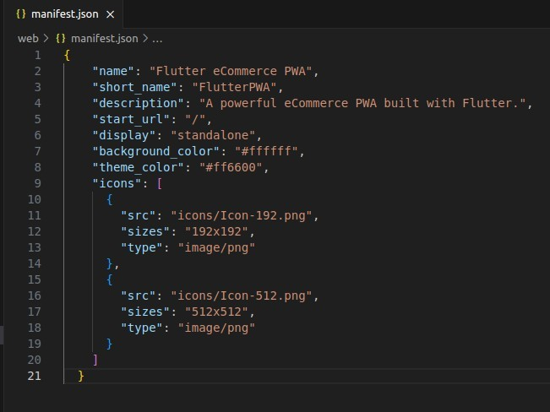**Open manifest.json file and modify in it.**

Enable Service Worker for Offline Support  
  
Ensure flutter_service_worker.js is registered in index.html:

<script>

    if('serviceWorker' in navigator ){

        window.addEventListener('load',function(){

            this.navigator.serviceWorker.register('flutter_

service_worker.js')

})

}

</script>

1. Navigate to the build/web/ directory:

* cd build/web

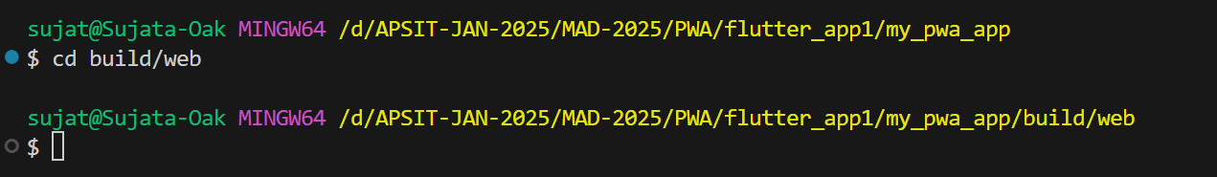

OR

1. Install Live Server:

* npm install -g live-server

1. **using node.js live server.**

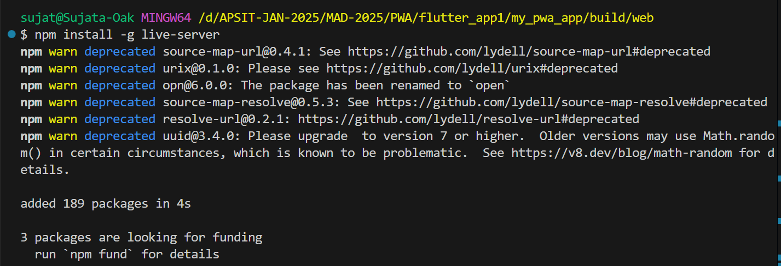

* live-server

This will automatically open the app in your browser.

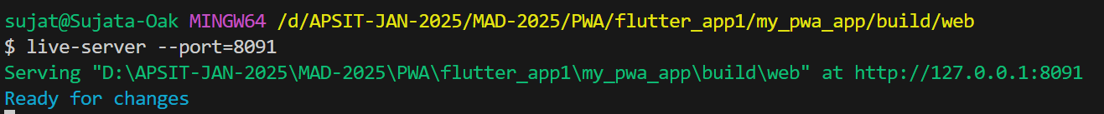

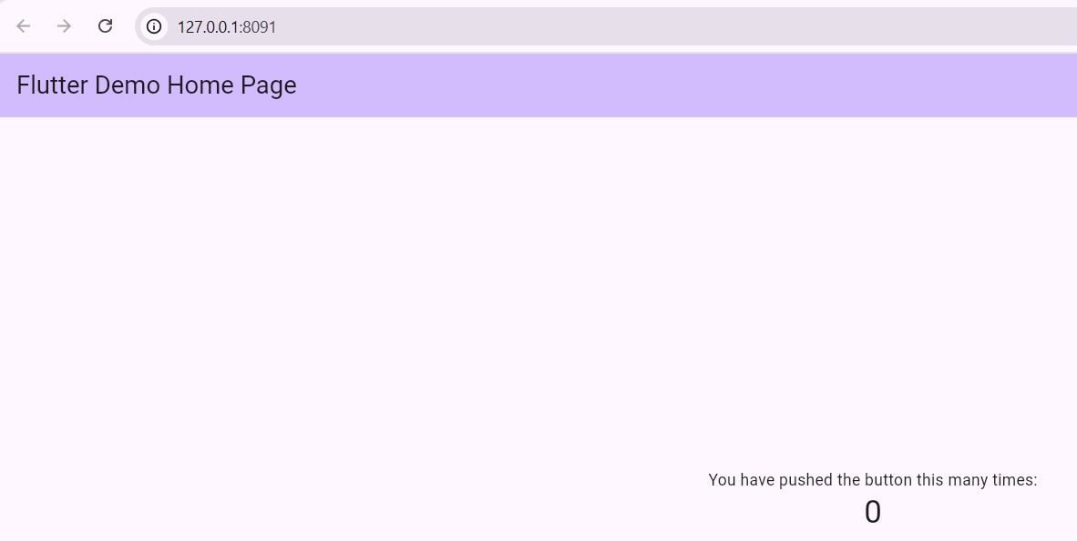

1. **project app installed successfully.**

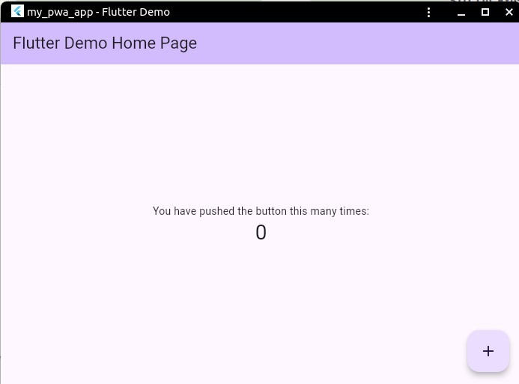

**Conclusion:** In this experiment we have designed PWA in a Web app manifest file to enable “add to homescreen feature”