Game Manual

Roboticon Quest is round-based, multiplayer game. Each rounds are made up of 5 phases and phase 1 for player 1 begins when the new game button is pressed.

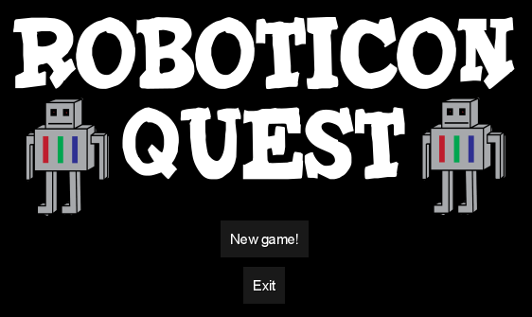

Table of Contents

**Phase 1: Acquire land****2**

**Phase 2: Buy/Customise Roboticons****3**

**Phase 3: Install Roboticon****4**

**Phase 4: Produce Resources****5**

**Phase 5: Buy and Sell Resources****6**

# Phase 1: Acquire land

The player is given the view of the map, the map can be dragged with the mouse and individual plots can be clicked on. When a plot is clicked you are given the option to buy that plot by pressing the button that appears. To buy another plot click anywhere except that button then click on a new plot to buy to bring up the button. When you are done press the next phase button to move to phase 2.

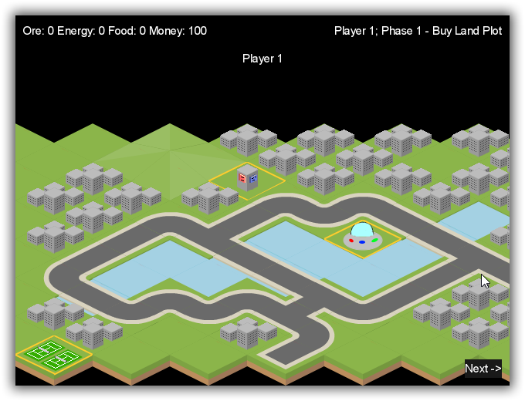

The game map.

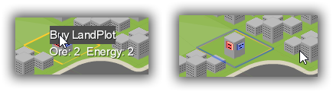

Click on the tile to bring up the options of buy the LandPlot.

# Phase 2: Buy/Customise Roboticons

Phase 2 takes place in the roboticon market. On the left hand side of the screen there is the option to buy roboticons, use the plus and minus buttons to increment and decrement the amount to buy. Then confirm your purchase with the confirmation button. On the right hand side of the screen is the customisation section. You can move through your roboticons with the arrows on either side of the image. You can then customise the displayed roboticon by selecting an option from the dropdown box and then confirming it. Press next phase to move on.

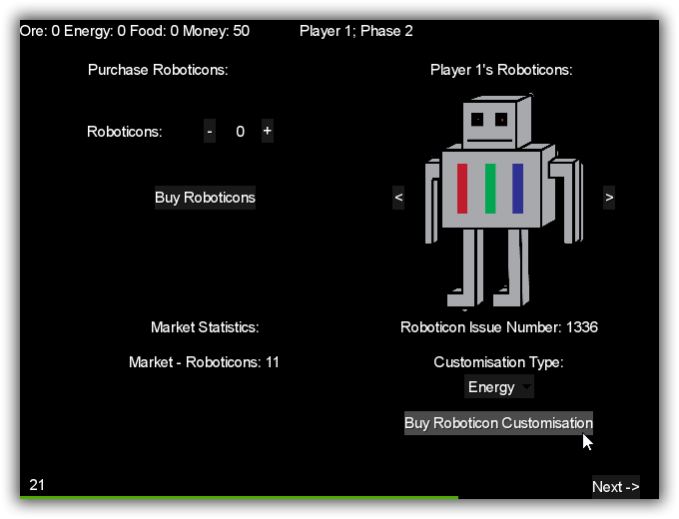  
The Roboticon purchase and customisation screen, with a time limit of 30 seconds.

# Phase 3: Install Roboticon

To install a roboticon select a land plot that you own by clicking on it. Then select the type of roboticon you wish to install from the drop down list, then press the confirm button. To back out press cancel and select another plot to install on. Press next phase to move on.

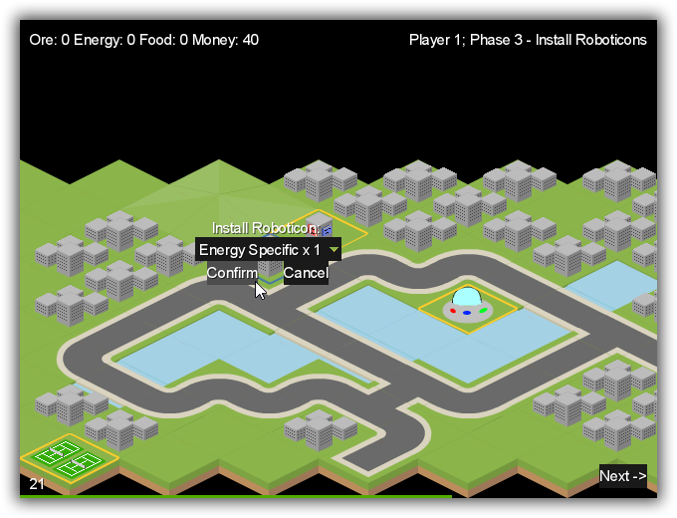

Click on the tile owned to bring up the roboticon installation dialog.

# Phase 4: Produce Resources

This phase it automated so you do not need to interact with it.

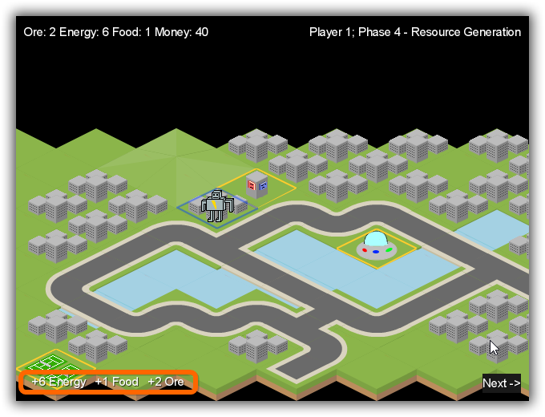

Resource generated this turn is shown on the left bottom corner.

# Phase 5: Buy and Sell Resources

Select amounts of gold and ore to buy or sell using the plus and minus buttons then confirm the sale or purchase you want to make with the confirmation button. Press next phase to end the round and swap to player 2.

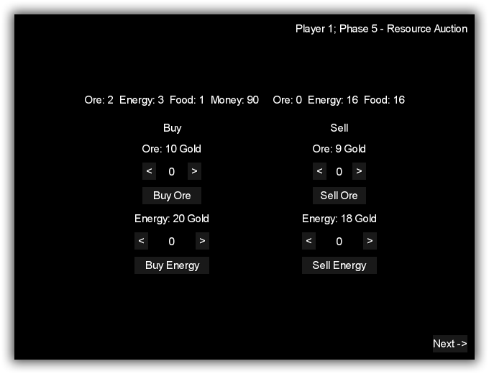

The resource market screen.