**User Manual**

The aim of the game is to gather as many resources (ore, food and energy) as possible before the game ends. This is done by purchasing roboticons and placing them on tiles that the player owns. Tiles that contain roboticons will produce resources during the production phase. The quantity that the tiles produce corresponds to the level of the roboticon that they contain.

**Starting the game**

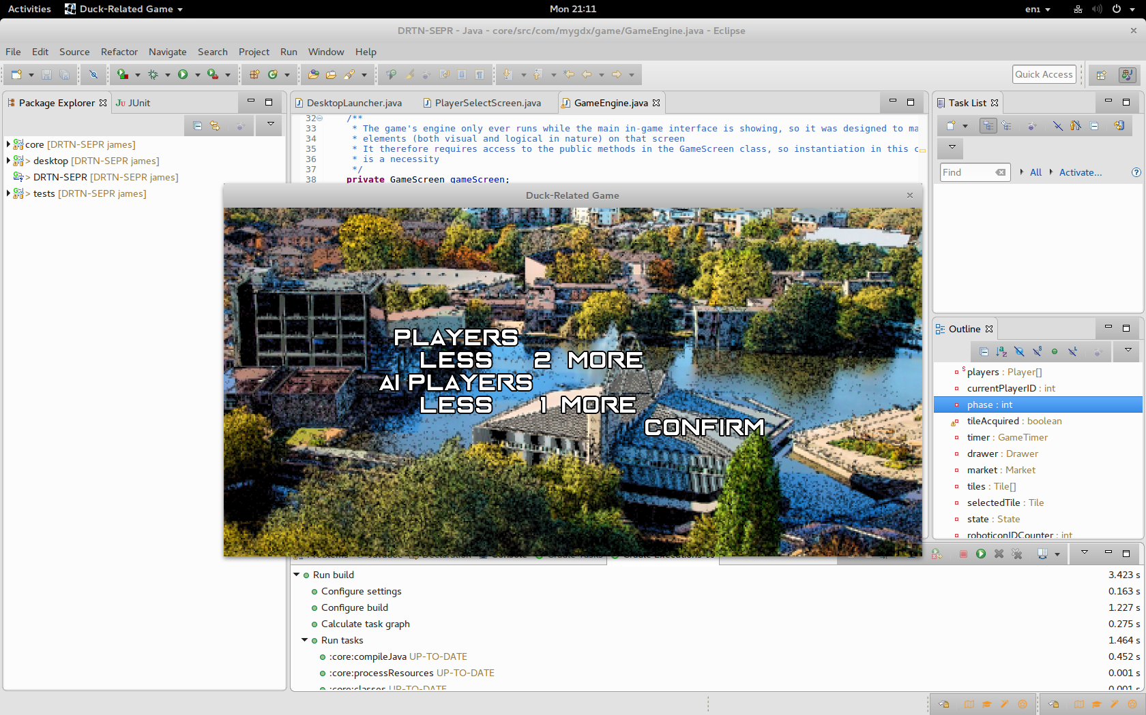

Choose a number of players on the above screen, increment and decrement the values with the less/more buttons and press confirm to begin a game. There can be 2-9 players with at least 1 human.

**Game Structure**

Phase 1 - Tile acquisition phase, each player must select a tile and claim it.

Phase 2 - Roboticon purchase phase, roboticons can be purchased fromm the market.

Phase 3 - Roboticons deployment/customisation phase, roboticons can be deployed on tiles and upgraded.

Phase 4 - Production phase, tiles containing roboticons will produce resources.

Phase 5 - Market phase, resources can be bought from/sold to the market.

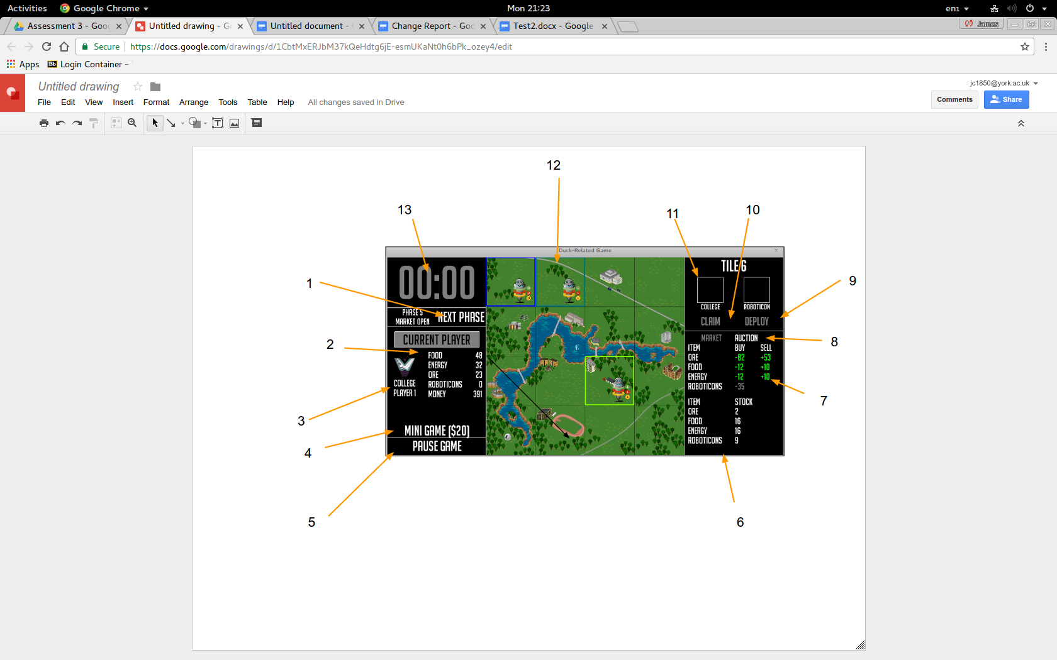

1. Press this button to end the turn and switch to the other player.

2. Shows the inventory of the current player.

3. Shows the college symbol of the current player.

4. Press to access the minigame for $20

5. Press to pause the current state of the game.

6. Shows the current stock of each resource within the market.

7. Shows the buy and sell prices of the resources in the market. Click the number under the buy/sell column in order to buy/sell the chosen resource. Red font signifies that the player can’t afford the resource, green font signifies that they can.

8. Buttons to move between the market and the auction

9. Press this button to deploy a roboticon within the selected tile, this button will change to ‘upgrade’ if there is a roboticon present within the tile.

10. Press this button to claim an unowned tile during phase 1.

11. The college symbol corresponding to the player that owns the selected tile.

12. The game map, owned tiles are highlighted in the colour corresponding to the college of the player that owns them.

13. Shows the current time left in the turn.

**The auction**

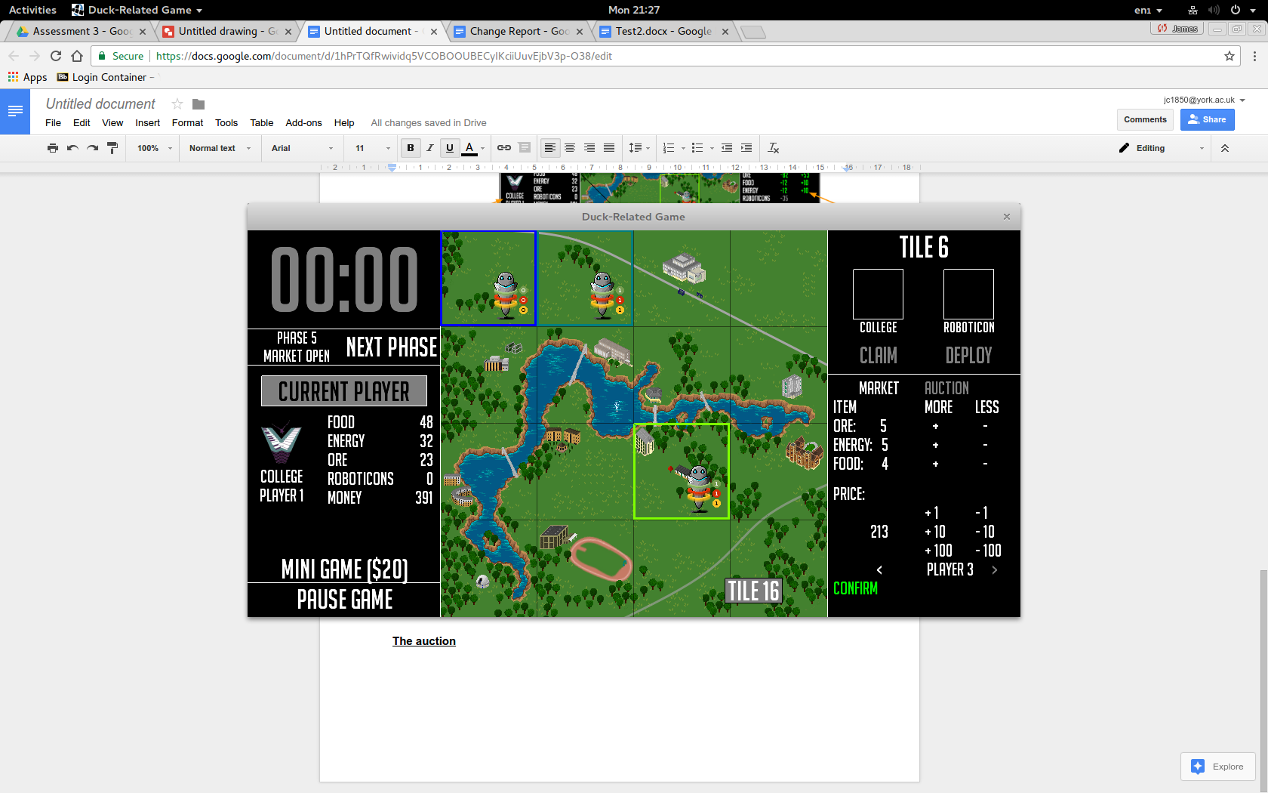

In the auction a player can select the amounts of the various resources they wish to sell to another player using the various +/-keys next to the corresponding resource. They can then set the price to sell them for with the buttons below, increasing and decreasing by 1s, 10s and 100s. The player can then scroll through the list of other players with the arrows at the bottom of the screen and select the player to send the trade to. Finally press confirm to send the trade.