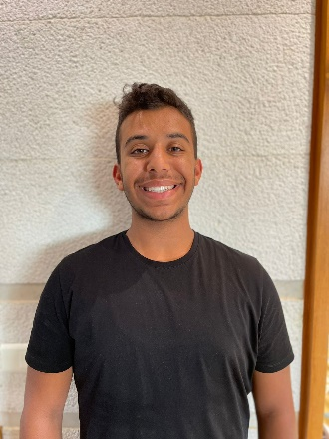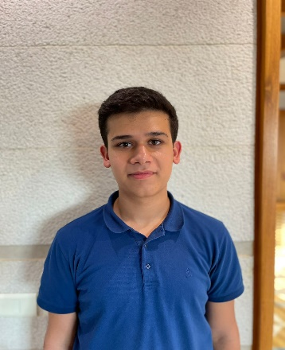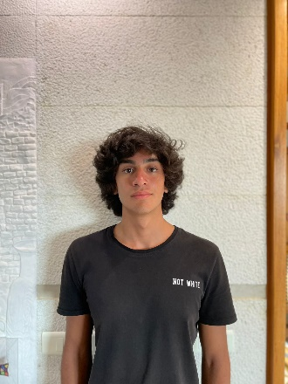

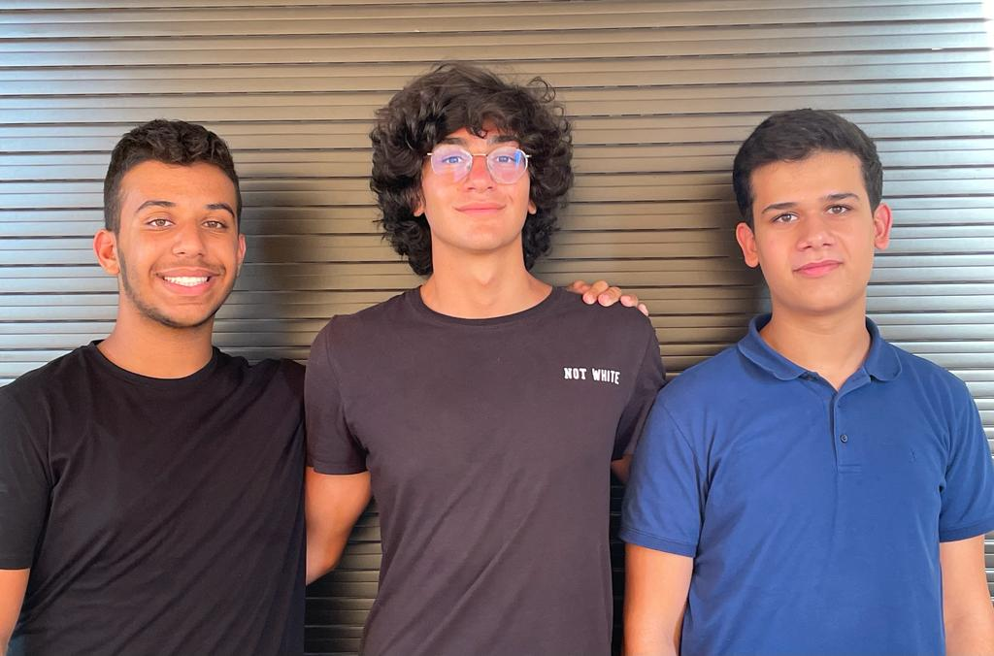

**Team Ghazel’s Manhouse**

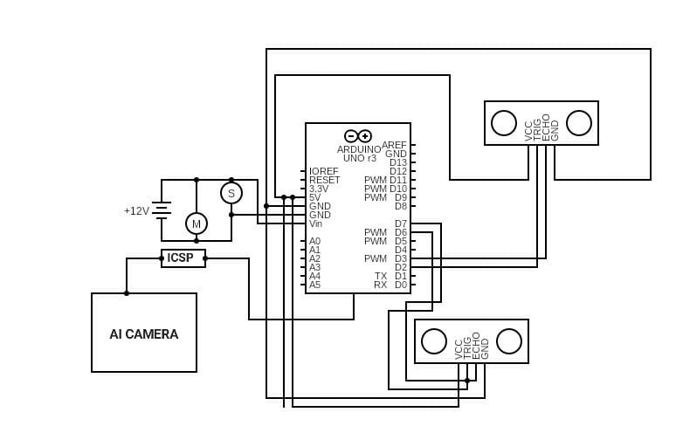

Ever since Team Ghazel was created, it only had one goal. Exploiting the full potential of electrics, mechanics, artificial intelligence and teamwork all in one car. And so was created Manhouse. By meticulously picking the right components, by analyzing each line of its code, by putting in the effort and trying again and again and again, we perfected our self-driving car to be as autonomous as it can be and as performing as it should be.

Manhouse finds it it’s beauty into its complexity, choosing the right components is a pretty hard step because we want our car to be as great as its potential can offer, however, finding a way to make all these components complete each other without breaking any dynamic is certainly a harder step. Though, we found a way to forge our car with the best components available and joining them all together in a smooth way. Manhouse is founded by many components such as:

* **A 12V DC Motor**
* **A Servo**
* **An Arduino Uno board**
* **3 Ultrasonic sensors**
* **3 Rechargeable batteries (3.7 V/4000mAh each)**
* **Voltage Regulator**
* **Motor Driver**
* **Pixy 2.1 AI camera**
* **4 wheels**
* **Jumper cables (20cm)**

Indeed, an adapted code is fundamental for our car’s performances. Our specifically chosen code is our car’s brain. It leads it to be as performing as it should be and guides it through the steps of the circuit. We meticulously founded our code by analyzing each and every line of code to make sure no error has been committed or any informatic bug found. By preparing 2 codes, we made sure that each issue isn’t determined by luck but by our preparation beforehand. We made sure each code is adapted to solve any difficulty without panicking on the D-Day or improvising but by being serene and making sure everything is meticulously built. Our car is built just like a human being, the code is the car’s brain, the sensors are like its eyes, the motor is its heart, the servo is its muscles and nerves, the wheels are like it’s arms and legs all connected y each other with cables taking the role of blood vessels that transmit the electricity to its wheels. Everything helped by the AI camera’s genius.

All in all, Manhouse is greatly built through all the small steps our team made. We slowly built our car by starting by a prototype and removed and added more advanced parts to its arsenal to build its final version. We created our car by joining teamwork, each other’s strengths that can palliate to another group member’s weakness. Our team was perfectly forged by having a balanced overall. Where sometimes a member of the group felt unfamiliar with a bit of the project, another went and helped him so we can build our final project. And by adding bit by bit to our code, by adding complex components, by using each member of the group’s strength in a subject and most of all by team work, we forged Manhouse and are determined to build her a strong future.