**V) C++ Code Implementation**

This document attempts to justify and show how the C++ code was implemented to fit the design pattern that was described in section IV)

The Director calls a Row Builder class in order to build a particular row object (In this case, Grants and Clinical Funding.) A multimap is also created in order to store Grant_rowObjects.



*Figure 5-1: Lines 163-165 of Director.cpp*

The Builder then uses buildRow function which then calls a series of getAttribute functions of Attribute Retriever class that returns every attribute from the Grants row.   
  
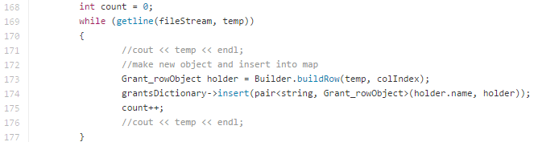

*Figure 5-2: Lines 168-177 of Director.cpp*

Once a row is built, it is then stored in the multimap.

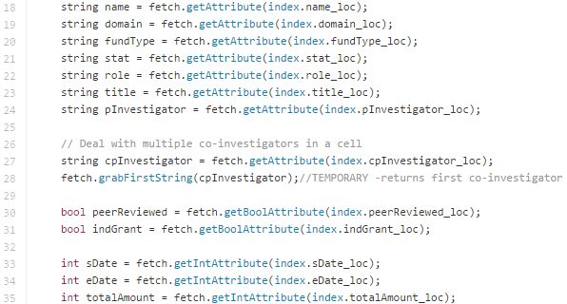

*Figure 5-3: buildRow function: Lines 18-35 of GrantRowBuilder.cpp*