# Teamwork Project Assignment Notes for the [High-Quality Code Course @ SoftUni](https://softuni.bg/courses/high-quality-code/)

You are given a C# desktop application. The project is written using the framework **Windows Forms**.

The application is a Player versus Environment variation of the most popular Poker Card Game – [Texas hold 'em](https://en.wikipedia.org/wiki/Texas_hold_'em).

### Poker Mechanics

On a table of six are placed **one player** and **five non-player characters** (hereinafter called "**bots**").

The first on turn is the player who decides to **call**, **raise**, **check** or **fold** (some of the actions might not be possible due to the game rules, e.g. they cannot **check** if there was a **raise** before them). Afterwards each of the bots makes a decision for its actions.

The cycle repeats until the **river** is flipped face up or 5 out of 6 players have **folded**. Then the game decides which of the remaining players has the [winning hand](https://en.wikipedia.org/wiki/List_of_poker_hands).

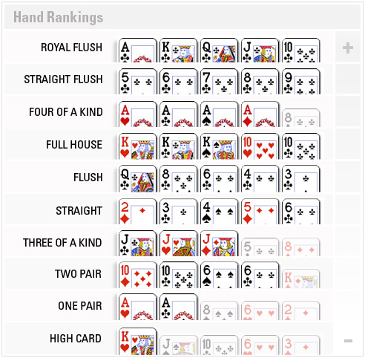

### Refactor the Project

Refactor the given project by applying the good principles of OOP and High-Quality Code. Improve the source code's readability and maintainability. Make it extensible and testable by applying SOLID, DRY, YAGNI, etc. principles.

You may leave the bot decision AI (the bot logic) and the form graphics as is. If you wish you may change the external application behavior. Feel free to apply the art of your coding skills.

### Testing the Refactored Project

You have to write unit tests for the **winning hand scenario**.

Each of the variations for winning hands across six players must be tested. If there are bugs in this scenario they have to be fixed. For example, if the wrong winning hand is chosen by the game you need to fix it (e.g. a bot/player with **Straight Hand** is chosen instead a bot/player with **Flush**).